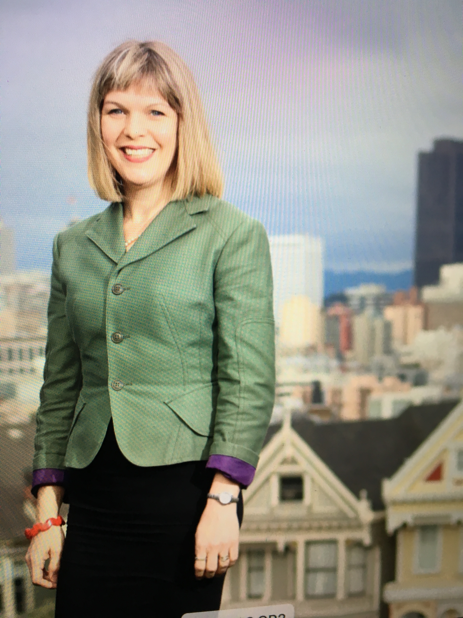

Title: The Psychology of Art Therapy for Trauma Recovery
Name: Amy Backos, PhD, ATR-BC
Notre Dame de Namur University: Graduate Art Therapy Psychology,
Belmont, California 94122 USA

Art making has provided relief and and recovery for individuals and communities who experienced interpersonal, community, and war-time traumas. This presentation reviews the purpose of art making and the use of Art Therapy to heal from trauma and PTSD in two groups who experienced traumas of war: veterans with PTSD in the United States and communities in in Nicaragua impacted by generations of war. Included will be outcome data, artwork, community intervention strategies, and case examples of how Art Therapy was used to express and heal from trauma.
For veterans, results indicated a clinically significant reduction in a self-report measure of PTSD symptoms for one-third of the participants, and a statistically significant reduction in the pre and post-test mean scores on a measure of depression. Artwork and case examples suggest impact from community interventions in Nicaragua. Results and artwork will be conceptualized in the context of Art Therapy research related to trauma, mindfulness, and neuropsychology. Community engagement practices will be discussed including cultural humility and train-the trainer models of intervention for visiting clinicians. Response art, survey, and writing from a group of Art Therapists in Nicaragua provides suggestions to enhance culturally appropriate interventions, promote work satisfaction and reduce burnout.
Clinical implications of Art Therapy and the historical importance of art making for groups and communities will be discussed and participants will consider how art interventions could be applied to their work with traumatized populations.

Biography

Dr. Backos is a Licensed Psychologist and a Registered and Board Certified Art Therapist living in San Francisco, California. She completed her doctorate at CSPP, San Francisco and an APA internship and residency at the Veterans Affairs Medical Center. She serve as the Chair of Graduate Art Therapy Psychology at Notre Dame de Namur University and serves on the Research Committee of the American Art Therapy Association, and on the editorial board of the Journal of the American Art Therapy Association. Her clinical expertise is in art therapy, trauma and addiction and she is published in art therapy and trauma.

Presenting author details
Full name: Amy Backos, PhD, ATR-BC
Contact number: 1-415-652-2440
Linked In account: Amy Backos, PhD, ATR-BC
Session name/ number: Trauma/PTSD
Category: Oral presentation

