Feeling Good Despite EDS: The Effects of a 5‐Week Online Positive Psychology Programme for Ehlers–Danlos‐Syndromes Patients
Larissa Kalisch, Ilona Boniwell, Evgeny Osin, Carolina Baeza-Velasco

Abstract (300 word limit)

Ehlers–Danlos-Syndromes (EDS) is a group of hereditary, chronic and potentially disabling conditions. Few studies have tested the effects of psychological interventions to increase well-being in this population. We hypothesized that Positive Psychology Interventions (PPI), first applied to healthy and mentally ill subjects, can also be useful for people with somatic conditions and conducted a study to evaluate the efficacy of a 5-week online PPI designed to improve well-being in EDS patients. A sample of 132 EDS patients were allocated to three groups: assigned PPI, self-selected PPI, and waitlist control- group (WLC). Measures of positive and negative affect, pain disability, fatigue, and life satisfaction were administered before program start, 6 weeks later, and 1 month later. Satisfaction with the program was also evaluated. The results revealed that participants in the self-selected PPI-group, but not in the assigned PPI group, reported significantly lower levels of fatigue and higher levels of positive affect and life satisfaction compared to WLC after 6 weeks. There were no effects on negative affect and pain disability measures. Finally, 77% of the participants were satisfied or very satisfied with the program. These findings confirm and extend previous research by showing the efficacy of PPI for people with chronic illness under the condition that individuals can choose the program content. From a healthcare perspective, online PPIs could complement treatments aimed at symptom reduction and increase well-being in patients with EDS.
Image

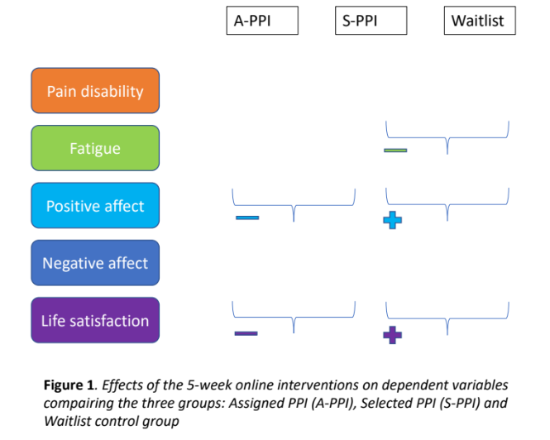
Recent Publications (minimum 5)
- Baeza-Velasco, C., Bourdon, C., Montalescot, L., de Cazotte, C., Pail- hez, G., Bulbena, A., & Hamonet, C. (2018). Low- and high-anx- ious hypermobile Ehlers-Danlos syndrome patients: Comparison of psychosocial and health variables. Rheumatology International, 38(5), 871–878.
- Krahe, A. M., Adams, R. D., & Nicholson, L. L. (2017). Features that exacerbate fatigue severity in joint hypermobility syndrome/ Ehlers–Danlos syndrome—Hypermobility type. Disability and Rehabilitation. https://doi.org/10.1080/09638288.2017.1323022
- Müller, R., Gertz, K. J., Molton, I. R., Terrill, A. L., Bombardier, C. H., Ehde, D. M., & Jensen, M. P. (2016). Effects of a tailored positive psychology intervention on well-being and pain in individuals with chronic pain and a physical disability: A feasibility trial. The Clinical Journal of Pain, 32(1), 32–44. https://doi.org/10.1097/ AJP.0000000000000225
- Rahman, A., Daniel, C., & Grahame, R. (2014). Efficacy of an out- patient pain management programme for people with joint hyper- mobility syndrome. Clinical Rheumatology, 33(11), 1665–1669. https://doi.org/10.1007/s10067-014-2539-9
- Peters, M. L., Smeets, E., Feijge, M., van Breukelen, G., Andersson, G., Buhrman, M., & Linton, S. J. (2017). Happy despite pain: A randomized controlled trial of an 8-week Internet-delivered posi- tive psychology intervention for enhancing well-being in patients with chronic pain. The Clinical Journal of Pain, 33(11), 962–975. https://doi.org/10.1097/AJP.0000000000000494



Biography (150 word limit)
Larissa Kalisch is a psychologist, researcher and trainer in positive psychology and education as well as in health psychology. Her research focuses on the quality of life of people with chronic diseases as well as on the resilience and well-being of children and adolescents. She is also passionate about the effectiveness and feasibility of positive psychology interventions. As a life coach, she accompanies teenagers and adults in finding their path, gaining confidence, managing the stress of everyday life, daring change and finding balance. She holds a Master of Science in Applied Positive Psychology (Anglia Ruskin University, Cambridge, UK) since 2018. In 2020, she completed the Interuniversity Diploma "Genetic Diseases - Transdisciplinary Approaches" at the University of Paris. She is also involved as a teacher at the University of Paris, at the University of Lorraine, as well as at the training organizations Positran and Orionsanté (nurse training).

Email: larissa@positive-force.com

Notes/Comments:

Presenting author details
Full name: Larissa Kalisch
Contact number: +33 (0)6 46 56 51 03
Twitter account: x
Linked In account: linkedin.com/in/larissa-kalisch-799801a7

Session name/ number:
Category: (Oral presentation/ Poster presentation)

