Engineering linkage-specific polyubiquitin antibodies as tools for elucidation of novel signaling pathways
Marissa L. Matsumoto, Department of Structural Biology, Genentech, Inc., South San Francisco, CA, USA

Abstract
Statement of the Problem: Ubiquitin is a post-translational modification involved in nearly every signaling pathway. Monoubiquitination occurs when the carboxy-terminus of ubiquitin is linked through an isopeptide bond to a lysine residue on a substrate. Ubiquitin itself contains seven lysines and a free amino-terminus through which additional ubiquitin subunits can be linked, resulting in polyubiquitin chains of different topologies. Determination of polyubiquitin chain linkages requires the use of ubiquitin mutants or complex mass spectrometry experiments. The purpose of this study is to engineer antibodies to detect specific polyubiquitin linkages to provide useful research reagents for the study of ubiquitination in cells. Methodology & Theoretical Orientation: We used phage display to engineer antibodies with exquisite specificity to the linear, K11, K48, and K63 linkages and used X-ray crystallography to elucidate the nature of their specificity. To detect more complex heterotypic chains containing mixed or branched linkages, we have developed bispecific antibodies using the knobs-into-holes technology. Findings: The antibodies are highly specific for a given linkage and work in numerous applications, including western blot, immunoprecipitation, and immunofluorescence. Epitope determination by X-ray crystallography demonstrates that rather than contacting the linkage itself, the antibodies recognize a conformational epitope that results from the relative orientation of two ubiquitin subunits as a consequence of the spatial positioning of the residue involved in the linkage. Conclusion & Significance: The polyubiquitin linkage-specific antibodies have provided ubiquitin researchers with an easy-to-use reagent to quickly and efficiently determine the linkages of polyubiquitin chains without the need for ubiquitin mutants or access to mass spectrometry equipment and expertise. These antibodies have become essential tools in studying ubiquitination in cell signaling and have aided in elucidation of numerous pathways including polyubiquitin chain editing, K11-linked chains in cell cycle control, and K11/K48-branched chains in cell cycle and protein quality control.

Image

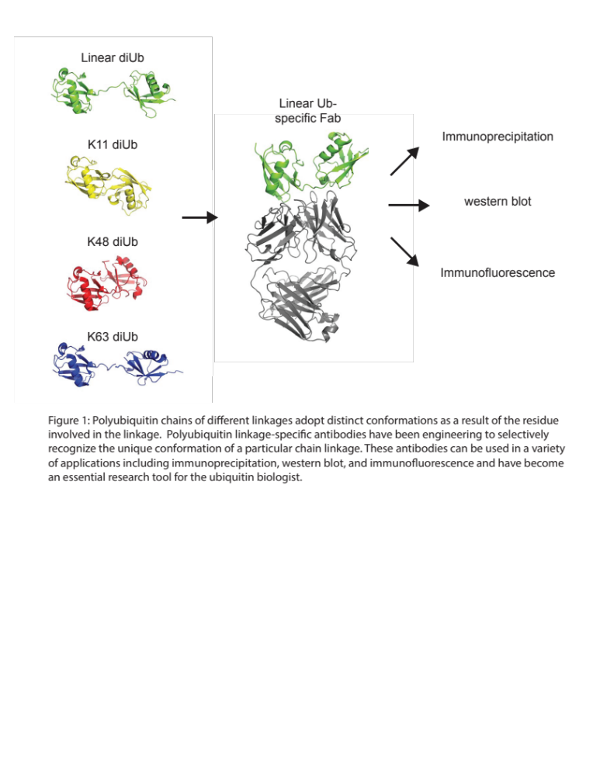

Recent Publications
- Komander, D., Rape, M. (2012) The ubiquitin code. Annu. Rev. Biochem. 2012. 81:203–29.
- Matsumoto, M.L., Dong, K.C., Yu, C., Phu, L., Gao, X., Hannoush, R.N., Hymowitz, S.G., Kirkpatrick, D.S., Dixit, V.M., Kelley, R.F. (2012) Engineering and structural characterization of a linear polyubiquitin-specific antibody. J. Mol. Biol. 418(3-4):134-144.
- Newton, K., Matsumoto, M.L., Ferrando, R.E., Wickliffe, K.E., Rape, M., Kelley, R.F, and Dixit, V.M. (2012). Using linkage-specific monoclonal antibodies to analyze cellular ubiquitination. Methods Mol. Biol. 832:185-196.
- Matsumoto, M.L., Wickliffe, K.E., Dong, K.C., Yu, C., Bosanac, I., Bustos, D., Phu, L., Kirkpatrick, D.S., Hymowitz, S.G., Rape, M., Kelley, R.F., Dixit, V.M. (2010) K11-linked polyubiquitination in cell cycle control revealed by a K11 linkage-specific antibody. Mol. Cell 39(3):477-484.
- Newton, K., Matsumoto, M. L., Wertz, I. E., Lill, J. E., Kirkpatrick, D. S., Tan, J., Dugger, D., Gordon, N., Sidhu, S.S., Fellouse, F.A., Komuves, L., French, D.M., Ferrando, R.E., Lam, C., Compaan, D., Yu, C., Bosanac, I., Hymowitz, S. G., Kelley, R. F., Dixit, V. M. (2008) Ubiquitin chain editing revealed by polyubiquitin linkage-specific antibodies. Cell 134(4):668-678.

Biography
Marissa Matsumoto is a Scientist at Genentech, Inc. in the Department of Structural Biology. Her lab focuses on protein and antibody engineering to develop novel research tools for the study of complex ubiquitination events in cell signaling. She obtained her Ph.D. from Washington University in St. Louis and her B.A. from Northwestern University.
Email: matsumoto.marissa@gene.com
Phone: +1-650-225-4711

