Expression of Hepatitis B surface Antigen (HBsAg) gene in transgenic banana ( Musa Sp.)
Elkholy SF, Ismail RM, Bahieldin A, Sadik AS, Madkour MA, AGERI, ARC, Giza, Egypt

Abstract  .  The Hepatitis B virus (HBV) infection is one of the most widespread viral infections of humans and causes acute and chronic hepatitis and hepatocellular carcinoma. The world wide problem of HBV infection has necessitated the development of an effective vaccine. Currently, immunization programs for large segments of the population in many areas of the developing world are very expensive. This limitation led us to attempt the expression of the recombinant Hepatitis B surface antigen (rHBsAg) in plants with the hope of developing a less expensive production system and a way to present the rHBsAg in edible plant tissues in a form that would be useful as an oral vaccine. In this study, we attempted to express the HBsAg in cv. Williams banana plants to be used as an edible vaccine. Using a Biolistic Gene Gun, apical meristem explants of banana were bombarded with plasmid pBHsAg harboring the gene encoding the HBsAg and the bar gene as a selectable marker. Bombarded explants were selected on media containing 3 mg/l Bialaphos. The HBsAg gene was detected using PCR analysis and its expression was tested via western blot analysis using specific polyclonal antibodies directed against human serum derived HBsAg. This study indicates the feasibility of the expression of foreign antigens in plants for possible use as an oral vaccine. | 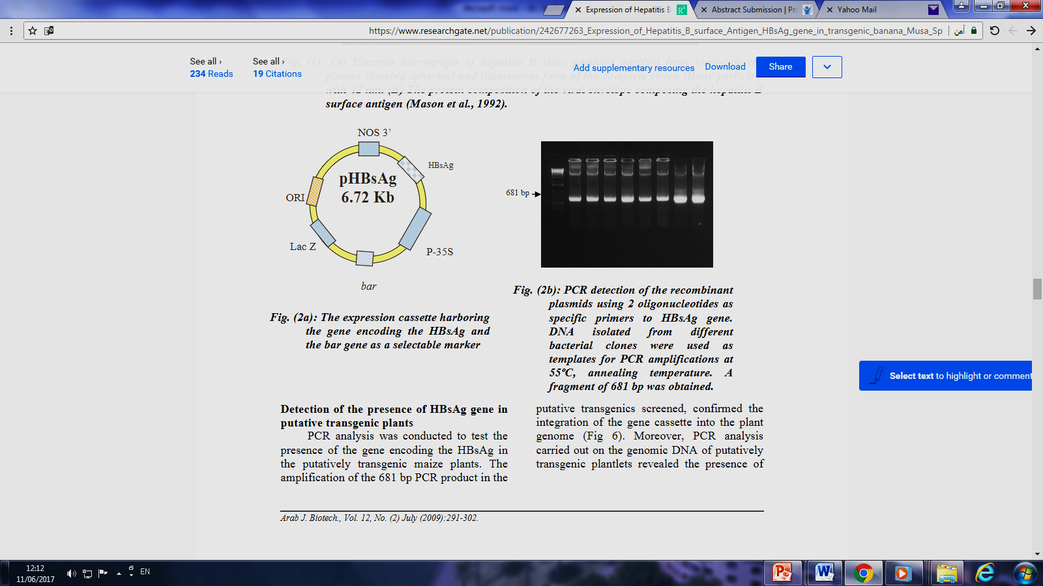  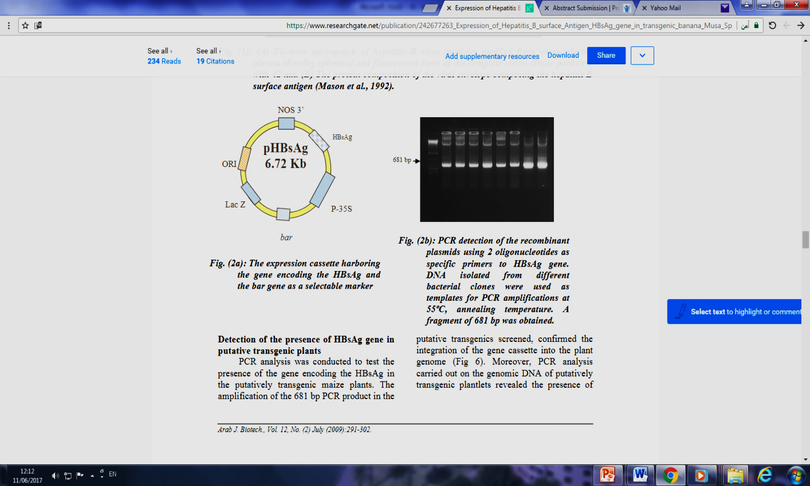  Figure 1The expression cassette harboring the gene encoding the HBsAg and the bar gene as a selectable marker and its PCR detection in recombinant plasmids.
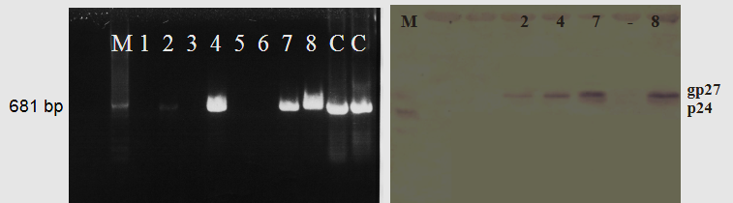

Figure 2: PCR and western blot detection of HBsAg in some putative transgenic banana plants.
Recent Publications
- Eldessoky S Dessoky, Ismail A Ismail, Attia O Attia and Atef S Sadik (2017). Genetic variations, in vitro propagation and conservation of some pomegranate cultivars grown in Taif province, KSA. Kasmera Journal, In press.
- Mohamed SH, Gado EA, Gomaa H, Sadik A.S. (2016). Characterization of bacterial soft rot strains and their specific phages isolated from soil at Taif. Pak. J. Biotechnol. 13: 111-116.
- Sadik AS, Noof A, Mohamed SH (2016). Isolation and characterization of free-nitrogen fixer bacterial strains (Azotobacter sp.) and their phages from maize rhizosphere-soil at Taif Pak. J. Biotechnol. 13: 31-37.
- Mohamed HS, Altalhi AD, El-Zahrani GB, Sadik AS (2015). Enzymatic activities of some streptomycetes isolated from soil at Taif region. Int. J. Curr. Microbiol. App. Sci. 4:19-32.

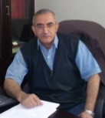

Dr. Sadik has his expertise in genetic engineering and production of transgenic plants , i.e., Banana, cucurbits resistant to a biotic and biotic stress. In addition, production of antisera specific to some plant viruses using the classical or biotechnological methods is also interested. Finally, prize of Scientific Ingenuity (2002) in Biotechnology from the Arab League (3rd Position) has been awarded.

Email: atef_sadik@yahoo.com
+201125569677

