Self-navigating drug- delivery vehicles driven by phages selected from polyvalent ‘landscape’ phage libraries through their inter- and intracellular migration

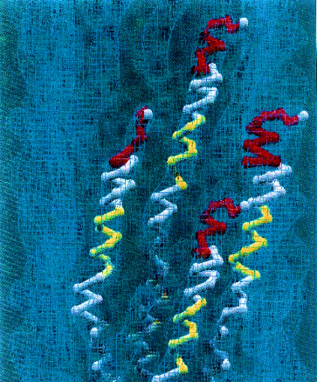
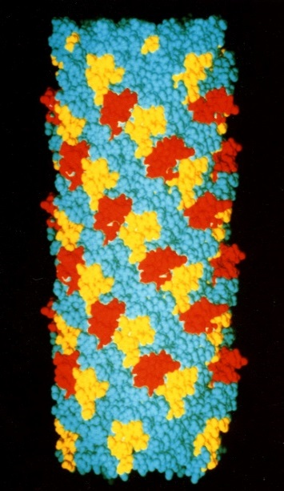
Abstract
Figure 1. Models of landscape phage libraries. Left: Ball-and-stick model of four neighbor p8-proteins with N-terminal random foreign peptides (red) and mutagenized central segments (yellow) on the surface of the phage capsid (blue contour). Right: Random foreign peptides grafted into the major coat protein. N-terminal foreign peptides are pictured with red atoms, central domains are pictured with yellow atoms. The distance between neighboring peptides is ∼ 2.7 nm. The model represents ~1% of the virion’s length.

The idea that a molecular probe could be delivered specifically to targeted cells within the organism, was ‘Holy Grail’ for several generations of bioengineers and biomedical scientists for the past hundred years. To approach to this illusive goal, we used our proprietary polyvalent peptide phage displayed ‘landscape’ libraries to select clones with specificity to various cancer types, which resulted in generating phage protein fusions containing functional motifs with selectivity to various cellular phenotypes and discovery of ‘promiscuous’ multi-motif phage proteins targeted to different cellular receptors. We proposed the novel ‘self-navigating drug’ paradigm, which relies on the use of ‘molecular self-navigating ligands’, selected from tissue-migrating polyvalent multi-motif landscape phage display libraries and accumulating ‘elementary binding units’ responsible for binding to different tissue cells. Phages isolated through their migration to the site of disease would be used for development of specifically targeted molecular navigating ligands that could bring any drug to any site of the body. Applied to the targeted drug delivery problem, this novel approach promises to replace the existing ‘point to point’ targeting concept for the novel ‘self-navigating’ drug delivery paradigm that can be used as a theoretical basis in development of a novel generation of molecular imaging probes and medications for precise and personal medicine.

Publications
- Petrenko VA, Gillespie JW. Paradigm shift in bacteriophage-mediated delivery of anticancer drugs: from targeted 'magic bullets' to self-navigated 'magic missiles'. Expert Opin Drug Deliv. 2017 Mar;14(3):373-384.
- Gross AL, Gillespie JW, Petrenko VA. Promiscuous tumor targeting phage proteins. Protein Eng Des Sel. 2016 Mar;29(3):93-103.
- Petrenko VA, Jayanna PK. Phage protein-targeted cancer nanomedicines. FEBS letters. 2014; 588(2):341-9.
- Phages from landscape libraries as substitute antibodies. Petrenko VA, Smith GP. Protein engineering. 2000; 13(8):589-92.
- Petrenko VA, Smith GP, Gong X, Quinn T. A library of organic landscapes on filamentous phage. Protein engineering. 1996; 9(9):797-801.

Biography

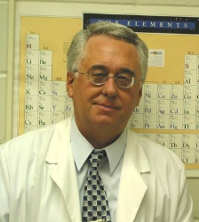
Biography. Valery A. Petrenko, Professor in Auburn University; graduated from Moscow State University (1972); received PhD and D.Sc. degrees from the Institute of Organic Chemistry (1976) and Moscow State University (1988), and Ranks of Senior Scientist (1984) and Professor in Bioorganic Chemistry and Molecular Biology (1992) from the Government of the USSR. He served as Senior Scientist (1977-1982), Laboratory Head (1982-1985), Associate Director of Research, Institute Director (1985-1989), Vice President of Research and Professor (1989-1993) in the Association “Vector” (Novosibirsk, Russia). In 1993 he joined the faculty of University of Missouri-Columbia as Visiting and Research Professor, and in 2000—the faculty of Auburn University as Professor. He is recipient (PI) of grants from the ARO, NIH-NCI, Calvert Research, LLC, and AURIC. He is member of National Academy of Inventors Chapter (2013), Auburn University Research Initiative in Cancer (AURIC), National Cancer Institute (NCI) Alliance for Nanotechnology in Cancer (2009) and Phi Zeta Honor Society of Veterinary Medicine. His research interests include monitoring and detection of biological threats, diagnosis of infectious and cancer diseases and tumor targeting.
Email: petreva@auburn.edu
Phone: +1-334-887-2014

