Engineering phosphoinositide-substrate specificity into Low Molecular Weight Protein Tyrosine Phosphatase (LMWPTP) by computational and structure-guided rational design
Eyong Esim Egbe, Faculty of Biology, Medicine and Health, University of Manchester, UK

Abstract (300 word limit)
Statement of the Problem: Phosphoinositide phosphatases (PTENs, Myotubularins, SACI domain phosphatase, synaptojanins) are regulatory enzymes that mediate critical cell processes such as cell signaling, cell cycle, growth and differentiation. Loss-of-function mutations in these enzymes are linked to several disease conditions including diabetes and cancer. Tumor suppressor PTEN, for example, is the most frequently mutated gene in various forms of human cancer. The objective of this research is to exploit the possibility of using engineered enzymes in replacement therapy to tackle these diseases. Methodology and findings: Protein engineering has been successfully applied to make new enzymes, change substrate specificity and catalytic efficiency of other enzymes. In the current research, we used a combination of structure-guided rational and computational design strategies to alter the substrate specificity of low molecular weight protein tyrosine phosphatase (LMWPTP), from tyrosine-specific to phosphoinositide-specific phosphatase. Designs were made by providing Rosetta Macromolecular Modelling suite with information from structural analysis, and Autodock 4.2 was used to validate the designs. Two double-point mutants dephosphorylate phosphoinositides. Mutant RT is strictly specific for PI5P, while mutant RK has broad substrate specificity; it dephosphorylates PI3P, PI4P, PI5P and PI35P2. Conclusion and significance: These mutants will subsequently be transformed into yeast knockout of phosphoinositide phosphatases to find out if they can rescue the associated loss-of-function phenotypes in yeast knockout. This will determine if in vitro activity of mutants can be replicated in vivo and possibly open up the opportunity to test the use of these engineered enzymes as bio-therapeutics in human disease treatment.

Image
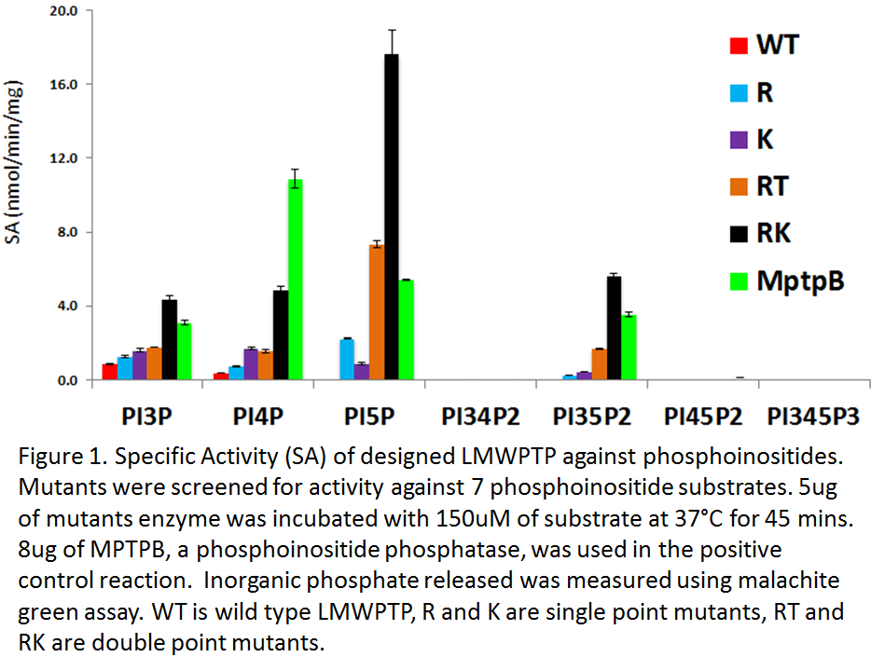
Recent Publications (minimum 5)
1. Chow, C.Y., Landers, J.E., Bergren, S.K., Sapp, P.C., Grant, A.E., Jones, J.M., Everett, L., Lenk, G.M., McKenna-Yasek, D.M., Weisman, L.S., Figlewicz, D., Brown, R.H., Meisler, M.H., 2009. Deleterious Variants of FIG4, a Phosphoinositide Phosphatase, in Patients with ALS. Am. J. Hum. Genet. 84, 85–88.
2. Johnston, S.B., Raines, R.T., 2015. Conformational Stability and Catalytic Activity of PTEN Variants Linked to Cancers and Autism Spectrum Disorders. Biochemistry (Mosc.) 54, 1576–1582.
3. Nakajima, J., Okamoto, N., Shiraishi, J., Nishimura, G., Nakashima, M., Tsurusaki, Y., Saitsu, H., Kawashima, H., Matsumoto, N., Miyake, N., 2013. Novel FIG4 mutations in Yunis–Varon syndrome. J. Hum. Genet. 58, 822–824.
4. Rodríguez-Escudero, I., Oliver, M.D., Andrés-Pons, A., Molina, M., Cid, V.J., Pulido, R., 2011. A comprehensive functional analysis of PTEN mutations: implications in tumor- and autism-related syndromes. Hum. Mol. Genet. 20, 4132–4142.
5. Tabernero, L., Aricescu, A.R., Jones, E.Y., Szedlacsek, S.E., 2008. Protein tyrosine phosphatases: structure-function relationships: PTP structure-function relationship. FEBS J. 275, 867–882.

Biography (150-word limit)
Eyong Esim Egbe is a final year PhD student in Molecular Cancer studies, who is very passionate and keen to achieve a positive impact on human health through research. He obtained a First class honors BSc in Biochemistry in 2008 from the University of Buea, Cameroon and graduated as the top student out of 2000 students. He won a Commonwealth Scholarship to study for a Masters in Biotechnology where he also finished in top spot with a distinction. He took up a management-consulting role with a chocolate manufacturing industry after undergoing a 2-year graduate trainee program. During 4 years of working with this company, he acquired transferrable skills in business management. He has now returned to conduct research in biotechnology with a view of returning to work with biopharmaceutical industries upon completion of his PhD.
Email: Eyong.Egbe@postgrad.manchester.ac.uk
Phone: +44-79499-16107

Notes/Comments:

