Novel signal peptides improve the secretion of recombinant Staphylococcus aureus Alpha toxin_{H35L} in Escherichia coli.
SooJin Han, MedImmune LLC, USA

Abstract

Secretion of heterologous proteins into E.coli cell culture medium offers significant advantages for downstream processing over production as inclusion bodies; including cost and time savings, and reduction of endotoxin. Signal peptides play an important role in targeting proteins for translocation across the cytoplasmic membrane to the periplasmic space and release into culture medium during the secretion process. Alpha toxin_{H35L} (AT_{H35L}) was selected as an antigen for vaccine development against S. aureus infections. It was successfully secreted into culture medium of E.coli by using bacterial signal peptides linked to the N-terminus of the protein. In order to improve the level of secreted AT_{H35L}, we designed a series of novel signal peptides by swapping individual domains of modifying dsbA and pelB signal peptides and tested them in a fed-batch fermentation process.

The data showed that some of the modified signal peptides improved the secretion efficiency of AT_{H35L} compared with E. coli signal peptides from dsbA, pelB and phoA proteins. In particular, one of novel signal peptides improved the yield of secreted AT_{H35L} by 4-fold in the fed-batch fermentation process and at the same time maintained the expected site for signal peptide cleavage. Potentially, these new novel signal peptides can be used to improve the secretion efficiency of other heterologous proteins in E.coli. Furthermore, analysis of the synthetic signal peptide amino acid sequences provides some insight into the sequence features within the signal peptide that influence secretion efficiency.

Image

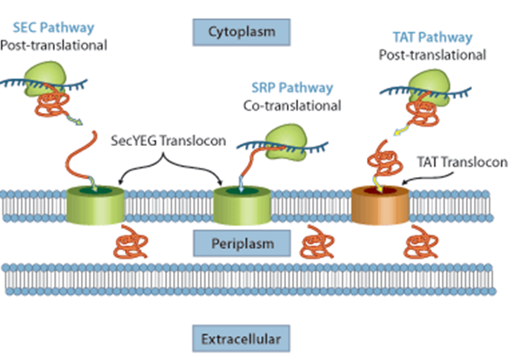

Recent Publications (minimum 5)

1. Han SJ et al. (1999) Interleukin (IL)-5 Downregulates Tumor Necrosis Factor (TNF)-Induced Eotaxin Messenger RNA (mRNA) Expression in Eosinophils. Am. J. Respir. Cell Mol. Biol. 21, p303-310.
2. Lim JH, Choi J, Han SJ and et al. (2001) Molecular cloning and characterization of thermostable DNA ligase from Aquifex pyrophilus, a hyperthermophilic bacterium. Extremophiles 5, p161-168.
3. Han SJ et al. (2003) Expression and characterization of a novel enantioselective lipase from Acinetobacter species SY-01. Biochimie 85(5), p501-510.
4. Han SJ et al. (2004) Enhancement of lipase activity from Acinetobacter species SY-01 by random mutagenesis and the role of lipase-specific chaperone. Enzyme and Microbial Technology 35(5), p377-384.
5. Han SJ et al. (2010) Mutational analysis of the latency-associated nuclear antigen DNA-binding domain of Kaposi's sarcoma-associated herpesvirus reveals structural conservation among gamma herpesvirus origin binding proteins. Journal of General Virology 91, p2203-2215.
6. Han SJ et al. (2013) Polymorphism in KSHV miRNA genes affect miRNA maturation and expression differences in clinical isolates from KS and MCD patients. J. of Virol 87(22), p12237-12248.

Biography
Soojin Han has completed her PhD from both KIST and Hanyang Univerisity in Korea and postdoctoral studies from University of Alabama and University of Florida in U.S. She has been working as a scientist of the department of cell culture and fermentation sciences at MedImmune, a Maryland based biotechnology development enterprise owned by AstraZeneca. She has much experience and great knowledge in mAb and non-mAb production in prokaryotic and eukaryotic expression platforms and published several papers in reputed journals.
Email: HanS@medimmune.com
Phone: +1-301-398-1857

Notes/Comments:

