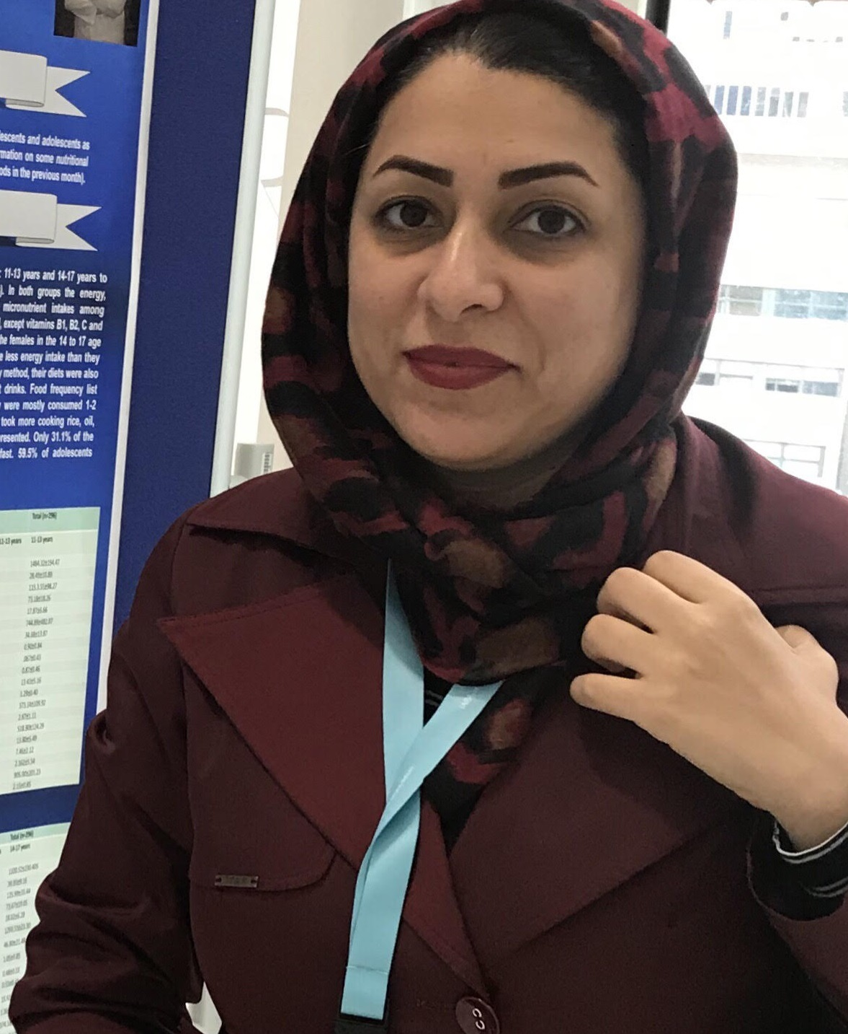

Title: Optimization of culture medium conditions and examination of GABA production potential by probiotic microorganisms extracted from local dairy products of western Iran in two culture mediums of MRS and whey protein
Fatemeh Zarei*, Leila Nateghi, Mohamad Reza Eshaghi, Maryam Ebrahimi Taj Abadi
Department of Food Science and Technology, Faculty of Agriculture, Varamin-Pishva Branch, Islamic Azad University, Varamin, Iran
Gamma-aminobutyric acid is a non-protein amino acid produced by lactic acid bacteria in fermented foods and includes unique functions in the human biological system. The aim of this study was optimization of culture media for gamma-aminobutyric acid production in probiotics extracted from local dairy products in west of Iran using two culture media of MRS broth and whey protein. The potential of gamma-aminobutyric acid production was assessed in Lactobacillus paracasei, Lactobacillus plantarum and Pediococos acidilactici, respectively extracted from doogh, yogurt and cheese using MRS broth and whey protein media and high performance liquid chromatography. To increase gamma-aminobutyric acid production, these media were optimized as pH (4-6), temperature (30-50°C), time (12-72 h) and glutamic acid concentration (25-250 mM). Results have shown that Lactobacillus plantarum extracted from doogh includes the highest potential of gamma-aminobutyric acid production (115.24 mg kg⁻¹) under the following conditions of a culture temperature of 37°C, incubation time 60 h at pH 5 in MRS broth containing 50 mM of glutamic acid. After optimization of Lactobacillus plantarum media, gamma-aminobutyric acid production increased to 170.492 mg kg⁻¹. The optimum conditions included a glutamic acid concentration of 250 mM, culture temperature at 37.27°C, pH=5.19 and an incubation time of 72 h. Based on the results, use of local isolated dairy products in west region of Iran and optimization of growth conditions increased the ability of gamma-aminobutyric acid production.
Biography

Fatemeh Zarei has completed his PhD at the age of 39 years from Department of Food Science and Technology, Faculty of Agriculture, Varamin-Pishva Branch, Islamic Azad University. She is working in Food and drug Administration (FDA) Tehran, Iran for 13 years.

Presenting author details
Full name: Fatemeh Zarei
Contact number: 00989904126862
Category: ( Poster presentation)

