Objectives: The aim of this study was to evaluate cases of dental trauma treated at the specialized center of Pontifical Catholic University of Paraná, Curitiba, Brazil, during a period of 2 years. Material and methods: A total of 647 patients were evaluated and treated. Data obtained from each patient were tabulated and analyzed as to gender, age, etiology, time elapsed after the injury, diagnosis (type of trauma), and affected teeth. Results: The results revealed that male individuals aged 7 to 13 years presented the highest prevalence of injury, and falling was the main causal factor. In most cases, the time elapsed between the accident and the first care ranged from 4 to 24 h. A total of 1747 teeth were affected, with higher incidence of concussion/subluxation and coronal fracture, followed by lateral luxation and avulsion. The permanent maxillary central incisors were the most commonly affected teeth. Conclusion: The frequency and causes of dentoalveolar trauma should be investigated for identification of risk groups, treatment demands and costs in order to allow for the establishment of effective preventive measures that can reduce the treatment duration and costs for both patients and oral health services. An intense program of instruction of “What to do in case of dental traumatism” must be develop in order to enable parents, teachers and health care professionals to take the correct dental trauma measures even in the place of the accident.

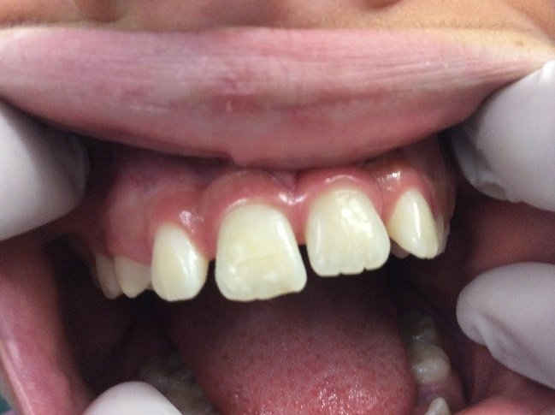
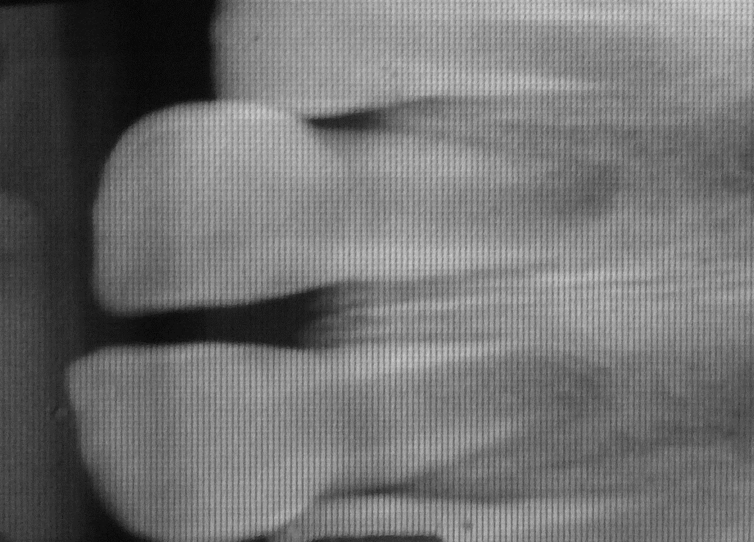

References:
- Fariniuk LF, Souza MH De, Westphalen VPD, Carneiro E, Silva Neto UX, Roskamp L, et al. Evaluation of care of dentoalveolar trauma. J Appl Oral Sci. 2010;18(4):343–5.
- Ritwik P, Massey C, Hagan J. Epidemiology and outcomes of dental trauma cases from an urban pediatric emergency department. Dent Traumatol. 2015;31(2):97–102.
- Petrovic B, Marković D, Peric T, Blagojevic D. Factors related to treatment and outcomes of avulsed teeth. Dent Traumatol. 2010;26(1):52–9.
- Fuss Z, Tsesis I, Lin S. Root resorption - diagnosis, classification and treatment choices based on stimulation factors. Dent Traumatol. 2003;19(4):175–82.
- Andreasen FM, Kahler B (2015) Diagnosis of acute dental trauma: the importance of standardized documentation: a review. Dental Traumatology 31,340–9.

Biography

Liliane Roskamp is born and lives in Curitiba, Brazil. She holds a bachelor 's degree in Dentistry from Universidade Federal de Parana - UFPR (1985), studied two years of dentistry at UNIVERSITÉ LIBRE DE BRUXELLES - ULB (1981-1983), and one year of medicine at the Evangelical Faculty of Paraná (1980). She obtained a specialist degree in Endodontics at UNIVERSIDADE DE SÃO PAULO - USP (1988) and Basic Immunology, Clinical, Epidemiology (Public Health) and Clinical and Molecular Diagnosis by UNIVERSIDADE POSITIVO (2005). She obtained master's degree in Dental Sciences, Endodontics concentration area in 2009 by PONTIFICIA UNIVERSIDADE CATOLICA DO PARANA – PUCPR and her PhD from the School of Health and Biosciences, post-graduation program in Dentistry, concentration-endodontics area in the same institution, in 2016. Has experience in the area of ​​Clinical Dentistry, with an emphasis on Endodontics and Dental Traumatology. She works at her own private office and give several lectures in pos-graduation dental schools.

Email: lroskamp@gmail.com

