Tropical Coronary artery disease and arrhythmogenic potentials
Ramachandran Muthiah
Morning Star Hospital, Marthandam, Kanyakumari District, India.
Abstract
The rising incidence of CAD is a new phenomenon in developing countries. The increasing burden of coronary artery disease (CAD) in tropical and subtropical belts of the Equator since it remains blurred and carries a grim prognosis. The worldwide burden is set to reach 47 million disability by the year 2020 as projected by World Health Organization . Several Western studies have demonstrated a significant role of various nutrients like fat, saturated fat and cholesterol in the causation of CAD. In contrast, the traditional Indian diet is low in fat content and, therefore cannot be the sole cause for the high prevalence of CAD in Indians. Plaque buildup in endocardium and coronary arteries, causing ischemic injury and arrhythmic episodes, is a vanishing mystery in its pathogenesis and emphasizing alternative routes for understanding and treatment of this enigmatic disease. Recently, an increase in the incidence of CAD was reported from southern states of India and other etiologies, the infectious or inflammatory conditions such as Endomyocardial fibrosis may provide an insight in its analysis. Virchow, first proposed an association between infection and IHD (ischemic heart disease) > 100 years ago. Cardiotropic viruses were first implicated in the pathogenesis of CAD in 1968 when experimental Coxsackie B₄ virus infection in mice was shown to produce acute coronary arteritis . Other investigators suggest a link between Coxsackie B virus and coronary artery disease, following a report of myocardial infarction, occurring in two normolipidemic male patients due to an unknown viral illness . Bacterial infection may lead to molecular sequelae that might have effects on the initiation and maintenance of atherosclerotic process. The individuals having seropositive for C. pneumoniae and H.pylori, shown to possess elevated levels of fibrinogen, a risk factor for CAD. Antibiotic treatment should slow its progressin and early eradication of the organism is important to prevent future cardiovascular events. Recently, evidence of myocardial injury, as defined as an elevated troponin level, is common among patients hospitalized with COVID-19, caused by cardiac microvascular damage and systemic inflammatory response syndrome (cytokine storm) with increased risk of a poor prognosis. Among patients who are diagnosed with COVID-19, there is a broad range for prevalent CAD. rates between 4.2 and 25 percent have been reported, with most series from China. Patient with COVID-19 pneumonia with respiratory failure may not be an optimal candidate to reap the benefit of myocardial reperfusion. The important steps to prevent and decrease the risk of CAD is to reduce the chance of getting this disorder by epidemiological measures with an advice of blood thinning medications such as small daily dose aspirin, statins, nitrates and antibiotics in susceptible individuals
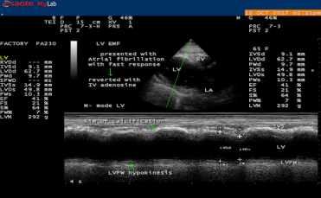
The M-mode LV study (green line) showing the rim of IVS (interventricular septum) calcification (upper arrow) and hypokinesia of LV (left ventricle) posterior wall (lower arrow) with LV dysfunction (EF-41%).

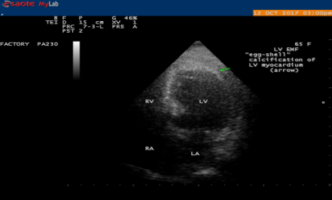
2D Echo showing the “egg-shell” calcification of Left ventricle (LV) (arrow), suggesting LV EMF (Endomyocardial fibrosis)
Publications
- Muthiah, R. (2017) “End-Stage” Constrictive Pericarditis—A Case Report. Case Reports in Clinical Medicine, 6, 255-273
- Muthiah, R. (2021) Isolated Acute Rheumatic Pancreatitis—A Case Report. Case Reports in Clinical Medicine, 10, 52-77
- Muthiah, R. (2019) Infective Endocarditis in Tetralogy of Fallot Complicating Brain Abscess—A Case Report. Case Reports in Clinical Medicine, 8, 105-126.
- Muthiah, R. (2018) Native Aortic Valve Endocarditis—A Case Report. Case Reports in Clinical Medicine, 7, 483-504.
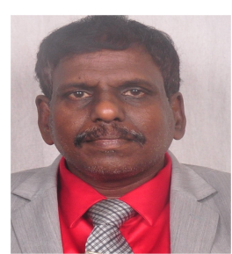
- Muthiah, R. (2018) Tropical Coronary Artery Disease and Arrhythmogenic Potentials—The Changing Pattern towards Endomyocardial Fibrosis—An Analysis. Case Reports in Clinical Medicine, 7, 397-429.

Biography
Ramachandran Muthiah, Consultant Physician & Cardiologist, Zion hospital, Azhagiamandapam and Morning star hospital, Marthandam, Kanyakumari District, India. Completed M.B.B.S (1983 to 1989- Tirunelveli medical college- Madurai kamaraj university), M.D. in General Medicine in 1996 (Tirunelveli medical college), D.M. in cardiology in 2003 (Madurai medical college) under Tamil Nadu Dr.MGR Medical University, Chennai, India. Worked as medical officer in Rural health services (keelachekkarakudi- thoothukudi, Aryappapuram- Tenkasi, ESI hospital- singanallur in coimbatore for 5 years and in teaching category as Assistant Professor at Madras medical college, Coimbatore medical college, Thoothukudi medical college and Professor at Dr.SMCSI Mission hospital & Medical college, Karakonam, Trivandrum and Azeezia Medical college, Kollam. Consultant at St. Thomas hospital, Pranavam hospital, Little flower mission hospital, vilakudy at Punalur in kollam district of kerala state. Published many papers in Cardiosource, American College of Cardiology Foundation, Case Reports in Clinical Medicine (SCIRP) and Journal of Saudi Heart Association. Special research on Rheumatic fever and Endomyocardial fibrosis in tropical belts, Myxomas, Ineffective endocarditis, apical hypertrophic cardiomyopathy, Ebstein’s anomaly, Rheumatic Taussig-Bing Heart, Costello syndrome and Tetralogy of Fallot.
Born on 10/5/1966 at keezhkulam village, father Muthiah belongs to Enayam thoppu and mother Swornam belongs to Palaninta vilai, keezhkulam- 629193 in kanyakumari district of Tamil nadu state (landline- +91 4651 203014). Mother’s Grand father- Thangaiah, Grand mother- Ammal belongs to keezhkulam, Father’s Grand father-Karuman belongs to Enayam thoppu). School education as Primary from Aanan villai at keezhkulam (1971 to 1975), Higher secondary from Concordia higher secondary school, Pootteti (1976 to1983) at Theruvukadai of karungal at kanyakumari district. Got married in 1992 with Rajula shanthy, an agricultural scientist at coimbatore and has one son named as Jeremy and marital status and job position went down in Tamil nadu state from 2004 onwards as transfer to institute of mental health, kilpauk at chennai from Madras medical college and career get spoiled as blockage of PhD study at chennai and Interventional cardiology course at Batra heart centre in New Delhi in 2006 on enemity from ruling political men and thereafter done brutal assaults and jail imprisonments in trivandrum district (balaramapuram- medical trust hospital, lodged at Neyatinkara subjail in kerala state) and brutal assaults on my head in kollam district at kalayapuram CSI mission hospital and Devi hospital, vellarada of kerala state, psychiatric custody at madurai medical college by police arrest from kanyakumari medical college, mental hospital deputation and police arrest from thoothukudi medical college hospital. Killing attempts happened on me at eraviputhurkadai, vettuventhi, vellarada and chasing away from malayedi of Vilavancode assembly limits recently. Now attached with a poor orphan girl R.Russulsy and remaining as ‘care - taker’ at present.
Presenting author details
Full name: Ramachandran Muthiah
Contact number: +91 7598755201
Landline +91 4651 203014, Palaninta vilai, keezhkulam- 629193, kanyakumari
District, Tamil nadu state, India
E-mail : cardioramachandran@yahoo.co.uk
Category: (Oral presentation/
Passport No:P8925619

