Ms. Indira Kumari Raut
Program Officer
Nepal Red Cross Society
CBHFA Project
Udayapur District Chapter

Title: Community Based Health & First Aid (CBHFA) Project as a success model of Nepal Red Cross Public Awareness and Responsibilities regarding Occupational Health and Safety issues.
Background:

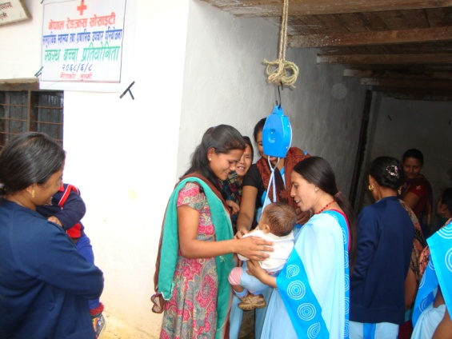
Nepal has a difficult geo-physical structure, limited health facilities, difficult transport and limited means of communication. Availability of health services and mode of transportation are confined to district headquarters only. Due to insufficient availability of health services and transportation facilities in remote community, people are facing difficulties during the accidents, injuries and health problems. Along with this, people in the communities have wrong attitude towards hygiene and health. Thousands of people die annually due to injuries, accidents and inappropriate health practices Therefore, CBHFA program activities has been playing a vital role in first aid, sanitation and hygiene promotion, community based health issues and community awareness
Objective:

To build capacity of the communities to promote their health and manage injuries and illness as well as prepare for and deal with disaster.
Method:

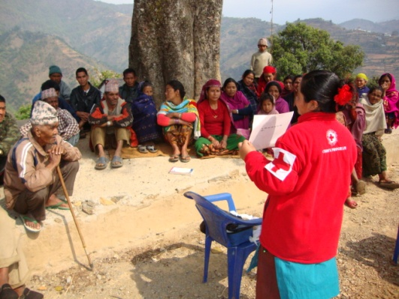
In the project area a number of committees are constituted to carry out the project activities such as Community Based Health & First Aid Volunteers selection, organize trainings for volunteers, volunteers meetings, and sanitation campaign and health promotion initiatives. Community participation is ensured from the planning to evaluation phases of the program. Local committees perform directly with the Red Cross agencies to the implementation of the project. The Group usually works with non-funded activities mobilizing their own local resources. It fights against social evils embedded in the society by generating awareness in the community.
Results:

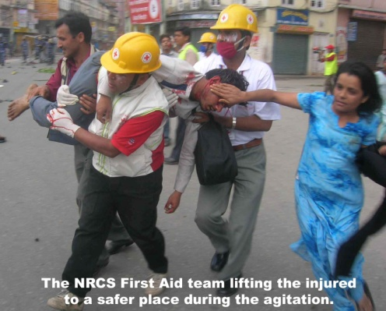
From ten districts, 750 households were surveyed. It demonstrates that about 93% of the local residents know about volunteers of their wards. According to the survey, about 95% people go with CBHFA-volunteers if any health problems or accidents happened to them. They are fully satisfied with the services provided by the volunteers. Volunteers frequently visit their home and motivate them for construction of toilet, promotion of hygiene and sanitation, demonstration of ORS preparation , disaster preparedness, create awareness regarding immunization, diarrheal diseases, ARI, malnutrition , antenatal check-up and so on. It also provides first aid and referral services. People’s satisfaction toward the volunteers’ services means they have become a most important components of the CBHFA program. All the above-mentioned responses are the clear indication for the future that the CBHFA program will be institutionalize in the community level.
Conclusion:
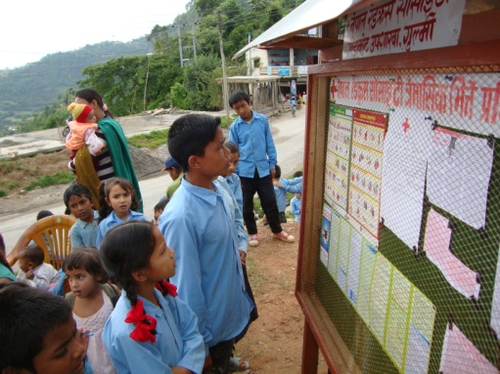
CBHFA service has established First aid service through volunteers in the community and enabling environment to practice positive health behavior. Communities are organized and prepared for probable disaster and Red Cross district chapters, sub-branches at local level are capable in promoting and managing CBHFA activities towards community. In the remote areas where health facilities are lacking, CBHFA program can be a useful and an affordable alternative for the timely relief and safety of the patients and wounded people of the community.

