PRACTICING POSITIVE CBT
FROM REDUCING DISTRESS TO BUILDING SUCCESS
Fredrike Bannink

Recent decades have witnessed a surge in the development of competency-based, collaborative approaches to working with clients. Practicing Positive CBT reveals how traditional CBT can become Positive CBT by shifting the focus of therapy from what is wrong with clients to what is right with them, and from what is not working to what is, thus creating a more optimistic process that empowers clients and therapists to flourish.
Drawing on insights and techniques from both Positive Psychology and Solution-Focused Brief Therapy, Fredrike Bannink reveals how Positive CBT combines the best elements of change-based and meaning-based psychotherapeutic approaches to offer a new perspective on traditional CBT. This transition represents an important shift from problem analysis to goal analysis, from a focus on deficits and the learning of new behaviours to one that builds on resources and competences clients already possess and from reducing distress to building success.
Prof. Paul Gilbert: “Fascinating insights and practical applications to change what we focus on and how we work in helping people change.”
Prof. Willem Kuyken: “What Bannink is doing is radical, synthesizing CBT with the psychology of resilience in a grounded and pragmatic way.”

After the workshop the attendants will have:
- knowledge of Positive CBT and how it is different from traditional CBT.
- skills to enhance positive emotions and hopeful and optimistic conversations.
- practical Positive CBT tools (e.g. positive FBA).

Description workshop
Keynote presentation and exercises for experience-based learning.

Content:
- What is Positive CBT?
- How is Positive CBT different from traditional CBT and how can it be combined?
- What is the role of the Positive CBT therapist?
- How to find competences, resources and what works to build successes within a CBT framework

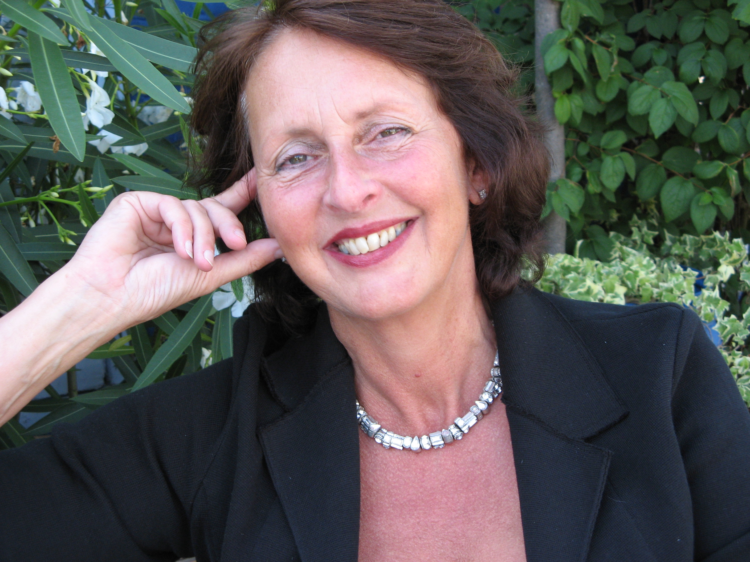

Dr. Fredrike P. Bannink MDR

Clinical psychologist; CBT, SFBT and PP trainer and supervisor.
Chair EABCT Special Interest Group Positive CBT.
Trainer Mental Health Team Doctors without Borders.
Owner therapy, training, coaching and mediation practice in Amsterdam.
International keynote speaker, presenter, trainer and author of 30+ books.
www.fredrikebannink.com
@FredrikeBannink

References
Bannink, F.P. (2010). 1001 Solution-Focused Questions. Handbook for Solution-Focused Interviewing. New York: Norton.
Bannink, F.P. (2012). Practicing Positive CBT. From Reducing Distress to Building Success. Oxford: Wiley
Bannink, F.P. (2014). Positive CBT. Journal of Contemporary Psychotherapy, 44, 1-8.

