For oral presentation

Mapping and determinants of inadequate minimum dietary diversity(MDD) among children age 6—23 months in 33 Sub—Saharan Africa countries.
Bayuh Asmamaw Hailu MPH in Epidemiology and Bio-statistics, Wollo University, Dessie, Ethiopia.

Abstract
Buckground Inadequate MDD is a public health concern in SSA. The purpose of this study is to investigate the geographic variation, factors, and consequences of inadequate MDD, as well as prospective intervention areas.
Methods Data for analyses were extrapolated from DHS. The study comprised 57,291 children from 355 regions/province in 33 countries in SSA. Geographical clustering, prediction, key selected determinants, and the impacts of inadequate MDD were all studied. The descriptive analysis found subnational consumption by different ways.
Findings In SSA, four children out of every five children were suffer in inadequate MDD. A high of 95·2% of children in Burkina Faso and a minimum of 63·7% of children in Kenya couldn't obtain adequate MDD. Any country cannot provide adequate MDD to two out of every five of its children. Most part of western and northern part of both Eastern and Centerla SSA childrens were seffur for inadequate MDD. Children suffer from different form of malnutration as a result of inadequate MDD. The maximum achievable adequate MDD increase about twofold by improving egg consumption. When eggs, other fruits and vegetables, legumes, and nuts are more easily accessible, adequate MDD increases fourfold (84%). Children whose aged 6 to 11 months, from not media-exposed mothers, and from living a long distance of health-facility were 2 times more likely to suffer inadequate MDD compared to their counterparts.
Conclusion Adequate MDD easily improve in SSA. The most effective strategy to effect significant change is to focus on an affordable, easily produced, readily stored, and readily transportable food category known as eggs. When adequate MDD is improved, the number of children who suffer from anaemia, stunting, and wasting decreases. Multisectoral activities or collaboration between the health sector and other sectors such as poultry, agriculture, education, market sectors, and social welfare are required.
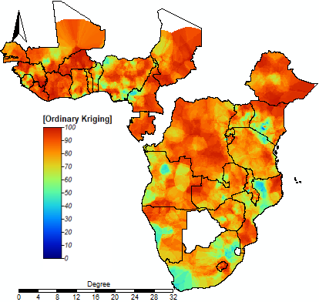
Figure: Interpolation of inadequate MDD in SSA: The interpolated continuous images were made in inadequate MDD using standard ordinary kriging interpolation. The transition from bold blue to bold red reflects an increase in the burden of inadequate MDD.

Biography
Bayuh Asmamaw Hailu is an Epidemiologist and Biostatistician at Wollo University. Bayuh Asmamaw has his expertise in evaluation and passion in improving the health and wellbeing. His open and contextual evaluation of geographic and non geographic models based on responsive constructivists creates new pathways for improving health care. He has been modeled in research after years of experience in evaluation, and administration in health, agriculture, and education sectors. He has ample knowledge of different open source GIS and other statistical software. He used to link his software ability and his health education background and experience, and he can easily show health problems for planners and decision-makers as well as any concerned bodies.
Email: bayuhasmamaw@gmail.com

Notes/Comments: Presenting author details Full name: Bayuh Asmamaw Hailu
Contact number: +251913584859 Linked In account: bayuhasmamaw@gmail.com Session name/ number: 5th Category: Oral presentation

