A moderated mediation model of mindfulness, wellbeing and age among Chinese adults in community settings: a parallel process latent growth curve approach from a randomized controlled trial
Man Ying Kangl, PhD student, Hong Kong Baptist University, Hong Kong
Dr. Joshua Kin Man Nan, Assistant professor, Hong Kong Baptist University, Hong Kong

Abstract (300 word limit)
Objectives: To test the effectiveness of online short-term audio-based mindfulness (SAM) in enhancing mental wellbeing and mindfulness levels in community settings in China and to explore possible moderators and mediators of the efficacy.

Methods: Participants (n=100) were randomized into the intervention group (n=50) and the waitlist control group (n=50). Participants in the mindfulness group needed to finish 3-week with 21 sessions mindfulness practice and complete four-time online measures while those in the waitlist control group needed to fill in the same scales twice. T-tests were used to compare the effects on the two groups and moderated mediation analysis was used to analyze intervention outcomes. Mediation was tested through the path of the mindfulness intervention to the growth factors of the mediator (individual mindfulness levels) to growth factors of the individual wellbeing. Lastly, the moderation by the potential moderator (e.g., age) on the mediation effects was tested.

Results: Online SAM was found to be effective in improving mental wellbeing as well as mindfulness levels. Age as the moderator was found to be significant between SAM and mindfulness at post-intervention, whose indirect effects were found between SAM and wellbeing.

Conclusions: Online SAM was effective in promoting mental wellbeing and mindfulness levels in community settings in China. Age affected the direct effect of mindfulness meditation on wellbeing.

Image
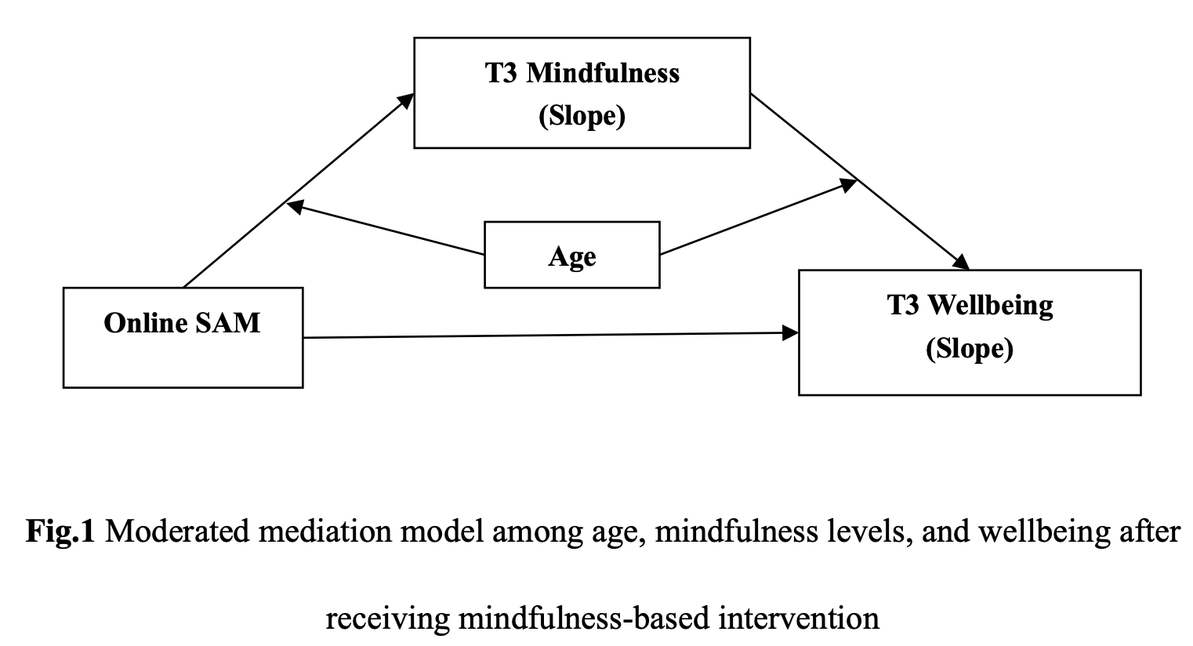
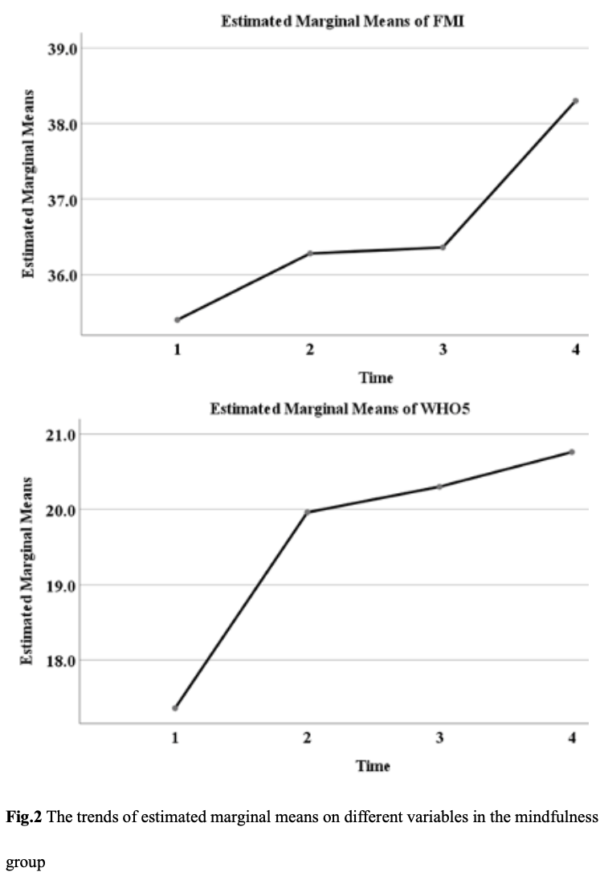
Recent Publications (minimum 5)
- Azam, M. A., Katz, J., Fashler, S. R., Changoor, T., Azargive, S., & Ritvo, P. (2015). Heart rate variability is enhanced in controls but not maladaptive perfectionists during brief mindfulness meditation following stress-induction: A stratified-randomized trial. International Journal of Psychophysiology, 98(1), 27-34. https://doi.org/10.1016/j.ijpsycho.2015.06.005
- Azam, M. A., Latman, V. V., & Katz, J. (2019). Effects of a 12-Minute Smartphone-Based Mindful Breathing Task on Heart Rate Variability for Students With Clinically Relevant Chronic Pain, Depression, and Anxiety: Protocol for a Randomized Controlled Trial. Jmir Research Protocols, 8(12). https://doi.org/10.2196/14119
- Bodenlos, J. S., Wells, S. Y., Noonan, M., & Mayrsohn, A. (2015). Facets of dispositional mindfulness and health among college students. The Journal of Alternative and Complementary Medicine, 21(10), 645-652. https://doi.org/10.1089/acm.2014.0302
- Cavanagh, K., Churchard, A., O’Hanlon, P., Mundy, T., Votolato, P., Jones, F., Gu, J., & Strauss, C. (2018). A randomised controlled trial of a brief online Mindfulness-Based intervention in a non-clinical population: replication and extension. Mindfulness, 9(4), 1191-1205. https://doi.org/10.1007/s12671-017-0856-1
- Cavanagh, K., Strauss, C., Cicconi, F., Griffiths, N., Wyper, A., & Jones, F. (2013). A randomised controlled trial of a brief online mindfulness-based intervention. Behaviour research and therapy, 51(9), 573-578. https://doi.org/10.1016/j.brat.2013.06.003
- Chen, S.-Y., & Zhou, R.-L. (2014). Validation of a Chinese version of the Freiburg mindfulness inventory–short version. Mindfulness, 5(5), 529-535. https://doi.org/10.1007/s12671-013-0208-8
- Chen, Y., Yang, X., Wang, L., & Zhang, X. (2013). A randomized controlled trial of the effects of brief mindfulness meditation on anxiety symptoms and systolic blood pressure in Chinese nursing students. Nurse education today, 33(10), 1166-1172. https://doi.org/10.1016/j.nedt.2012.11.014
- Harrison, A. M., Scott, W., Johns, L. C., Morris, E. M. J., & McCracken, L. M. (2017). Are We Speaking the Same Language? Finding Theoretical Coherence and Precision in "Mindfulness-Based Mechanisms" in Chronic Pain. Pain Med, 18(11), 2138-2151. https://doi.org/10.1093/pm/pnw310
- Iqbal, N., & Dar, K. A. (2015). Negative affectivity, depression, and anxiety: Does rumination mediate the links? Journal of Affective Disorders, 181, 18-23. https://doi.org/10.1016/j.jad.2015.04.002
- James, W. (2007). The Principles of Psychology. Encyclopaedia Britannica.
- Jerath, R., Crawford, M. W., Barnes, V. A., & Harden, K. (2015). Self-Regulation of Breathing as a Primary Treatment for Anxiety. Applied Psychophysiology and Biofeedback, 40(2), 107-115. https://doi.org/10.1007/s10484-015-9279-8
- Kabat-Zinn, J., & Hanh, T. N. (2009). Full catastrophe living: Using the wisdom of your body and mind to face stress, pain, and illness. Delta.
- Khoury, B., Lecomte, T., Fortin, G., Masse, M., Therien, P., Bouchard, V., Chapleau, M.-A., Paquin, K., & Hofmann, S. G. (2013). Mindfulness-based therapy: a comprehensive meta-analysis. Clinical psychology review, 33(6), 763-771. https://doi.org/10.1016/j.cpr.2013.05.005
- Kim, S. Y., Suh, H., Oh, W., & Daheim, J. (2020). Daily change patterns in mindfulness and psychological health: A pilot intervention. Journal of Clinical Psychology, 77(3), 496-451. https://doi.org/10.1002/jclp.23043
- Lama, D. (2011). Stages of meditation: Training the mind for wisdom. Random House.
- Liu, S., Yang, L., Zhang, C., Xiang, Y.-T., Liu, Z., Hu, S., & Zhang, B. (2020). Online mental health services in China during the COVID-19 outbreak. The Lancet Psychiatry, 7(4), e17-e18. https://doi.org/10.1016/S2215-0366(20)30077-8
- Mak, W. W., Tong, A. C., Yip, S. Y., Lui, W. W., Chio, F. H., Chan, A. T., & Wong, C. C. (2018). Efficacy and Moderation of Mobile App-Based Programs for Mindfulness-Based Training, Self-Compassion Training, and Cognitive Behavioral Psychoeducation on Mental Health: Randomized Controlled Noninferiority Trial. JMIR Ment Health, 5(4), e60. https://doi.org/10.2196/mental.8597
- Querstret, D., Cropley, M., & Fife-Schaw, C. (2018). The Effects of an Online Mindfulness Intervention on Perceived Stress, Depression and Anxiety in a Non-clinical Sample: A Randomised Waitlist Control Trial. Mindfulness, 9(6), 1825-1836. https://doi.org/10.1007/s12671-018-0925-0
- Si, M., Xiao, W., Pan, C., & al., e. (2021). Mindfulness-based online intervention on mental health and quality of life among COVID-19 patients in China: an intervention design. Infectious Diseases of Poverty, 10(1), 1-10. https://doi.org/10.1186/s40249-021-00836-1
- Snippe, E., Dziak, J. J., Lanza, S. T., Nykliek, I., & Wichers, M. (2017). The Shape of Change in Perceived Stress, Negative Affect, and Stress Sensitivity During Mindfulness-Based Stress Reduction. Mindfulness, 8(3), 728-736. https://doi.org/10.1007/s12671-016-0650-5
- Spijkerman, M., Pots, W. T. M., & Bohlmeijer, E. T. (2016). Effectiveness of online mindfulness-based interventions in improving mental health: A review and meta-analysis of randomised controlled trials. Clinical psychology review, 45, 102-114. https://doi.org/10.1016/j.cpr.2016.03.009
- Van den Heuvel, M., Johannes, M., Henrichs, J., & Van den Bergh, B. (2015). Maternal mindfulness during pregnancy and infant socio-emotional development and temperament: the mediating role of maternal anxiety. Early human development, 91(2), 103-108. https://doi.org/10.1016/j.earlhumdev.2014.12.003
- Zeidan, F., Martucci, K. T., Kraft, R. A., McHaffie, J. G., & Coghill, R. C. (2014). Neural correlates of mindfulness meditation-related anxiety relief. Social Cognitive and Affective Neuroscience, 9(6), 751-759. https://doi.org/10.1093/scan/nst041

Biography (150 word limit)


Man Ying Kang has her expertise in mindfulness-based therapy in improving the mental health and wellbeing. She is a PhD student in Department of Social Work in Hong Kong Baptist University.
Email: 20481985@life.hkbu.edu.hk

Notes/Comments:

Presenting author details
Full name: Man Ying Kang
Contact number: +852 62102717
Category: Oral presentation

