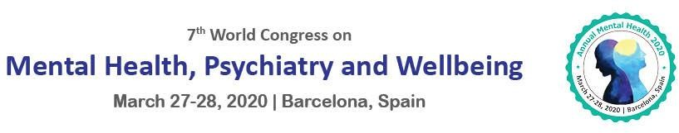

To,
Ms. Sarah Coldwell
Electrical Industries Charity
United Kingdom

Letter of Acceptance
Date: January 29, 2020.

Conference Series is pleased to announce that your abstract titled, “The implications of psychopathic moral deficit for therapy: towards a theoretical model” has been selected for the Workshop Presentation at the “7th World Congress on Mental Health, Psychiatry and Wellbeing” which is going to be held during March 27-28, 2020 Barcelona, Spain to share your knowledge and views in respective to the theme “Mental Health Matters: Mental illness is not a choice, but Recovery is for Wellbeing”.

The 7th World Congress on Mental Health, Psychiatry and Wellbeing will definitely offer you an unforgettable experience in exploring new opportunities.

We look forward to your active participation.

With Thanks,

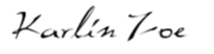
With Regards,
Karlin Zoe | Program Manager
Annual Mental Health 2020 | Well-being Event Psychology, Psychiatry, Mental Health Events

