Title: Harnessing Technology to Eradicate Social Isolation: Connected is A Solution Built

on The Conceptual Model of Integration After Loss
Monica A. Ross, LPC, Doctoral Candidate in Social Work at The University of Southern California in Los Angeles, CA, USA

Abstract (300 word limit)
Statement of the Problem: The American Academy of Social Work and Social Welfare designated Eradicating Social Isolation as one of the major initiatives of the 21st century. The socially isolated are at risk for future disease and disability as a lack of social contact creates a compromised ability to buffer stress and receive feedback (Lubben et al., 2015, Holt-Lunstad, Smith, & Layton, 2015). Individuals often regress from social engagement when grieving and especially in relationship to persistent and complicated grief (Solomon & Shear, 2015; Shear et al., 2011; Stroebe & Shut, 1999). Scholars argue that Persistent and Complex Bereavement Disorder (PCBD) as defined by the latest version of the DSM V is in fact a subtype of complicated grief (CG) and ignores grief caused by loss that extends beyond bereavement or death-related grief. The numbers of individuals suffering from CG related to other types of loss could be much larger than the estimated 10% (Kersting et al., 2011) to 20% (Shear et al., 2011) of those suffering from PCBD. A lack of training in clinical programs on postmodern grief theories and treatment protocols is the practice problem that is contributing to fewer treatment options for those socially isolating due to CG (Ober, Granello, & Wheaton, 2012; Eckerd, 2009). Connected is an innovative solution proposed as part of my doctoral capstone project with two main goals 1. change the behaviors of clinicians such that they utilize CG treatment methods 2. guide the socially isolated into relating online and in-person instead of suffering in loneliness and isolation. These efforts should improve overall population health outcomes and foster resiliency for the socially isolated.

Working Model
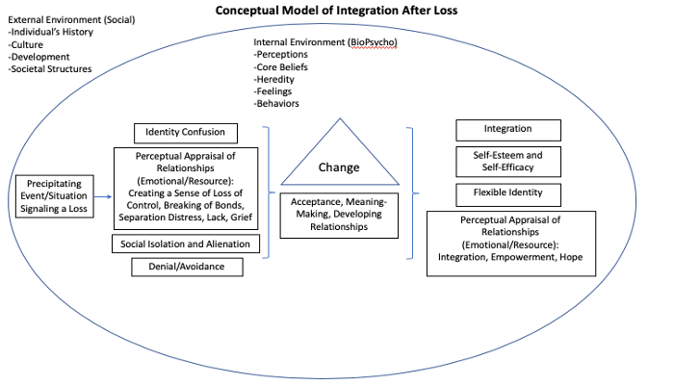
Recent Publications (minimum 5)
Note: Paper entitled “Harnessing Technology for the Social Good: Empowering Consumers with Immediate Feedback and Self-Directed Means of Care to Address Affordability, Access, and Stigma in Mental Health” has been selected for publication in the peer-reviewed journal Health and Social Work by NASW press.

Biography (150 word limit)
Monica Ross is a Licensed Professional Counselor with over 20 years of experience in corporate, government, academic, and nonprofit settings. She holds an MA in Counseling Psychology from St. Edward’s University and is a Doctoral Candidate in the Suzanne Dworak-Peck School of Social Work at USC in Los Angeles. Ms. Ross is currently working on a capstone project addressing health disparities. Her conceptual model of integration after loss elevates the dialogue on grief, loss, and life transition in order to improve health outcomes. She has built this model relying on personal experience with grief and loss and years of research for her capstone project. The foundation is based on trauma-based psychological interventions such as the adaptive information processing model created by Dr. Francine Shapiro founder of EMDR and Urie Bronfenbrenner’s Ecological systems theory.
Email:rossmoni@usc.edu
- Full Name: Monica Ross
- Personal Email: monica.a.ross@gmail.com
- Mobile Number: 1-512-571-0055
- Linked In: https://www.linkedin.com/in/rossmonica/
- Facebook: https://www.facebook.com/empathicsage
- Session Name/ number:
- Category: (Oral presentation/ Poster presentation)
- Date of Birth: 8/11/1973
- Postal Address: 9501 N Capital of TX HWY Ste 301 Austin, TX 78759

Notes or Comments:

