Title: Authenticity and subjective well-being: The mediating role of mindfulness
Zhimin Zou, PhD, Sun Yat-sen University, China

Abstract (300 word limit)
Statement of the Problem: Authenticity is generally indicated to be an important predictor to subjective well-being. However, remarkably few empirical researches investigated possible psychological mechanism underlying the process. The purpose of the current research is to explore whether mindfulness can explain one pathway between authenticity and subjective well-being.
Methodology & Theoretical Orientation: Two studies were conducted. In Study 1, we preliminarily explored how authenticity is related to mindfulness and subjective well-being through cross-sectional data. In Study 2, we used a time-lagged design to replicate the same mediating model in Study 1.
Findings: The research verified that higher authenticity associated higher subjective well-being via higher mindfulness. Furthermore, the effect of authenticity on subjective well-being was specifically through two facets of mindfulness–describing and acting-with-awareness.
Conclusion & Significance: These results contribute to a better understanding of the association of authenticity and subjective well-being. Moreover, these findings suggest that mindfulness training may be a useful technique to accelerate the transformation from being thyself to being happy.

Image
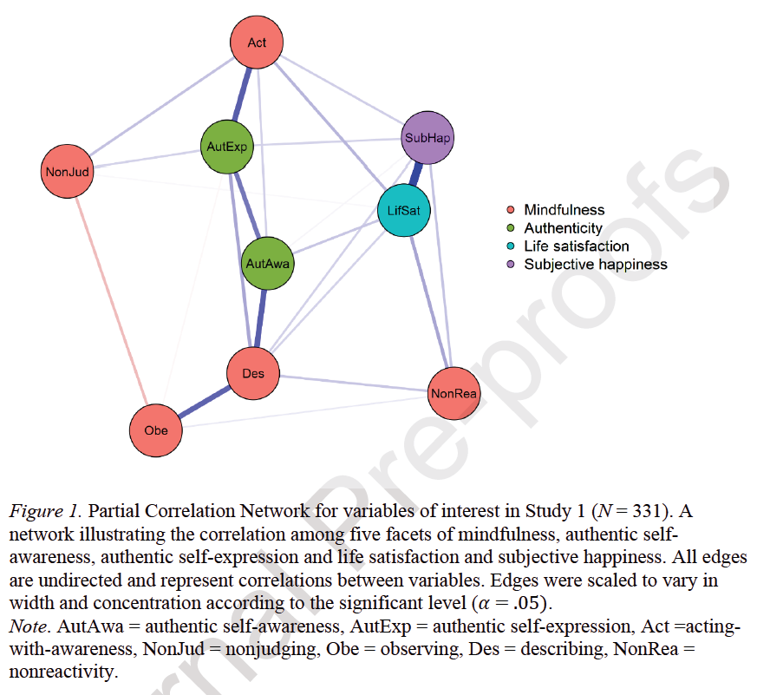
Recent Publications (minimum 5)
1. Zheng, S., Sun, S. Huang, C. & Zou, Z. *(2020). Authenticity and subjective well-being: The mediating role of mindfulness. Journal of Research in Personality, 84C, doi: 10.1016/j.jrp.2019.103900. Zou, Z., & 2. Wang, D. (2009). Guilt vs. Shame: A Chinese Perspective to Distinguish the Two. Social Behavior and Personality, 37 (6), 601-604.
3. Jiang, J., Zou, Z., et al. (2011). Emotional Reactions to Scandals: When Does Moral Character Make a Difference? Asian Journal of Social Psychology, 14(3), 207-216.
4. Kim, Y. H., Chiu, C., & Zou, Z., (2010). Know Thyself: Misperceptions of Actual Performance Undermine Achievement Motivation, Future Performance and Subjective Well-Being. Journal of Personality and Social Psychology, 99(3), 395-409.

Biography (150 word limit)
Zhimin Zou (Ph.D. Peking University) is an assistant professor in the Department of Psychology, Sun Yat-sen University. Her research interests focus on consumers’ information processing of marketing communication, social emotion in advertising. She has published papers in Journal of Personality & Social Psychology, Journal of Research in Personality, among others.
Email:zouzhm@mail.sysu.edu.cn
- Full Name: Zhimin Zou
- Personal Email: zhiminzou@sina.com
- Mobile Number:
- Linked In:
- Facebook:
- Session Name/ number:
- Category: (Oral presentation/ Poster presentation)
- Date of Birth:
- Postal Address:

