Title: The Relation between Bullying at School and Cyberbullying: Risk and Protective Factors
Stylianou, I., Ioannou., M., & Stavrinides P., Cyprus

Abstract (300 word limit)
Introduction: Bullying and victimization have long-term consequences on mental health. Cognitive interventions are among the recommended, but there is limited research investigating the effect of cognitive strategies on bullying and their reciprocal interactions. The aims of the study were to (a) test the extent to which adaptive and maladaptive cognitive emotion regulation strategies (CERS) are used by adolescents who get involved in bullying incidents and (b) examine the bidirectional reciprocal effect between bullying, victimization and CERS using a cross-lagged design.
Methods: 560 adolescents aged 15-18 from Cyprus participated in this longitudinal study with three time points over a year (every 4 months) and completed among other questionnaires, the Bullying Victimization Questionnaire Revised (BVQ-R) and the Cognitive Emotion Regulation Questionnaire (CERQ). The cross-lagged design allowed examination of the long-term reciprocal interactions between bullying and CERS, using Mplus 7.3.
Results: With regard to the frequency of CERS used, significant differences existed only for self-blame and catastrophizing (higher for victims), as well as others-blame (higher for bully/victims). The cross-lagged longitudinal model with continuous variables showed good fit, with χ² (230)= 885.755, p< .001, CFI= .962, TLI= .916, RMSEA= .062. Long-term victimization was consistently significantly predicted by the use of maladaptive CERS, with emphasis on self-blame, rumination and catastrophizing, whereas the reverse relationship was not supported. Long-term bullying at time 3 was significantly predicted by use of others-blame at time 2, and again no reciprocal effect was detected.
Conclusions: The findings supported the unidirectional effect of maladaptive CERS on long-term victimization and bullying. This supports that training on CERS and CBT informed challenging of cognitive distortions about self-blame could be protective, especially against long-term victimization.

Image
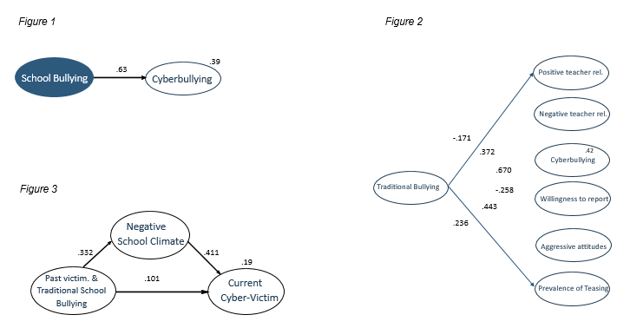
Recent Publications (minimum 5)
- Baldry, A. C., Farrington, D., & Sorrentino, A. (2015). “Am I at risk of cyberbullying”?. A narrative review and conceptual framework for research on risk of cyberbullying and cybervictimization: The risk and needs assessment approach. Aggression and Violent Behavior, 23, 36-51. https://doi.org/10.1016/j.avb.2015.05.014
- Bradshaw, C. P. (2015). Translating research to practice in bullying prevention. American Psychologist, 70, 322-332. http://dx.doi.org/10.1037/a0039114
- Charalampous, K., Kokkinos, C. M., Apota, E., Iliadou, A., Iosifidou, M., Moysidou, S., & Vriza, E. (2016). Pre-adolescents’ representations of multiple attachment relationships: the role of perceived teacher interpersonal behaviour. Learning Environments Research, 19, 63-86. https://doi.org/10.1007/s10984-015-9196-z
- Durlak, J., Weissberg, R. P., Dymnicki, A. B., Taylor, R. D., & Schellinger, K. B. (2011). The impact of enhancing students' social and emotional learning: A meta-analysis of school-based universal interventions. Child Development, 82, 405-432. https://doi.org/10.1111/j.1467-8624.2010.01564.x.
- Hase, C. N., Goldberg, S. B., Smith, D., Stuck, A., & Campain, J. (2015). Impacts of traditional bullying and cyberbullying on the mental health of middle school and high school students. Psychology in the Schools, 52, 607-617. https://doi.org/10.1002/pits.21841

Biography (150 word limit)
Ms. Ifigenia Stylianou is a licensed School Psychologist. She has a BA in Psychology and has completed a 3-year MA degree in Applied School Psychology from the University of Cyprus. She currently runs a private practice while at the same time she is a doctoral candidate in Clinical Psychology at the University of Cyprus, where she is also employed part-time as an instructor and a research scientist. She has experience in working with children, adolescents and young adults with psychosocial problems and behavioural difficulties. She also has expertise in developing and implementing prevention and intervention programs in schools and the corporate environment. These programs focus on developing basic skills such as self-regulation, stress management skills, effective goal setting, time management etc.). She is also an expert in implementing interventions that involve counselling, behaviour modification, and family therapy. Ifigenia has published much of her research in School and Clinical Psychology and she has presented her work in numerous international conferences. Her research has been funded by 2 scholarships for from the Cyprus State Scholarship Foundation and a research grant from the Cyprus Youth Organization.

Email:ifigenias1@hotmail.com
- Full Name: Ifigenia Stylianou
- Personal Email: ifigenias1@hotmail.com
- Mobile Number: 0035799643439
- Linked In: https://www.linkedin.com/in/ifigenia-stylianou-b8ab9992/
- Facebook: https://www.facebook.com/stylianouschoolpsychologist/?modal=admin_todo_tour
- Session Name/ number:
- Category: (Oral presentation/ Poster presentation): Oral Presentation
- Date of Birth: 18/11/1992
- Postal Address: Nafpliou 16 Parissinos, 2066, Nicosia, Cyprus

