Title: Mindfulness facets and their relations with neuroticism and psychological well-being
Luca Iani, Ph.D., European University of Rome, ITALY

Abstract (300 word limit)
Introduction: This study examines whether differences in the habitual use of mindfulness skills were associated with specific well-being and neuroticism aspects. Methods: Two hundred eleven volunteers aged 21–84 years completed measures of mindfulness, neuroticism, psychological well-being (PWB), and subjective well-being (SWB). Results: Describing, observing, and acting with awareness (i.e., the mindfulness “what” skills) were positively correlated with personal growth, purpose in life, and autonomy (i.e., the “core” eudaimonic components of PWB). Nonreactivity and nonjudging (i.e., the mindfulness “how” skills) were negatively associated with neuroticism aspects, such as withdrawal (e.g., depression) and volatility (e.g., anger). Describing and nonreactivity were the only mindfulness skills significantly correlated with the SWB measures. Acting with awareness mediated the effect of both withdrawal and volatility on eudaimonic well-being outcomes. Describing had consistent mediation effects across all well-being measures, but only for the withdrawal aspect. Nonreactivity and nonjudging did not mediated withdrawal when considering eudaimonic well-being as outcomes. Mediation effects for nonjudging and nonreactivity were found between volatility and SWB markers as well as between volatility and self-acceptance, environmental mastery, and positive relations with others (i.e., the “other” eudaimonic PWB components). Discussion: The mindfulness “what” skills were important for eudaimonic well-being, especially for internalizing individuals. The relationships between neuroticism aspects with hedonic and eudaimonic well-being measures via mindfulness might suggest which unique mindfulness skills could be prioritized for targeting clinical interventions aimed to promote well-being and to reduce psychological distress. For example, anxious and depressed individuals can learn to describe thoughts and feelings and act with awareness, in turn enhancing their ability to deal with internal and external sources of stress, to reduce the likelihood of relapse, and to improve well-being. Our findings provided preliminary evidence suggesting that also laypersons high on neuroticism can improve their well-being through incorporating mindful awareness practices into their everyday lives.

Image
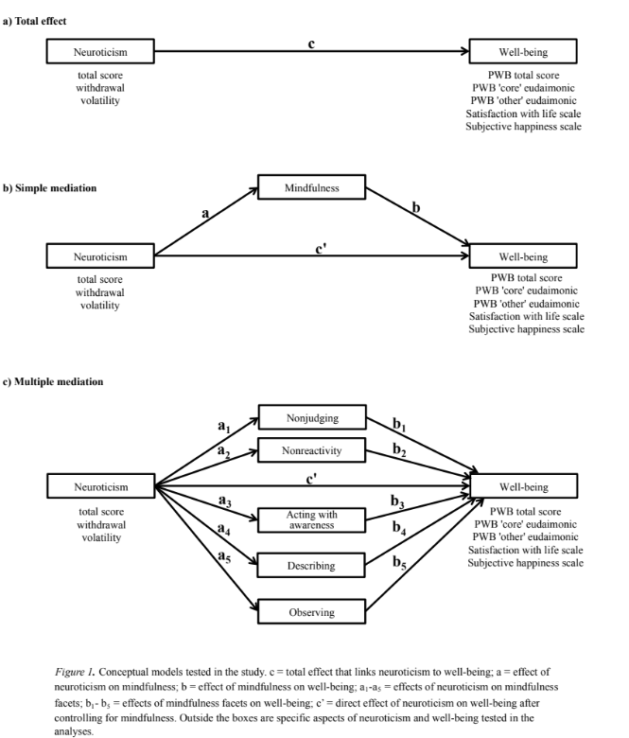
Recent Publications (minimum 5)
- Garland EL, Farb NA, Goldin P, Fredrickson BL (2015) Mindfulness broadens awareness and builds eudaimonic meaning: a process model of mindful positive emotion regulation. Psychological Inquiry 26: 293–314.
- Giluk TL (2009) Mindfulness, big five personality, and affect: A meta-analysis. Personality and Individual Differences 47: 805–811
- Lauriola M, Iani L (2017) Personality, positivity and happiness: A mediation analysis using a bifactor model. Journal of Happiness Studies 8: 664–676.
- Ryan RM, Huta V, Deci EL (2008) Living well: A self-determination theory perspective on eudaimonia. Journal of Happiness Studies 9: 139–170.
5. Steel P, Schmidt J, Shultz J (2008) Refining the relationship between personality and subjective well-being. Psychological Bulletin 134: 138–161.

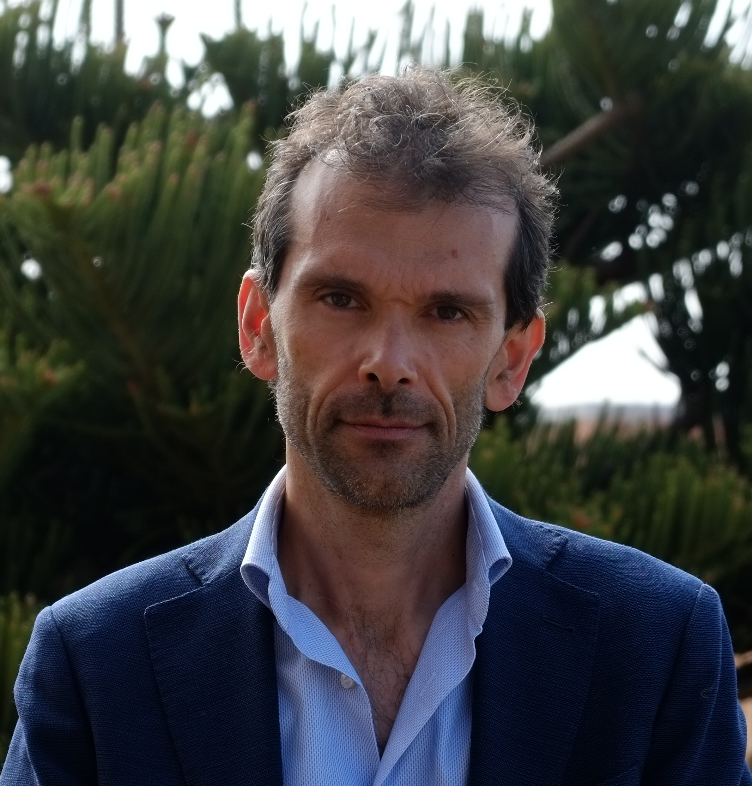

Biography (150 word limit)

Luca Iani received his M.A. in Psychology from Sapienza University of Rome and his Ph.D. in Health Psychology from the University of Florence. He is an Assistant Professor of Clinical Psychology at the European University of Rome (Italy), where he has taught courses on Health Psychology and Psychosomatics. He obtained the National Scientific Habilitation as Associate Professor in Clinical and Dynamic Psychology. His research focuses on two general areas. The first centers on the effects of positive psychology interventions on well-being and psychological distress in clinical contexts. The second examines the processes by which psychiatric and chronic disease patients can improve their well-being through inner strenghts (e.g., positivity, sense of coherence, spiritual well-being). He has published articles in Mindfulness, Journal of Happiness Studies, Journal of Health Psychology, Journal of Psychosomatic Research, and elsewhere. He has served as Consulting Editor for Psychology Research and Behavior Management.
Email: luca.iani@unier.it
- Full Name: Luca Iani
- Personal Email: luca.iani@unier.it
- Mobile Number:
- Linked In:
- Facebook:
- Session Name/ number:
- Category: Oral presentation
- Date of Birth:
- Postal Address:

Notes or Comments:

