Title: Post Traumatic Growth
Tazeen Zahra Rizvi, Graduate Student, The Family Institute, Northwestern University, USA

Abstract

Post Traumatic Growth (PTG) is a positive change experienced as a result of the struggle with a traumatic event. It can include an awareness of new opportunities, changes in relationships, increased sense of strength and perseverance, greater appreciation for life, and strengthening of the spiritual domain.
Factors which contribute to this growth include brutally honest optimism, a strong sense of self, a perception of control over events, and the coping style. It leads to decrease of depression and anxiety, less substance abuse, development of hope, and an enhanced Quality of life (Qol).
Rationale: Why is this topic especially relevant for counselors? This is because posttraumatic growth fits ideally with their wellness and growth-oriented perspective. In listening to clients with respect for their strength, counselors can learn lessons from them, and identify vicarious posttraumatic growth. They can identify the strengths that the client continues to demonstrate, and then highlight them.
Learning Objectives: Attendees/participants will be able to define Posttraumatic Growth (PTG), review its characteristics and benefits, understand the relevance of this topic for counselors, and get information about current research and future studies.
Discussion: Research has shown that openness to experience, agreeableness, and extraversion, are correlated with PTG. Death of a loved one, physical threat and life transition problems seemed to lead to higher levels of this growth. Cognitive-Behavioral Conjoint therapy (CBCT) for PTSD seems to facilitate PTG. Social support reduces PTSD, and promotes PTG, through the path from self-esteem to hope.
Future research can focus on several questions. For example, PTG can be enhanced through PTSD therapy, but, is it a favorable treatment outcome? Would the development of PTG during therapy promote the reduction of PTSD symptoms? Is it a constructive outcome of cognitive processes, or a positive illusion in favor of avoidance and denial?

Image
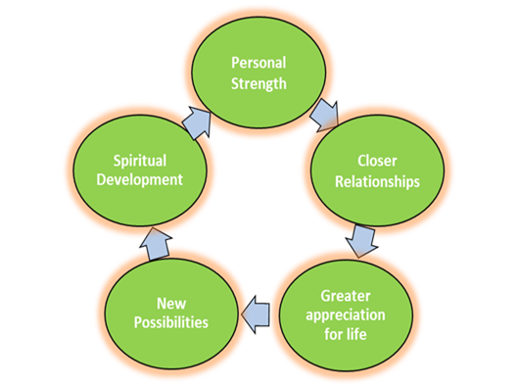



Figure: Domains of PTG

References

1, Connor-Smith, J.K. & Flachsbart, C. (2007) Relations between personality and coping: a meta-analysis. J Pers Soc Psychol. 93(6):1080-107.
2. Cummings, J., & Swickert, R. (2010). Relationship between locus of control and posttraumatic growth. Individual Differences Research, 8(3), 198-204.
3. Monson, C.M., Fredman, S.J., & Macdonald A . Effects of a cognitive-behavioral couple therapy for PTSD. Journal of the American Medical Association. 30(8):700–709. doi: 10.1001/jama.2012.9307.
4. Schubert, C.F., Schmidt, U., & Rosner, R. (2016) Posttraumatic Growth in Populations with Posttraumatic Stress Disorder. Clin Psychol Psychother., 23(6):469-486.
5. Voss Horrell, S. C., Holohan, D. R., & Vance, G. T. (2011). Treating traumatized OEF/OIF veterans. Professional Psychology: Research and Practice, 42(1), 79-86.
6. Wagner, A. C. & Monson, C. M. (2016). The Role of Posttraumatic Growth in a Randomized Controlled Trial of CBCT for PTSD. Journal of Traumatic Stress, 29(4), 379–383.

Biography
Tazeen Zahra Rizvi is a graduate student at the Family Institute at Northwestern University. She has a degree in medicine, and is doing Masters in Counseling due to her immense interest in this field. She plans to focus on different topics, including trauma, during her work as a counselor. She has presented in different conferences and has chosen the topic of post traumatic growth for this presentation. This is because much focus has been placed on the topic of PTSD and post traumatic growth has not been given that much attention.
Email: tazeenrizvi2018@u.northwestern.edu
• Full Name: Tazeen Zahra Rizvi
• Category: (Poster presentation)



