Title of Abstract: Effects of Mindfulness and Self-Awareness in Rest and Stress: Biofeedback and Neurofeedback measures and training.
Name & Affiliation & Country
Rose Schnabel MA, MSW, RSW, PhDstudent, University of Toronto, Ontario, Canada.

Abstract (300 word limit)
Statement of the Problem:. Stress has been known to accumulate and negatively impact emotional and psychological states. When faced with stress, one of the first line of recommendations is to take time away and withdraw from a stressors. Practices such as mindfulness have been increasingly been recommended by many healthcare professionals particularly when stressors cannot be removed. .Researchers in the field of neurology have reported that Mindfulness Meditation training can alter regions of the brain known to coordinate stress processing and physiological stress responses (Taren, A.T. et.al., 2015). In field research and in real life it can be difficult to maintain a practice of mindfulness. Without daily practice the benefits of Mindfulness are reduced. Neuro and Biofeedback can be used a real time feedback to teach self regulation and potentially be used as an aid for Mindfulness Meditation (Brandmeyer, et. al. 2013). Rest as much as it prescribed for immediate relief of stress is not that clearly defined. A period of rest could provoke mind-wandering and time to think of stressful thoughts. Not only is this internal stress difficult to observe objectively from others but many have difficulty identifying and recognizing their own internal state. Lack of awareness of stress levels could contribute to difficulties in emotion regulation. The purpose of this study is to assess the effects of self-awareness( mindfulness) on stress recovery (rest/ neuro-psychophysiology). Hypothesis: Mindfulness Meditators (MM) have significant difference in psychophysiological self awareness and emotion regulation during rest and recovery than non-Mindful Meditators (nMM) Methodology: Procedure: Psychophysiological Measure (GSR, EEG, EEG; EMG, HR, Temperature) used to measure Base-line, Rest (Post-stressors)/Recovery. Script on a computer screen with the following sequence of events will be presented:1. Baseline psychophysiology (no stressor), stressor 1 (colour stroop test), rest, stressor 2 (numbers and speed), rest, stressor 3 (timed recall), rest period. Self-Report Methods :Mindfulness attention awareness scale (MAAS) and Short compassion scale will also be used Results: Significant differences were found between MM and nMM in some psychophysiological measures (EEG and GSR). Self-awareness significantly improved Rest and Recovery in both groups. Mindfulness and self-awareness could help improve emotional and physical effects of stress.

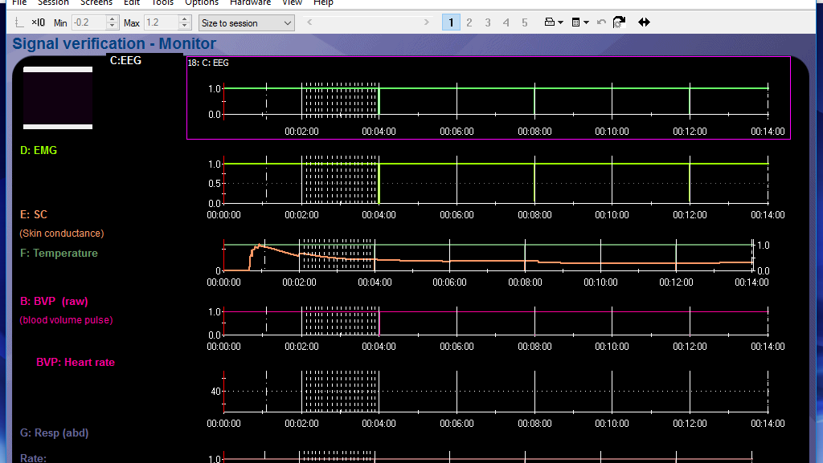
Neuro-psychophysiological measures used to increase self awarenes, aid in mindfulness and improve rest/recovery.
Recent Publications (minimum 5)
- Brandmeyer, T., & Delorme, A. (2013). Meditation and neurofeedback. Frontiers in Psychology, 4, 688.
- Bush G, Jiang A, Talavage T and Kennedy D. An automated system for localization and characterization of functional MRI activations in four dimensions. In: Belliveau PFJ, Kennedy D, Rosen B and Ungerleider L, eds. Second International Conference on Functional Mapping of the Human Brain. Orlando, FL: Academic Press; 1996, p. S55..
- Baer, R. (2003). Mindfulness training as a clinical intervention: a conceptual and empirical review. Clinical Psychology: Science and Practice, 10(2), 125–142.
- Beitel, M., Ferrer, E., & Cecero, J. J. (2005). Awareness of self and others. Journal of Clinical Psychology, 61(6), 739–750.
.
5. Taren, A. A., Gianaros, P. J., Greco, C. M., Lindsay, E. K., Fairgrieve, A., Brown, K. W., … Creswell, J. D. (2015). Mindfulness meditation training alters stress-related amygdala resting state functional connectivity: a randomized controlled trial. Social Cognitive and Affective Neuroscience, 10(12), 1758–1768 http://doi.org/10.1093/scan/nsv066

Biography (150 word limit)
Rose Schnabel has expertise in bio/neurofeedback to assist and research methods to improve self-regulation for optimal experiences. evaluation The application of her treatment model are useful in a clinical setting and research settings. He main areas of study and application is improved resting state, flow state, emotion and cognition.. She has built this model after years of experience in research, evaluation, teaching and administration both in hospital and education institutions.
Email: Rpschnab2@gmail.com

Presenting Author details:
Contact Number:Rose Schnabel
Session/Track Name/ Number:
Category: Type of Presentation: Oral presentation/ Poster presentation/Workshop: poster presentation

Notes/Comments:

