Positive Psychology – the Applications

More and more professionals are discovering the potential of positive psychology.
In Bannink’s recent book 201 Positive Psychology Applications, she invites all professionals
working in (mental) health, coaching, organizations, education, sports, and society to focus (more) on strengths and what is working.
The many applications described in her book are based on the five elements of Seligman’s well-being theory: 1. positive emotion, 2. engagement, 3. positive relationships, 4. meaning, and 5. accomplishment. These five elements can help individuals reach a life of fulfillment, happiness, and meaning. The model can also be applied to institutions to develop programs to help people develop new cognitive and emotional tools. Professionals may use them themselves, or present them to their clients, patients, students, employees or coachees. Most applications can be used in several settings.

Fredrike Bannink, a master at presenting big ideas in manageable parts, offers participants many ideas and easy-to-implement applications to take the “what” of positive psychology to the “how.” From humor to self-compassion, and from gratitude to reflecting on how people wish to be remembered, they will find all they need to maximize their and others life experiences.
Bannink, F.P. (2017). 201 Positive Psychology Applications. Promoting Well-Being in Individuals and Communities. W.W. Norton, NY.

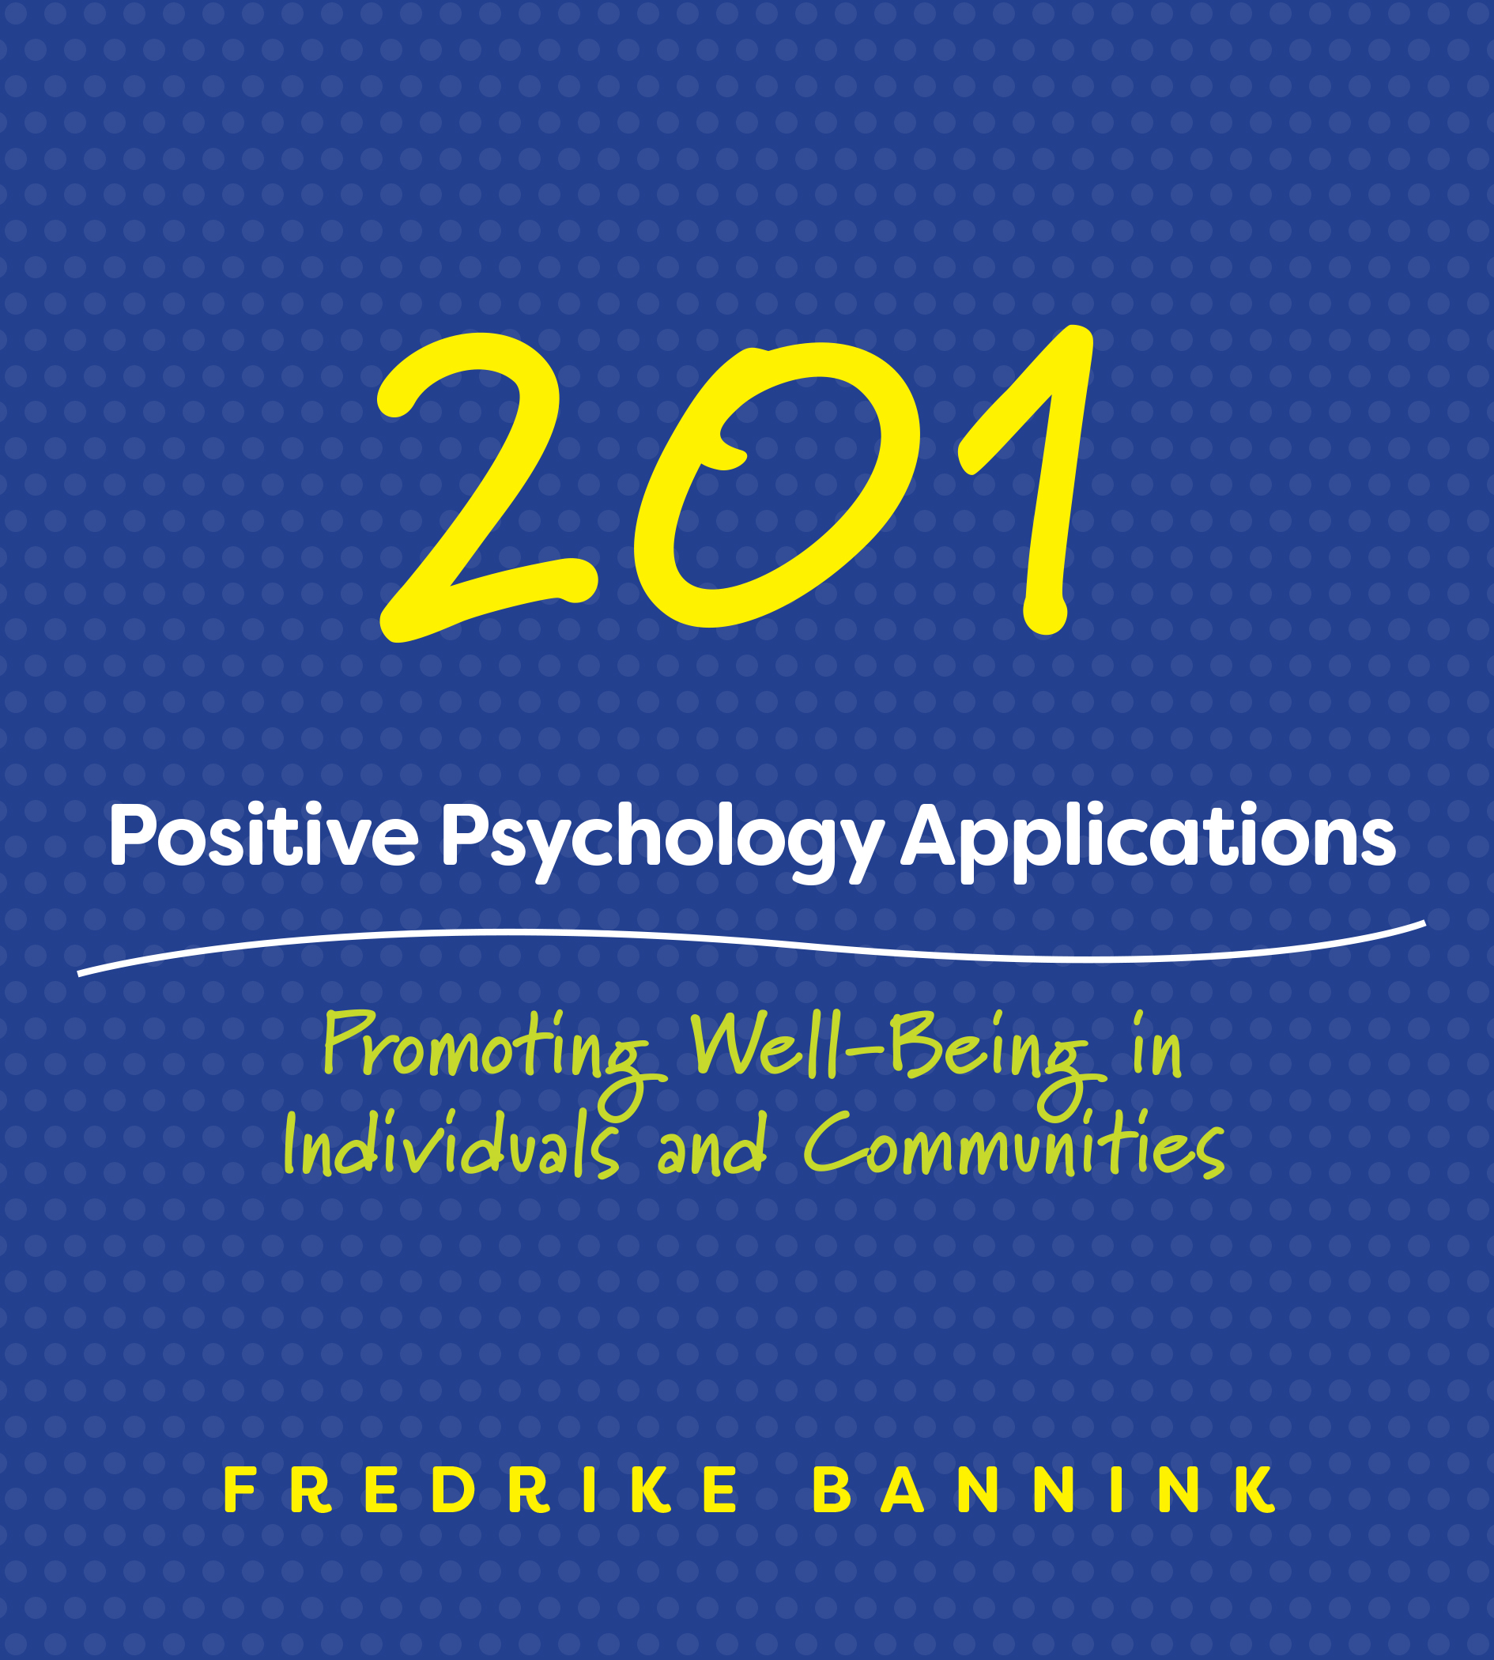

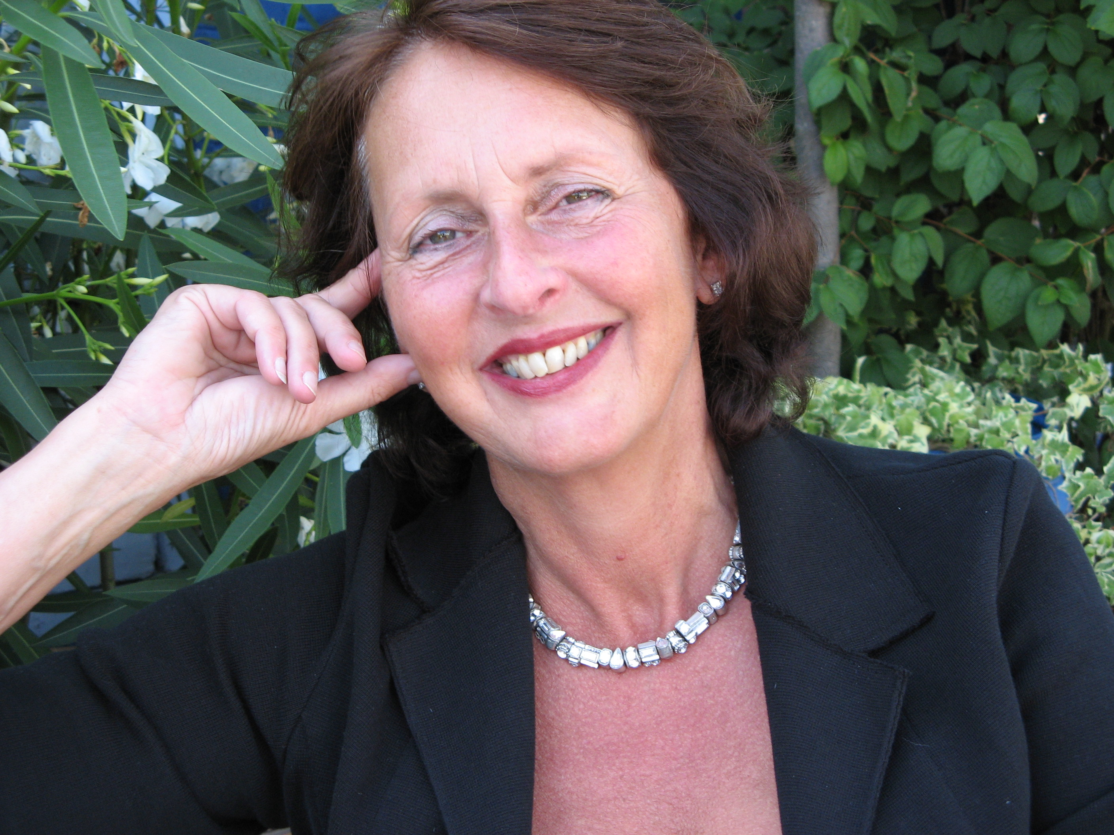

Dr. Fredrike P. Bannink MDR

Clinical psychologist; CBT, SFBT and PP trainer and supervisor.
Master of Dispute Resolution; International Full Certified ADR Mediator and Conflict Coach.
Mental Health Trainer for Doctors without Borders.
Owner therapy, training, coaching and mediation practice in Amsterdam, the Netherlands.
International keynote speaker, trainer and author of 30+ books.
www.fredrikebannink.com
@FredrikeBannink

