Twisted polymeric fiber based actuators
M.D. Lima, L. Wu, Y. Yang, S. Ganeyev, A. Hingeley, S. Li, M. Guerrero.
LINTEC-NSTC, USA

Abstract:
It has been demonstrated^{1,2,3} that highly twisted polymeric fibers are also capable to generate impressive tensile actuation, providing large strokes and vastly exceeding the work and power capabilities of natural skeletal muscle. Contraction of over 50%, and lifting capacity up to 270 pounds weight have achieved using a single coiled fibers. These actuators are also can operate as torsional motors: a thin fiber can rotate heavy rotors at up to 100,000 rpm for 1,000,000 cycles. Actuation can be driven by electrical signals or by relatively small variation in environmental temperature, which can be converted into mechanical work. That allows the use of these new actuators for automatic temperature and air flow control and natural light absorption or reflection in small and large structures such as residences and factory installations. Fig. 1 shows an example of environmental temperature control using only twisted polymeric fibers which are capable to open and close the roof a simulated greenhouse in order to regulate its internal temperature. Another filed of applications is on soft-robotics: since these actuators are very flexible, capable to produce large tensile strength and easily assembled into arrays they are suitable for construction of soft manipulators, as shown in Fig. 2.

1. Lima, M.D., et al. Science 338 (2012) 929
2. Haines, C.S., et al. Science 343 (2014) 868
3. Lima, M.D., et al. Small 11 (2015) 3113
Keywords: solid state actuators, artificial muscles, soft robotics, carbon nanotubes, polymeric fibers.
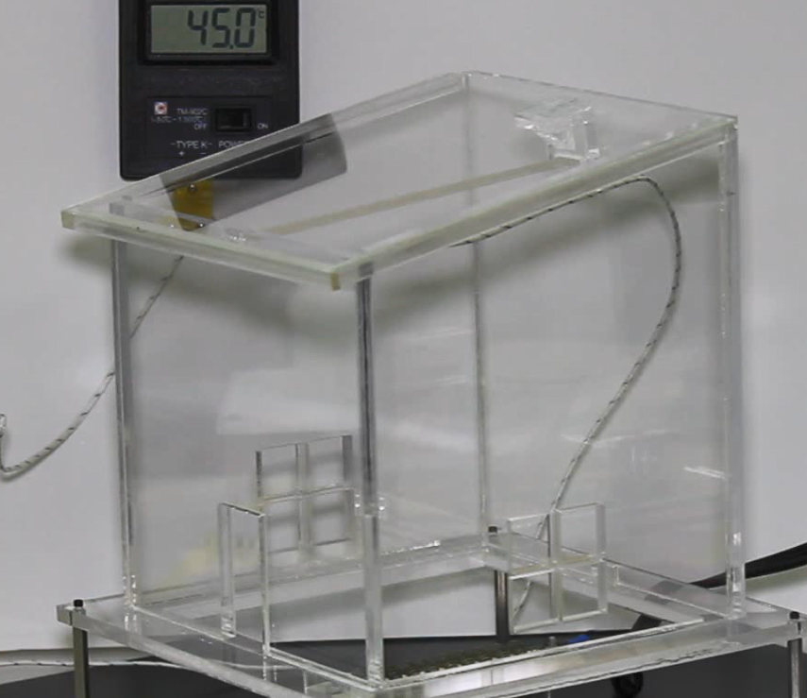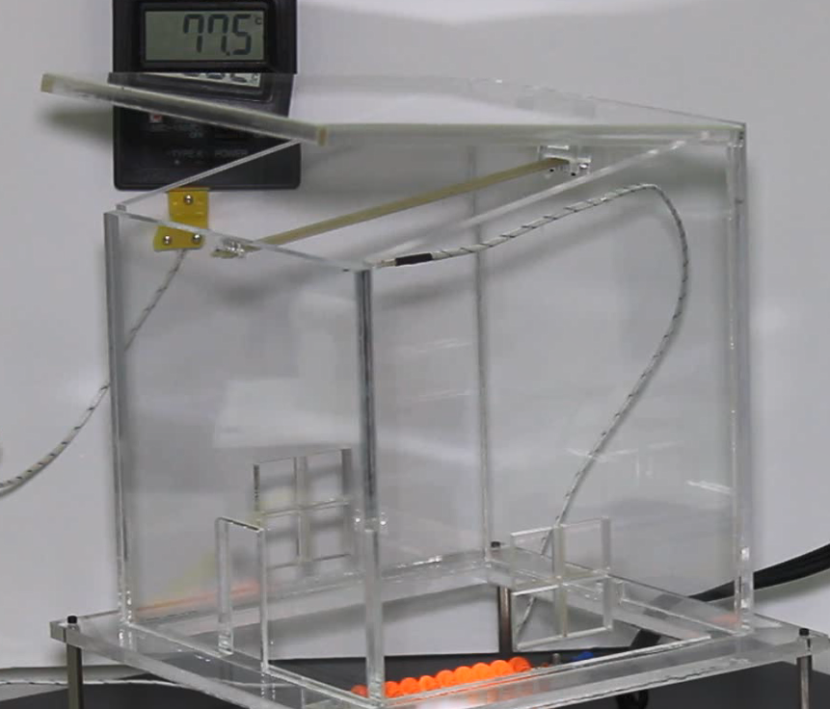
Fig. 1: A few coiled polymeric fibers automatically open the roof of a simulated greenhouse in order to allow hot air to escape and control its internal temperature.

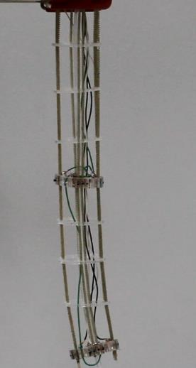
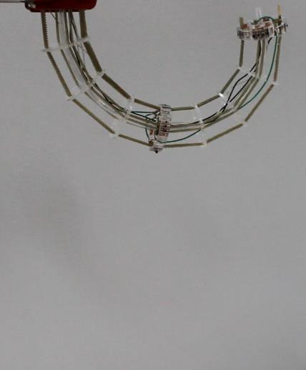
Fig. 2: A “tentacle” 25 cm long and using 8 independent arrays of coiled, polymeric fibers. Movement took 2.5 seconds.

