Polymeric ion-exchange selective membranes for selectrodialysis: applications in metal separation and recovery
X. Vecino^{1,2}, PhD
M. Reig^{1,2}, PhD
J. López^{1,2}, PhD student
C. Valderrama^{1,2}, Auxiliar Professor
O. Gibert^{1,2,3}, Associate Professor
J.L. Cortina^{1,2,3}, Full Professor
¹Chemical Engineering Dept., UPC-Barcelona TECH, C/ Eduard Maristany, 19 (Campus Diagonal-Besòs), 08930 Barcelona, Spain.
²Barcelona Research Center in Multiscale Science and Engineering, C/ Eduard Maristany, 19 (Campus Diagonal-Besòs), 08930 Barcelona, Spain.
³CETaqua, Carretera d'Esplugues, 75, 08940 Cornellà de Llobregat, Spain.

Abstract (300 word limit)
Selectrodialysis (SED) is a novel configuration of the conventional electrodialysis (ED) technique in which there is one monovalent selective cation or anion exchange (MVC or MVA) membrane between the standard anion (AEM) and cation exchange (CEM) membranes. The used MVC and MVA membranes are composed by polyvinylchloride (PVC) polymer; moreover sulfonic acid and ammonium functional groups are located in the MVC and MVA, respectively. Figure 1 shows the aspect of a monovalent selective cation membrane used in a SED stack supplied by PCCell Laboratory Electrodialysis Cells company (Germany).
The first work of SED was reported by Zhang and collaborators in 2012. They showed the SED as a fractionation process of divalent ions (sulphate) from monovalent ions (chloride) on a synthetic wastewater. Recently, Reig and coworkers (2016) used the SED in combination with bipolar membrane electrodialysis for industrial process brines treatment. Additionally, Tran et al. (2014, 2015) described the SED as phosphate recovery and pre-concentrate process.
On the other hand, we proposed a new application of SED configuration for the metallurgical and mining industries. The aim of this work is the separation and concentration of Cu(II) from streams containing mixtures of H₂SO₄/H₃AsO₄. Thus, as preliminary step of this work, the morphology of the MVC polymeric ionic selective membranes was studied by Scanning electron microscopy (SEM) and Fourier transform infrared spectroscopy (FTIR).
Membrane SEM images were obtained with a JEOL JSM-7001F scanning electron microscope operating at an acceleration voltage of 20.0 kV for secondary-electron imaging (SEI). Also, membranes were analyzed by FTIR in the range 4000–500 cm⁻¹ using a JASCO FT/IR-4100.
The SEM images, after the SED process, revealed that carbon, oxygen, sulfur, copper and chloride elements are presented on the membrane composition. Furthermore, the roughness of the membrane surface increased due to the copper deposition.

Image
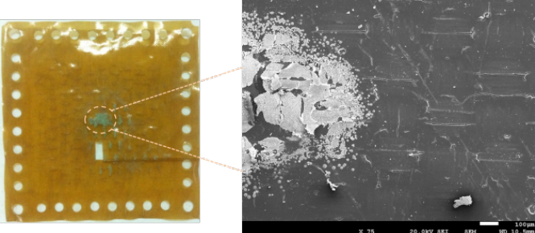
Figure 1. MVC membrane from PCCell company and its SEM image after the SED process for copper and arsenic separation.
Recent Publications (minimum 5)
- Reig M, Valderrama C, Gibert O, Cortina JL (2016) Selectrodialysis and bipolar membrane electrodialysis combination for industrial process brines treatment: Monovalent-divalent ions separation and acid and base production. Desalination 399:88–95.
- Tran ATK, Zhang Y, Lin J, Mondal P, Ye W, Meesschaert B, Pinoy L, Van Der Bruggen B, (2015) Phosphate pre-concentration from municipal wastewater by selectrodialysis: Effect of competing components. Separation and Purification Technology 141:38–47.
- Tran ATK, Zhang Y, De Corte D, Hannes JB, Ye W, Mondal P, Jullok N, Meesschaert B, Pinoy L, Van der Bruggen B, (2014) P-recovery as calcium phosphate from wastewater using an integrated selectrodialysis/crystallization process. Journal of Cleaner Production 77:140–151.
- Zhang Y, Desmidt E, Van Looveren A, Pinoy L, Meesschaert B, Van Der Bruggen B, (2013) Phosphate separation and recovery from wastewater by novel electrodialysis. Environmental Science and Technology 47:5888–5895.
- Zhang Y, Paepen S, Pinoy L, Meesschaert B, Van Der Bruggen B, (2012) Selectrodialysis: Fractionation of divalent ions from monovalent ions in a novel electrodialysis stack. Separation and Purification Technology 88:191–201.

Biography (150 word limit)
X. Vecino is a PhD in the Chemical Engineering Department at the Universitat Politècnica de Catalunya (UPC)-Barcelona TECH, and her research focuses on the sustainable utilization of agro-industrial wastes through biotechnological processes in order to obtain valuable products as well as in the separation processes using membrane and adsorption technologies.
Email: xanel.vecino@upc.edu

Notes/Comments:
This research received support from the Waste2Product project (CTM2014-57302-R) financed by the Spanish Ministry of Economy and Competitiveness (MINECO). As well, Mònica Reig, Julio López, and Xanel Vecino thank MINECO for their predoctoral grants (ref. BES-2012-051914 and ref. BES-2015-075051) and Juan de la Cierva contract (ref. FJCI-2014-19732), respectively.

