Preparation of Surface Modified Nanodiamond Hybrid Composite
Aslı Beyler-Çiğil PhD, Marmara University, Turkey
Memet Vezir Kahraman Professor, Marmara University, Turkey

Abstract

Recently, the preparation of nanodiamond hybrid composites has attracted the attention of materials scientists due to the unique properties of nanodiamonds. In this study we report the modification of NDs with functional groups which are UV reactive. This modification promotes the covalent bonding of NDs to the UV-curable matrix by crosslinking photo-polymerization and thus homogeneous hybrid composites are formed. NDs surface was photografted with polyethylene glycol acrylate (PEGA) to produce hydroxyl groups. Hydroxyl functionalized ND/PEGA were acrylated using Isocyanato ethyl methacrylate (IEM) in order to improve the dispersion and interfacial interaction in composites. UV-curable formulation was prepared by mixing the acrylate modified nanodiamond, aliphatic urethane acrylate, trimethylolpropane triacrylate (TMPTA), glycidyl methacrylate (GMA) and photoinitiator. The prepared hybrid composite was treated with polyethylene imine (PEI). As a result, this hybrid composite has NH₂ end groups. Chemical structure of hybrid material was characterized by FTIR. FTIR spectra showed that the photografting of nanodiamond was prepared successfully. Thermal properties of the hybrid material was characterized by thermogravimetric analysis (TGA). The hybrid composite presented good thermal stability. The morphology of the hybrid composite was characterized by scanning electron microscopy (SEM).
Image
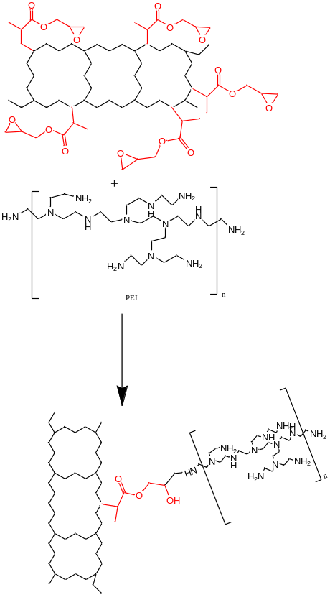
Recent Publications
- Beyler-Çiğil A, Çakmakçı E, Kahraman MV (2016) Thermal Properties of Phosphorylated Nanodiamond Reinforced Polyimides. Polymer Composites 37:2285-2292.
- Beyler-Çiğil A, Kahraman MV (2016) Effect of surface modification on nano-diamond particles for surface and thermal property of UV-curable hybrid coating. Progress in Organic Coatings 101:468-476.
- Joongmin S, Xiaojing L, Naveen C (2016) Polymer surface modification using UV treatment for attachment of natamycin and the potential applications for conventional food cling wrap (LDPE). Applied Surface Science 386:276-284.
- El-Sheikh Manal A (2016) A novel photo-grafting of acrylamide onto carboxymethyl starch. 1. Utilization of CMS-g-PAAm in easy care finishing of cotton fabrics. Carbonhydrate Polymers 152: 105-118.
- Matsuguchi M, Kubo S, Sakai Y (1999) A Capacitive-type relative humidity sensor having a double layer structure consisting of a photocrosslinked PVCA and a PMMA film. Electrochemistry 67:170-174.

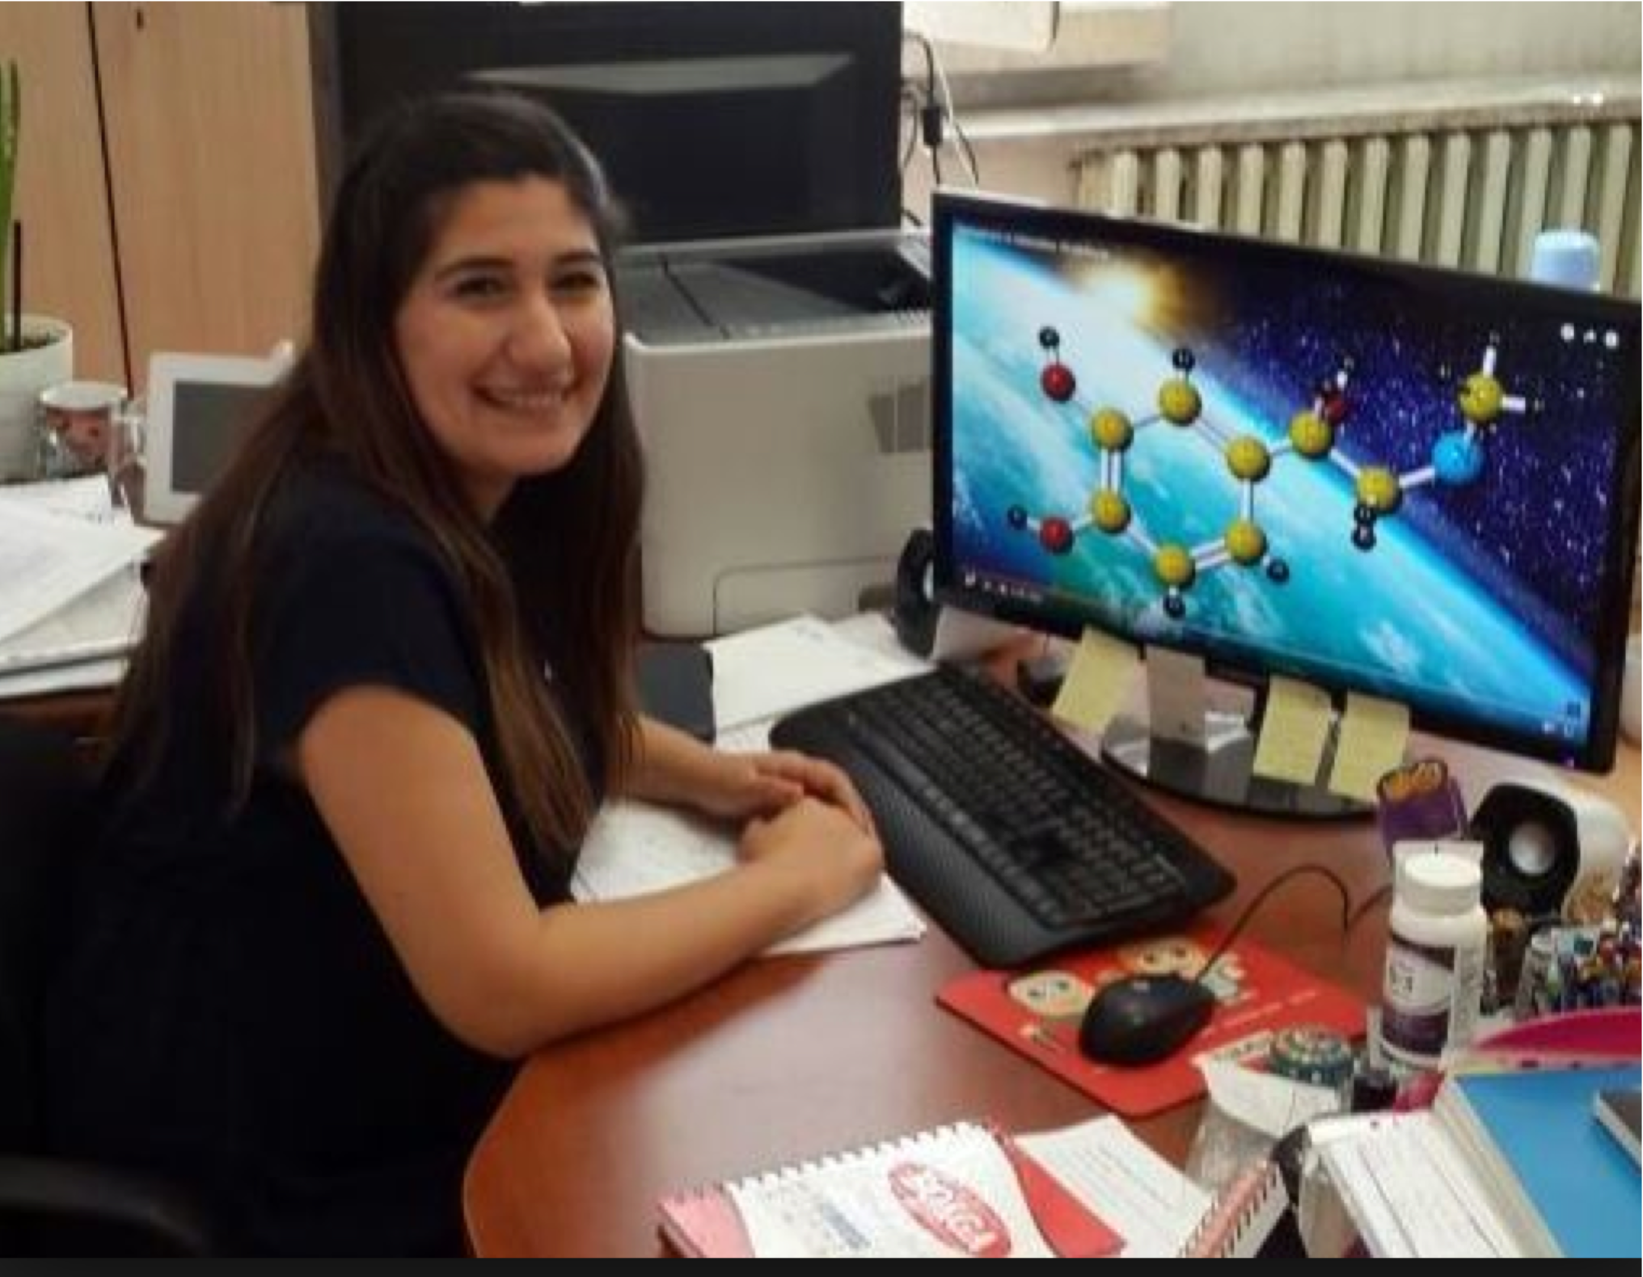
Biography Aslı Beyler Çiğil received her MSc degree in Chemistry from Gazi University in 2012. She is currently working on her PhD thesis under the supervision of Memet Vezir KAHRAMAN in Marmara University. Her main study area includes the synthesis and preparation of photocurable materials for enzyme immobilization and sensor applications.
Email: asli.beyler@marmara.edu.tr

