Interaction Between Polymer Brushes Bearing Phophorylcholine and Inverse-Phophorylcholine Groups
Motoyasu Kobayashi, Kogakuin University, Japan

Abstract

Phosphocholine (PC) is a zwitterion group which can be found in phophatidylcholine lipids of cell membrane in nature. It is widely known that the polymer bearing PC group reveals excellent bio-compatibility and antifouling properties due to extremely weak interaction between PC and protein molecules. In this work, adhesive interaction of polyzwitterion brushes containing sulfo- and phospho-betaine groups in water was estimated by force curve measurement using scanning probe microscopy. Polyzwitterion brushes with a 110 nm thick (dry state) on silicon wafer was prepared by surface-initiated atom transfer radical polymerization of methacrylate monomers bearing sulfobetaine (SB), PC, and inverse-PC (iPC). Inverse PC is a zwitterionic group having inverted charge orientation of quaternary amine and phosphate in contrast to PC. Chemical structure of polymers with PC and iPC were shown in Figure 1.
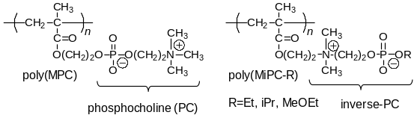

Figure 1. Chemical structure of poly(MPC) bearing with PC group and poly(MiPC-R) with inverse-PC group
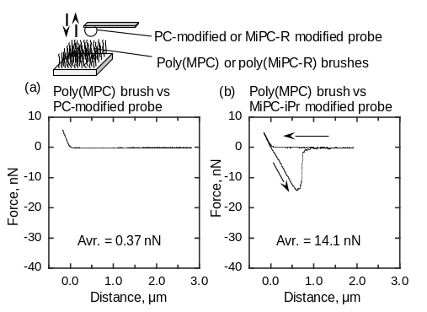

Figure 2. Force curve measurement on (a) poly(MPC) brush and (b) poly(MiPC-iPr) brush surface in water by using PC or iPC functional groups-immobilized silica probe

Force curve measurement was performed by atomic force microscopy using a handmade sphere probe. Silica particle (d = 20 μm) covered with SB, PC, and iPC functional groups was immobilized at the edge of a tipless cantilever with a small amount of epoxy resin. Adhesion force on the surface of SB and PC brushes were lower than 1 nN, whereas larger force than 20 nN was obtained between PC and iPC brush (Figure 2). Specific strong attractive interaction between PC and iPC were clearly observed. Poly(SB) brushes showed temperature dependency of adhesive interaction corresponding to the UCST behavior in water.

Recent Publications
- Hirai T, Kobayashi M, Takahara A (2017) Control of the primary and secondary structure of polymer brushes by surface-initiated living/controlled polymerization, Polym. Chem. 8: 5456-54658.
- Yoshioka H, Izumi C, Shida M, Yamaguchi Y, Kobayashi M (2017) Repeatable adhesion by proton donor-acceptor interaction of polymer brushes, Polymer 119: 167-175.
- Kobayashi M, Higaki Y, Kimura T, Boschet F, Takahara A, Ameduri B (2016) Direct Surface Modification of Poly(VDF-co-TrFE) Films by Surface-initiated ATRP without Pretreatment, RSC Advances 6: 86373-86384.
- Kobayashi M, Kaido M, Suzuki A, Takahara A (2016) Tribological Properties of Cross-linked Oleophilic Polymer Brushes on Diamond-Like Carbon Films, Polymer 89: 128-134.
- Kikuchi M, Terayama Y, Ishikawa T, Hoshino T, Kobayashi N, Ohta N, Jinnai H, Takahara A (2015) Salt Dependence of the Chain Stiffness and Excluded-Volume Strength for the Polymethacrylate-Type Sulfopropylbetaine in Aqueous NaCl Solutions, Macromolecules 48:19 7194-7204.
- Kobayashi M, Tanaka H, Minn M, Sugimura J, Takahara A (2014) Interferometry Study of Aqueous Lubrication on the Surface of Polyelectrolyte Brushes, ACS Applied Materials & Interfaces 6: 20365-20371.
- Kobayashi M, Ishihara K, Takahara A (2014) Neutron Reflectivity Study of the Swollen Structure of Zwitterionic Polymer Brushes in Aqueous Solution Compared with Polycation Brush, J. Biomat. Sci.: Polym. Ed. 25: 1673-1686.



Prof. Kobayashi received his Ph.D. in 2000 from the Tokyo Institute of Technology, Japan, and was appointed as an assistant professor in the Faculty of Engineering, Yamagata University, Japan (200-2004). From 2004 to 2005, he worked as a researcher at Kyushu University, Japan, and was appointed as an assistant professor in the Institute for Materials Chemistry and Engineering, Kyushu University, in 2006. He has been a group leader of the JST-ERATO project (2009-2013). After that, he moved to Kogakuin university in 2013 as an associate professor and has been full professorship since 2014. His research interests are polymer synthesis, bio-inspired chemistry, surface and interface science, such as wettability, adhesion, and the tribology of ion-containing polymers. He has been published more than 70 scientific articles, and 20 books/book chapters.
Email: motokoba@cc.kogakuin.ac.jp

