Optimized synthesis of pyridine-based porphyrins for comparative homogeneous electrocatalytic reduction of CO₂
Billy Deng, B.Sc.
University of Toronto, Canada.

Abstract
The conversion of carbon dioxide (CO₂) into fuels has been a focal point in contemporary research aiming to tackle the issue of climate change. However, reducing the CO₂ into usable compounds such as methanol is a challenge due to the high thermodynamic and kinetic stability partially attributed to the linear structure of CO₂. Pyridine (Py) and pyridine derivatives have been shown as efficient electrocatalysts for stepwise CO₂ reduction to methanol by serial proton-coupled electron transfers but are noted for their low stability and current densities.
Here, we have designed and optimized the synthesis of different symmetrical and nonsymmetrical pyridine porphyrin (Pyp) isomers, which are very stable catalysts due to the unique porphyrin structure. We will also compare the electrochemical behaviors between Pyp isomers in terms of CO₂ reduction using Cyclic Voltammetry (CV). The impact of conjugation on redox efficiency will be assessed.

Image

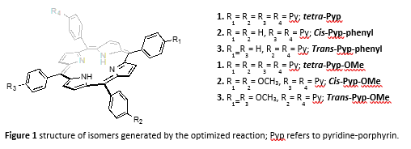

Recent Publications (minimum 5)
- Deng, B., Abdinejad, M., Dao, C., (2018) Carbon Dioxide Capture Using Amino Porphyrins Under Mild Conditions. Inorganic Discussion, Ryerson University, Toronto, Canada.
- Abdinejad, M., Dao, C., Deng, B., Kamal, A., Sharma, R., Dong, Lei., Kraatz, H. B., Zhang, X. Facile and Versatile Synthesis of Porphyrin Isocyanates and Polyureas with Carbon Dioxide

Biography (150 word limit)
Billy Deng received his B.Sc. from the University of Toronto, double majoring in Biochemistry and Immunology. His focus is on the functionalization of porphyrins for carbon dioxide capturing and reduction.
Email: billy.deng@mail.utoronto.ca

