Pendant Homopolymer and Copolymers as Solution-Processable Thermally Activated Delayed Fluorescence Materials for Organic Light-Emitting Diods
S. Yan, Z. Ren
Beijing University of Chemical Technology, College of Materials Science and Egineering, Beijing, 100029, China
email: skyan@mail.buct.edu.cn
Summary
This study reports a series of polymers with an insulating backbone and varying ratios of 2-(10H-phenothiazin-10-yl)dibenzothiophene-S,S-dioxide as a pendant TADF unit. Green emitting OLED devices employing these polymers as spin-coated emitting layers give high performance.

Introduction
Organic light-emitting diode (OLED) devices have been in continous development since the early 1960s. To improve the external quantum efficiency (EQE) of OLEDs, extensive studies have focused on synthesizing new emissive materials. One of the most important challenges in this field stems from the fact that fluorescent materials harvest emission only from singlet excitons and thus have the limitation of reaching a maximum internal quantum efficiency (IQE) of 25%, whereas statistically 75% triplet excitons are wasted. Metal-free, thermally activated delayed fluorescence (TADF) materials are considered to be third-generation emitters for OLEDs.¹⁻³ Polymeric TADF emitters are particularly suitable for solution processing technologies. However, synthesizing TADF oligomers and polymers is challenging and there are no clear guidelines for their optimal molecular structures. Firstly, simultaneously achieving a small energy splitting between the singlet and triplet states (ΔE_{ST}) and suppressing internal conversion is very difficult in molecules containing numerous atoms. Secondly, the triplet population in polymers is easily quenched by intramolecular and intermolecular triplet-triplet annihilation.⁴ However, there are only a few reported examples of polymeric TADF materials.
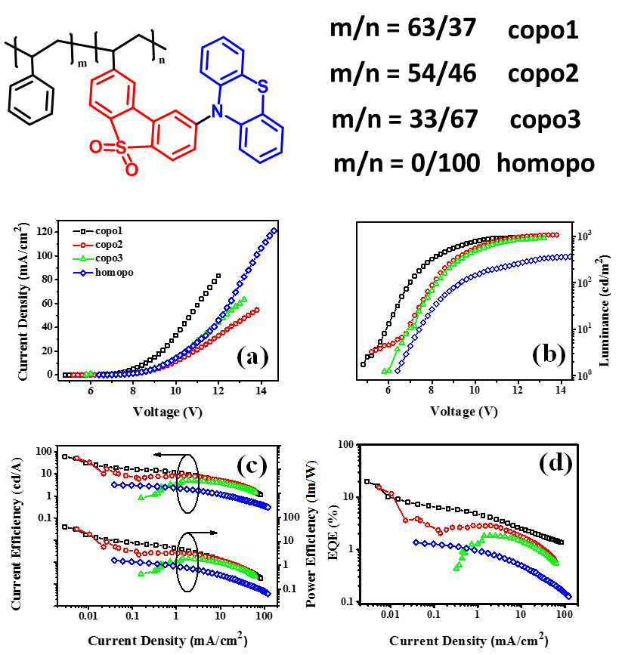
Discussion

As shown in Fig.1, a series of polymers with an insulating backbone and varying ratios of 2-(10H-phenothiazin-10-yl)dibenzothiophene-S,S-dioxide as a pendant TADF unit, copo1, copo2, copo3 and homopo, have been synthesized and characterized successfully. They exhibit good film forming ability, high thermal decomposition temperatures and suitable glass transition temperatures. Steady-state and time-resolved fluorescence spectroscopic data confirm the efficient TADF properties of the polymers. Styrene, as a co-monomer, is shown to be a good dispersing unit for the TADF groups, by greatly supressing the internal conversion and triplet-triplet annihilation. Increasing the styrene content within the copolymers results in relatively high triplet energy, small energy splitting between the singlet and triplet states (ΔE_{ST}) and a strong contribution from delayed fluorescence to the overall emission. Green emitting OLED devices employing these polymers as spin-coated emitting layers give high performance, which is dramatically enhanced in the copolymers compared to the homopolymer. Within the series, copo1 with a regiorandom ratio of 37% TADF units : 63% styrene units displays the best performance with a maximum external quantum efficiency (EQE) of 20.1% and EQE at 100 cd m⁻² of 5.3%.
Fig. 1. Chemical Structure, device performance of copolymers.

Conclusions

In summary, a series of pendant polymers with 2-(10H-phenothiazin-10-yl) dibenzothiophene-S,S-dioxide as TADF units and insulating styrene units as side chains have been synthesized and structure/property/OLED performance relationships have been established. Photophysical data confirm that for all the polymers the reverse intersystem crossing mechanism is able to compete with internal conversion and triplet-triplet annihilation. The effect of styrene content on the properties of the TADF properties of the polymers has been evaluated. The triplet energy and the delayed fluorescence contribution increases with increasing styrene content of the copolymers; meanwhile, the energy splitting between the singlet and triplet states (ΔE_{ST}) decreases with reducing styrene content of copolymers. OLED devices based these polymers as spin-coated emitting layers gave high performance, which is enhanced for the copolymers compared to the homopolymer. The best EL performance was achieved for the copo1-based device with CE_{max} of 61.3 cd/A, PE_{max} of 40.1 lm/W, and EQE_{max} of 20.1%. To our knowledge this is the highest EQE reported to date for a TADF polymer.²⁶⁻³⁰ Furthermore, at 100 cd m⁻² the EQE was 5.3%. High EQE, even at very low luminance, is widely recognized as an important figure-of-merit for OLED efficiencies.³⁸ The key molecular features we have developed in this work, namely a non-conductive polymer backbone with pendant TADF units separated by non-emissive units, should be versatile for the design of new families of TADF polymers. It remains to be seen if polymers, which have the potential benefits of high thermal stability, good film-forming ability and reduced phase separation, can be widely exploited for color tuning and enhanced TADF-OLED performance.

References
[1] Q. Zhang, J. Li, K. Shizu, S. Huang, S. Hirata, H. Miyazaki, C. Adachi, J. Am. Chem. Soc. 134, 14706-14709, 2012.
[2] F. B. Dias, K. N. Bourdakos, V. Jankus, K. C. Moss, K. T. Kamtekar, V. Bhalla, J. Santos, M. R. Bryce, A. P. Monkman, Adv. Mater. 25, 3707-3714, 2013.
[3] Y. Tao, K. Yuan, T. Chen, P. Xu, H. Li, R. Chen, C. Zheng, L. Zhang, W. Huang, Adv. Mater. 26, 7931-7958, 2014.
[4] R. S. Nobuyasu, Z. Ren, G. C. Griffiths, A. S. Batsanov, P. Data, S. Yan, A. P. Monkman, M. R. Bryce, F. B. Dias, Adv. Opt. Mater. 4, 597-607, 2016.

