Electrochemical Stimuli Driven Facile Metal Free Hydrogen Evolution from Pyrene-Porphyrin Based Crystalline Covalent Organic Framework.

Anirban Pradhan, PhD, INSPIRE FACULTY,
Indian Association for the Cultivation of Sciences (IACS), Kolkata, India
Subhajit Bhunia, MSc, IACS, Kolkata, India
Bidhan Chandra Patra, MSc, IACS, Kolkata, India

Abstract
Metal free electrocatalyst has a great significance in electrocatalytic hydrogen evolution from water. Recently we report a new porphyrin-based metal free covalent organic polymer (COP) and covalent organic framework (COF), prepared by a simple and efficient condensation between triformyl phloroglucinol (Tp) or pyrene tetra aldehyde (Py) and 5,10,15,20-tetra(4-aminophenyl)-21H,23H-porphyrin (PAM). TpPAM showed a greater catalytic efficiency compared to various metal free electrocatalysts with a low overpotential of 250 mV to achieve 10 mA/cm² and a small Tafel slope (106 mv/decade). Theoretical density functional theory (DFT) calculation compared with experimental findings which synergetically favours the high HER catalytic efficiency of porous polymer TpPAM. The Faradic efficiency of TpPAM based electrode was found to be 98 % which is very close to the ideal value of 100%. Moreover, the as synthesized catalyst shows a good stability by retaining 91% of initial current density after 1000 test cycles.
Image

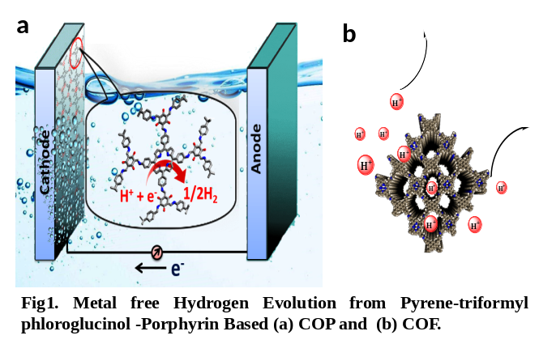
In the case of PAM-Py COF Normally such COF also show exceptional stability even in strong acid and alkaline solution. We have investigated the charge carrier mobility and metal free hydrogen evolution by imposing an electrochemical stimulation by exploiting the imine (C=N-) based site and porphyrin-hyperporphyrin tautomerization occurring in SB-PORPy COF. We believe that the topologically strained crystalline imine based covalent organic framework will add to the structural diversity of such COF class of materials and find widespread utility and applications based on the electrochemical properties of COFs.

Recent Publications
1. Highly Twisted Arenes by Scholl Cyclizations with Unexpected Regioselectivity. A. Pradhan, P. Dechambenoit, H. Bock, F. Durola, Angew. Chem. 2011, 50, 12582.
2. Twisted polycyclic arenes by intramolecular Scholl reactions of C3-symmetric precursors. A. Pradhan, P. Dechambenoit, H. Bock, F. Durola, J. Org. Chem. 2013, 78, 2266. (Highlighted in Synfacts. 2013, 9(6), 0617.
3. Helicenes from diarylmaleimides. H. Bock, D. Subervie, P. Mathey, A. Pradhan, P. Sarkar, E. Hillard, P. Dechambenoit, F. Durola, Org. Lett. 2014, 16(6), 1546
4. Fused Helicene Chains: Towards Twisted Graphene Nanoribbons, A. Pradhan, P. Dechambenoit, H. Bock, F. Durola, Chem. Eur.J. 2016, 22,18227.
5.Electrochemical Stimuli-Driven Facile Metal-Free Hydrogen Evolution from Pyrene-Porphyrin-Based Crystalline Covalent Organic Framework, S. Bhunia, S. K. Das, R. Jana, S. C. Peter, S. Bhattacharya, M. Addicoat, A. Bhaumik, and A. Pradhan*, ACS Appl. Mater. Interfaces, 2017, 9, 23843.
6. A Metal-Free Covalent Organic Polymer for Electrocatalytic Hydrogen Evolution, B. C. Patra, S. Khilari, R. N. Manna, S. Mondal, D. Pradhan, A. Pradhan*, and A. Bhaumik, ACS Catal. DOI: 10.1021/acscatal.7b01067

 Biography
I, Anirban Pradhan received my B.Sc. from University of Calcutta, India (2008), M.Sc. from Indian Institute of Technology, Bombay, India (2010), and Ph.D. in Organic Chemistry from University of Bordeaux, France under supervision of Dr Fabien Durola (Student of Nobel laureate Prof. J. P. Sauvage) 2013. I did my Postdoctoral research at University of Trieste, Italy (2014) and working as a foreign expert in Xiamen University (Energy center), China, 2015. I started my independent career as an Inspire faculty in Indian association for the cultivation of Science Kolkata, India, 2016. My research is focused on COPs, COFs, PAHs and PACs materials for energy application and drug research.
Email: msap5@iacs.res.in

