A system for safe and eco-friendly wastewater treatment
Joy Manglani, Only Nature Endures, NGO (OneNature.com), India

Abstract
A system for treatment using wastewater and unutilized solar energy, as resources to produce; vegetation (say grass) and clean water. The system is occupationally safe and eco-friendly. wherein there is no bad odour, no mosquitoes, no colour in the said clean water. It helps recycling of material and energy; enhancement of environment, energy conservation, enhancement of air, soil, water, plants and animals feeding on these plants, bio-energy generation, reduction in global warming and climate change, development of havens for wildlife including flora and fauna, enhanced quantity, quality and distribution of rainfall, enhanced dissolved oxygen in water, watershed development, enhanced aquaculture and fisheries development, flood control. The treatment primarily includes a Collection and Seeding Tank (CST) for pre-treatment, a Sieve Cage (SC) to sieve out plastic bags and other solids, a Solar Bio-Reactor (SBR) for further treatment, a cleaner water tank from where treated clean water is pumped out for usage.

Keywords: Air, Aeration, Climate change, Conservation, Development, Eco-friendly, Energy, Environment, Fauna, Flood, Flora, Global warming, Green, Health, Oxygen, Rain, Recycle, Safe, Solar, Sustainable, Vegetation, Waste, Wastewater, Water, Watershed.

Introduction
"Human activity has had a negative impact on the environment because it has caused deforestation, ocean acidification, and the extinction of important biodiversity." (https://www.wikihow.com/Write-a-Paper)
“Current Sanitation methods convert pollution to disaster; They lead to major problems faced by society today, such as; water pollution, water scarcity, loss of soil fertility, global warming, poor economy, poor health and loss of life”. (Dr Steven Esrey & Ingvar Anderson, Water & Sanitation Council, WHO in 1999)
These methods continue to decompose (break-up) valuable elements, found in the so called waste, into foul gases & acids, even now! The gases badly pollute the air and acids badly pollute the land and sub soil water.

However, this new system of treatment for community wastewater, which includes sullage, kitchen sink food waste pulverized wastewater, wash water, bath water, sewage both human and animal, storm water, polluted water bodies, wherein besides the plastic bags and other solids plastic bags and other solids, the liquid component is about 99% water and 1% organic matter primarily made up of natural elements such as carbon, oxygen, hydrogen, nitrogen, sulfur and other trace elements found in all health biology, these are nutrients and are converted to healthy vegetation such as grass and cleaner water is filtered out, wherein there is no odour, no mosquitoes, no colour in the said cleaner water, no abnormal color of the vegetation.
This new Technology to utilize wasted resources (including solid, liquid, gaseous waste and solar energy) for Air purification, Water recycling, Sanitation and Greening etc wherein the so-called waste is recomposed and not decomposed, to resolve the said problems. OWD is an Economical, Efficient & Sustainable method for Sanitation, Water Recycling and River Cleaning.
In this system, inorganic waste and photosynthesis are used to neutralize and completely convert sewage to grass (vegetation) and clean water as seen above. Thus no foul gases, unclean water or acids are released as in other STPs. The treated water is colourless, odour free, pH neutral and does not attract mosquitoes, unlike other STPs. This water can be made potable or used eg. as an excellent liquid fertilizer. This is evergreen, reducing carbon footprint and giving oxygen.
This is at least 10 times economical, efficient, safer and ecological compared to alternatives.

Photos of a plant

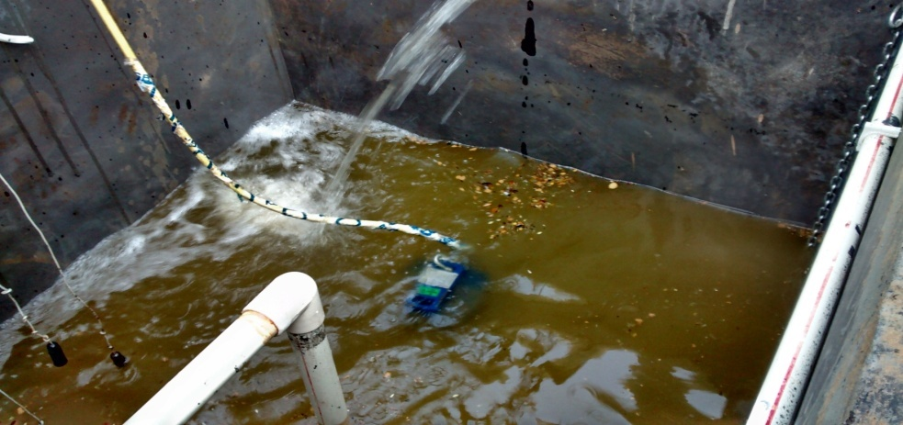

Sewage tank
The fresh sewage is automatically collected, mixed and pumped onto a Bioreactor from here. 10% of treated clean water is recycled here to initiate the treatment. This helps to remove the bad odour. The pump used has automatic level controls.

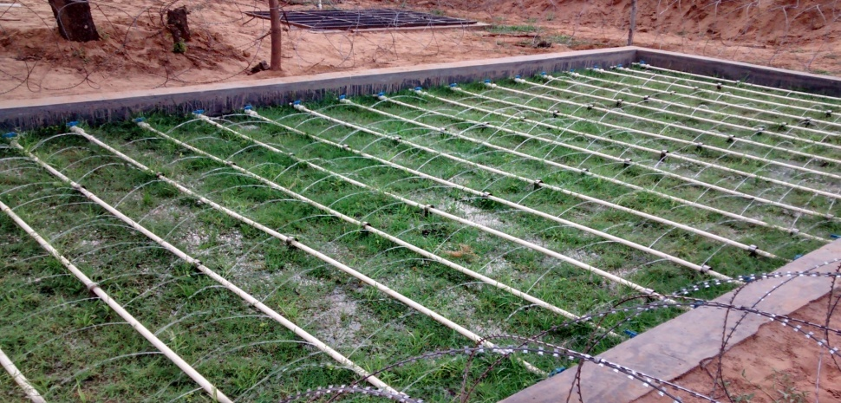

Bioreactor
The sewage is automatically distributed on the Bioreactor as shown and converted to grass and clean water. It comprises a 1.5 mtr deep tank, with a slightly inclined bottom and with a specially designed bio-media which allows fast percolation. The water flows through an underground pipe in the corner end of the bioreactor to the underground tank whose surface is seen behind.
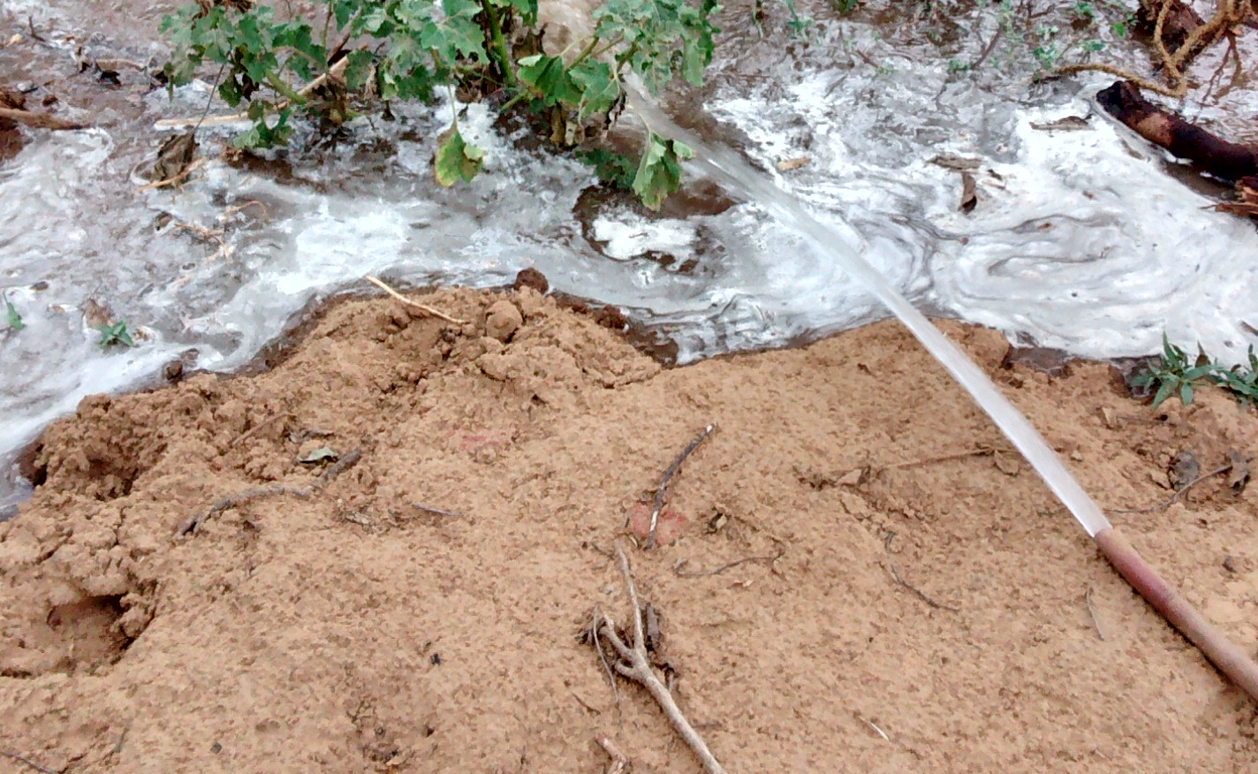

Treated Clean Water
In about 25 minutes the treated clean water is automatically pumped out of the underground tank seen behind the Bioreactor. The pump used has automatic level controls.

Conclusion
This is a system of wastewater treatment wherein, said useful products comprise clean and naturally aerated water, healthy clean vegetation, cleaner and healthy soil, cleaner air because of the above. Analysis of said clean water, comparison with prevalent standards and accordingly release part for applications and part for said recycle, said products have applications comprising usage by humans, animals, plants and other objects, said clean water applications further comprise water for; drinking, cooking, bathing, washing, cleaning, planting vegetation in available spaces and watering it with water that is odour and itch free etc., gardening, irrigation, aquaculture, industrial usage, hydroelectricity generation, fire-fighting, recycling into clear water bodies comprising natural streams, rivers, ponds, lakes, sea, recycling into man-made water reservoirs comprising; fisheries, aquaculture, recycling into polluted water bodies to dilute their pollution content.

Reference
- https://www.wikihow.com/Write-a-Paper
- (Dr Steven Esrey & Ingvar Anderson, Water & Sanitation Council, WHO in 1999)

Contacts;
Phone; +91 98694 02067
Email; joymanglani2@mail.com,

