Simulation of Impact of Climate Change on Food Security of Punjab for Mid-century Scenarios, Pakistan
Nusrat Ehsan, National College of Busies Administration and Economics, Lahore Pakistan

Abstract (300 word limit)
The climatic changes impacts with an average increase in temperature by 0.5°C over the past 60 years is threatening food security in Pakistan. The present study evaluates the variation in climatic variables and wheat production in Punjab, Pakistan during baseline and mid-century scenarios using ten models. The baseline results indicated that the mean annual minimum and maximum temperature in selected area has increased over the past 30 years. The total annual precipitation during the baseline showed a decrease. The total wheat cultivated area has increased from 175,000 ha (1988) to 205,000 ha (2018). The overall comparison of experimental (observed) and simulated results showed positive correlation. Wheat cultivar (Faisalabad-2008) showed early anthesis than Sehar-2006. Faisalabad-2008 showed early anthesis and maturity as compared to Sehar-2006, whereas, Sehar-2006 showed more yield, higher Leaf Area Index (LAI) and Harvest Index (HI) as compared to Faisalabad-2008. The wheat yield, grain number per meter square, HI and LAI, for both wheat cultivars increased with increase in nitrogen application with less variation in wheat yield of Faisalabad-2008 (5959 kg/ha) and Sehar-2006 (5465 kg/ha) at N-220 kg. The simulation trend of mid solar radiations, maximum and minimum temperature under both Representative Concentration Pathways (RCPs) showed an increasing trend compared to the baseline while rainfall for mid-century indicated increase of 2.5 mm to 3.2 mm (RCP 4.5) and 0.40 mm to 0.51 mm (RCP 8.5) compared to the baseline taken as zero. The harvest at maturity of Faisalbad-2008 showed increasing trend for mid-century as compared to the baseline. The application of modern knowledge based on scientiﬁc research and international strategies could help local farmers better adapt to climate change in order to increase agricultural output and provide long-term economic sustainability.
Key Words: Climate change; Wheat; farm-management; agricultural policies; food security
.

Image
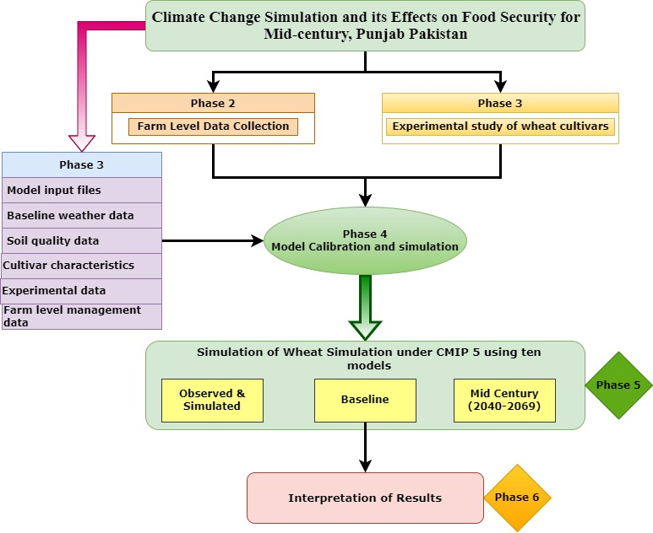
Figure 1: Theoretical framework for climate change impact on wheat cultivars during mid-century scenarios using crop simulation model
Recent Publications (minimum 5)
- N. Ehsan, Qamar, M. K., Wajid, S.A., Ahmed I., Khan, W.A. (2021). Elevation of Wheat Cultivars at Various Levels of Nitrogen through Field Experimentation and Modeling Approach in Punjab, Pakistan. Pakistan Journal of Science. 73 (2), 437-445.
- S. Sharif, Zaman,Q., Hassan, F., Javaid, S., Arif,K., Mansha, M.Z. Ehsan, N., Nazir, S., Gul, R., Iqbal, M., Nazir. I. (2021). Coagulation of Metallic Pollutants from Wastewater Using a Variety of Coagulants Based on Metal Binding Interaction Studies. De Gruyter. Phys. Chem. 235 (4): 467– 481.
- N. Ehsan, Qamar, K., Zaman, Q., Ahmed,W., Aslam, A., Mehmood, F. (2021). Sustainable remediation solution for heavy metal contaminated soils of Pakistan: A review. Pure Appl. Biol., 10(2): 474-491, http://dx.doi.org/10.19045/bspab.2021.100051
- Aslam, A., Thomas-Hall, Mughal T., Zaman, Q., Ehsan N., Javied S., Schenk P. (2019). Heavy metal bioremediation of coal-fired flue gas using microalgae underdifferent CO2 concentrations. Journal of Environmental Management 241 (2019) 243–250
- Tabssum, F., Zaman, Q., Chen, Y., Riaz, U., Ashraf, W., Aslam, A., Ehsan N., Nawaz, R., Aziz H. and. Shah, S. (2018). Exogenous application of proline improved salt tolerance in rice through modulation of antioxidant activities. Pakistan Journal of Agricultural Research, 32(1): 140-151. DOI: http://dx.doi.org/10.17582/journal.pjar/2019/32.1.140.151
- N. Ehsan, Shan, A., Riaz, S., Zaman, Q., Javied, S., Jabeen, M. (2018). Health Risk Assessment due to Exposure of Arsenic Contamination in Drinking Water of District Shiekhupura, Punjab, Pakistan. Human and Ecological Risk Assessment: An International Journal. DOI: 10.1080/10807039.2018.1498292Harper C (2009) The neuropathology of alcohol-related braindamage. Alcohol Alcohol 44:136-140.
- N. Ehsan. (2017). Spatial Distribution of Heavy metals and their health impacts on community of Tehsil Sharaqpur, Pakistan, Presented on 9th international conference on chemistry Pakistan Institute of Nuclear Science and Technology (19-21 September, 2017)
- N. Ehsan, Nawaz, R., Ahmad, S., Arshad, M., Umair, M., Sarmad, M. (2016). Remediation of Heavy Metal-Contaminated Soil by Ornamental Plant Zinnia (Zinnia elegance L.). Asian Journal of Chemistry. 28(6):1338-1342

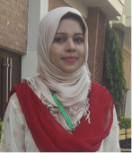 Biography
Paste your Logo here
Ms. Nusrat Ehsan is working as Visiting Lecturer at Department of Environmental Management, National College of Business Administration and Economics, Lahore. Nusrat Ehsan is a PhD Scholar who has conducted her research in “climate change simulation and its impacts on agriculture and food security in Punjab Pakistan” at Department of Agriculture and Biological Engineering, University of Florida, USA.
Ms. Ehsan has served university of Lahore as Lecturer, at Department of Environmental Sciences for six years i.e. (2015-2020). She is an enthusiastic researcher with focus on diverse environmental issues like climate change, carbon sequestration, food security, water pollution and environmental toxic impacts on human health.
Besides the research activities Ms. Ehsan has worked as Environmental Consultant at private consultancies for three years (i.e. 2012-15). During this period she has worked on many Environmental Impact Assessment (EIA), Initial Environmental Examination (IEE) and Social reports like Land Acquisition and Resettlement Plans (LARPs).
Ms. Ehsan has skills on many software tools used for statistical analysis, evaluation and reporting such as DSSAT, Sigma-plot, Minitab, SPSS, and GIS. Based on her research she has published a good number of publications in renowned peer-reviewed National and International journals, conferences and workshops.

Email: nusrat.ncbae@gmail.com

Notes/Comments:

Presenting author details
Full name: Nusrat Ehsan
Contact number: 092355772333
Mail id: nusrat.ncbae@gmai.com
Category: (Oral presentation)

