PHYTOTOXIC EFFECTS OF EFFLUENT OF PULP INDUSTRY ON GROWTH OF MUSTARD (BRASSICA CAMPESTRES) PLANT
Rizwan Saeed MS Environmental Sciences, University of Lahore, Pakistan

Abstract (300 word limit)

Pulp and paper industry utilizes large quantity of water during pulp processing. This results in huge amount of wastewater which contains many toxic contaminants like absorbable organic halides (AOX), resin acids and acids synthetic dyes. Various methods have been designed and developed for treating the industrial waste water in pulp and paper industry, including; aerobic, anaerobic and combined biological treatment processes. The present study was carried out at laboratory scale to check the performance of sequential wastewater treatment along with anaerobic and aerobic treatments for wastewater and to assess the potential of treated water on germination and seedling/growth of mustard plant (Brassica compestris). For execution of aerobic and anaerobic treatments the electric air diffuser were used while minimal salts medium in sealed bottles at control temperature were used. During the 40 days of experiment, sequential (anaerobic and aerobic) treatment, showed significant results by removing 81% Chemical Oxygen Demand (COD), 65% TSS, 60% TDS and 68% Turbidity. TSS removal efficiency of aerobic treatment was found to be higher than anaerobic treatment while COD, TDS, and Turbidity were effectively removed by anaerobic process. The sequential treatments greatly reduced the phyto-toxicity of the water, 90%, 70% and 60% seed germination was found from sequential, anaerobic and aerobic treatment respectively while only 30% germination was shown by untreated wastewater. The results depicted that sequential treatment of the wastewater was most effective in reducing the phyto-toxicity of mustard plant.
Image
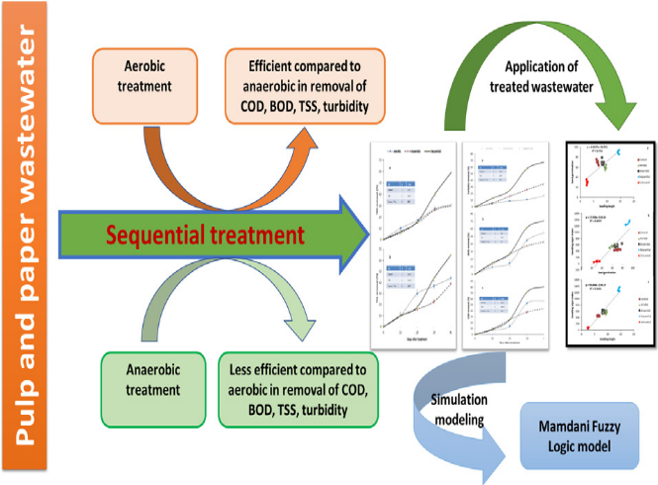
Recent Publications (minimum 5)
- Gao, P., Xu, W., Ruan, X., Qian, Y., Xue, G., Jia, H., 2018. Long-term impact of atetracycline concentration gradient on the bacterial resistance in anaerobicaerobicsequential bioreactors. Chemosphere 205, 308-316.
- Nadiri, A.A., Asadi, S., Babaeizadeh, H., Naderi, K., 2018a. Hybrid fuzzy model topredict strength and optimum compositions of natural Alumina-Silica-basedgeopolymers. Comput. Concr. 21 (1), 103-110.
- Nadiri, A.A., Shokri, S., Tsai, F.T.-C., Moghaddam, A.A., 2018b. Prediction of effluentquality parameters of a wastewater treatment plant using a supervised committeefuzzy logic model. J. Clean. Prod. 180, 539-549.
4. Oguntade, A.O., Adetunji, M.T., Arowolo, T.A., Salako, F.K., Azeez, J.O., 2015. Use ofdye industry effluent for irrigation in Amaranthus cruentus L. production: effecton growth, root morphology, heavy metal accumulation, and the safety concerns.Arch. Agron Soil Sci. 61 (6), 865-576.
5. Priac, A., Badot, P.-M., Crini, G.G., 2017. Treated wastewater phytotoxicity assessmentusing Lactuca sativa: focus on germination and root elongation test parameters.C. R. Biol. 340, 188-194


Biography (150 word limit)
Student of University of Lahore of M.phill. Most of Research area on water quality & air quality. Different instrument used for air & water quality.
Email: rizwan_saeed012@yahoo.com

Notes/Comments:

