Coal fired thermal power plant emitted pollutants, Central Indian Population residing in the vicinity of thermal power plant and their respiratory health impact/risk assessment
Puspita Barik, AcSIR (CSIR-National Environmental Engineering Research Institute) Ph.D. Scholar, India

Abstract (300 word limit)
Statement of the Problem: For developing nation like India Coal fired thermal power plant considered one of the major sources of pollution and it one of the largest threats to the environment Thermal power plant (TPP) contribute a significant burden of diseases due to air pollution. TPP emissions contain toxic particulate matter (PM), hazardous heavy metals (Mn, Cd, Cu, Hg, Mg, etc.), SOx, NOX, CO2, etc.
Therefore, in the present study, the case control epidemiological study design applied to assess respiratory health risk assessment of the Central Indian population residing nearby TPP was carried out using different statistical tools. Multivariate analysis was used to understand the impact of confounding factors on the prevalence of respiratory illness. Univariate and multivariate analysis revealed the strong association of BMI, occupational exposure, smoking and family history with the occurrence of respiratory diseases. This study shows a weak association of PM intake dose with the occurrence of respiratory disease in the human subjects residing nearby TPPs.
Findings: In the present study it revealed that different confounders like body mass index (BMI), smoking status of family, occupational exposure, with the prevalence of respiratory disorders. The statistical analysis both the univariate and multivariate analysis revealed a marginal increase in odds ratios in the subjects with intake dose level of particulate matter >35 μg/kg-day compared to the cut off value of ≤35μg/kg-day. Since the dispersion modeling considers only point sources of emission, the obtained results may further need to be revalidated using real-time on-site air quality monitoring. Future health risk assessment studies should be designed to quantitatively estimate the contribution of each variable (hazard index) to the development of respiratory disorders.
Image
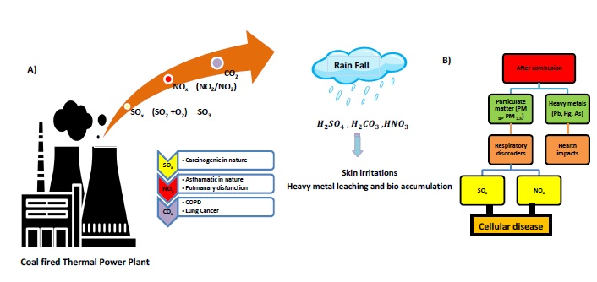
Recent Publications (minimum 5)
- Puspita Barik; Dinesh Wadikar, Pravin Naoghare, Amit Bafana, Tunde Ogbemi Etchie, K.V George, Krishnamurthi Kannan, Sarvanadevi Sivanesan, “Respiratory health risk assessment of the Central Indian population residing nearby coal-fired thermal power plants” Environmental monitoring and assessment communicated.
- Puspita Barik; Pravin Naoghare, Krishnamurthi Kannan, Sarvanadevi Sivanesan “A review on Coal-based thermal power plants in India and their impact on human health: Current status and the way forward” Environmental science and pollution research communicated.
- Manojkumar N; Srimuruganandam B, Pushpita Barik; Krishnamurthi K; Tunde O. Etchie; Padma S. Rao; K.V. George; Saravanadevi Sivanesa, Assessment Of Respiratory Deposition Doses And Mortality Attributed To Fine Particulate Matter In Nagpur, India, Air Quality, Atmosphere & Health Communicated
- Puspita Barik. Sarvanadevi Sivanesan. Krishnamurthi Kannan, coal mining activities air pollution and human health risk assessment of the central Indian population human health in Nagpur, India. (under preparation)

Biography (150 word limit)
Puspita Barik has her Master degree in Environmental science from Utkal University Bhubaneswar and currently working as a AcSIR PhD scholar at CSIR-NEERI. Her research interest is in Environment, Energy and Sustainability, pollution control, human health, risk assessment, air pollution, and environment impact assessment, environmental management, policies and regulations etc. She has communicated both research and review articles in the same areas and is willing to exchange knowledge with other researchers
Email: puspitabarik54@gmail.com ; pb_barik@neeri.res.in

Notes/Comments:

