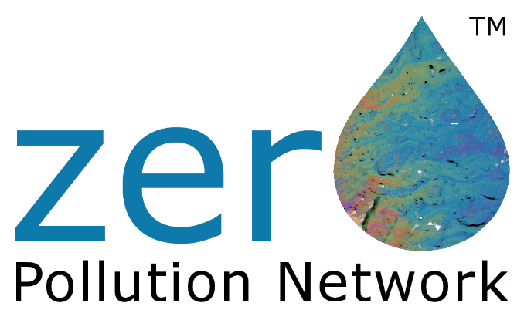

We all share a common aquatic world yet evert second of every day it becomes more polluted with plastics and other noxious waste that escapes via our drains, sewers and sewage treatment processes into our waterways and oceans.
This paper talks about the launch of the Zero Pollution Network www.zero-pollution.net which has the objective of bringing together the solution providers to tackle aquatic pollution head-on, at source rather than wasting valuable resource in trawling for plastics in the oceans.
The Networks aim is to raise the awareness that we have talked for too long, watched from the side lines too many documentaries such as Blue Planet, when there is technology, best practices and willing practitioners that can deliver solutions today, but their ambitions and good intentions are stifled by a regulatory culture that is decades behind what we see in place to combat climate change.

Brian M Back BEng(Hons) CEng FIET
Founding Director
Zero Pollution Network

