Loading capacity of sewage sludge for forestry application
Xiaoxia Zhang, Beijing Forestry University, Beijing 100083, China;

Abstract
The application of sewage sludge (SS) in forestry is considered a viable option. However, the long-term application potentially leads to metal accumulation, posing an environmental risk. Understanding the loading capacity (LC) of SS for forestry application is of great significance. This work describes the spatial distribution of eight metal environmental quality, and potential ecological risks using ArcGIS, and calculates the LC in each Chinese provincial capital cities (PCCs). The data were collected basing on published literatures 2005-2017. The results were as follows: (1) Cd, Hg, Cu, Pb, and Zn were chosen as priority control metals; 9 PCCs (Beijing, Chengdu, Tianjin, Changsha, Shijiazhuang, Shenyang, Ji'nan, Changchun, and Xi'an) were chosen as priority control PCCs according to the metal concentrations in soil. (2) A clear southeast/northwest boundary marked the urban soil metal pattern, which was aligned with the famous demographic, geological, and economic boundary known as the “Hu-line.” (3) Cd was the priority control metal in most of the PCCs (27/31), except Cu in Shanghai and Guangzhou, Hg in Beijing and Zn in Tianjin when SS is applied to forestry. (4) The mean value of the priority control threshold was 32.67 t/ha/y in 31 PCCs, while the range of variations were from 7.12 t/ha/y to 91.35 t/ha/y among different PCCs. (5) The total loading capacity was 507.41 million t/y, which was 125 times higher than the total quantity of the dry SS (404.40 × 104 t) for the 31 PCCs. Our results provide basic information that can assist to avoid further degradation of soil by preventing and monitoring metal contamination in PCCs, and suggest that SS disposal policies need to be tailored to specific regions and provide a scientific basis, which have guiding value for the development of national and provincial forestry policies.

Image

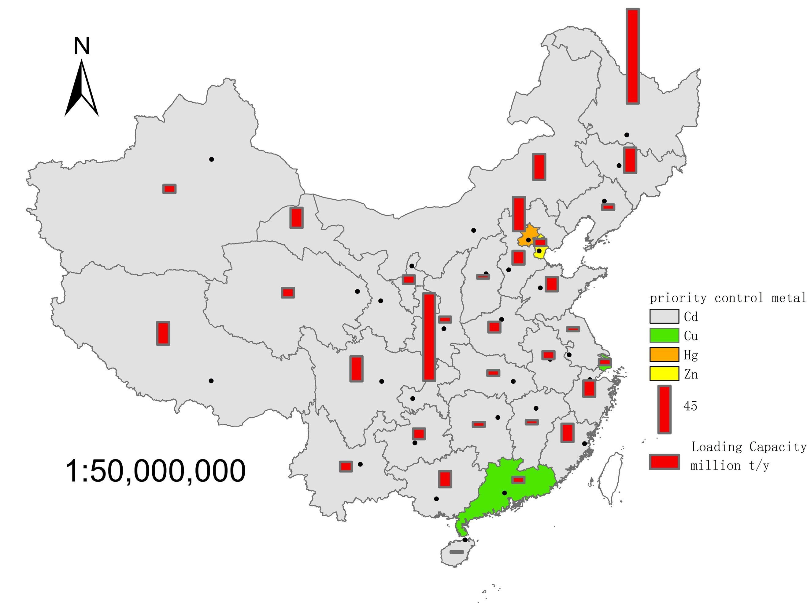
Figure 1 The priority control metal and loading capacity in 31 Chinese provincial capital cities
Recent Publications
Zhang XX., Zhe TG., Guo XP., et al (2018). Spatial distribution of metal pollution of soils of Chinese provincial capital cities. Science of the Total Environment 643 (2018) 1502–1513,
Zhang XX., Zha TG., Zhao Y., et al. (2017). Sustainable Effects of Small Hydropower Substituting Firewood Program in Majiang County, Guizhou Province, China. Sustainability, 9, 988; doi:10.3390/su9060988.
Zhang XX., Yang ZR., Zha TG., et al. (2017). Changes in the physical properties of soil in forestlands after 22 years under the influence of the Conversion of Cropland into Farmland Project in Loess region, Western Shanxi Province. Acta Ecologica Sinica, 37(2):416-424.
Yu HY., Zha TG., Zhang XX., et al. (2019). Vertical distribution and inﬂuencing factors of soil organic carbon in the Loess Plateau, China. Science of the Total Environment, 693, 133632.

Biography (150 word limit)
Xiaoxia Zhang has her expertise in soil degradation and ecological restoration. She has a deep research on the evaluation of soil environment and the utilization of sludge resources in China, which is of great significance to China's environmental policy-making.
Email：zhangxx0708@bjfu.edu.cn

