Two faces of geotextiles in coast ecosystems: a matter of anti- or profouling effects
Markus A Wetzel, German Federal Institute of Hydrology – BfG, Koblenz, Germany
Roberta Varello, University of Padova, Italy
Francesca Cima, University of Padova, Italy

Abstract (300 word limit)
Geotextile materials that are made from polypropylene, polyester or polyethylene have physical, mechanical and hydraulic properties which are used in coastal protection as an alternative to natural stone, slag, and concrete. In coastal ecosystems, they could reveal different impacts on the biodiversity of resident communities resulting in preventing fouling settlement or favouring dominant species. In the first case, they could represent a new tool as antifouling not-chemical systems alternative to the widely biocide mixtures employed in antifouling paints, since the geotextile fuzzy surface disturb the larva and propagule settlement with continuous micromovements. On the other hand, geotextiles could be used as restoration management of degraded ecosystems by means of their capability to favour the species settlement.
In a 10-month experiment, the colonization of macrofouling organisms on four different nonwoven geotextile substrates was investigated in the Lagoon of Venice, Italy - a particular environment of temperate transitional waters with high biodiversity -, and compared with the colonization on wood as a natural reference substrate. The ecological succession was analyzed monthly beginning from the biofilm formation to the stable coverage of sessile animal and plant species, with particular attention to changes in community structure compared to control panels.
Geotextile fabrics reveal to affect both settlement and growth of the macrofouling depending on their texture and chemical composition: biomass development differed significantly from that of wood. On the geotextiles, the climax of biomass development occurred significantly earlier and reached lower biomass values indicating that nonwoven geotextile substrates support macrofouling communities that display unique properties, such as selected species and low biomass. This pioneering study is a preliminary research that is based on more eco-friendly barriers to the biofouling settlement will provide insights for future studies of selective capacity on settlement and possible applications in the coastal environment.

Image

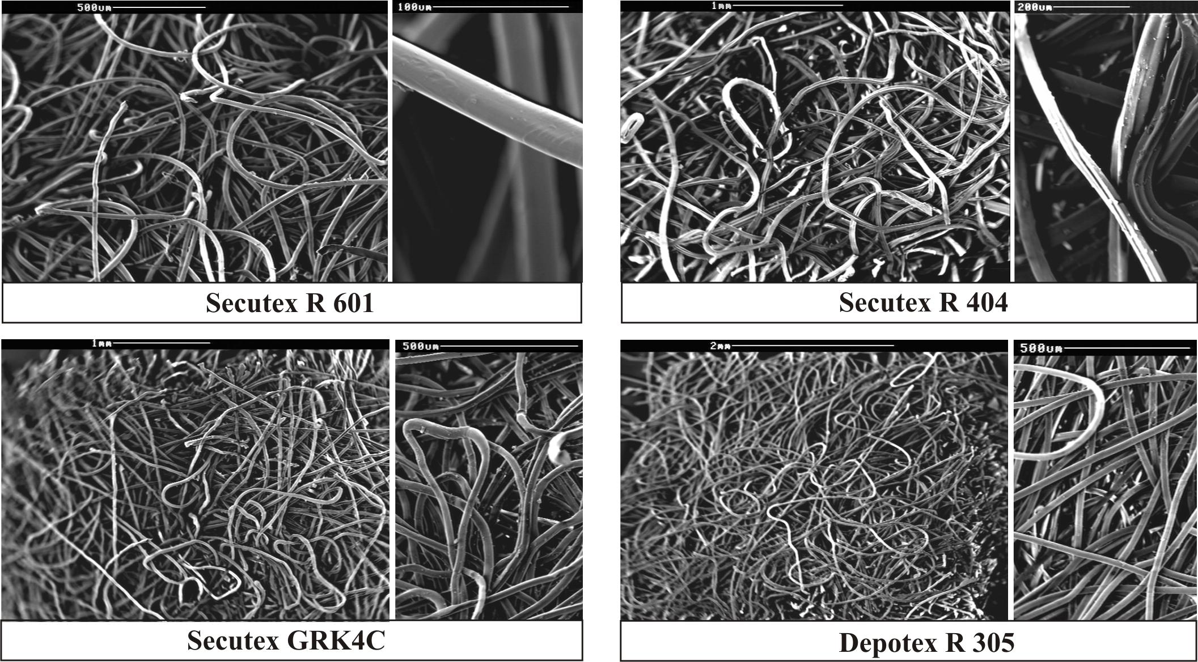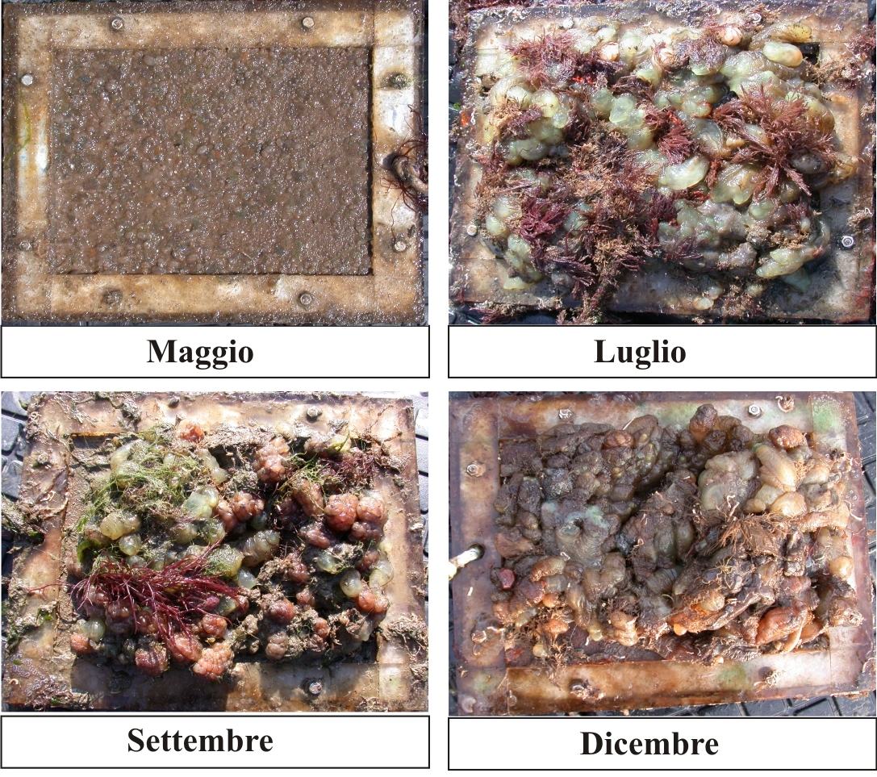

Figure 1. Surface of nonwoven geotextiles under SEM and an example of settlement of macrofouling on a geotextile panel

Recent Publications (minimum 5)
- Cima F, Ballarin L (2008) Effects of antifouling paints alternative to organotin-based ones on macrofouling biocoenosis of hard substrates in the lagoon of Venice. Fresenius Environmental Bulletin 17:1901–1908.
- Wetzel MA, Wiegmann M, Koop JHE (2011) The ecological potential of geotextiles in hydraulic engineering. Geotextiles and Geomembranes 29:440–446.
- Yu Q, Zhang Y, Wang H, Brash J, Chen H (2011) Anti-fouling bioactive surfaces. Acta Biomaterialia 7:1550–1557.
- Cima F, Ballarin L (2013) A proposed integrated bioindex for the macrofouling biocoenosis of hard substrata in the lagoon of Venice. Estuarine, Coastal and Shelf Science 130:190–201.
- Wetzel MA, Scholle J, Teschke K (2014) Artificial structures in sediment-dominated estuaries and their possible influences on the ecosystem. Marine Environmental Research 99:125–135.

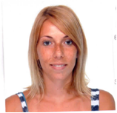Biography (150 word limit)
Roberta Varello has her expertise in recognition of macrofouling organisms of the hard-substrates by means of direct observation and photo analysis. She has built a methodology to study the ecological succession of the coastal communities by developing interactive methods of evaluation of abiotic and biotic parameters on biodiversity. The approach utilizes indexes concerning environmental parameters (salinity, pH, temperature) and indexes for the evaluation of changes in community composition (species richness, coverage area, community structure, biomass, similarity index). She recently obtained a PhD fellowship on a project entitled “Evaluation of effects of new antifouling systems, alternative to organotin compounds, on benthic marine invertebrates at ecosystem, organismal and cellular level”.

Email: roberta.varello@phd.unipd.it

Notes/Comments:

