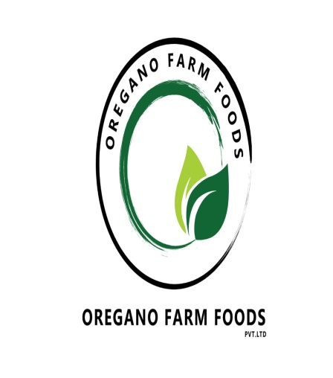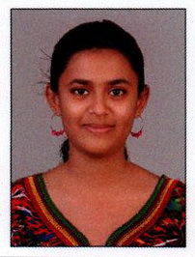 COMPANY: OREGANO FARM FOODS
Waste to Wealth to Health
Waste management hierarchy tends to deal with organic food waste and compost. The venture prioritizes actions that protect the environment through an integrated approach.
The farming techniques would be encompass the natural ways of doing and looking at things .We would delve into organic farming and try to extract its benefit in order the serve the greater good. The initiative tries to inculcate the Sustainable Development Goals. Organic farming does hold an advantageous position on a longer run.
Mission statement:
Inculcating Waste management hierarchy into farming and thereby circulate vegetables as they are rather than coating them with chemicals making these look attractive. Where quality cannot take a backhand and customers are our first priority. Contentment and health go hand in hand.
Vision statement:
The necessity to look back has risen exponentially and achieving the goal of recycling, reusing and reducing MSW [Municipal food waste] is what we plan to achieve.
Social impact:
- SDG 2 – End hunger (Organic foods are the next to door option to end malnutrition)
- SDG 12 – Responsible consumption and production (educating and spreading awareness through positive intervention)
- SDG 13 – Climate action(reducing carbon footprint and methane production)
- SDG 15- life on land (embracing nature as it is )
Goal / purpose:
1) Utilization of food waste that is looming large in the corporation and thereby extending a helping hand to the government
2) Shift from the mudane system of using HYV and GM seeds into using natural variants for production
3) Vermicomposting of waste which has become obsolete in this era
4) Involvement of masses would ignite growth and popularity
5) Advertising through innovative ideas
We could be the changemakers if we are given an opportunity to project the necessity of such a concept coming into existence immediately.
Market analysis:
The targeted audience at the receiving end would be the public comprising of people of all ages who pester upon receiving good quality natural foods but rarely do .On placing orders we would collaborate with government run institutions and SHGs to meet the demands of greater masses.
Competition would be considered as a part of game as it is a method to improve our mettle. The competition has gone glocal and hence we would be taking it in our stride as the innovative ideas are mentioned in the value proposition (if selected).
This local neighbourhood initiative would be focusing on conversion of food waste that is also received from backyards and thereby adding to the involvement of a larger mass.

SITE : Warangal , Telangana , India
STAKEHOLDERS: Mr Gugulothu Sreenu and Ms Anjali Nair
This is a joint venture on making agriculture a pesticide free zone by the utilization of the food waste that has loomed large since the past decade. We, Post graduates in Development Studies from Rajiv Gandhi National Institute of Youth Development would like to evolve as a positive influence on people into embracing nature. We are currently analyzing variegated aspects of Waste management hierarchy to ensure its proper inculcation into our initiative.

