THE WATER QUALITY OF THE
WOOD RIVER AND THE EFFECTS OF LAND USE

A Thesis Submitted to the College of
Graduate Studies and Research in Partial Fulfilment of the Requirements for the Degree of Master of Science
In the Division of Environmental Engineering
University of Cape Town

By
Muhawenimana Saidi

Keywords: water quality, land use, nutrients, agriculture, municipal waste water

© Copyright Jennifer K. Holm, March 2004. All rights reserved.

PERMISSION TO USE

In presenting this thesis in partial fulfilment of the requirements for a graduate degree from the University of Cape Town, I agree that the Libraries of this University may make it freely available for inspections. I further agree that permission for copying of this thesis in any manner, in whole or in part, for scholarly purposes may be granted by the professor or professors who supervised my thesis work, or in their absence, by the Head of the Division or the Dean of the College in which my thesis work was done. It is understood that any copying or publication or use of this thesis or parts thereof for financial gain shall not be allowed without my written permission. It is also understood that due recognition shall be given to me and to the University of Cape Town in any scholarly use which may be made of any material in my abstract.

Requests for permission to copy or to make other use of material in this thesis in whole or on part should be addressed to:

Head of the Division of Environmental Engineering
University of Cape Town, Private Bag X3, Rondebosch 7701, South Africa

ABSTRACT

The Wood River, located in the Old Wives Lake watershed in southern
Saskatchewan, is an important water resource for people living in this area. Agriculture dominates land use in the basin, while the river receives waste water effluent from the town of Gravelbourg twice yearly. Both land usage in the basin and the dumping of municipal waste water effluent have the potential to degrade water quality in the river. To date however, the water quality of the Wood River has been relatively unstudied. The purpose of this study was threefold. First, to evaluate the water quality of the Wood River and compare it to similar river systems. Then, to evaluate the effects of nutrients on the pelagic phytoplankton in the river to determine the biological responsiveness to nutrient additions which might occur as a result of agricultural land use and municipal waste water effluent. Lastly to propose mitigative measures that could help to reduce the potential threat of increased nutrients.
To determine the effect that agricultural land use and municipal waste water effluent was having on river water quality, nutrient and chlorophyll a (a measure of algal biomass) levels in the river were examined. Five sites, having different land use patterns, were chosen for this purpose. These included a reference site at a regional park not directly affected by agriculture, a site where agricultural land use dominated, a site utilized by cattle, a reservoir within the river system used for drinking water and surrounded by agriculture and finally, a site just downstream from where Gravelbourg's municipal waste is released.
Nitrogen (N) and phosphorus (P) levels were high in the Wood River when compared to similar systems. The mean TP concentration for the Wood River over the two years of this study was 474 µg/L (± 246 STD) while the mean ammonia concentration was 223 µg/L (± 993 STD). These concentrations exceeded water quality guidelines. Algal biomass and nutrient concentrations were higher at sites where nonpoint source pollution from agriculture or point source pollution from sewage effluents was present. Nutrient enrichment bioassays also indicated that the algal population in the Wood River was responsive to additions of nutrients, therefore, increases in nutrients will increase algal biomass in the river. The bioassays also revealed that at the sites where agriculture and municipal waste water were present, the algal population was N limited indicating an excess of P in the river. The municipal point source of pollution had a great effect on algal biomass and these effects lasted for about three weeks after the release. Different land use patterns and municipal waste water effluent were potentially having a negative effect on the water quality of the Wood River.
An examination of mitigative strategies available in the Old Wives Lake area revealed that land management tools including the implementation of soil conservation practices and riparian management could be useful in protecting the Wood River from degradation. Neither soil conservation practices nor riparian management are used extensively in the watershed, and both of these practices could help improve the water quality of the Wood River.

ACKNOWLEDGEMENTS

I wish to express my gratitude to Dr. Marley Waiser and Dr. Ken Belcher who cosupervised this thesis, Dr. Joe Schmutz, the other member of my supervising committee, and to Dr. Jon Gillies, who chaired the committee. In particular I wish to express my appreciation to Dr. Marley Waiser for being a mentor to me for many years now. Thank you for all of your help and support, and for reminding me to keep my sense of humour. Part of the funding for my thesis was kindly provided by Canadian Adaptation and Rural Development Saskatchewan through a grant to Dr. J.K. Schmutz and Dr. A. Hucq, Centre for Studies in Agriculture, Law, and the Environment, University of Saskatchewan. I would also like to thank Sask Environment, the CCFIA, and the Department of Environmental Engineering for their financial support. Also, sincere thanks go to Penny Yeager for accompanying me on all of those long trips to Gravelbourg. I also wish to thank Elise Pietroniro for her help with the GIS data.
I would also like to thank my parents, Jeff and Audrey Holm, and my sister Jo for encouraging me to follow my dreams, and for all of their love and support. And finally, I would like to thank Alun Roberts for his help in "making science" and for all of his encouragement throughout this process.

TABLE OF CONTENTS

PERMISSION TO USE i
ABSTRACT ii
ACKNOWLEDGEMENTS iv
TABLE OF CONTENTS v
LIST OF TABLES viii
LIST OF FIGURES ix
LIST OF ABBREVIATIONS x

- INTRODUCTION.....................................................................................................1 1.1 Background ......................................................................................................1
  - Problem …........................................................................................................2
  - Objectives .........................................................................................................2
  - Thesis Organization ..........................................................................................3

- CHAPTER ONE - LAND USE IMPACTS ON WATER QUALITY......................4
  - Introduction....................................................................................................4
  - Effects of Agriculture and Municipal Waste Water Effluents
on Water Quality………………………………………………………4
    - Nutrients ............................................................................................6
2.1.1.1 Nitrogen ................................................................................8
2.2.1.2 Phosphorous ........................................................................10
    - Pesticides .........................................................................................12
    - Sediment ..........................................................................................14
    - Pathogens .........................................................................................15
    - Endocrine Disrupting Substances ....................................................17
  - Summary….…………………….………….…………………………….18

- CHAPTER TWO - THE WOOD RIVER AND ITS WATERSHED........................19
  - Introduction ...............................................................................................19
  - Materials and Methods ..............................................................................19
  - Physical Setting .........................................................................................20 3.4 Climate ......................................................................................................20
  - Geology .....................................................................................................23
  - Soils ...........................................................................................................25 3.7 Settlement ..................................................................................................25
  - Population ..................................................................................................25
  - Water Resources ........................................................................................27
  - Land Use ..................................................................................................29 3.10.1 Crop Type ....................................................................................29
    - Cattle ...........................................................................................29
    - Soil Conservation Methods ........….............................................32
    - Percentage Land Use ...................................................................33
3.11 Summary…………..………………………………...………………….33

- CHAPTER THREE - THE WATER QUALITY OF THE WOOD RIVER ………37
  - Introduction .................................................................................................37
  - Materials and Methods ...............................................................................37
    - Study Sites .....................................................................................37
    - Sample Collection ........................................................................38
    - Water Chemistry ...........................................................................40 4.2.4 Chlorophyll a ................................................................................41
    - Bioassays .......................................................................................41
    - Sestonic Ratios ..............................................................................42
  - Results ........................................................................................................43
    - Nitrogen ........................................................................................43
      - 2002 .........................................................................43
      - 2003 .........................................................................43
    - Phosphorus……………….………………………………………46
      - 2002………….……………………………………46
      - 2003………….……………...…………………….46
    - Total Dissolved Solids ..................................................................51
    - Chlorophyll a .................................................................................51
      - Relationships between Chl a and Nutrient
Concentrations………………………………51
4.3.5
Bioassays........................................................................................56
4.3.6 Sestonic Ratios ..............................................................................58
      - 2002 ......................................................................58
      - 2003.......................................................................62
  - Discussion ...................................................................................................62
    - Water Chemistry ...........................................................................62
    - Factors Affecting Algal Biomass ..................................................68
    - Land Use Effects on Water Chemistry..........................................71
    - Climatic Effects on Water Chemistry…........................................73
  - Summary .....................................................................................................74
- CHAPTER FOUR - MITIGATION OF LAND USE IMPACTS …………………75
  - Introduction ................................................................................................75
  - Economics of Nonpoint Source Pollution ..................................................75
  - Policy Strategies to Mitigate Nonpoint Source Pollution ...........................77
    - Incentive Based Policies ............................................................79
    - Regulatory Based Policies .........................................................80
  - Supportive Tools ........................................................................................81
    - Education ..................................................................................81
    - Research ....................................................................................83
  - On-Farm Strategies to Mitigate Nonpoint Source Pollution ......................84
    - Nutrient Management ...............................................................84
    - Land Management ....................................................................85
  - Summary…………………………………………...…..….………………86

- CONCLUSIONS AND RECOMMENDATIONS................................................87

- REFERENCES .....................................................................................................91

LIST OF TABLES

Table 3.1. Temperature and precipitation at Assiniboia Saskatchewan…………………24
Table 3.2. Discharge data in dam³ for the Wood River near Lafleche…………………..28
Table 3.3 Area of major crop types in the Old Wives Lake watershed……………….…30
Table 3.4 Number of cattle and calves by Rural Municipality (RM) in the Old Wives
Lake watershed ………………………………………………...…….…31 Table 3.5 Average percentage of farms using selected soil conservation techniques in the
Old Wives Lake watershed …………………………………...……....…34
Table 4.1 Sampling sites…………………………………………………………………39
Table 4.2 Results of Tukey multiple comparison test on phosphorus concentrations
(2003) between study sites. (*) indicates sites that are significantly
different…………………………………………………………..……....50
Table 4.3 Bioassay results showing nutrient limitation by nitrogen (N), phosphorus (P),
or co-limitation by both nutrients (N+P)………………...……...……..…57

LIST OF FIGURES

Figure 3.1. Map of the Wood River watershed showing watershed boundaries, major
roads and location of Rural Municipalities (RMs)……………….……21
Figure 3.2. Road map of the Old Wives Lake watershed area showing location of roads,
towns, and waterbodies.…………………………………………..22
Figure 3.3. Map of the soils of the Old Wives Lake watershed…………….….……...…26
Figure 3.4. Map of the Old Wives Lake watershed showing the distribution of
land use……………………………………………………………...35
Figure 4.1. Ammonia levels of the Wood River, 2002-2003………………………........44
Figure 4.2. Total dissolved nitrogen levels of the Wood River, 2002-2003…...…......…45
Figure 4.3. Total phosphorus levels of the Wood River, 2002-2003………………..…..47
Figure 4.4. Ortho-phosphorus levels of the Wood River, 2002-2003.………...……......48
Figure 4.5. Total dissolved phosphorus levels of the Wood River, 2002-2003……........49
Figure 4.6. Total dissolved solids (TDS) concentration of the Wood River. The
Saskatchewan and federal objectives for TDS are also shown..…..52
Figure 4.7. Chlorophyll a levels of the Wood River, 2002- 2003…………….………....53
Figure 4.8. Linear regression analysis of total nitrogen vs. chlorophyll a for both 2002
and 2003 (A), only 2002 (B), and only 2003 (C)….………..….…54
Figure 4.9. Linear regression analysis of total phosphorus vs. chlorophyll a for both
2002 and 2003 (A), only 2002 (B), and only 2003 (C)………..…55
Figure 4.10. Sestonic ratio PN:PP for 2002. Y axis indicates boundary for P sufficiency
or deficiency as outlined by Healey and Hendzel (1980)……...…59
Figure 4.11. Sestonic ratio PP:PC for 2002. Y axis indicates boundary for P sufficiency
or deficiency as outlined by Healey and Hendzel (1980)…….…..60
Figure 4.12. Sestonic ratio PN:PC for 2002. Y axis indicates boundary for N sufficiency or deficiency as outlined by Healey and Hendzel (1980)…….…..61
Figure 4.13. Sestonic ratio PN:PP for 2003. Y axis indicates boundary for P sufficiency
or deficiency as outlined by Healey and Hendzel (1980)………..63
Figure 4.14. Sestonic ratio PP:PC for 2003. Y axis indicates boundary for P sufficiency
or deficiency as outlined by Healey and Hendzel (1980)……...…64
Figure 4.15. Sestonic ratio PN:PC for 2003. Y axis indicates boundary for N sufficiency or deficiency as outlined by Healey and Hendzel (1980)…....…...65
Figure 5.1. Marginal costs (MC) and benefits (MB) of fertilizer use…………...………78

LIST OF ABBREVIATIONS

Chl a - chlorophyll a
MB - marginal benefit
MC - marginal cost
MC_{P} - private marginal cost MC_{S} - social marginal cost
N - nitrogen NH₃ - ammonia
NPS - nonpoint source
OP - ortho-phosphorus
P - phosphorus
PP - particulate phosphorus
PN - particulate nitrogen
PC - particulate carbon
TDN - total dissolved nitrogen
TDP - total dissolved phosphorus
TDS - total dissolved solids
TP - total phosphorus

1. INTRODUCTION

1.1 Background
Water is needed by all living organisms. It plays an important role in many natural processes and is essential in countless physical and chemical reactions. Water is considered a renewable resource, renewable referring to that portion which circulates through the hydrological cycle. According to the United Nations’ World Water Development Report (2003), although 70% of the earth’s surface is covered by water, only 2.5% of that water is fresh and only 0.3% of that water is available for human use. Furthermore, pressures on this resource are growing. Currently it is estimated that humans appropriate 54% of all the accessible freshwater contained in rivers, lakes and underground aquifers and by 2025 this will increase to 70% (United Nations/World Water Assessment Program (UN/WWAP) 2003). This estimate reflects the impact of population growth alone. If per capita consumption of water resources continues to rise at its current rate, humankind could be using over 90% of all available freshwater within 25 years, leaving just 10% for all other organisms (UN/WWAP 2003).
At the beginning of the twenty-first century, the Earth is facing a serious water crisis (UN/WWAP 2003). All indicators suggest that it is worsening and will continue to do so, unless corrective action is taken. Between 1972 and 1996, for example, Canada's rate of water withdrawals increased by almost 90%, from 24 billion m³/yr (cubic metres per year) to 45 billion m³/yr. Our population, however, increased by only 33.6% over the same period (Environment Canada 1992a). Water availability per person in Canada is among the highest in the world, while water quality is ranked second (UN/WWAP 2003). Perhaps because of this, Canadians use more water per capita than any other nation on earth and also pay the least for it (Davies and Mazumder 2003). As readily available supplies of fresh water are being used and degraded, it becomes apparent that there are real limits to how much water is available.
In addition to water supply issues, water quality is a problem in many areas of Canada. Environment Canada (2001) identified 15 threats to sources of drinking water and aquatic ecosystem health in Canada. These include: waterborne pathogens; algal toxins and taste and odour problems; pesticides; persistent organic pollutants and mercury; endocrine disrupting substances; nutrients; aquatic acidification; ecosystem effects of genetically modified organisms; municipal waste water effluents; industrial point source discharges; urban runoff; landfills and water disposal; agricultural and forestry land use impacts; natural sources of trace element contaminants and impacts of dams, diversions and climate change. These threats are prevalent across Canada and warrant further investigation in order to protect water supplies.
The Wood River is located in the Old Wives Lake watershed in southern
Saskatchewan. It is an important water resource in the area supplying drinking water for humans and livestock, irrigation water for agricultural use, as well as providing a source for recreation. Despite the importance of the Wood River to the livelihood, health and well being of some 10,000 inhabitants of the basin, very little is known about its water quality. Even more alarming is the fact that no effort has been made to evaluate the effects that agricultural land use or municipal waste water effluent might have on overall water quality of this river. This thesis addresses these concerns by focusing on the effects that nutrients, agricultural land use, and municipal waste water effluent have on the water quality and biotic integrity of the Wood River.

1.2 Problem
The Old Wives Lake watershed is relatively unstudied and recently there have been concerns over the water quality of the Wood River. The issue is nutrients, and the impacts of municipal waste water effluents and agricultural land use on water quality. Municipal waste water effluents and agricultural land use could be raising nutrient levels in this watershed. Increased nutrients are expected to have an impact on the biological community and water quality of the Wood River.

1.3 Objectives
The primary objectives of this study are to quantify the level of nutrients in the river, identify major sources of these nutrients, and examine impacts of these nutrients on the phytoplankton community. Methods of addressing these impacts will also be examined. The specific objectives are:
- Determine the impacts that municipal waste water effluents and agricultural land uses have on water quality through a review of the literature.
- Determine the pattern of land use in the Old Wives Lake watershed.
- Quantify nutrient levels, chlorophyll levels (a measure of phytoplankton biomass) and water chemistry.
- Compare the findings to other areas. Also, relate the findings to the threats that agriculture and municipal waste water effluent pose to water quality.
- Evaluate the potential causes of this pollution and what can be done to mitigate it by using a simple economic model.

1.4 Thesis Organization
The first chapter will, through a review of the relevant literature, identify what threats nutrients, agriculture, and municipal waste water effluents pose to water quality. These are the main threats to the water quality in this watershed and their impacts will be discussed in this chapter.
The second chapter will examine the Wood River and its watershed. The physical setting of the watershed will be discussed along with aspects such as soils, climate, population, and water resources. The pattern of land use in the watershed will also be identified. This chapter is intended to be an introduction to the study area.
The third chapter will examine what level of water quality is currently present in the Wood River. This chapter is empirically based and will include an analysis of water quality parameters measured as well as an analysis and discussion of experimental results.
This chapter will also link the water quality results to adjacent land uses.
The last chapter deals with the possible causes of pollution from agriculture in an economic sense and methods of mitigating these impacts. Different policy, education and research strategies will be examined and methods specifically suited to this area will be identified.
Results from this thesis will increase our understanding of the water quality of the Wood River as well as how land use is affecting that water quality. It will also suggest actions which could be taken to mitigate impacts and improve the water quality in the watershed.

2. CHAPTER ONE
LAND USE IMPACTS ON WATER QUALITY

2.1 Introduction
Landscape properties such as riparian zone condition, channel slope and aspect, local geology, vegetation, and hydrography all affect the structure and function of aquatic ecosystems (Tong and Chen 2002). One of the most significant determinants of water quality however, is land use and land cover (Griffith et al. 2002). Land use and land management practices affect the quantity and quality of runoff water and, in turn, the water budget, water chemistry and biodiversity of aquatic organisms in receiving waters (Environment Canada, 2001). Agriculture, specifically annual crops and ranching, represent a large portion of the land use in the Old Wives Lake watershed. Runoff from these lands could have a major impact on the water quality of the Wood River, one of the watershed’s dominant water resources. The other major threat facing this river is the release of municipal waste water effluent into the Wood River from the town of Gravelbourg. The release takes place twice a year, once in the spring and once in the fall. The town employs a lagoon type system in which sewage is treated by biological processes in a series of shallow basins. This process is commonly used in small communities and produces effluent equivalent to secondary treatment (Chambers et al. 2001).
In this chapter, the discussion will focus on the following impacts on water quality that are common to both municipal waste water effluent and agriculture: nutrients, pathogens, and endocrine disrupting substances, as well as the impacts of pesticides and sediment that are unique to agriculture.
2.2 Effects of Agriculture and Municipal Waste Water on Water Quality Agriculture and municipal waste water effluent represent two different types of pollution. Pollution from municipal sewage is considered to be point source, emanating from a single source. Point sources of pollution are relatively simple to monitor and regulate and can often be controlled by treatment at the source because the source can be readily identified. Pollution from agriculture is, for the most part, considered to be nonpoint source, that is, pollution that is diffuse across a landscape. Nonpoint sources of pollution are often intermittent and linked to seasonal agricultural activity or irregular events such as heavy precipitation. Nonpoint sources of pollution often originate from extensive areas of land and are transported overland, underground, and through the atmosphere to receiving waters (Carpenter et al.1998). Nonpoint sources are therefore difficult to measure and regulate.
Municipal waste water is a complex mixture of human waste, suspended solids, debris and a variety of chemicals derived from residential, commercial, and industrial sources (Environment Canada 2001). It represents the largest source of effluent discharge to Canadian waters (Chambers et al. 1997). The impacts of municipal sewage are felt at multiple levels of biological organization, from cellular, organ, and organism levels, to community and trophic levels (Porter and Janz 2003). Materials contained in municipal waste water effluents that have a negative effect on aquatic ecosystems include: nutrients, such as nitrogen and phosphorus; pathogens, such as Cryptosporidium; and endocrine disrupting substances, such as antibiotics and hormones from birth control pills.
Agricultural activities are among the most frequently cited sources for degradation and pollution of aquatic systems (Griffith et al. 2002). It has been estimated that in 77% of the rivers and streams of the Great Plains, agriculture is a source of impairment (Great Plains Agricultural Council Water Quality Task Force 1992). Agriculture is also the largest consumer of freshwater globally (Novotny 1999). More than 95% of the arable grassland in western Canada has been converted to production of cereal crops and livestock using intensive agricultural practices that are environmentally damaging (Hall et al. 1999). The conversion of riparian areas and native grasslands to crop and pasture land can have a profound influence on stream chemistry and also affects stream discharge, temperature, channel characteristics, bed disturbance regime, and organic matter input (Osborne and Kovacic 1993). These physical changes in turn affect stream biota through changes in species composition, and degradation of habitat (Richards et al. 1996, Wichert and Rapport 1998, Cuffney et al. 2000). These negative effects seem to increase as agricultural intensity increases as well. For example, fish communities showed an almost linear decline in condition as the level of agricultural intensity increased in multiple rivers in the United States (Cuffney et al. 2000). The major pollutants arising from agricultural lands are nutrients, particularly nitrogen and phosphorus; pesticides; sediment; pathogens; and endocrine disrupting substances (Environment Canada 2001, Chambers et al. 2000b). The presence of these substances can make water unfit for use by humans, and can destroy habitat.

2.2.1 Nutrients
Nutrients are chemical substances that provide nourishment and promote growth of micro-organisms and vegetation. They include nitrogen, phosphorus, carbon, hydrogen, oxygen, potassium, sulfur, magnesium and calcium (Chambers et al. 2001). The addition of nutrients to an aquatic or terrestrial ecosystem increases the biomass of plants and, ultimately, decreases the number of species (Carpenter et al. 1998). Although ecosystems managed for plant yield, such as agriculture and forestry, obtain economic benefits from added nutrients, natural ecosystems generally suffer an undesirable change in plant and animal communities (Environment Canada 2001).
Nutrients from sewage and agricultural sources have long been recognized as pollutants of aquatic ecosystems (Verduin 1970). In fact, municipal waste water is the largest point source of nitrogen (N) and phosphorus (P) to the Canadian environment while agriculture is the largest nonpoint source (Chambers et al. 2001). In the United States, total phosphorus and total inorganic nitrogen export from agricultural land can be up to 3 and 12 times higher, respectively, than from forested land (Cooke and Prepas 1998). Omernik (1977) also showed that streams draining agricultural watersheds had considerably higher nutrient concentrations than those draining forested watersheds. Moreover, nutrient concentrations were generally proportional to the percent of land in agricultural production. Many rivers in Canada show signs of moderate nutrient enrichment downstream of municipal waste water discharges or areas of intensive agriculture (Chambers et al. 2001). Rivers receiving moderate nutrient enrichment from sewage and agriculture have shown increases in biological productivity (Chambers et al. 2000b). Elevated algal levels in agriculturally impacted rivers are present worldwide (Hatch 2002, Moreau et al. 1998, Carr and Chambers 1998). Agricultural watersheds have been shown to have larger quantities of aquatic macrophytes and dense algal mats than watersheds with other land uses, due to an increase in nutrient levels (Rothrock et al. 1998). Sewage discharges have been shown to release phytoplankton from nutrient limitation allowing periods of high growth (Scrimgeour and Chambers 2000).
World-wide, nutrient transport by farming systems has overwhelmed natural nutrient cycles. Globally, more nutrients are added as fertilizers than are removed as produce (Novotny 1999). This flux creates a nutrient surplus on agricultural lands which is the underlying cause of nonpoint pollution from agriculture (Carpenter et al. 1998).
Net accumulation of nutrients in soil on a worldwide basis is about 3.1 kg ha⁻¹ yr⁻¹ (Novotny 1999).
An increase in nutrients in surface waters due to nonpoint source pollution can cause eutrophication. Natural eutrophication is the process by which waterbodies gradually age and become more productive (Campbell and Edwards 2001). It normally occurs over very long time scales. Humans, however, have greatly accelerated this process. Eutrophication caused by excessive inputs of N and P is the most common impairment of surface waters in North America (Carpenter et al. 1998). Eutrophication has many negative effects on aquatic ecosystems including: increased biomass of phytoplankton; shifts in phytoplankton to bloom-forming species such as cyanobacteria, that may be toxic or inedible; increased biomass of benthic and epiphytic algae; changes in macrophyte species composition and biomass; decreases in water transparency; oxygen depletion; taste, odour, and water treatment problems; increased incidence of fish kills; loss of desirable fish species; and, decreases in perceived esthetic value of the water body (Carpenter et al. 1998). Increased growth of algae and aquatic weeds interferes with use of the water for fisheries, recreation, industry, agriculture, and drinking. Oxygen shortages caused by senescence and decomposition of nuisance plants cause fish kills by using up available oxygen (Miranda et al. 2001). However, cyanobacterial blooms are among eutrophication's most harmful effects. Cyanobacteria are toxic to livestock, humans and other organisms. Cyanobacteria produce two types of toxins neurotoxins, and hepatotoxins (Codd 2000). Neurotoxins can cause twitching, muscle contraction, convulsions and death while hepatotoxins cause weakness, anorexia, and liver damage (Rusin et al 2000). Long term exposure to cyanobacterial toxins has also been associated with liver cancer (Codd 2000). In freshwater, blooms of cyanobacteria are a prominent symptom of eutrophication (Kotak et al.1993). Most blooms are caused by Anabaena, Microcystis or Aphanizomenon species (Rusin et al 2000). These blooms contribute to a wide range of problems including summer fish kills, foul odours, unpalatability of drinking water, and formation of trihalomethanes during water chlorination in treatment plants (Kotak et al.1993). Trihalomethanes have been shown to be carcinogenic (Singer 1999) and as algal production increases, so does the potential for trihalomethane production. (Jack et al. 2002).

2.2.1.1 Nitrogen
Nitrogen is essential for plant growth, as it is a component of proteins, chlorophyll and other organic compounds (Chambers et al. 2001). N is abundant on earth but less than 2% of it is available to organisms (Galloway 1998). Reactive nitrogen, defined as N bonded to carbon, oxygen or hydrogen, is created largely by biological nitrogen fixation of unreactive nitrogen, which is triple bonded N (Wetzel 2001).
Globally, industrial N fixation for fertilizers has increased dramatically from virtually zero in the 1940s to about 80 x 10⁶ Mg/yr by 1998. (Carpenter et al. 1998). In the United States and Europe, only about 18% of the N input is removed in the crop leaving behind 174 kg ha⁻¹ yr⁻¹ (Carpenter et al. 1998). This surplus may accumulate in soils, leach into surface and ground water, or enter the atmosphere. Much of the N volatilized to the atmosphere, however, is redeposited on land or water and eventually enters aquatic systems (Carpenter et al. 1998). Sources of nitrogen in aquatic systems include: precipitation, nitrogen fixation both in the water and in the sediments, and inputs from surface runoff and groundwater. The amount of nitrogen added to surface waters from precipitation can be significant to the nitrogen cycle and for productivity (Wetzel 2001). Inputs of nitrogen from groundwater can also be large, particularly in regions rich in limestone. Surface runoff, especially in agricultural areas, is most likely the dominant input of N to aquatic systems (Wetzel 2001).
Nitrogen occurs in fresh waters in numerous forms: dissolved molecular N₂; particulate organic nitrogen (PON); a large number of low molecular weight organic compounds, such as amino acids; ammonia (NH₄⁺); nitrite (NO₂⁻); and nitrate (NO₃⁻). Ammonia is generated by biological dissimilation of nitrate, although much of the ammonia present in aquatic systems also arises as the primary end product of the decomposition of organic matter by heterotrophic bacteria (Wetzel 2001). Ammonia is the most energy efficient source of nitrogen for plants, as nitrate must be reduced to ammonia before is can be used (Wetzel 2001).
Strong relationships between nitrogen concentrations in aquatic systems and agricultural land use have been shown in many studies (Correll and Dixon 1980, Thomas and Crutchfield 1974, Jones et al. 1976, Tong and Chen 2002). Cooke and Prepas (1998) showed that agricultural watersheds exported up to 50 times more nitrogen than forested watersheds. They also showed that agricultural practices also influenced the fractionation of nitrogen in runoff. Nitrate was the predominant form of N in runoff draining cropland, whereas ammonia was the dominant form of N in mixed agricultural watershed. Since ammonia is the preferred form of nitrogen for the algal community, this could have a significant effect on the aquatic environment. The dominant form of N in municipal waste water is also ammonia (Chambers et al. 2001).
Excess nitrogen can stimulate rapid growth of aquatic plants and algae. Excessive growth of these organisms, in turn, can clog water intakes, use up dissolved oxygen as they decompose, and block light to deeper waters (Environment Canada, 2001). This seriously affects respiration of fish and aquatic invertebrates, leads to a decrease in animal and plant diversity, and affects human use of the water for fishing, swimming, and boating (Environment Canada 2001). Excessive nitrate in drinking water can be harmful to young infants or livestock (Chambers et al. 2001). Nitrate causes methaemoglobinaemia, also known as “Blue Baby Syndrome”, in young animals and human infants. This condition decreases the ability of the blood to carry oxygen (Chambers et al.2001). Prolonged exposure to excessive nitrate concentrations has also contributed to the decline in amphibians in southern Ontario (Hecnar 1995). Tadpoles exposed to nitrate have shown reduced feeding activity and weight loss, and decreased survivorship (Hecnar 1995). Ammonia is toxic to fish and other aquatic organisms, even in very low concentrations.
When levels reach 0.06 mg/L, fish can suffer gill damage while at concentrations of 0.2 mg/L, sensitive fish like trout and salmon begin to die (Chambers et al. 2001). Ammonia levels greater than approximately 0.1 mg/L usually indicate polluted waters (Chambers et al. 2001).

2.2.1.2 Phosphorus
At the cellular level, phosphorus (P) is required to synthesize nucleotides, phospholipids, sugar phosphates, and other phosphorylated intermediate compounds (Wetzel 2001). Phosphate is also an important component of a number of low molecular weight enzymes and vitamins essential to metabolism. Compounds containing P influence nearly all phases of cellular metabolism and are particularly important in the energy transformation of phosphorylation reactions during photosynthesis in plants (Wetzel 2001).
No other element in fresh water has been studied more than phosphorus (Wetzel 2001). In the 1970's, strong relationships between P loading rates and lake trophic status were identified (Vollenweider 1976). Studies also showed that P has a primary role in promoting algal growth in a series of whole lake enrichment studies in the Experimental Lakes Area of Ontario (Schindler 1974, 1975). Studies such as these firmly established P as the central focus of biogeochemical and ecological studies in freshwater (Elser et al. 1990). This early work even prompted detergent companies to remove phosphorus from their products to reduce eutrophication problems (Wetzel 2001).
Interest in P stems from its major role in biological metabolism and the relatively small amount of P available in most aquatic systems. Usually, phosphorus is the limiting nutrient in aquatic systems (Carpenter et al. 1998). Liebig’s "Law of the Minimum" states that if one nutrient is deficient or lacking, growth will be poor even when all the other elements are abundant (Liebig 1840). Any deficiency of a nutrient, regardless of how small an amount is needed, will limit productivity.
Phosphorus is accumulating in the world’s agricultural soils. A consistent feature of intensive agriculture is that it operates with a P surplus, with more P entering the system than leaves in agricultural product (Heaney et al. 2001). Between 1950 and 1995, approximately 600 x 10⁶ Mg of fertilizer P was applied to the Earth’s surface (Carpenter et al. 1998). During the same period, approximately 250 x 10⁶ Mg of P was removed from croplands through harvest, of which, some was reapplied to cropland as manure (Carpenter et al. 1998). This means that the net addition of P to croplands over this period was about 400 x 10⁶ Mg of P (Carpenter et al. 1998). This P either remained in the soil or was transported to surface waters through erosion or runoff.
There are many sources of P addition to aquatic systems. As with nitrogen, precipitation carries some load of P although generally the amount of P in precipitation is less than that of N (Wetzel 2001). In heavily fertilized agricultural regions, the phosphorus content of precipitation is much higher during the active growing season than in winter (Wetzel 2001). P bound to soil particles enters aquatic systems by way of runoff and is a major source of P to surface waters (Sharpley et al. 1994). Applications of fertilizers and certain land management practices modify and generally increase the amount of nutrients in runoff. The addition of P to water from municipal and industrial wastes is also an important source.
Phosphorus found in aquatic systems in both the dissolved and particulate forms (Wetzel 2001). Particulate phosphorus includes P present in organisms, and mineral phases of rock and soil (Wetzel 2001). Dissolved P consists of orthophosphate; polyphosphates, often originating from synthetic detergents; organic colloids or phosphorus combined with adsorptive colloids; and low molecular weight phosphate esters (Wetzel 2001). In contrast to the numerous forms of nitrogen in aquatic systems, the most significant form of phosphorus is orthophosphate (PO₄³⁻). Orthophosphate, the most biologically available form of P, is typically found only in very low concentrations in unpolluted waters. Its concentration averages about 10 µg/L worldwide among unpolluted rivers, while total dissolved P averages around 25 µg/L (Wetzel 2001). Most of the P exported from agricultural watersheds is in the dissolved form, and more P is exported from watersheds with a mix of agricultural uses (crop and animal production) than from watersheds with cropland alone (Cooke and Prepas 1998). Omernik (1976) found that mean total phosphorus concentrations were nearly ten times greater in streams draining agricultural lands than in streams draining other land uses and that 40% of the total phosphorus was in the orthophosphorus form.
Increased P inputs can have many negative effects on aquatic ecosystems including: increased biomass of phytoplankton; shifts in phytoplankton to bloom-forming species such as cyanobacteria, that may be toxic or inedible; increased biomass of benthic and epiphytic algae; changes in macrophyte species composition and biomass; decreases in water transparency; oxygen depletion; and, decreases in perceived esthetic value of the water body (Carpenter et al. 1998). Increased growth of algae and aquatic weeds interferes with use of the water for fisheries, recreation, industry, agriculture, and drinking.
Studies have shown that steady phosphorous loading of the system is critical to sustaining increased productivity in most lakes of low or medium productivity (Schindler 1974). In order to reduce the productivity of a lake that is receiving a continuous loading of nutrients, algal growth is usually decreased most effectively by reduction of P inputs to below the levels of losses within the lake (Schindler 1974). To mitigate the effects of eutrophication, reduction of total P is usually the objective, since P is typically the nutrient in greatest demand in relation to supply. P is chemically reactive, technologically easier to remove than N, and does not have major reservoirs in the atmosphere (Wetzel 2001).

2.2.2 Pesticides
In Canada, pesticides are the primary means of control of weeds, insects and diseases that affect animal and crop production. Herbicides constitute approximately 85% of pesticide sales in Canada and approximately 70% of pesticides purchased are applied in the Prairie region (Chambers et al. 2002). Furthermore, the use of agricultural pesticides has increased threefold during the last two decades (Peterson et al. 1994) Surface runoff, spray drift, and direct overspray from agricultural and urban lands are important pathways for introducing pesticides to surface waters (Peterson et al. 1994). Pesticides are often detected in irrigation return flows, rivers, streams, lakes and wetlands. Of 25 Saskatchewan dugouts studied, all contained detectable concentrations of at least one herbicide (Chambers et al. 2002). In study done in Alberta, 27 streams were sampled and a direct correlation between pesticide levels in streams and levels of agricultural inputs in the watershed were noted (Chambers et al. 2002). With the exception of wetlands, concentrations of herbicides are usually below water quality guidelines (Donald et al. 1999). The levels of some pesticides in many prairies wetlands have been shown to exceed guidelines for the protection of aquatic life following high precipitation events in early summer (Donald et al. 1999). Also, a study reported that an estimated 24% of the small wetlands in Saskatchewan had pesticides levels in water that exceeded those guidelines as well (Chambers et al. 1997). Lindane and triallate concentrations exceeded guidelines most frequently (Donald et al. 1999).
Pesticide contamination of groundwater is a significant public concern as well. Although pesticides have been detected in the groundwater of many intensively cropped areas, concentrations are mostly below guidelines for drinking water (Reynolds et al., 1995). Low-level nonpoint source entry of pesticides into groundwater poses a significant risk because of its extent and the difficulty in controlling it. As pesticides move towards the water table, their leaching potential is influenced by climatic conditions, the chemical and physical properties of soil, agricultural practices, and properties of the chemical (Fairchild et al., 2000). A variety of pesticides have been identified in Canadian groundwater, such as diclofop, triallate, trifluralin, 2, 4-D, bromoxynil and dicamba (Waite et al.1992, Miller et al. 1995, Fitzgerald et al. 2001). However, those most commonly detected pesticides are widely used, degrade slowly, dissolve in water, and are not tightly held by soil or organic matter particles (Reynolds et al. 1995).
Impacts of agricultural pesticides are numerous. Depending on the compound involved, impacts can include: direct kills of fish and other organisms, which can interrupt the food chain; sub-lethal effects on reproduction, respiration, growth and development; cancer, mutations, and fetal deformities; inhibition of photosynthesis in non-target plants; and bioaccumulation and biomagnification through the food chain (Gregorich et al. 2000). Endosulfan, a chlorinated hydrocarbon insecticide used extensively in Canada, has been shown to increase the overall time it takes for fish eggs to hatch. Fry that hatched from eggs exposed to endosulfan were smaller, and individuals exposed to moderate levels of endosulfan swam significantly less than individuals from the control group (Gormley and Teather 2003). All of these effects can increase mortality through predation (Gormley and Teather 2003). Results have also suggested that even at the lowest concentrations tested, and with no observable physical effects, endosulfan can have significant impact on fish populations by disrupting their reproductive behavior (Beulig and Pilonieta 2002). Herbicides have been shown to inhibit growth of algal species when they enter surface waters (Peterson et al. 1994, Nystrom et al. 1999). Since algae are an important food source in aquatic systems, this could have devastating effects on the food chain. Pesticides have also been shown to increase mortality rates and decrease the number of species of macroinvertebrates, another important food source in aquatic systems (Shulz and Liess 1999). Pesticide contamination of Canadian waters is therefore a significant concern.

2.2.3 Sediment
Much of the increased sediment load to streams arises from agricultural practices such as tillage and livestock access to streams (Chambers et al. 2000a). These practices increase erosion and the movement of soil from farmland into adjacent waters. Much of the phosphorus and pesticide losses from farm land to surface water are bound to eroded soil particles (Skinner et al. 1997).
Sediments from agricultural fields that enter water bodies through overland flow can have significant effects on aquatic systems. Off-stream impacts of sediment include increased flood damage, decreased water body capacity through sedimentation, and an increase in water treatment costs (Skinner et al. 1997). Sediment contributes to flood damage by increasing the frequency and depth of flooding due to the filling-in of streambeds, and by increasing damage caused by sediment deposition by the flood waters (Libby and Boggess 1990). Sedimentation of reservoirs and irrigation ditches raises annual dredging costs. As well, the costs of treating water for municipal use increases because sedimentation basins must be built and filters cleaned more frequently. In-stream impacts of increased suspended sediment include increases in turbidity, damage to aquatic organisms, and problems with water based recreation, and navigation. Suspended sediments increase turbidity which results in a decrease in light available for photosynthesis. This results in a decrease in the primary productivity of streams (Van Nieuwenhuyse and LaPerrier 1986) and reservoirs (Hoyer and Jones 1983). This reduction in algal biomass leads to a reduced food supply for invertebrates. High levels of suspended sediment combined with high flow rates can scour algae off stream beds and thereby reduce invertebrate food sources further (Newcombe and MacDonald 1991). A direct effect of increased suspended sediment on invertebrates is the clogging of the feeding structures of filter feeders. This reduces feeding efficiencies, and therefore reduces growth rates and increases mortality rates (Newcombe and MacDonald 1991). Increased suspended sediment can also affect animal behaviours. For example, those organisms that depend on sight for foraging, mating and escape from predators will be negatively affected by increased turbidity (Servizi and Martens 1992, Berg and Northcote 1985). Increased suspended sediments can impede respiration in fish through gill abrasion (Environment Canada 2001). Fish reproduction is also affected by sediments covering bottom gravel and degrading spawning habitat and also covering eggs which may suffocate or develop abnormally (Newcombe and Macdonald 1991). Fish have been shown to respond to increases in suspended sediment by decreasing the frequency of spawns, delaying the timing of spawns, and reducing the proportion of ripe eggs spawned (Burkhead and Jelks 2001). Increased suspended sediment can therefore affect many levels of biological organization.

2.2.4 Pathogens
Pathogen contamination of aquatic ecosystems is known to occur from a range of sources including municipal waste water effluents, agricultural wastes, and wildlife (Environment Canada 2001). The World Heath Organization (WHO) has stated that infectious diseases are the world's single largest source of human mortality (WHO 1996). Many of these infectious diseases are waterborne and have tremendous adverse impacts in developing countries. Pathogen water quality problems are still prevalent in Canada and the United States. It is possible that about 90,000 cases of illness and 90 deaths occur annually in Canada as a result of acute waterborne infections (Environment Canada 2001). Water borne pathogens may be bacterial, for example Salmonella typhi (typhoid fever), Vibrio cholerae (cholera), Esherichia coli (E.coli), and Legionella pneumophila (Legionnaire’s disease); protozoan such as Giardia lamblia (beaver fever) and Cryptosporidium parvum; or viral such as Hepatitis A and the Norwalk virus (Rusin et al. 2000).
Waterborne pathogens can pose significant human health threats, as witnessed by recent outbreaks of waterborne disease in both Walkerton, Ontario, and North Battleford, Saskatchewan. The cause of illness at Walkerton was E. Coli 0157:H7. The groundwater used for drinking water in this community was contaminated by cow manure (Hrudey and Hrudey 2002). This bacterium produces two toxins that lead to severe cramping, bloody diarrhea and occasionally kidney failure which can be fatal (Rusin et al.2000). Mortality rates can be as high as 50% in the elderly (Rusin et al.2000). Seven people died and 2,300 became ill in Walkerton because of the outbreak of this pathogen in May 2000 (Hrudey et al. 2003). The cause of illness at North Battleford was Cryptosporidium. The infectious part of Cryptosporidium’s life cycle is called an oocyst, which enters the environment via human and animal wastes (Rusin et al. 2000). Oocysts are resistant to disinfection by chlorination (Sharma et al. 2003). Within 3 to 10 days of ingestion of oocysts, nonbloody, voluminous watery diarrhea begins and lasts 10 to 14 days (Rusin et al. 2000). There is no treatment and the disease is self-limiting. Immunocompromised hosts can succumb to this disease and rapid fluid loss can be fatal in the young and elderly. A more serious drinking water incident involving Cryptosporidium in Milwaukee, Wisconsin, in 1993 resulted in 54 deaths and over 400,000 cases of illness (Hoxie et al. 1997).
Waterborne pathogens also pose threats to recreational waters resulting in illnesses and economic impacts on local communities (Environment Canada 2001). Pathogens such as Cryptosporidium and Giardia are known to occur across Canada in aquatic ecosystems that serve as sources of recreation and drinking water.
Another critical aspect of waterborne disease is the threat that pathogens pose to aquatic ecosystems and biodiversity. Just as there is concern about emerging human pathogens, there is growing concern about non-human pathogens and their impacts on wildlife in Canada and globally (Environment Canada 2001). Infectious diseases are strong biotic forces that can threaten biodiversity by causing population declines and accelerating extinctions (Harvell et al. 2002). Pathogens have been implicated in the recent declines of threatened species such as lions, cranes, eagles and the black footedferret (Harvell et al. 2002).

2.2.5 Endocrine Disrupting Substances
Internationally, there is growing concern about environmental risks posed by endocrine disrupting substances (EDS). Endocrine systems involve complex mechanisms that coordinate and regulate internal communication among cells (Hewitt and Servos 2001). These systems can be affected by a number of chemicals, including a wide variety of environmental contaminants such as polychlorinated biphenyls (PCBs) and organochlorine pesticides, that can exert a diverse array of effects on growth, development and reproduction in biota (Hewitt and Servos 2001). Effects may occur at extremely low concentrations and be expressed in following generations well after the original environmental exposure. These subtle effects may be extremely difficult to detect, even though they may have significant impacts on populations and ecosystems.
Intensive agriculture and municipal waste water effluent are two major sources of EDS in the environment (Servos et al. 2001). Studies have demonstrated a clear link between concentration of sewage effluent and the percentage of hermaphroditic fish caught below sewage treatment plants (McMaster 2001). Studies have also linked exposure to sewage treatment effluent with alterations in sex steroid hormone levels (Porter and Janz 2003). Porter and Janz (2003) determined that it is the presence of estrogens and estrogen-mimicking compounds in sewage that are causing adverse effects in fish. These compounds are present in birth control pills (Porter and Janz 2003, McMaster 2001). Studies have also demonstrated a clear link between animal wastes and other agricultural runoff and endocrine disruption in fish (McMaster 2001).
Other endocrine disrupting substances detected in Canadian waters include industrial chemicals such as PCBs; pesticides, such as DDT, and atrazine; dioxins and furans; and natural products such as hormones in sewage effluent (Hewitt and Servos 2001). Effects of EDS that have been observed in Canadian wildlife include: deformities and embryo mortality in birds and fish exposed to industrial chemicals and organochlorine insecticides; impaired reproduction and development in fish exposed to pulp and paper mill effluents; depressed thyroid and immune system functions in fish-eating birds of the Great Lakes; and, feminization of fish exposed to municipal effluents (Servos et al. 2001). Reductions in gonad size, delayed sexual maturation, and reduced expression of secondary sexual characteristics have been shown in fish exposed to EDS in pulp mill effluents (McMaster et al. 1991). Bird species have been shown to have significant declines in reproduction, particularly in egg survival, in areas heavily sprayed with pesticides (Bishop et al. 2000). A study showed that predatory birds in agricultural areas of Saskatchewan and Alberta carried significant residues of organochlorine pesticides, PCBs and mercury accumulated from local food webs (Fyfe et al. 1976). Most importantly, this study showed that reproductive success significantly declined in these birds as a direct result of pesticide exposure.

2.3 Summary
The literature has indicated that agricultural land use and waste water effluents can contribute significantly to the degradation of water quality on a world wide scale. Of specific interest in this thesis, however, are the impacts of nutrient addition from agricultural land use and municipal waste water effluent. In order to attempt to make the connection between agricultural land use and the water quality of the Wood River it is first necessary to determine the pattern of land use in the basin.
As will be discussed in the following chapter, land use patterns of the Old Wives Lake watershed are dominated by agricultural land uses and this could have a significant effect on the water quality of the Wood River. The pattern of land use will be identified so that potential areas of concern may be identified. Other important aspects of the watershed will also be discussed, such as soils, climate, geology and population.

3. CHAPTER TWO
THE WOOD RIVER AND ITS WATERSHED

3.1 Introduction
The Wood River is located in the Old Wives Lake watershed in south central Saskatchewan north of 49º latitude and west of 105º longitude. Much of the land in the watershed is in agricultural production, and much of the population lives in towns and villages. Because of this, the two main threats to water quality of the Wood River will most likely be nutrients and other substances arising from agricultural land and municipal waste water effluent. The water resources of this watershed are important to many users. The river is used for drinking water for humans and livestock, irrigation, and recreation, as well as a receiving source for municipal waste water. Despite its importance, there is a surprising lack of information available on water quality in this area.
This chapter will characterize the water resources, settlement, climate, geology soils and land use of the Old Wives Lake watershed. When studying a river or lake, the entire watershed must be examined because the two are closely linked. The drainage basin clearly regulates the characteristics of rivers and lakes within it (Likens 1984). The geomorphology of the basin determines the soil composition, slope, and, in combination with climate, vegetation cover. Vegetation and soil composition influence not only the amount of water runoff but the composition and quantity of organic matter that enters streams and lakes as well. And, perhaps most importantly, one cannot study aquatic systems without consideration of human influences. Land use patterns and soil conservation practices also have effects on water quality. Consequently, this chapter will also examine present land use patterns and soil conservation practices used in the Old Wives Lake watershed so that linkages between these and the water quality of the Wood River can be made in subsequent chapters.

3.2 Materials and Methods
In order to determine the area under cultivation, the numbers of livestock present and soil conservation methods used in the watershed, seven representative rural municipalities (RM) were chosen along the Wood River. These include Waverley No. 44, Mankota No. 45, Glen McPherson No. 46, Wood River No. 74, Gravelbourg No. 104, Rodgers No. 133 and Shamrock No. 134. These RMs were chosen because the Wood River flows through them. Data was obtained from the Canadian Census of Agriculture (1993, 1999, and 2002).
To determine the percentage land use in the watershed, GIS land cover data was obtained from the Information Services Corporation of Saskatchewan (ISC). The land cover data has a 30 meter resolution and is stored in 1:50,000 vectorized map sheet tiles. The map tiles covering the watershed were merged together and then clipped using a file supplied by the Prairie Farm Rehabilitation Association (PFRA) containing the boundary of the watershed. ESRI’s ArcGIS software was used to calculate the percentage land use in the watershed.

3.3 Physical Setting
The Old Wives Lake watershed occupies about 22,500 square kilometers in south central Saskatchewan (Fig. 3.1, Fig. 3.2) (Sask Water, 1994). The basin is closed with no point of outflow. All of the water that falls as precipitation in the Old Wives Lake basin is returned to the atmosphere through evaporation or transpiration from water, land or vegetation surfaces with the exception of that lost to groundwater recharge or consumption (Sask Water 1994).
The watershed falls within the Alberta Plateau physiographic region. It is subdivided into the Old Wives Lake Plains in the centre, upland areas of Wood Mountain and the Cypress hills to the south and west, and, the Missouri Coteau which runs from the southeast to the north (Sask Water, 1994). Highest elevations of approximately 1,000 meters above sea level (masl) are found in the Wood Mountain uplands and the lowest elevation at Old Wives Lake, approximately 660 masl (Sask Water 1994).

3.4 Climate
The Canadian prairies are characterized by a semi-arid continental climate and experience wide variations in seasonal temperatures and precipitation. Evaporation exceeds precipitation and this has tremendous influence on hydrological cycles (LaBaugh et al. 1996). For example, aquatic ecosystems within this basin experience a loss of water

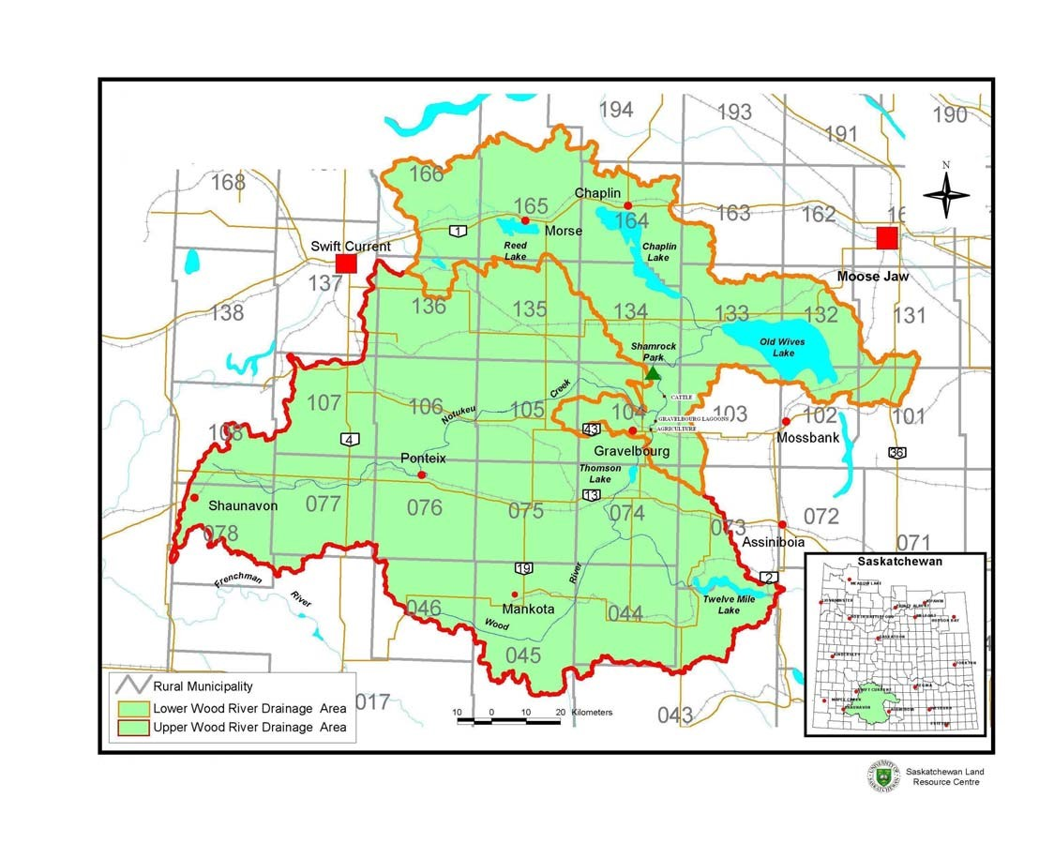
Figure 3.1. Map of the Wood River watershed showing watershed boundaries, approximate location of study sites, and location of Rural Municipalities (RMs).

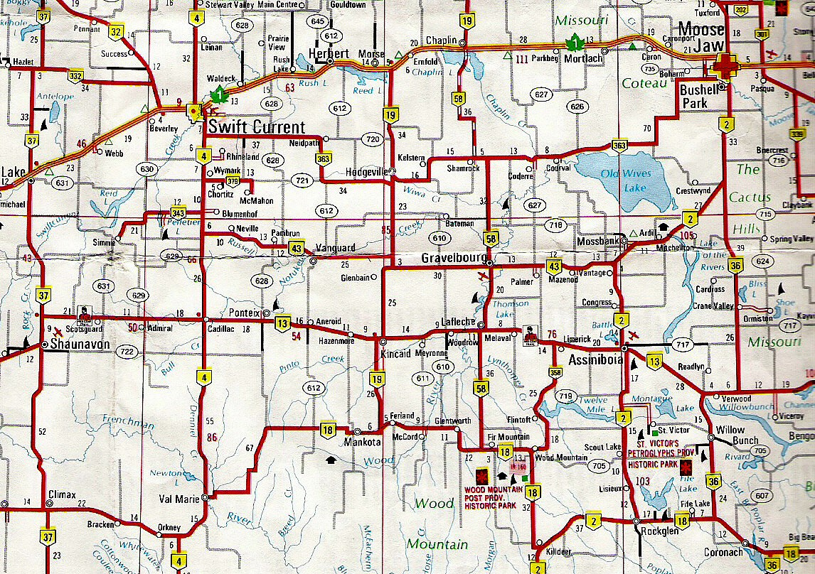
Figure 3.2. Road map of the Old Wives Lake watershed area showing location of roads, towns, and waterbodies (Tourism Saskatchewan 2004).
volume and therefore water depth on a seasonal basis. The northern Great Plains often experiences precipitation deficits exceeding 300 mm/year (Hall et al. 1999). Mean annual precipitation for the area varies from 330 mm to 400 mm with approximately 100 mm occurring as snowfall, and with the wettest months being June and July (Sask Water 1994). Characteristic of this semi arid climate, the temperature of the area varies widely, both monthly and annually. Historically, temperatures recorded at the community of Gravelbourg, located in the centre of the basin, have ranged from -49ºC to nearly 43ºC (Sask Water 1994). Climate data for Assiniboia, SK, located in the southern portion of the watershed is summarized in Table 3.1. In this table, climatic normals represent the average of the temperature and precipitation values recorded at this location over the period of 1971 to 2000. International standards dictate that climatic normals be calculated over such a thirty year period (Environment Canada 2003).

3.5 Geology
Southern Saskatchewan occupies a central part of the Alberta upland of the Great Plains of Canada. It is comprised of primarily flat or undulating, treeless, grass-covered plains or prairies though many trees and shrubs grow on the north side of the Wood Mountain upland (Fraser et al. 1935). Glaciation of almost the entire area of southern Saskatchewan occurred in Pleistocene era, from approximately 1.8 million to 12, 000 years ago (Fraser et al. 1935). As a result, the area became hilly or undulating in areas of morainal deposits and flat on the bottoms of glacial lakes. Diversion channels, now dry valleys, were formed, draining the temporary lakes which had been dammed by the retreating ice. Most of the area is mantled by glacial drift that covers the underlying sediments (Fraser et al. 1935). The Old Wives Lake watershed is underlain mostly by the Bearpaw formation consisting of marine shales, with small areas of the Eastend formation consisting of sands (Fraser et al. 1935). The glacial till of the area is composed of almost equal parts of sand, silt and clay (Freeze 1969).
The Gravelbourg plain is an example of a very flat plain on an ancient lake bottom (Fraser et al. 1935). Most of the lakes in this area are remnants of much larger late Pleistocene lakes, and lie in valleys that were formed by the runoff of glacial waters or lie

Table 3.1. Temperature and precipitation at Assiniboia, Saskatchewan, 2002-2003.
(Environment Canada, 2003).
May to Sept May to Sept
Mean Normal Total Normal Total Mean Normal
Year Month Temperature Temperature Precipitation Precipitation Precipitation Precipitation
2002 Jan -10 -12.9 9.6 17.5 382.4 265.4
Feb -5.5 -9.5 5.3 12.8
Mar -13.3 -3.2 18.9 24 Apr 0.1 4.9 11.7 18.8
May 8.4 11.3 15.6 53.9
Jun 16.1 16.3 161.2 64.5
Jul 20.1 18.6 57.2 65
Aug 15.9 17.8 82.8 44.2
Sep 12.8 11.8 65.6 37.8
Oct -0.1 5.6 18.1 18.1
Nov -1.2 -4.5 7.5 17.5
Dec -5.5 -10.6 8.6 21.7
TOTAL: 462.1 395.8
2003 Jan -11.3 -12.9 22.2 17.5 176.6 265.4
Feb -12.5 -9.5 8.8 12.8
Mar -5.5 -3.2 17 24 Apr 6.1 4.9 26.8 18.8
May 11.2 11.3 74.2 53.9
Jun 15.5 16.3 49.8 64.5
Jul 20.5 18.6 3.8 65
Aug 21 17.8 16.2 44.2
Sep 11 11.8 32.6 37.8
Oct 7.9 5.6 12.5 18.1
Nov -9.5 -4.5 14.6 17.5
Dec N/A -10.6 N/A 21.7
TOTAL: 278.5 395.8

in depressions in the morainal areas (Fraser et al. 1935). Most are undrained and are alkaline.

3.6 Soils
The majority of the soil found in this area is classified as Chernozemic (Figure 3.2). Chernozemic soils are soils that have developed under grasses and forbs, or under grassland-forest transition vegetation, in cool to cold, sub-arid to sub-humid climates (Soil Classification Working Group, 1998). These soils have a dark-colored surface horizon and a B or C horizon or both. This soil order consists of the Brown, Dark Brown, Black, and Dark Gray great groups. In the Old Wives Lake Basin, the Brown and Dark Brown groups are present, reflecting both increases in soil moisture and the amount of organic matter in the soil encountered when moving from south to north in the watershed. There is an area of Regosolic soils in the southern part of the basin. These soils are weakly developed and have insufficient A or B horizons to meet the requirements of other soil orders (Soil Classification Working Group, 1998). There is also a small area of Gleyosolic soil under Old Wives Lake. These soils developed under wet conditions and permanent or periodic reduction and have low chromas, or prominent mottling, or both, in some horizons (Soil Classification Working Group, 1998).

3.7 Settlement
Parties of land surveyors surveyed most of the townships within the Wood River district in 1883 but these lands were not open to homesteading for another twenty five years (Wood River Historical Society 1980). During that time, however, some land was leased for grazing to ranching companies and all of it was open range. The influx of agricultural settlers into this area began in the first decade of the twentieth century (Turner 1960). In 1906, the missionary priest, Father Emile Gravel, founded the French colony of Gravelbourg and within two years settlers began to flood the area (Wood River Historical Society 1980).

3.8 Population
Based on the town and village population from the 2001 census, it is estimated that the current population in the watershed is approximately 10,000 people (Statistics

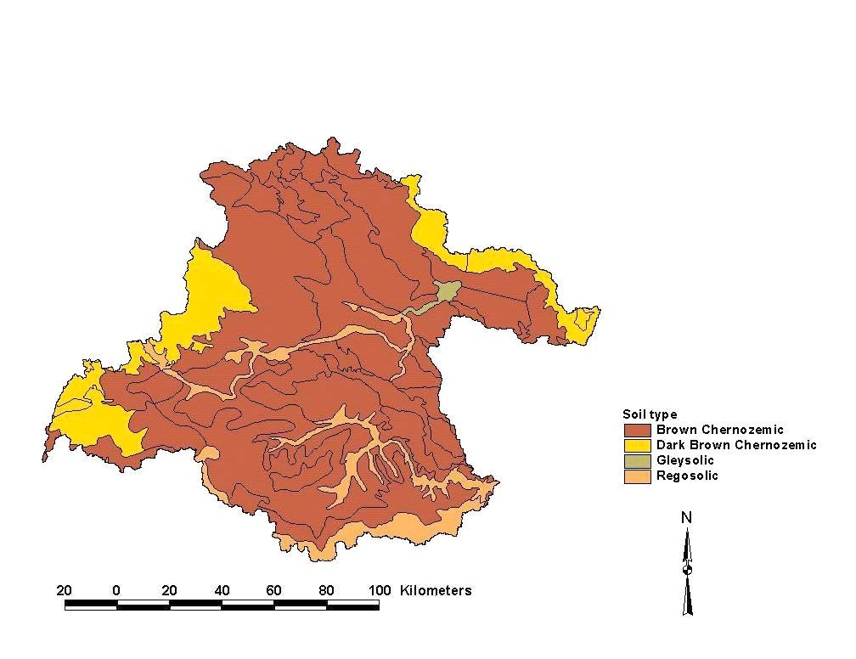
Figure 3.3. Map of the soils of the Old Wives Lake watershed.
Canada 2002a). Population trends here have generally mirrored those of most rural areas in Saskatchewan, with a steady overall decline since the end of World War II (Sask Water 1994). The area’s three largest communities are Gravelbourg with a population of 1,187, Assiniboia with a population of 2,483, and Shaunavon with a population of 1,775 (Statistics Canada 2002a). According to Sask Water (1994), 48% of the watershed’s population lives in towns and villages.

3.9 Water Resources
The Wood River and Old Wives Lake are the dominant surface water resources in the Old Wives Lake watershed (Sask Water 1994). Most of the surface flow originates from the slopes of the Cypress Hills and Wood Mountains (Sask Water 1994). The Noteku, Pinto, Wiwa and Russell creeks along with Twelve Mile Lake, Reed Lake and Chaplin Lake are other important local water resources (Fig. 3.1, Fig. 3.2). The Wood River rises along the southern extremity of the area, then flows to the north and east where it ultimately drains into Old Wives Lake.
Data provided from Sask Water hydrometric stations indicates that flow in the Wood River and its tributaries vary in a fashion typical of most prairie streams (Sask Water 1994). Prairie streams depend on snowmelt and early spring rains for most of their annual flow. As a result, extremes of high flows and little or even no flow may be encountered within short time frames. In 2002, for example, flows in the Wood River were high due to the fact that this area received 117 mm more precipitation than normal (Environment Canada 2003). In 2003, however, high discharges were seen early in the year with the maximum daily discharge occurring in March. Flow rates then dropped to values of zero in September and October. As can be seen from this data (Table 3.2), the two study years were quite different in terms of flow in the Wood River.
The mean total discharge of the Wood River near Lafleche was 43,600 cubic decameters (dam³) for the period 1944 to 1990 (Sask Water 1994). The total discharge was 34,487 dam³ in 2002 and 35,902 dam³ in 2003. The maximum daily discharge for 2002 was 27 m³/s on June 14 and for 2003 was 53.3 m³/s on March 18 (Water Survey of Canada 2002, 2003).

Table 3.2. Discharge data in dam³ for the Wood River near Lafleche (Water Survey of Canada 2002, 2003).

2002 | March | April | May | June | July | Aug | Sept | Oct
Mean | 0 | 1.07 | 0.142 | 5.12 | 1.87 | 2.46 | 2.08 | 0.208
Total | 0 | 2760 | 379 | 13300 | 5020 | 6580 | 5390 | 558
Max | 0 | 6 | 0.259 | 27 | 5.63 | 7.44 | 10.5 | 0.353
Min | 0 | 0 | 0.037 | 0.005 | 0.376 | 0.282 | 0.383 | 0.142
2003 | March | April | May | June | July | Aug | Sept | Oct
Mean | 8.43 | 3.97 | 0.846 | 0.197 | 0.078 | 0.005 | 0 | 0
Total | 22600 | 10300 | 2270 | 510 | 210 | 12.4 | 0 | 0
Max Min | 38.2  0.088 | 13.1  0.787 | 1.84  0.191 | 0.635  0.087 | 0.248  0.023 | 0.022 0 | 0  0 | 0  0

Thomson Lake, with a capacity of 37, 300 dam³ is the largest man made reservoir in the area and stores runoff from the upper portion of the Wood River (Sask Water, 1994). The reservoir provides drinking water for the towns of Gravelbourg and Lafleche as well as to another 53 separate users through rural water lines (Wood River Historical Society 2001). The dam was originally a project of the Prairie Farm Rehabilitation Association (PFRA) and is now controlled by the Saskatchewan Water Corporation (Wood River Historical Society 2001). The dam was completed in the fall of 1957 and the reservoir began to fill in the spring of 1958 (Wood River Historical Society 2001).
Groundwater in the area tends to be highly mineralized, but may still be acceptable for domestic and municipal use without treatment other than chlorination. In most cases however, it is not suitable for irrigation purposes (Sask Water, 1994). The major bedrock aquifer in this area, the Judith River aquifer formation, underlies most of the area. Water from this formation is only potable in the western third of the basin. There are a number of integrated bedrock valley aquifers present in the central portion of the watershed, the Gravelbourg aquifer being one of this type. Its' water is highly mineralized. There are also a number of drift aquifers found above the bedrock surface. Ground water discharge is common throughout the area. According to Sask Water (1994), groundwater supplies in the Old Wives Lake watershed are largely uncharacterized.

3.10 Land Use

3.10.1 Crop Type
Major crops grown in the watershed include wheat, dried field beans and alfalfa and alfalfa mixtures (Table 3.3). Cultivation of dried field beans and peas is a relatively new development, with large areas under cultivation for these crops only reported in 2001. None were reported in 1991 and little reported in 1996.

3.10.2 Cattle
Currently, there are approximately 75,000 head of cattle in this watershed (Table 3.4). Data from all three years examined shows that the largest number of cattle is to the south of the watershed in RMs 46, 45 and 44. The center of the watershed is dominated by annual field crops, with cattle being more important again to the north. Cattle

Table 3.3. Area of major crop types in the Old Wives Lake watershed (Statistics Canada, 1993, 1999, 2002b).

Crop | 1991 Hectares | 1996 Hectares | 2001 Hectares
Wheat | 219623 | 220007 | 162888
Barley | 4631 | 8269 | 13434
Oats | 6322 | 9529 | 9390
Alfalfa and Alfalfa Mixtures | 9611 | 17001 | 24378
Canola | 64 | 1172 | 4382
Lentils | 1852 | 4561 | 13905
Dry Field Peas | 0 | 0 | 13557
Dry Field Beans | 0 | 0 | 45936

Table 3.4. Number of cattle and calves by Rural Municipality (RM) in the Old Wives Lake watershed (Statistics Canada, 1993, 1999, 2002b).
 | 1991 | 1991 | 1996 | 1996 | 2001 | 2001
RM | Farms Reporting | Total Cattle and Calves | Farms Reporting | Total Cattle and Calves | Farms Reporting | Total Cattle and Calves
46  45  44  74  104  133  134  Total: | 56  110  93  50  47  56  73  485 | 8442  21141  11906  2735  3539  5082  5515  58360 | 47  116  97  47  53  49  71  480 | 10198  24206  18688  4378  4335  7768  7489  77062 | 42  97 96  42 37 41  66  421 | 10474  24129  17182  3805  3269  7855  8141  74855

production increased 32% from 1991 to 1996 and 28% from 1991 to 2001 although the total number of farms decreased. There is therefore an increase not only in cattle numbers, but also in the number of cattle per farm.

3.10.3 Soil Conservation Methods
Soil conservation methods are employed not only to protect and maintain soil resources, but also to protect water resources. Water can be polluted by wind blown or water transported soil particles which tend to contain high amounts of organic matter, nutrients and pesticides (McNabb 1999). Soil conservation methods reduce erosion in three ways: by maintaining a protective cover on the soil, by creating a barrier to the erosive agent, and by modifying the landscape to control runoff amounts and rates (Wall et al. 1995). Some soil conservation methods also encourage the infiltration of water rather than runoff.
A number of soil conservation practices are currently employed in the Old Wives Lake watershed. These include:
- Contour cultivation: cultivating the field across the slope to reduce soil erosion from rapid water run-off.
- Crop rotation: alternating crops each year, or in a multi-year cycle, for soil conservation or disease control purposes.
- Grassed waterways: either natural or constructed to control soil erosion. The waterway is permanently grassed and consists of a shallow channel designed to slow down run-off water. The grass stabilizes the soil and prevents it from being washed away.
- Low-till: preparing the land for seeding by leaving most of the crop residues on the surface of the soil.
- No-till: leaving soil completely undisturbed between harvest and planting the next crop. Also known as zero till, this approach involves seeding directly into crop stubble.
- Permanent grass cover: keeping a field in grass cover indefinitely to prevent soil erosion.
- Strip-cropping: controlling soil erosion by dividing the farm into narrow fields of different crops, with or without fallow. If used to control wind erosion, the strips are usually planted at right angles to the prevailing winds.
- Windbreaks/Shelterbelts: consists of trees either planted or present naturally. The trees slow wind velocities and trap snow.
- Winter cover crops: crops, such as fall rye, seeded in the fall to protect against soil erosion. The plants protect the soil from wind erosion as they germinate in the fall, while the roots hold the soil together, protecting it against water erosion.
Crop rotation is the most widely used practice followed by strip cropping, although strip cropping use has decreased 38% from 1991 to 2001 (Table 3.6). Grassed waterways, which specifically protect water resources from pollution by agriculture, is slowly increasing but is not widely used. Winter cover crops, contour cultivation, strip cropping, shelterbelts, and low till practices have all decreased in use from 1991 to 2001. But even those practices that have increased in use, have only increased slowly. For example, over the ten year period from 1991 to 2001, permanent grass cover has only increased by 6%, grassed waterways by 2%, and no till by 12%. Generally, not only are soil conservation techniques not widely used in this area, but their use is declining. This could have a profound impact on the water quality of the Wood River.

3.10.4 Percentage Land Use
According to the GIS data, 68% of the Old Wives Lake watershed is in crop production, 22% is native dominant grassland (native pasture), and 2% is tame pasture. Therefore, 92% of the land use in this watershed is related to agricultural use. Only 0.9% is farmstead/urban. The other land covers specified in the ISC data make up very small percentages of the total land use. The distribution of these land uses indicates that the majority of the agricultural land uses are near the river and in the central portion of the watershed (Fig 3.3). Most of the pasture land is in the south near the Cypress Hills and in the north near Chaplin and Old Wives Lakes.

3.11 Summary
The Old Wives Lake watershed is one with multiple uses and is dominated by

34

Table 3.5.
Average percentage of farms using selected soil conservation techniques in the Old Wives Lake watershed (Statistics
Canada, 1993, 1999, 2002b).

Year
Crop
Rotation
Permanent
Grass Cover
Winter Cover
Crops
Contour
Cultivation
Strip Cropping
Grassed
Waterways
ShelterbeltLow TillNo Till
199111
714711517283
not reported
199674251124115141148
20017731173317131615

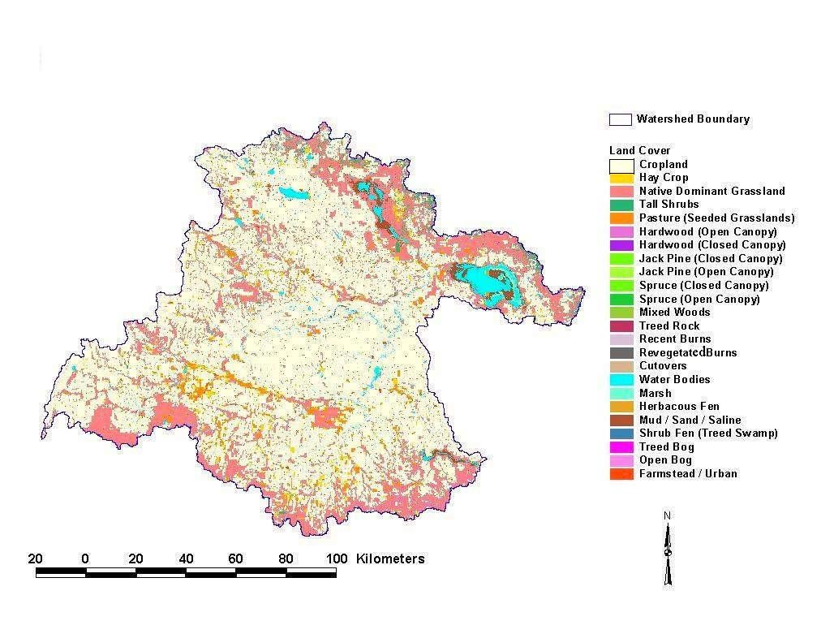
35

Figure 3.4.
Map of the Old Wives Lake watershed showing the distribution of land use.
agriculture. 92% of the watershed is in agricultural production of some kind, and some
48% of the watershed's inhabitants live in towns and villages. Various field crops are grown and there are a significant number of cattle in the watershed. Also, the river and its reservoirs and tributaries provide water for human and livestock consumption, are used for recreation, and as receiving waters for the sewage of the town of Gravelbourg. The data has also shown that cattle production is increasing and soil conservation practice use is decreasing.
Because agriculture is so prevalent in the Old Wives Lake watershed, the following chapter will examine nutrient levels to see if this land use is having an effect on the Wood River. As well, the release of sewage from the town of Gravelbourg will be examined to see what effects this release has on water quality.

4. CHAPTER THREE
WATER QUALITY OF THE WOOD RIVER

4.1 Introduction
In the Old Wives Lake watershed, agriculture accounts for 92% of the land use. Additionally, 48% of its population lives in communities. Although the Wood River provides the majority of water for drinking and agricultural usage in the basin, little is known regarding the effects of agricultural land use or municipal waste water effluent on the water quality of this important water resource.
Other studies have shown that agricultural land use negatively affects water quality (Jordan et al. 1997, Cuffney et al. 2000, McKee et al. 2001). In the United States, total phosphorus and total inorganic nitrogen export from agricultural land can be up to 3 to 12 times higher, respectively, than from forested land (Cooke and Prepas 1998). Omernik (1977) also showed that streams draining agricultural watersheds had considerably higher nutrient concentrations than those draining forested watersheds. Furthermore, nutrient concentrations were generally proportional to the percent of land in agricultural production. It is therefore important that this study examine this relationship in the Old Wives Lake watershed, as approximately 10,000 people use the water resources in this watershed for drinking water, recreation, or other purposes. The focus of this chapter is to measure the water quality of the Wood River and the impact of land use on this water quality.

4.2 Materials and Methods

4.2.1 Study Sites
Five sampling sites were chosen based on surrounding land use along the Wood River (Figure 3.1, Table 4.1). Site 5, Thomson Lake was furthest upstream while site 1, Shamrock Park, was furthest downstream. Shamrock Park is a regional park in an area characterized by abundant riparian vegetation. There is no agriculture adjacent to the waters' edge. This site was chosen as a reference or control site to be used for comparison amongst sites. Although downstream from the other sites, it is not directly influenced by agriculture. According to Richardson and Vymazal (2001), reference or undisturbed sites must be included in all biomonitoring analyses if changes in communities are to be assessed accurately. Reference sites serve as a standard against which other sites will be judged. Finding and sampling a large number of reference sites to define regional variability may not be necessary if physically similar sites (size, hydrology, elevation, etc.) can be found in close proximity to the disturbance site. Reference sites such as these should be selected based on physical or chemical attributes not affected by human activities (Rader and Shiozawa 2001). If a few local reference sites cannot be found there are other options. For example, sampling minimally affected sites could work (Wright et al. 1995). This was the strategy that was chosen for this study as there were no unaffected sites in this watershed.
Site 2 is just downstream from a ranch where cattle have free access to the river. Manure has been seen in the river and there is an abundance of benthic algae at this site (pers. obs.). Site 3 is where the town of Gravelbourg dumps its sewage into the river. Sewage is pumped from a double pump lift station to a two cell lagoon located approximately 0.4 km east of the town. The dump takes place twice a year, once in the spring and once in the fall. In 2002, this site was sampled before and after the town’s spring effluent dump which occurred on May 31st. The spring effluent dump was not studied in 2003 due to an unexpected early release of the effluent in March. Site 4 is surrounded by agriculture. At this site, annual crops are grown right to the waters edge. And finally, Site 5 is Thomson Lake. Thomson Lake is a reservoir formed by a dam in the river. There is also a regional park on its western shore. The lake shore is primarily recreational on the east side of the lake (golf course, campgrounds, etc.) and crop land on the west side. In places the entire riparian zone is cultivated and used to produce annual crops such as wheat.

4.2.2 Sample Collection
During 2002, samples were collected seven times from May to September at approximately 3 week intervals. During 2003, samples were collected once monthly from May to September. Water was collected with a clean bucket from midstream and then

Site | Location | Surrounding Land Use | Direction of river flow
Site 1 | Shamrock Park | regional park
Site 2 | Ranchland | cattle
Site 3 | Gravelbourg | sewage lagoons
Site 4 | Cropland | intensive agriculture
Site 5 | Thomson Lake | intensive agriculture and regional park
Table 4.1. Sampling sites

screened through 153 µm Nitex mesh, to remove large zooplankters. The water was then placed in clean amber Nalgene bottles, and transported in the dark, on ice, back to the lab.

4.2.3 Water Chemistry
On each sampling date, water was analyzed for total, total dissolved and ortho phosphorus (TP, TDP, and OP), ammonia nitrogen (NH₃), nitrate-nitrite nitrogen (NO₂ + NO₃), total dissolved and particulate organic nitrogen (TDN and PON), and particulate organic carbon (POC). Samples for TDP, OP, NO₂ + NO₃, TDN, POC and PON were filtered through a GF/C filter (nominal pore size 1.2 µm). POC and PON samples were acidified with 3 mL of 0.3% H₂SO₄ to drive off any inorganic carbon present on the filter. The NH₃ samples were preserved with 1 mL of 10% H₂SO₄. All of these samples were analyzed at the Water Quality Laboratory at the National Water Research Institute (NWRI) according to methods in Environment Canada (1992). In 2003, NO₂ + NO₃ was analyzed in May and June only as levels were often below detection limits.
Temperature and pH were measured in the field using a Hydrolab multiparameter water quality monitoring system fitted with an H₂O multiprobe (Hydrolab Hach Company, Loveland Colorado).
Total dissolved solids (TDS), which refers to any minerals, salts, metals, cations or anions dissolved in water, were measured in the lab according to Standard Methods (Clesceri et al. 1998). Water samples were filtered through a 47 mm GF/C filter and then placed in weighed, combusted glass dishes and dried it at 104ºC until all water evaporated.
Dishes were then re-weighed and TDS calculated according to the following equation:
(A-B)*1000/sample volume in mL
where:
A = weight of dried residue + dish (mg) B = weight of dish (mg).
A one way analysis of variance (ANOVA) followed by a post hoc Tukey’s test was used to test for differences in water chemistry among sites, and a t-test on the raw data was used to test for differences between years using SPSS’s SigmaStat software (P< 0.05).

4.2.4 Chlorophyll a
Chl a concentrations were used to obtain a measure of pelagic phytoplankton biomass in the river. The phytoplankton community was examined in order to gain an understanding of how the nutrients in the Wood River were affecting the biological community. This is important because phytoplankton are the base of the food chain. An increase or decrease in biomass as a result of increased nutrients could have an impact on higher trophic levels (i.e. invertebrates). Also, it has been shown that water chemistry monitoring can fail to indicate poor conditions even when land use impacts are clearly affecting the biota of a stream (Whiles et al. 2000).
A known volume of water was filtered through a 47 mm GF/C filter for
chlorophyll a (chl a) analysis. Filters were then wrapped in foil and frozen until analysis. Chl a was extracted in boiling 90% ethanol and determined fluorometrically using a Turner Designs 10-AU model fluorometer (Nusch 1980). A one way analysis of variance (ANOVA) followed by a post hoc Tukey’s test was used to test for differences in chl a between sites. A t-test done on the raw chl a data of all the sites was used to test for differences between years (P<0.05). A linear regression was used to look for differences between land uses when mean chl a concentration was plotted against the mean concentration of total phosphorus and total nitrogen.

4.2.5 Bioassays
Enrichment bioassays were conducted at each site once in 2002 and monthly in 2003. These bioassays were used to determine the potential for nutrient limitation of the pelagic phytoplankton community in the river, and to determine the potential for phytoplankton to respond to nutrient addition. Four treatments were used: a control with no nutrient addition, a phosphorus treatment (+P), a nitrogen treatment (+N), and a nitrogen and phosphorus treatment (+N+P). Nitrogen and phosphorus were added to achieve a 16:1 molar ratio of N:P (Waiser and Robarts 1995). Water for these bioassays was collected from the sampling sites at the same time as water samples for water chemistry analysis. 150 mL of river water was filtered through a GF/C filter to remove all phytoplankton and subsequently placed into 250 mL flasks. Then, 10 mL of unfiltered river water was added to inoculate the flasks with the natural assemblage of algae from each site. Each treatment was run in triplicate.
Flasks were incubated at 18ºC and on a 12 hour light/dark cycle in a Percival environmental growth chamber. Flasks were periodically hand shaken throughout the incubation period. At the end of the sampling period, the bottoms of the flasks were scraped, and the liquid was filtered through a GF/C filter. The filters were then fluorometrically analyzed for chl a as above.
The re-growth or dilution bioassay described above is usually used where high levels of phytoplankton growth are expected or where background levels of chl a are high (Sterner 1994). Chl a levels taken several times before the first bioassays were initiated in August of 2002 indicated high levels of chl a in the Wood River (mean chl a concentration recorded = 30 µg/L). After the release of sewage at Gravelbourg in 2002 the Wood River phytoplankton responded rapidly to nutrient addition and this was another reason that the dilution type of bioassay was chosen. Dilution bioassays are thought to be superior to undiluted bioassays because growth of diluted algae can be density-independent for several generations and cells can grow for the duration of the experiment under the nutrient concentrations present in the original sample (Sterner 1994).
A one way analysis of variance (ANOVA) followed by a post hoc Tukey’s test was used to test for differences between treatments using SPSS’s SigmaStat software (P< 0.05). If the normality test failed, then a Kruskal-Wallis one way ANOVA on ranks (nonparametric) was performed followed by a post hoc Tukey’s test.

4.2.6 Sestonic Ratios
Sestonic ratios were used to evaluate the nutrient status of the phytoplankton community. Seston for POC and PON was collected on pre-combusted 25 mm GF/C filters and then washed with 3 mL of 0.3 % H₂SO₄ to remove inorganic materials. POC and PON were then measured as noted. PP was calculated by subtracting TDP from TP. Phytoplankton sestonic ratios of PN: PC, PN: PP and PP: PC were then calculated on a molar basis and interpreted as per Healey and Hendzel (1980). PP: PC ratios of less than 20 and PN: PP ratios greater than 10 were indicative of P deficiency, while PN: PC ratios less than 140 were indicative of N deficiency (Healey and Hendzel 1980).

4.3 Results

4.3.1 Nitrogen
Ammonia nitrogen and total dissolved nitrogen levels in the Wood River fluctuated widely in 2002 but were more stable in 2003 (Fig. 4.1, 4.2). A t-test run on the ammonia nitrogen data for all of the sites revealed a statistically significant difference (P=0.010) in the NH₃ concentrations between years. There was, however, no significant difference in the TDN concentrations between the two study years (P=0.123). 4.3.1.1 2002
After the release of the Gravelbourg effluent in 2002, nitrogen levels rose dramatically. Ammonia levels increased more than two orders of magnitude from 0.035 mg/L to 7.02 mg/L (Fig 4.1) while TDN levels increased one order of magnitude from 0.92 mg/L to 9.20 mg/L (Fig 4.2). These measurements were taken 5 days after the release so these values were most likely much higher immediately afterwards. Also, levels did not return to the lower levels present before the dump during the study period. In 2002, Shamrock Park had the lowest levels of ammonia and TDN. Gravelbourg had the highest levels followed by the agricultural site.

4.3.1.2 2003
In 2003, although ammonia nitrogen and total dissolved nitrogen levels were similar to those seen in 2002, there was much less seasonal fluctuation, and much less variation between sites (Fig 4.1, 4.2). Although nitrogen concentrations were generally constant through out the study season, they gradually decreased as the season progressed. In spring, the highest levels of NH₃ and TDN were observed at Thomson Lake and the agricultural site. Thomson Lake had the highest ammonia levels and there was a statistically significant difference between the sites (P=0.013). There was no significant difference in the TDN concentrations between sites (P=0.702).

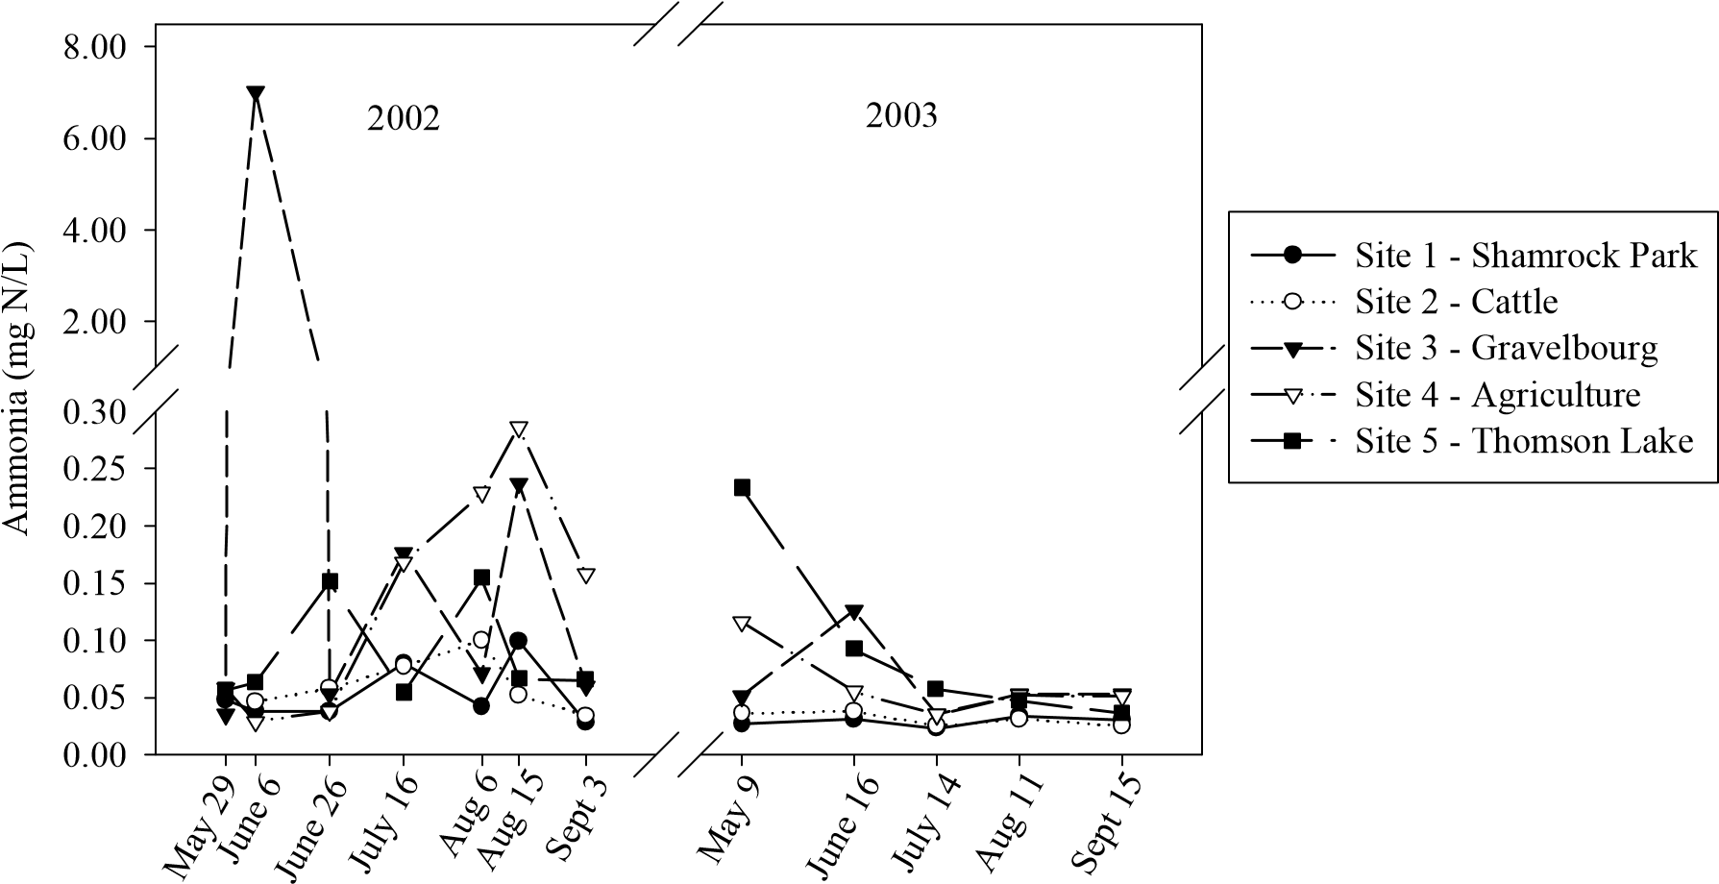

Figure 4.1. Ammonia levels of the Wood River, 2002-2003.

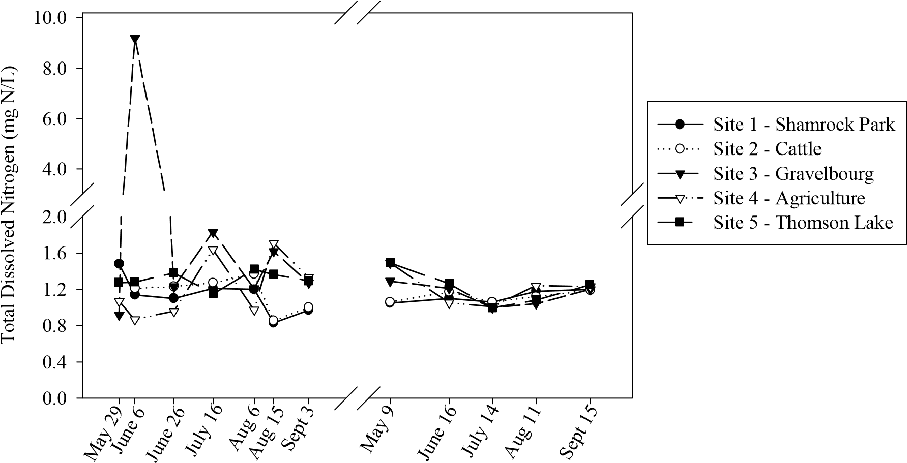
Figure 4.2. Total dissolved nitrogen levels of the Wood River, 2002-2003.

4.3.2 Phosphorus
Phosphorus levels fluctuated widely in 2002 but showed much less variation in 2003 (Fig. 4.3, 4.4, 4.5). A t-test revealed a significant difference in P concentrations between the two study years (P<0.001).

4.3.2.1 2002
The release of the effluent from the town of Gravelbourg in 2002 increased the phosphorus levels dramatically and levels did not return to values present prior to sewage release for the remainder of the study (Figs. 4.3, 4.4, 4.5). TP, Op and TDP levels were 4, 2 and 3 times higher, respectively, after the effluent dump. In 2002, Shamrock Park had the lowest levels of all forms of phosphorus. Gravelbourg had the highest levels of TP (Fig. 4.3) and OP (Fig. 4.4), but Thomson Lake had the highest concentrations of TDP (Fig. 4.5). The agricultural site’s TP value was higher than Thomson Lake’s. All three of these sites (Gravelbourg, Thomson Lake, and the agricultural site) however, had similar phosphorus levels. As seen for the nitrogen data, there was no statistically significant difference in the P concentrations between sites in 2002. Again, this is most likely due to the high amount of variation in the data.

4.3.2.2 2003
In 2003 there was much less fluctuation in P levels. There were, however, differences between sites that were not seen with nitrogen. For example, there was a clear distinction between the Gravelbourg site, Thomson Lake, and the agricultural site, and Shamrock Park and the cattle site (Figs. 4.3, 4.4, 4.5) Shamrock Park and the cattle site had lower levels of TP than the other three sites, which had similar levels. Gravelbourg, the agricultural site, and Thomson Lake had high levels of TP that gradually increased seasonally. Levels at these three sites doubled from approximately 0.35 mg/L to approximately 0.7 mg/L (Fig 4.3). Shamrock Park and the cattle site tended to hover around 0.2 mg/L (±0.05 STD) throughout the season. The same pattern was seen in the OP and TDP levels (OP: 0.16±0.05 STD, TDP: 0.12±0.05 STD). Shamrock Park and the cattle site had significantly lower concentrations of all forms of P when compared to Gravelbourg, the agricultural site, and Thomson Lake (Table 4.2).

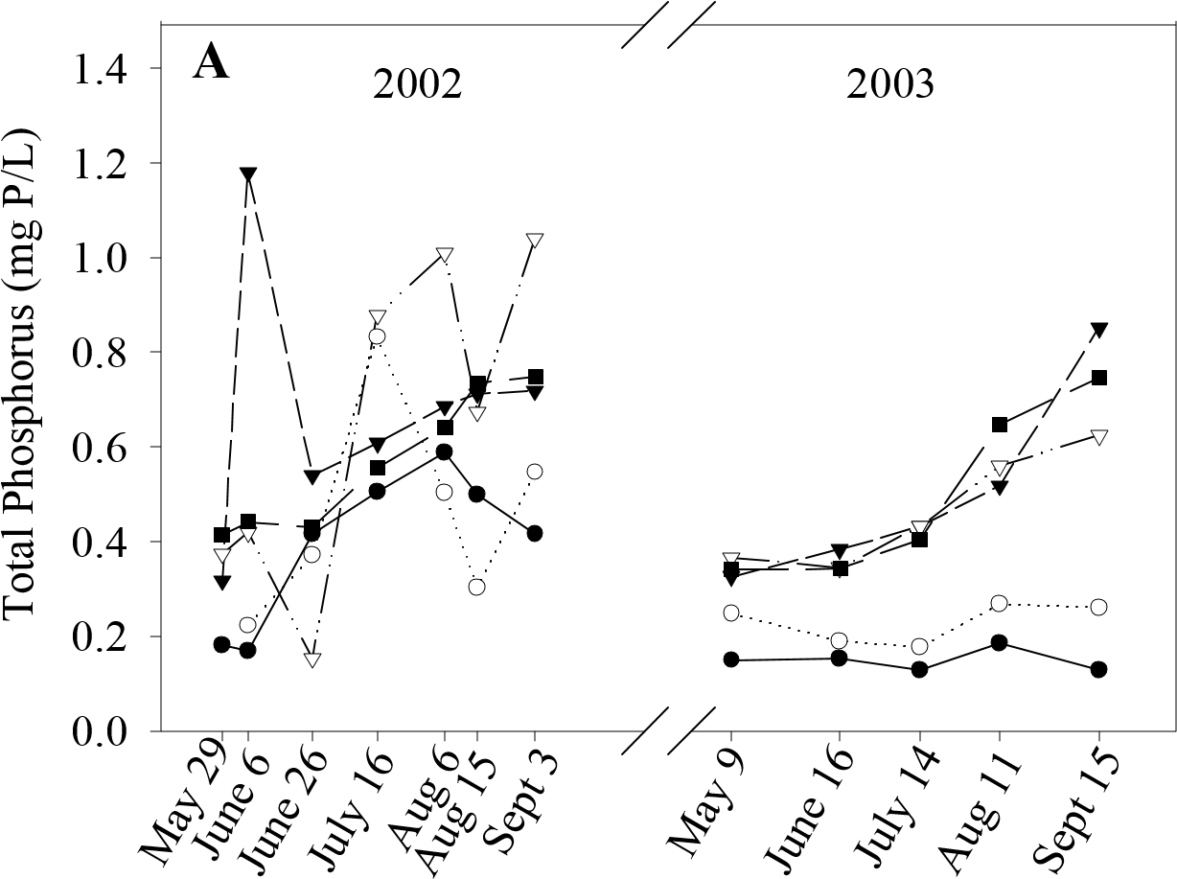
  Site 1 - Shamrock Park
  Site 2 - Cattle
  Site 3 - Gravelbourg
  Site 4 - Agriculture
  Site 5 - Thomson Lake

Figure 4.3. Total phosphorus levels of the Wood River, 2002-2003.

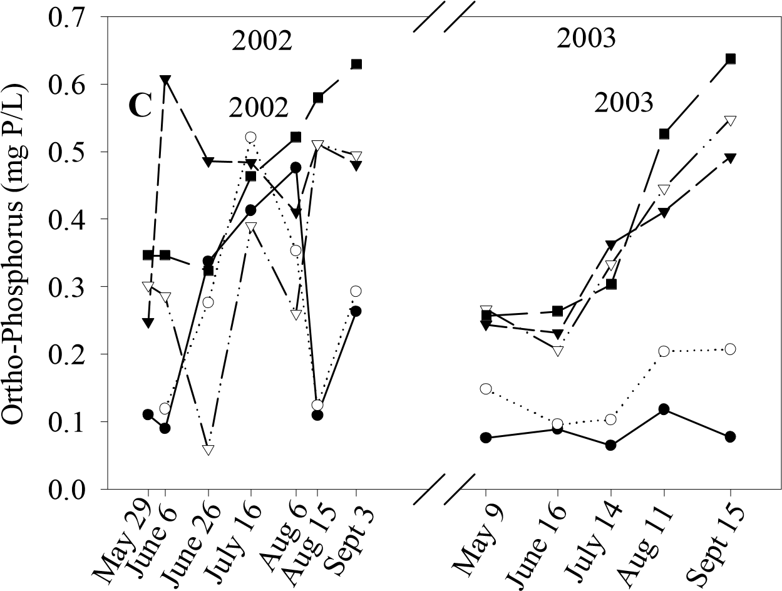
  Site 1 - Shamrock Park
  Site 2 - Cattle
  Site 3 - Gravelbourg
  Site 4 - Agriculture
  Site 5 - Thomson Lake

Figure 4.4. Ortho-phosphorus levels of the Wood River, 2002-2003.

Site 1 - Shamrock Park
Site 2 - Cattle
Site 3 - Gravelbourg
Site 4 - Agriculture
Site 5 - Thomson Lake
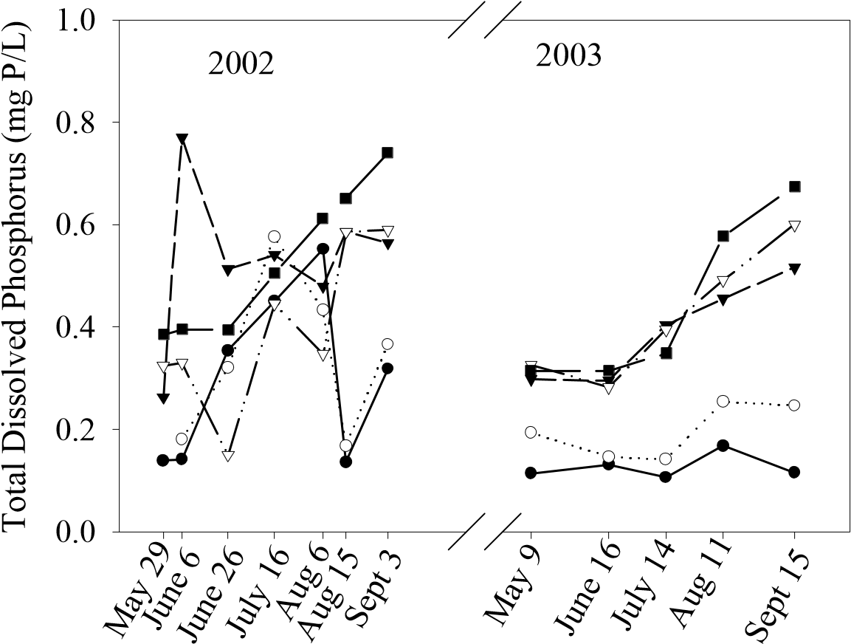
Figure 4.5. Total dissolved phosphorus levels of the Wood River, 2002-2003.

Table 4.2. Results of Tukey multiple comparison test on phosphorus concentrations (2003) between study sites. (*) indicates sites that are significantly different.

TP | Site 1 | Site 2 | Site 3 | Site 4 | Site 5
Site 1 - Shamrock Park |  | 0.889 | 0.004* | 0.013* | 0.006*
Site 2 - Cattle |  |  | 0.031* | 0.086 | 0.042*
Site 3 - Gravelbourg |  |  |  | 0.987 | 1
Site 4 - Agriculture Site 5 - Thomson Lake |  |  |  |  | 0.996
OP | Site 1 | Site 2 | Site 3 | Site 4 | Site 5
Site 1 - Shamrock Park |  | 0.884 | 0.012* | 0.008* | 0.003*
Site 2 - Cattle |  |  | 0.084 | 0.061 | 0.021*
Site 3 - Gravelbourg |  |  |  | 1 | 0.958
Site 4 - Agriculture Site 5 - Thomson Lake |  |  |  |  | 0.985
TDP | Site 1 | Site 2 | Site 3 | Site 4 | Site 5
Site 1 - Shamrock Park |  | 0.844 | 0.007* | 0.003* | 0.001*
Site 2 - Cattle |  |  | 0.06 | 0.028* | 0.012*
Site 3 - Gravelbourg |  |  |  | 0.996 | 0.938
Site 4 - Agriculture Site 5 - Thomson Lake |  |  |  |  | 0.995

4.3.3 Total Dissolved Solids
Total dissolved solids fluctuated widely in both study years (Fig 4.6). Spring concentration were high in both years but became lower as the season progressed. TDS concentrations in 2003 were lower than in 2002 (t-test; P<0.001). Concentrations ranged from approximately 300 mg/L to 2500 mg/L.

4.3.4 Chlorophyll a
Higher chl a levels were observed in 2002 as compared to 2003 overall (t-test; P=0.019). In 2002, chl a values fluctuated widely (Fig. 4.7). At the Gravelbourg site, chl a levels were 20 times higher after the effluent dump. They increased from 9.91 µg/L to over 200 µg/L. Within 20 days, however, chl a concentrations returned to levels seen before the release. On average, chl a levels in 2002 were highest at the Gravelbourg site and the agricultural site, while lowest concentrations were seen at Thomson Lake. Chl a concentrations were lower at Thomson Lake and Shamrock Park than at the other 3 sites, which had similar concentrations (P<0.001).
In 2003, the chl a values fluctuated much less and there was much less variation amongst sites (Fig 4.7). Chl a levels were highest at Thomson Lake, due to an algal bloom which was tentatively identified as the cyanobacteria Aphanizomenon spp. This bloom began in July and remained until the end of the study period. Lowest chl a levels were seen at Shamrock Park with sites 2, 3 and 4 being intermediate between Thomson Lake and Shamrock Park. There was a statistically significant difference (P=0.040) between chl a concentrations at Thomson Lake and Shamrock Park, but not between the other sites.

4.3.4.1 Relationships between Chl a and Nutrient Concentrations
The linear regression of the mean value for total N vs. chl a revealed that nitrogen concentrations were having a stronger effect on chlorophyll levels than TP in the Wood River (Fig 4.8 A, Fig 4.9 A). According to the regression, 67% of the variation in chl a levels can be explained by TN levels when data from both years is considered. This relationship is equally strong when the years are considered separately - 73% in 2002 and 76% in 2003 (Fig 4.8 B, C). N therefore, appears to have a strong influence on phytoplankton biomass in both study years.

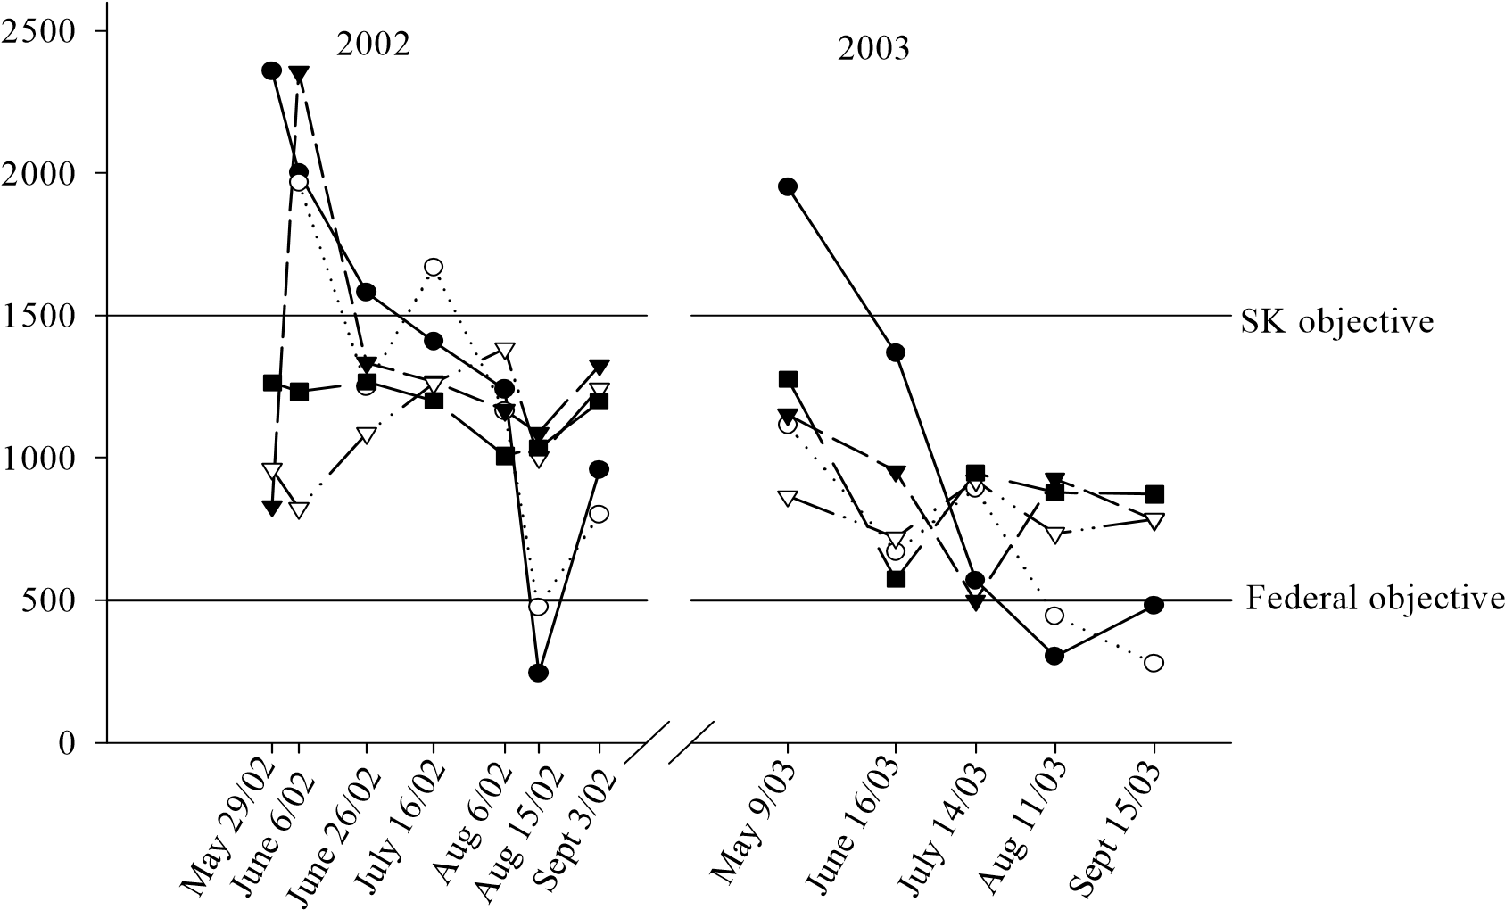
Total Dissolved Solids (mg/L)

Site 1 - Shamrock Park
Site 2 - Cattle
Site 3 - Gravelbourg
Site 4 - Agriculture
Site 5 - Thomson Lake

Figure 4.6. Total dissolved solids (TDS) concentration of the Wood River. The
Saskatchewan (SK) and federal drinking water objectives for TDS are also shown.

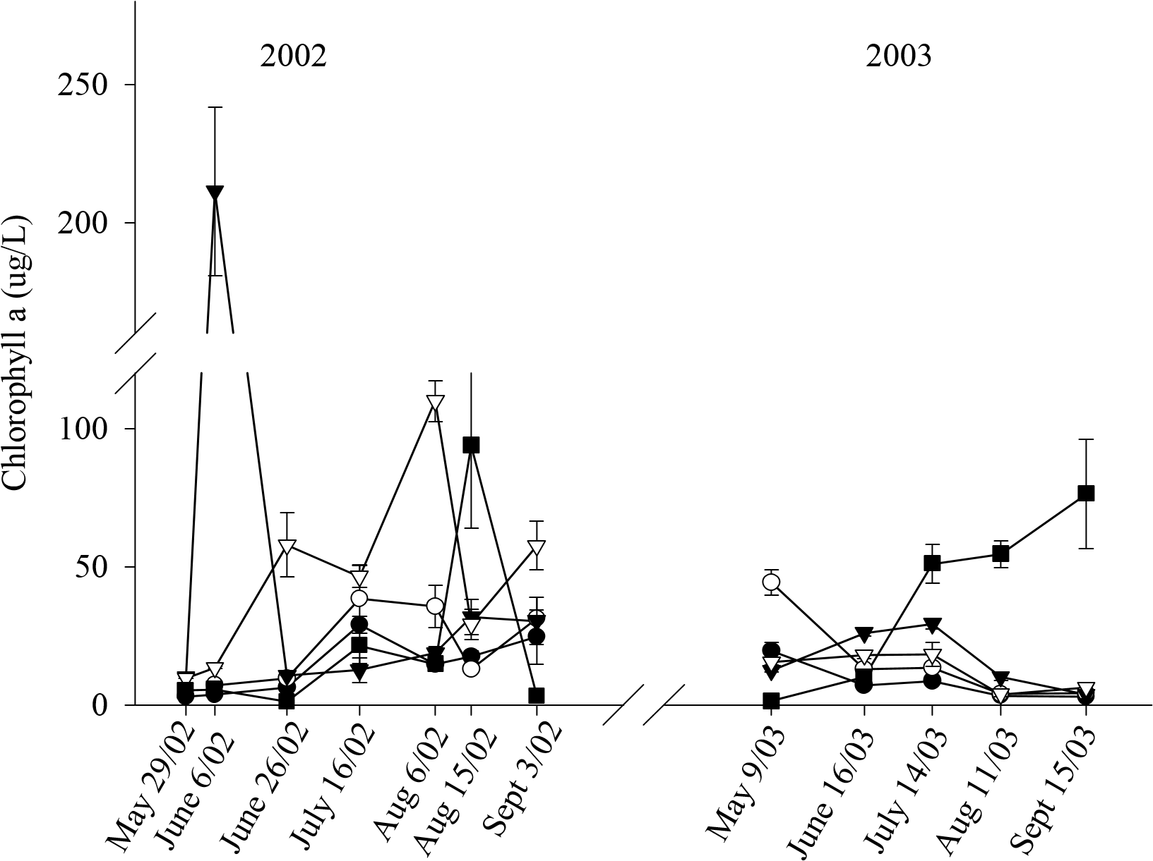
Site 1 - Shamrock Park
Site 2 - Cattle
Site 3 - Gravelbourg
Site 4 -Agriculture
Site 5 - Thomson Lake
Figure 4.7. Chlorophyll a levels of the Wood River, 2002-2003.

A
Total Nitrogen (mg N/L)
3
2
1
0
Chlorophyll
a
(
µ
g/L)
0
10
20
30
40
50
r
2
=0.67
Thomson Lake
Gravelbourg
Cattle
Agriculture
Shamrock Park
2002
2003
Gravelbourg
Agri
c
ulture
Thomson Lake
Cattle
Shamrock Park
B C
T
ota
l
N
i
t
r
oge
n
(
m
g

N/
L
)
0
1
2
3
Chlorophyll
a
(
µ
g/L)
10
20
30
40
r
2
=0.76
Thomson Lake
Gravelbourg
Cattle
A
griculture
Shamrock Park
Total Nitrogen (mg N/L)
4
2
1
3
Chlorophyll
a
(
µ
g/L)
0
10
20
30
40
50
r
2
=0.73
Gravelbourg
Agriculture
Thomson Lake
Cattle
Shamrock Park

Figure 4.8. Linear regression analysis of total nitrogen vs. chlorophyll a for both 2002 and 2003 (A), only 2002 (B), and only 2003 (C).
A
Total Phosphorus (mg P/L)
0.2
0.3
0.4
0.5
0.6
0.7
0.8
0.1
Chlorophyll
a
(
µ
g/L)
0
10
20
30
40
50
r
2
=0.59
Thomson Lake
Gravelbourg
Cattle
Agriculture
Shamrock Park
2002
2003
Gravelbourg
Agriculture
Thomson Lake
Cattle
Shamrock Park
B C
Total Phosphorus (mg P/L)
0.55
0.50
0.40
0.45
0.60
0.35
0.65
0.70
Chlorophyll
a
(
µ
g/L)
10
15
20
25
30
35
40
45
50
r
2
=0.85
Cattle
Shamrock Park
Gravelbourg
Agriculture
Thomson Lake
Total Phosphorus (mg P/L)
0.2
0.1
0.3
0.4
0.5
0.6
Chlorophyll
a
(
µ
g/L)
5
10
15
20
25
30
35
40
r
2
=0.30
Thomson Lake
Gravelbourg
Cattle
Agriculture
Shamrock Park

Figure 4.9. Linear regression analysis of total phosphorus vs. chlorophyll a for both 2002 and 2003 (A), only 2002 (B), and only 2003 (C).

According to the linear regression of chl a vs. TP, 59% of the variation in chl a levels can be explained by variation in TP (Fig 4.9 A). This relationship, however, was much stronger in 2002 (r²=0.85) than in 2003 (r²=0.30) (Fig 4.9 B, C). Therefore, TP seems to have had a much stronger effect on phytoplankton biomass in 2002 than in 2003. When examining the linear regression analysis of the chl a vs. nutrient plots (Figs. 4.8 A, 4.9 A) the separation of sites becomes apparent. The linear regression of chl a vs. TP for all the sites (Fig. 4.9 A) showed the agricultural site and Gravelbourg in 2002 grouped together, with higher concentrations of TP and higher levels of chl a were observed at these sites. Thomson Lake in 2003 was also high. The cattle site, Shamrock Park, and Thomson Lake points from 2002 grouped together with the Gravelbourg and agriculture sites from 2003. These sites had moderate levels of nutrients. The cattle and Shamrock Park data points from 2003 were grouped together at the lowest mean TP concentrations and lowest levels of chl a.
The plot of chl a vs. TN yielded similar results (Fig 4.8 A). The agricultural and Gravelbourg data points from 2002 as well as the Thomson Lake point from 2003 were grouped together at the high end of both the TN and the chl a concentrations. The rest of the points grouped together in this graph, with the cattle and Thomson Lake points from 2002 being slightly higher than the rest and Shamrock Park 2003 being the lowest. 4.3.5 Bioassays
Nutrient enrichment bioassays indicated that pelagic phytoplankton communities of the Wood River are primarily limited by nitrogen, although occasionally limited by a combination of nitrogen and phosphorus (Table 4.3).
The single bioassay carried out in 2002 showed that Shamrock Park, the cattle site, Gravelbourg, and the agricultural site were all limited by a combination of both N and P, but that Thomson Lake was limited solely by nitrogen.
The bioassay carried out in May of 2003 indicated that Shamrock Park was limited by both N and P. The remainder of the sites were limited by nitrogen alone. In June, Shamrock Park and the cattle site were limited by both N and P while the other sites were limited by N. In July, Shamrock Park was again limited by N and P, however, the

Table 4.3. Bioassay results showing nutrient limitation by nitrogen (N), phosphorus (P), or co-limitation by both nutrients (N+P).

Date | Thomson Lake | Agriculture | Gravelbourg | Cattle | Shamrock Park
Aug-02 | N | N+P | N+P | N+P | N+P
May-03 | N | N | N | N | N+P
Jun-03 | N | N | N | N+P | N+P
Jul-03 | N | N+P | N | N | N+P
Aug-03 | N | N | N | N | N
Sep-03 | N+P | N | N | N+P | N+P
 | 83% N | 67% N | 83% N | 50% N | 17% N

agricultural site also seemed to be limited by the two nutrients while the other sites were again only limited by N. The bioassay carried out in August showed that all sites were limited by N except Gravelbourg, which was limited by both N and P. And finally, the bioassay carried out in September showed that Shamrock Park, the cattle site and Thomson Lake were limited by a combination of N and P while Gravelbourg and the agricultural site were limited by N. It appears therefore, that nitrogen is the primary limiting nutrient for pelagic phytoplankton in the Wood River, although occasionally co- limitation by N and P is important. It also appears, however, that nutrient limitation changes as the river flows downstream. Thomson Lake, the agricultural site, and the Gravelbourg site all show primarily N limitation (Table 4.3). The cattle site shows 50% N limitation and 50% co-limitation of N and P and Shamrock Park seems to be co-limited by N and P most (83%) of the time (Table 4.3). Therefore, as the river flows downstream, nutrient limitation changes from N to co-limitation of N and P.

4.3.6 Sestonic Ratios

4.3.6.1 2002
In 2002, PN:PP ratios generally indicated that none of the sites were P deficient (Fig. 4.10). The agricultural site was briefly severely P-deficient on June 6th. Thomson Lake and the Gravelbourg effluent site both become moderately P-deficient on the same date. Otherwise, this ratio indicates that the other sites were P sufficient.
The PP:PC ratio indicates the same general state of P sufficiency except for Thomson Lake (Fig 4.11). The PP:PC ratio indicated that Thomson Lake generally had moderate P deficiency. As with the PN:PP ratio, the PP:PC ratio showed severe P deficiency on June 6th at the agricultural site.
The PN:PC ratio indicates that 3 of the 5 sites, Shamrock Park, the cattle site, and the site of intensive agriculture, were moderately N deficient at the start of the study season but were gradually released from this deficiency (Fig. 4.12). Thomson Lake and the Gravelbourg effluent site start the season in the spring with sufficient N. Thomson Lake fluctuated between N sufficiency and deficiency throughout the season and all sites seem to hover around the deficiency/sufficiency boundary throughout the season.

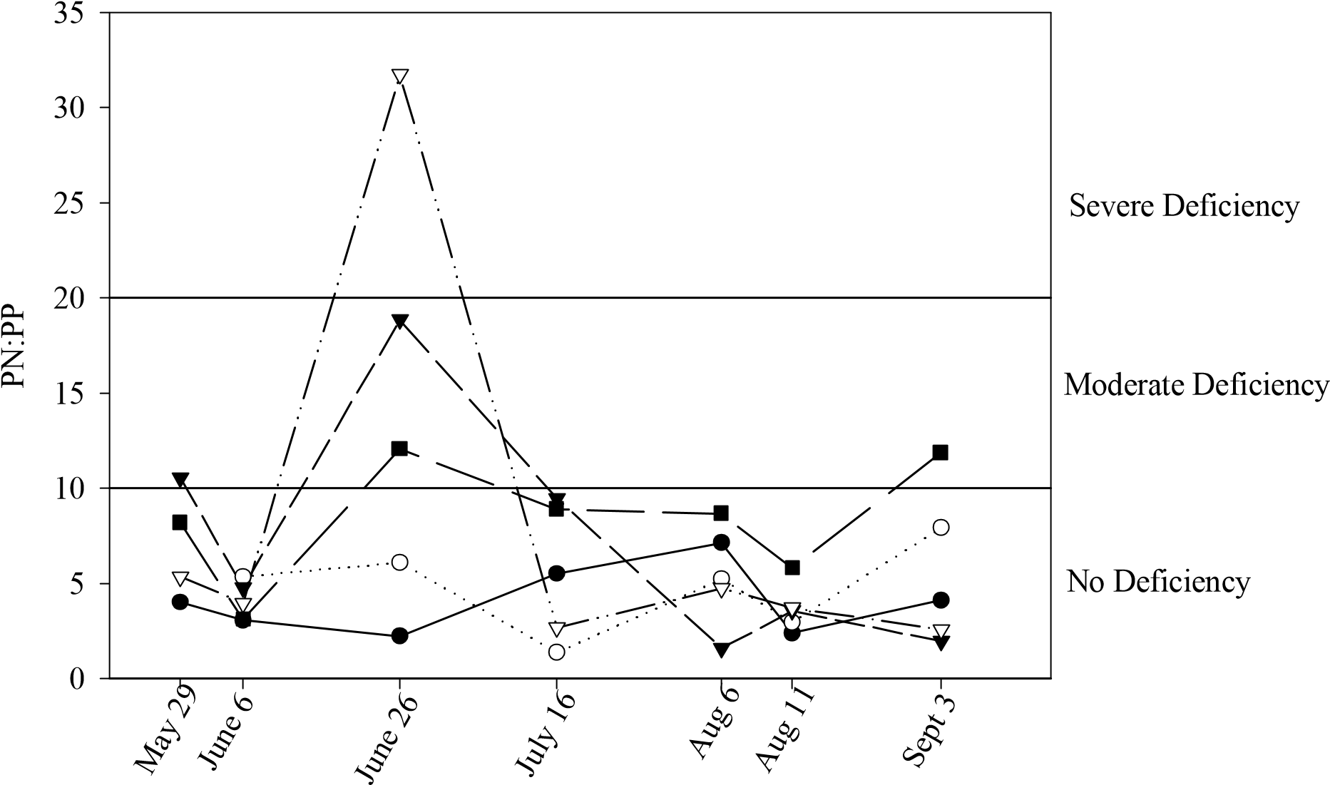
Site 1 - Shamrock Park Site 2 - Cattle
Site 3 - Gravelbourg Site 4 - Agriculture
Site 5 - Thomson Lake

Figure 4.10. Sestonic ratio PN:PP for 2002. Y axis indicates boundary for P sufficiency or deficiency as outlined by Healey and Hendzel (1980).

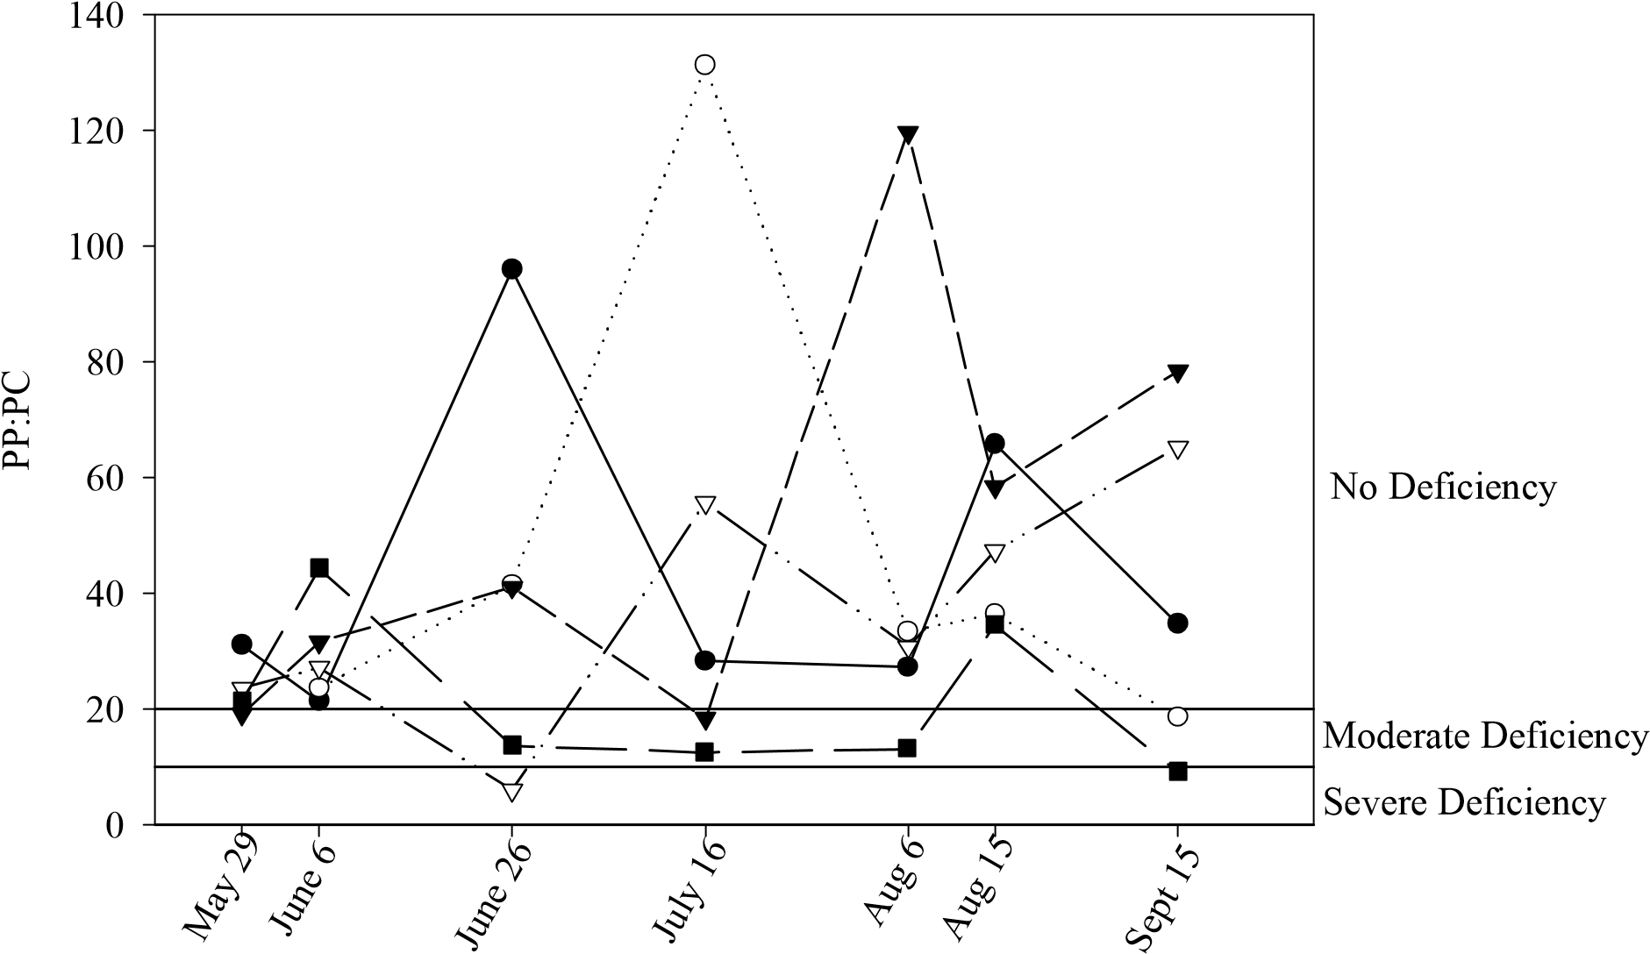
Site 1 - Shamrock Park Site 2 - Cattle
Site 3 - Gravelbourg Site 4 - Agriculture
Site 5 - Thomson Lake

Figure 4.11. Sestonic ratio PP:PC for 2002. Y axis indicates boundary for P sufficiency or deficiency as outlined by Healey and Hendzel (1980).

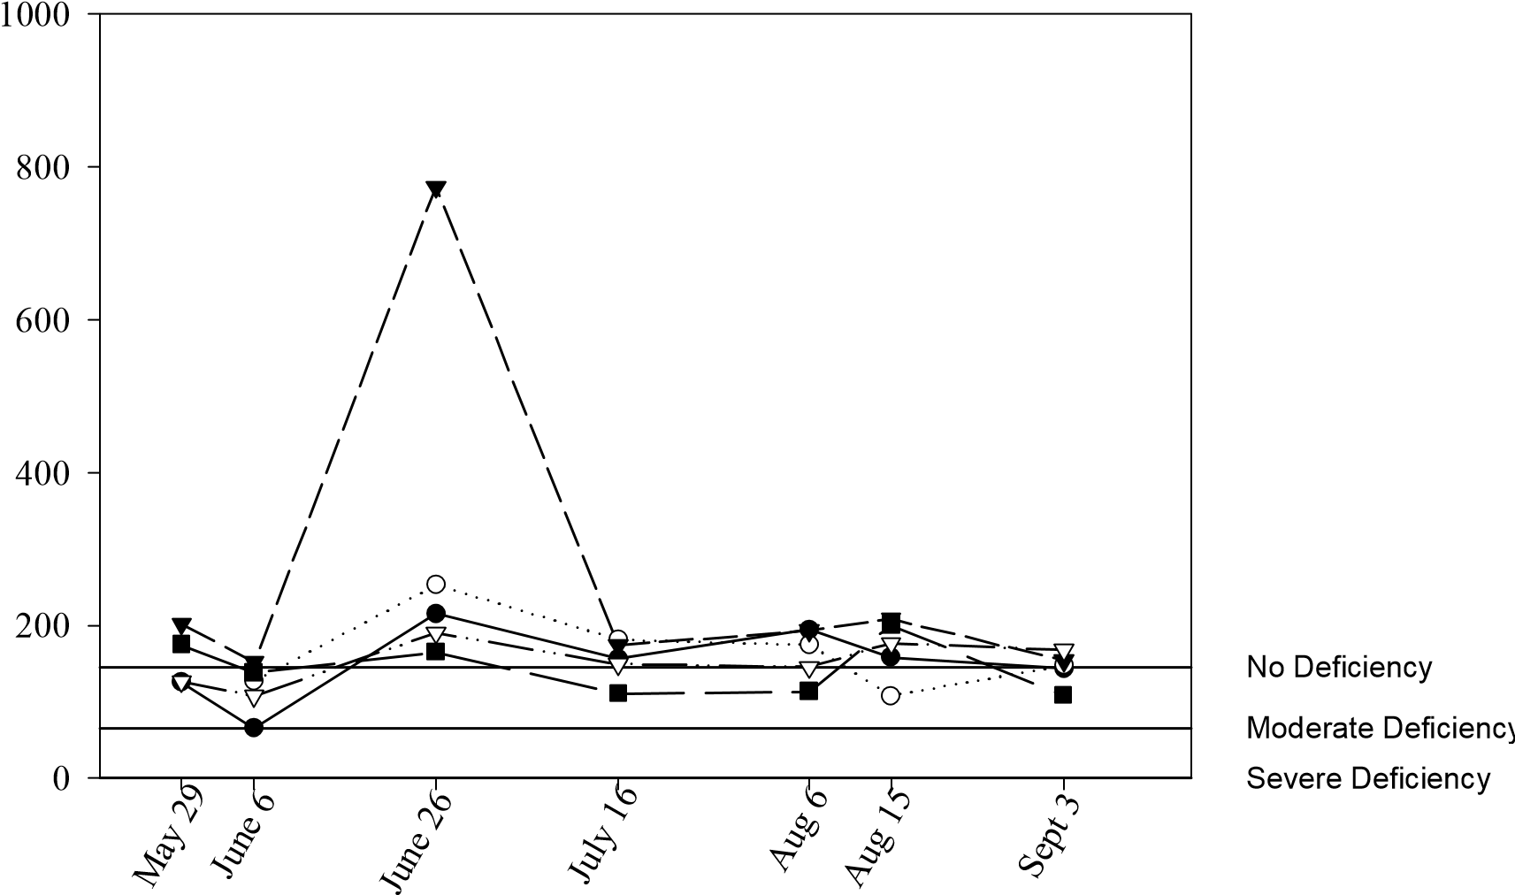
PN:PC
Site 1 - Shamrock Park Site 2 - Cattle
Site 3 - Gravelbourg Site 4 - Agriculture
Site 5 - Thomson Lake

Figure 4.12. Sestonic ratio PN:PC for 2002. Y axis indicates boundary for N sufficiency or deficiency as outlined by Healey and Hendzel (1980).

4.3.6.2 2003
In 2003, the PN:PP ratio generally showed no phosphorus deficiency (Fig 4.13). The PP:PC ratio produced the same results (Fig 4.14). Both ratios indicate that the agricultural site was slightly P deficient on July 14, otherwise, all sites seem to be P sufficient throughout the study season.
The PN:PC ratio shows all of the sites started the season with an N deficiency (Fig 4.15). No N deficiency was seen on the July and August sampling dates, but three of the sites, Shamrock Park, the cattle site, and Thomson Lake, become N deficient again in September.

4.4 Discussion

4.4.1 Water Chemistry
Not only are nitrogen and phosphorus concentrations high in the Wood River, they are high compared to other rivers worldwide. For example, TP concentrations of most uncontaminated surface waters range between 10 and 50 µg/L (Wetzel 2001). Mean TP concentration for the Wood River over the two years of this study was 474 µg/L (± 246 STD). OP averages about 10 µg/L worldwide among unpolluted rivers, while TDP averages 25 µg/L (Wetzel 2001). The mean OP concentration of the Wood River was 311 µg/L (± 160 STD) and for TDP it was 365 µg/L (± 171 STD) during the course of this study. Furthermore, TP concentrations in the Wood River place it strongly in the eutrophic category as TP concentrations of over 75 µg/L are considered eutrophic (Dodds et al. 1998). As well, the nutrient concentrations in this river are significantly higher than those of rivers in Alberta and the Midwest region of the United States that have similar land uses (Carr and Chambers 1998, Leland and Porter 2000). For example, the Bow River in Alberta was found to have an average TP concentration of 56 µg/L (±3.0 STD), the Oldman River 61 µg/L (±8.0 STD), and the South Saskatchewan River 104 µg/L (±17.0 STD) (Carr and Chambers 1998). More importantly, TP concentrations in the Wood River exceed the Alberta guideline for the protection of aquatic life (Alberta Environment 1999). Comparison to Alberta guidelines is necessary because neither federal nor Saskatchewan provincial guidelines for phosphorus levels in aquatic systems exist.

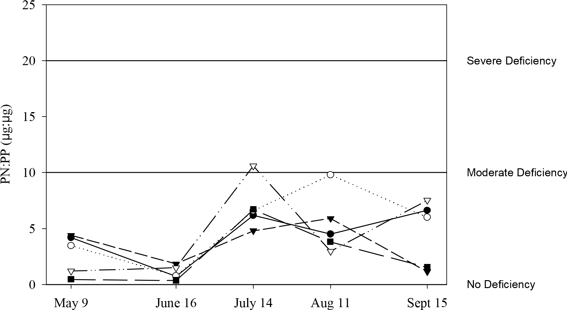
Site 1 - Shamrock Park Site 2 - Cattle
Site 3 - Gravelbourg Site 4 - Agriculture
Site 5 - Thomson Lake

Figure 4.13. Sestonic ratio PN:PP for 2003. Y axis indicates boundary for P sufficiency or deficiency as outlined by Healey and Hendzel (1980).

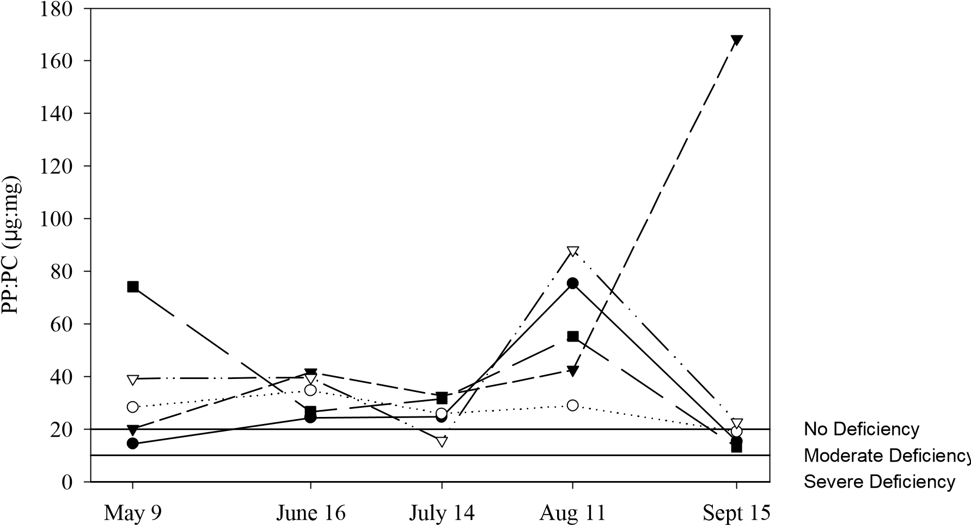
Site 1 - Shamrock Park Site 2 - Cattle
Site 3 - Gravelbourg Site 4 - Agriculture
Site 5 - Thomson Lake

Figure 4.14. Sestonic ratio PP:PC for 2003. Y axis indicates boundary for P sufficiency or deficiency as outlined by Healey and Hendzel (1980).

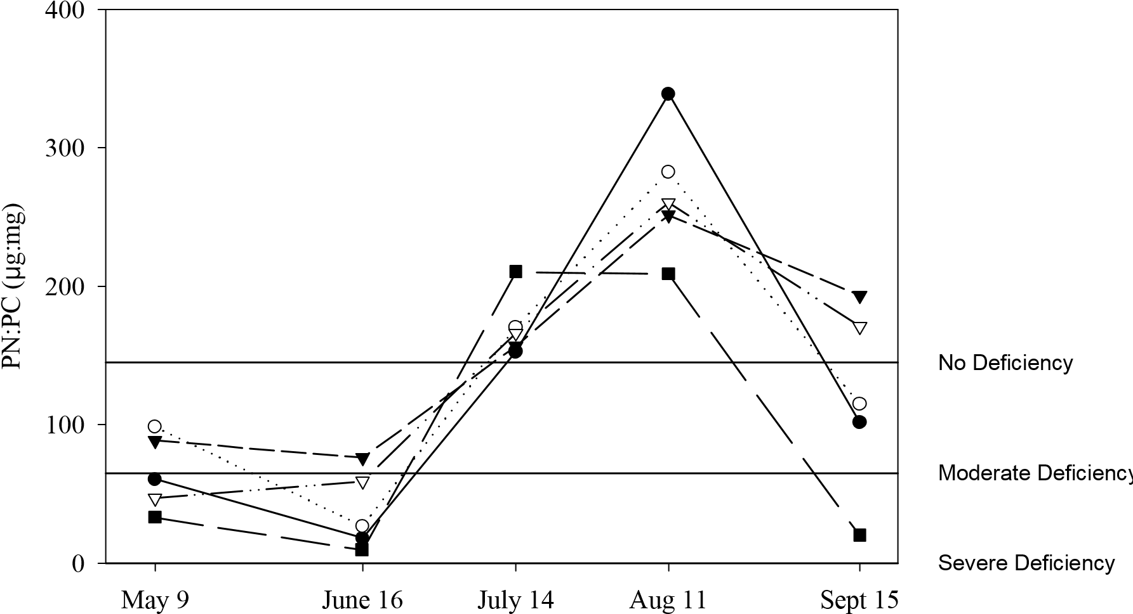
Site 1 - Shamrock Park Site 2 - Cattle
Site 3 - Gravelbourg Site 4 - Agriculture
Site 5 - Thomson Lake

Figure 4.15. Sestonic ratio PN:PC for 2003. Y axis indicates boundary for N sufficiency or deficiency as outlined by Healey and Hendzel (1980).

Nitrogen levels in the Wood River were also high. As with TP concentrations, TN concentrations of the Wood River also suggest that it was eutrophic. Concentrations greater that 1500 µg/L are considered to be in the eutrophic range (Dodds et al. 1998), and the mean TN concentration of the Wood River over the period of this study was 1680 µg/L (± 996 STD). Nitrogen levels in this river are also higher than those of Alberta and American rivers, which experience similar land uses (Carr and Chambers 1998, Leland and Porter 2000). As with TP, TN concentrations in the Wood River exceeded the Alberta guideline for the protection of aquatic life. There is no Saskatchewan guideline for TN in aquatic systems, but the Wood River occasionally exceeded the Saskatchewan provincial objective for ammonia toxicity during the study period (Saskatchewan Environment 1997). Ammonia toxicity is pH and temperature dependent. Although ammonia concentrations tend to be low in natural river waters, 7-60 µg/L (Wetzel 2001), the mean ammonia concentration of the Wood River over the two years of this study was high (223 µg/L ± 993 STD). Ammonia is toxic to fish and aquatic organisms, even in very low concentrations. When levels reach 60 µg/L, fish can suffer gill damage, and when levels reach 200 µg/L, sensitive fish like trout and salmon begin to die (Chambers et al. 2001). Ammonia levels greater than approximately 100 µg/L usually indicate polluted waters (Chambers et al. 2001), and the Wood River generally exceeded this value throughout the study period.
Based on research presented here, there seems to be a need for provincial guidelines in this province for N and P levels in aquatic systems. The Wood River, whose watershed is dominated by agricultural land use, is not unusual in the province of Saskatchewan. Many waterbodies are located within or adjacent to land which undergoes cultivation. Consequently, there is a strong likelihood that many of these waterbodies receive N and P as a result of runoff from agricultural lands. This study has shown that the Wood River currently has high levels of N and P, and the bioassay data has shown that algae in the river are responsive to additions of N and P. But, because there are no provincial water quality guidelines in place, there are no standards against which to judge current nutrient levels in the Wood River. While water quality guidelines are not regulations and cannot not deal with potential sources of water quality degradation, they can be used as a first step to identify areas of concern. Based on research presented here, water quality guidelines would identify the Wood River as an area of concern. In the United States for example, the Environmental Protection agency (EPA) has suggested that more stringent nutrient criteria may be required for streams that feed in to lentic waters (EPA 2000). For example, it is proposed that 35 µg/L TP concentration and a mean concentration of 8 µg/L chl a constitute the dividing line between eutrophic and mesotrophic lakes (OECD 1982). By contrast, Dodds et al. (1998) suggests a TP boundary of 75 µg/L and a chl a boundary of 30 µg/L for streams and rivers. Thus, unacceptable levels of chl a may occur in lakes at much lower nutrient concentrations compared to streams (Dodds and Welch 2000). This is important in the Old Wives Lake watershed as the Wood River flows in to Old Wives Lake and multiple reservoirs. Nutrient guidelines for the Wood River could be modeled around nutrient concentrations at Shamrock Park as they represented the most favourable nutrient concentrations in the river.
As with the nutrient concentrations, total dissolved solids in the Wood River are also high. The federal drinking water objective for TDS is 500 mg/L which the Wood River exceeds in 88% of the samples (Fig. 4.6) (Canadian Council of Ministers of the Environment 1999). The Saskatchewan guideline, however, is 1500 mg/L, and the samples only exceed this objective 12% of the time (Saskatchewan Environment 2002). Issues with high TDS levels are well known in the area as there are problems with taste and colour of their drinking water (Schmutz 2000). Drinking water treatment does not remove TDS, in fact, the chemicals added to treat water actually increases the TDS concentration (Environment Canada 2001). The TDS values recorded may also exceed guidelines for irrigation purposes in some areas as well (Canadian Council of Ministers of the Environment 1999, Saskatchewan Environment 1997). The water quality guidelines for cattle were not exceeded, therefore, the areas included in this study are still suitable for this purpose (Canadian Council of Ministers of the Environment 1999).

4.4.2 Factors Affecting Algal Biomass
In 2002, there was more variation in and higher levels of chl a compared to 2003. The differences between years may be explained by hydrological differences. For example, studies have shown that horizontal water movement controls the time available for attached and suspended biota to interact with transported materials as well as controlling a host of other factors important to aquatic ecosystem function such as turbulence, dilution, turbidity, and nutrient supply (SØballe and Kimmel 1987). Consequently, low flows of 2003, and thus increased water residence time, could lead to higher algal abundances by allowing algae more time to take up nutrients before they move downstream. The high flows of 2002, on the other hand, could lead to shorter water residence times, could affect nutrient availability, and thus, algal biomass by moving nutrients downstream more quickly. But, higher levels of chl a were seen in 2002 than in 2003. This apparent contradiction may be due to a number of factors. For example, high chl a, N and P concentrations associated with the release of the Gravelbourg waste water effluent were included in the study in 2002. This may have skewed the mean values upward. Also, 2002 was dry in spring and became wetter as summer progressed. There was little precipitation around the time of fertilizer application. Large precipitation events occurred in June, which could have allowed for movement of nutrients into the river from upland sources (Correll et al. 2001, Interlandi and Crockett 2003, Little et al. 2003). Large discharges were also recorded at this time. This likely disturbed sediments thus releasing nutrients (Stevenson and White 1995, McKee et al. 2001). This was also a time that was conducive to algal growth. Temperatures were warm (Table 3.1) and days were long - ideal conditions for algal growth (Stevenson and White 1995). This, coupled with the increase in nutrients, could account for the high chlorophyll a values recorded in 2002. But, the river was also more turbid as a result of the increased flow (pers. obs.), which potentially could have dampened the effect of the nutrient addition somewhat by decreasing the light available for photosynthesis (Stevenson and White 1995, Hatch 2002).
Conversely, in 2003, there was more precipitation than normal in the spring, right at the time of fertilizer application. As a result, there was likely significant movement of nutrients into the river from upland sources due to the timing of this increased precipitation (Correll et al. 2001, Interlandi and Crockett 2003, Little et al. 2003). In the spring of 2003, Thomson Lake and the agricultural site both began the season with higher levels of TDN and NH₃ than the other sites, mostly likely because these two sites are in close proximity to agriculture. During this time, however, temperatures were low (see Table 3.1) and days were shorter - both factors which could impede algal growth (Stevenson and White 1995). The release of the Gravelbourg effluent could possibly have been well timed in this year, as it was most likely too cold to support a large bloom of phytoplankton as was seen in 2002. Since this was also a time of high flow, nutrients were probably moved downstream and dispersed rather effectively. There was, therefore, not enough time for the phytoplankton to take up these nutrients. Consequently, then the Gravelbourg effluent could conceivably be released early in the season without causing the large increases in chl a seen in 2002.
Studies have also shown that there is a shift from biotic to physical control of nutrient fluxes as residence time decreases in streams, rivers and rapidly flushed impoundments (SØballe and Kimmel 1987). In these situations, algal abundance often depends more on variations in physical characteristics (temperature, turbidity, flow variations) than on nutrient concentrations (SØballe and Kimmel 1987). Thus, higher variability in the algal-phosphorus relationship is expected in short-residence systems. This could account for the poor correlation between TP and chl a concentrations in the Wood River when discharge was high in 2002.
Results from the bioassays indicate that nitrogen was limiting phytoplankton growth particularly at the sites most influenced by agriculture and municipal waste water effluent. The results also show that this limitation changes to co-limitation of N and P in areas less affected by land use. These results are in agreement with other studies conducted on aquatic ecosystems where land use is dominated by agriculture. For example, N is more important as a limiting nutrient of phytoplankton in streams than in lakes, particularly in watersheds that are dominated by agriculture (Lohman et al. 1991, Chessman et al. 1992, Biggs 1995, Scrimgeour and Chambers 2000, Stelzer and Lamberti 2001). Reasons for N limitation are closely tied to P concentrations, as observed in the Wood River. When phosphorus is available in quantities adequate to support metabolism, nitrogen availability can become limiting, particularly to phytoplankton (Wetzel, 2001). Phytoplankton take up N and P in a specific ratio, known as the Redfield ratio. For every molecule of P taken up, 16 N are required (16:1 molar ratio) (Redfield 1958). Therefore under excess P conditions, which are present in the Wood River, especially at sites affected by agriculture and sewage effluent, much more N is taken up than P, hence the N limitation in the river in areas of intensive land use (Thomson Lake, the agricultural and Gravelbourg sites). In areas less affected by land use (Shamrock Park, cattle site), lower levels of P were measured, therefore less nitrogen was taken up, which could account not only for the lack of N limitation seen here but also for co-limitation of phytoplankton by N and P.
The bioassay results presented here showed the potential for phytoplankton in the Wood River to respond to nutrient additions. Consequently, there was an expectation that if excess nutrients were added to the river an increase in algal biomass would result. This was exactly what was seen when the effluent dump occurred in 2002. Chl a levels increased by a factor of 20 after the effluent dump. There seem to be a direct link, therefore, between high levels of nutrients added by municipal effluent and an increase in phytoplankton biomass in the river.
Unlike nutrient levels, however, which indicated that the Wood River was eutrophic, chl a levels indicated that the Wood River was mesotrophic (Dodds et al. 1998). This was also apparent when the data from the Wood River was compared to data from rivers in Alberta. Although the nutrient levels were much higher in the Wood River than in the Alberta rivers tested, the chl a levels were only slightly higher (Carr and Chambers 1998). But, the bioassay experiments showed that the phytoplankton of the Wood River respond readily to nutrient addition. This apparent contradiction suggests that other significant factors, not just nutrients, contribute to the regulation of phytoplankton in this river. These factors could include nutrient availability, light, current velocity, or temperature (EPA 2000). For example, increased sediment load during high discharge events in 2002 and early 2003 caused increased turbidity in the river (pers. obs.). This increased turbidity probably decreased light penetration and thereby limiting phytoplankton growth (Van Nieuwenhuyse and LaPerrier 1986, Stevenson and White 1995, Basu et al. 2000). Nutrients are also known to bind to sediment, so this increased suspended sediment could have decreased the absolute amount of nutrients available for phytoplankton growth (Correll et al. 1999). Such factors may explain why, despite high N and P concentrations, chl a levels in the river reflect mesotrophic, not eutrophic conditions.

4.4.3 Land Use Effects on Water Chemistry
One of the important results of this study is the apparent link between land use and water quality in the Wood River. Not only are nutrient levels in this river high, even when compared to watersheds with similar land uses (Carr and Chambers 1998, Leland and Porter 2000), nutrient levels differ in areas with different land uses. The contention of a link between land use and nutrient concentrations is further bolstered by the robust relationship between chl a and N and P concentrations (Figs. 4.8 A and 4.9 A). The regression of chl a vs. N and P visually demonstrates the separation of sites based on land use. The chl a vs. TP regression for 2002 (Fig. 4.9B) revealed that the agricultural site and Gravelbourg were grouped together and appeared much higher on the regression line than the other sites. Gravelbourg had high mean TP and chl a concentrations in 2002 most likely because of the effect of the effluent release. In 2002, the agriculture site was most likely high due to the greater than average amount of precipitation which likely moved nutrients off the land and into the river (Correll et al. 2001, Little et al. 2003). It is interesting to note that the release of the Gravelbourg effluent was a one time event and a point source of pollution whereas the movement of nutrients into the river from cropland at the agricultural site was a persistent event and a nonpoint source of pollution, yet overall their influence on mean nutrient concentrations were quite similar. Point sources of pollution are quite visible and easy to suggest as a source of pollution, but this data shows that nonpoint sources of pollution are equally important.
The data point for Thomson Lake in 2003 was also high on the regression line. As discussed earlier, there was probably considerable movement of nutrients into Thomson Lake and the agricultural site early in the season because of high precipitation around the time of fertilizer application. Thomson Lake however, would have a higher retention time for nutrients than the agricultural site, because it is a reservoir (Stevenson and White 1995). As the season progressed, nutrients were probably still available when conditions (temperature and light) became more favourable for algal growth (Stevenson and White 1995), thereby contributing to the large phytoplankton bloom seen in Thomson that year. The cattle site, Shamrock Park, and Thomson Lake points from the 2002
regression were grouped together with the Gravelbourg and agriculture sites from 2003. These sites had moderate levels of nutrients, note that even the reference site (Shamrock Park) had moderate levels of nutrients in 2002. Again, this is most likely due to high precipitation and high river discharges seen in this year. The cattle and Shamrock Park data points from 2003 had the lowest mean TP concentrations. The reason for this similarity is most likely due to the apparent absence of cattle at the cattle site in 2003. Cattle were not seen in this area at all during the 2003 study season whereas as they were seen during 6 of the 7 sampling times in 2002. Since there was probably little influence from land use (cattle) it is not surprising that nutrient concentrations there were similar to those of the reference site.
The reference site had the lowest concentrations of N and P and chl a in comparison to the other sites. Shamrock Park, therefore, served its purpose as a reference site. This site was minimally impacted by land use and its water quality was also the least degraded of all the sites. This suggests that land use is likely having an effect on nutrient levels.
The research presented here shows that areas in the Old Wives Lake watershed that have intensive land use (the agricultural site, Thomson Lake, the Gravelbourg effluent site) have higher levels of nutrients than areas where agricultural intensity is low, such as Shamrock Park and the cattle site (2003). Another important result of this study was the effect of municipal waste water effluent on the water quality of the Wood River. The effluent dump dramatically increased both nutrient concentrations and chl a levels. These results are in close agreement with many other studies which have shown increased nutrients in rivers of watersheds dominated by intensive agriculture, or that receive municipal wastewater effluents. Many rivers in Canada, for example, show signs of moderate nutrient enrichment downstream of municipal waste water discharges or areas of intensive agriculture (Chambers et al. 2001, Cooke and Prepas 1998). Studies have also show the pattern of spatial variability in water quality compares to the variation of land use within a watershed, as was seen in the Wood River (Whiles et al. 2000, Interlandi and Crockett 2003, Little et al. 2003). Areas of intensive agriculture have water quality that is poor whereas undisturbed or minimally disturbed areas have better water quality, even along the same river. Rivers in agricultural watersheds have been shown to have much higher TP and TN concentrations than rivers in watersheds with other land use types (Tong and Chen 2002). Omernik (1976) found that mean TP concentrations were nearly ten times greater in streams draining agricultural lands than in streams draining other land uses. Results presented here are in agreement with these studies. But the data presented here does differ from the literature in one important aspect. N and P concentrations in the Wood River are higher than other rivers that have similar land use. At this point in time, the reasons for this anomaly are not clear, but it is certainly deserving of further research.

4.4.4 Climatic Effects on Water Chemistry
Upon examination of the water quality data, it is evident that the two study years were quite different with greater variation in nutrient concentrations and higher chl a observed in 2002 than in 2003. When considering what factors could have caused such variation, it became apparent that climate could potentially have been an influence since the two years were very distinct in terms of precipitation and, consequently, discharge and water levels. The timing of precipitation may also be an important factor. Although spring 2002 was dry and became wetter as summer progressed, there was little precipitation around the time of fertilizer application. Other than the effluent dump at the end of May, therefore, there was probably little movement of nutrients into the river from upland sources during this period. Large precipitation events did, however, occur in June, allowing for movement of nutrients into the river from upland sources (Correll et al. 2001, Interlandi and Crockett 2003, Little et al. 2003). Large discharges and water levels were recorded at this time. These could be factors in the high variation in nutrient and chl a levels seen in this year. Conversely, in 2003, there was much more precipitation than normal in the spring, right at the time of fertilizer application. There was likely a great deal of movement of nutrients in to the river from upland sources at this time due to the timing of this increased precipitation (Correll et al. 2001, Interlandi and Crockett 2003, Little et al. 2003). The summer then became quite dry with little precipitation. Consequently, although nutrient levels were high in the spring, they were not sustained by further additions later in the year. This may explain why there was less variation in nutrient levels and lower levels of chl a in this study year.
Climatic variability, therefore, appears to have the potential to affect water quality in the Old Wives Lake watershed. Decreased water availability is predicted to be one of the most profound impacts of climate change, especially on the Canadian prairies that are already operating under a water deficit (Environment Canada 1997). Decreased stream discharge is typically associated with increases in the concentration of chemical constituents, but decreases in total export of chemical constituents, because of decreased stream volume (Schindler et al. 1997). A warmer, drier climate also increases the residence time of chemical constituents within surface waters and soils, and causes longer flushing times for pollution (Murdoch et al. 2000). In general, however, concentrations of constituents typically derived from surface runoff or erosion may decrease, and constituents derived from point sources will increase in a warmer, drier climate (Schindler et al. 1997). This could have consequences in the Old Wives Lake watershed. Nonpoint source pollution from agriculture might decrease, but the effects of sewage effluent may become more severe, and the effects may be longer lasting due to lower flows. The Wood River ecosystem may therefore be quite vulnerable to the effects of climate change. Consequently, global warming and the resulting changes in precipitation patterns could significantly alter the quality of surface waters in this area.

4.5 Summary
Nutrient levels are high in the Wood River and are also higher than in rivers that are surrounded by similar land uses. The data presented here shows higher nutrient concentrations at sites where agricultural land use dominates and where sewage is released than at the reference site. This suggests that current land use factors are contributing to the high nutrient levels observed in the Wood River. Nutrient concentrations already place the Wood River in the eutrophic category. Under certain climate change scenarios, such as changes in precipitation patterns, significant changes in the water quality and biology of the river could result. There is a real need therefore, for mitigative measures to be implemented in the Old Wives Lake watershed.
Strategies such as nutrient management and land management tools such as soil conservation practices and riparian management are mitigative measures that have been used to reduce the effects of nonpoint source pollution on water quality. It has been shown that land use, particularly in riparian zones, influences stream habitat (Quinn et al. 1997), water quality (Gregory et al. 1991, Jordan et al. 1993), and thus stream communities. Although the majority of studies to date have focused on forested riparian zones, studies have shown that similar relationships exist for prairie streams draining an agricultural landscape and that riparian zones should be a focal point for stream management in this prairie region (Whiles et al. 2000). The following chapter will examine various mitigative strategies that can be used to reduce nonpoint source pollution from agriculture in the Old Wives Lake watershed and improve the water quality of the Wood River.

5. CHAPTER FOUR
MITIGATION OF LAND USE IMPACTS

5.1 Introduction
The research from this study has demonstrated that both municipal waste water effluents and agricultural land use in the Old Wives Lake watershed may have a negative effect on the water quality of the Wood River. This chapter will focus on strategies that can be used to help mitigate the nonpoint source pollution arising from agricultural land use. Strategies such as nutrient management and land management tools including soil conservation practices and riparian management will be discussed. It has been shown that land use, particularly in riparian zones, influences stream habitat (Quinn et al. 1997), water quality (Gregory et al. 1991, Jordan et al. 1993), and thus stream communities. Studies have also suggested that riparian zones should be a focal point for stream management in the prairie region (Whiles et al. 2000).
In order to examine the options available to mitigate this water quality impairment, it must first be understood why this impairment is occurring. The economics of nonpoint source pollution will help to explain farmers' decisions with respect to their land. An economic framework will also aid in choosing mitigation strategies that are economically viable. Subsequently, these different strategies will be discussed, and their viability in the region of the Wood River will be determined. 5.2 Economics of Nonpoint Source Pollution
Development and implementation of successful nonpoint source pollution control strategies requires not only knowledge of source areas and transport pathways of pollution, but also an understanding of why pollution is occurring. A case study approach will be used to examine the economics of nonpoint source pollution effects on water quality. At issue is the fact that agriculture can have a detrimental effect on water quality. To simplify the problem, it will be discussed in terms of a single farmer who uses fertilizer on his land. The fertilizer is increasing nutrient levels in a river flowing through his property. The stakeholders here are the farmer and the other users of the river, “society”. The river in this case is an open access resource, it is non-excludable, in that people cannot be prevented from using the resource, or that exclusion of other users is very expensive. Also, it is rival in that the quality of the water can be decreased by one user or stakeholder which decreases the water quality for all users downstream. The cause of the market failure in this case, therefore, is the presence of an open access resource, due to the externalities (decreased water quality) imposed on society by the farmer.
In the model (Fig 5.1), MC_{S} represents the marginal cost of fertilizer use to society and MC_{P} represents the marginal cost of fertilizer use to the farmer. MB represents the marginal benefits of fertilizer use. The model (Figure 5.1) indicates that there are external costs associated with fertilizer use such that the social costs of fertilizer use (MC_{S}), that is, the costs to society, are greater than private costs, the costs to the farmer (MC_{P}). These external costs reflect a number of costs associated with increased fertilizer use including increased water treatment costs downstream, decreased aesthetic values, etc. These costs are external to the farmer, and as such are not recognized by the farmer. This may be why nutrient levels are so high in the Wood River, farmers do not recognize the external costs associated with fertilizer use. The quantity of fertilizer used (Q_{P}) is actually more than what is socially optimal (Q*). The farmer operates at Q_{P} because water quality is nonexcludable which means that there can not be well defined property rights assigned to the farmer. It is because of this that the market failure occurs. Without any policies in place, the farmer will operate where his marginal benefits equal his marginal costs, point “a” in Figure 5.1. The socially optimal point, where social marginal costs equal marginal benefits, is marked “b” in Figure 5.1. This leads to an estimated loss of welfare to society due to the market failure of area “A” in Figure 5.1. To correct for this market failure, a range of policies may be put in to place to attempt to internalize this externality and thereby make fertilizer use socially optimal.

5.3 Policy Strategies to Mitigate Nonpoint Source Pollution
Economics has an important, if not vital role to play in identifying policy strategies that can address management activities that have a negative impact on water quality. An economics framework can coordinate policy formulation among different

MB
p
*
Q
*
MC
S
MC
P
p
P
Q
P
Price
(
Dollars
per unit)
Quantity (units)
b
a
A

Figure 5.1. Marginal costs (MC) and benefits (MB) of fertilizer use. levels of government and help to unify policies across regions. Reducing pollution requires changing the behaviour of polluters. Since polluters are already operating within an economic framework, the profit maximizing one, water quality protection policies can be seen as altering some of the economic variables a polluter considers when making every day production decisions. On the other hand, economics can also help determine the optimal level of water quality protection. Society does not benefit from overly stringent and costly water quality goals. Measuring the benefits of water quality protection to users in economics terms is often difficult, since many benefits are not represented in a market, for example, the aesthetic benefits of clean water. Even where water quality impacts on markets are observed, it can be difficult to ascertain just how water pollution affects the ability of the resource to provide economic goods. Nevertheless, information on benefits is essential to developing socially optimal water quality protection policies.
As seen in the case study, NPS pollution occurs at inefficiently high levels because farmers, when making their production decisions, have no incentive to consider the costs pollution imposes on others. Policy makers have a number of tools available to address NPS pollution. These include incentives, standards, education, and, research and development (Ribaudo et al. 1999). The diffuse nature of nonpoint source pollution influences how various policy options for controlling NPS pollution might perform. 5.3.1 Incentive Based Policies
Economic incentive-based instruments, such as taxes or subsidies, are used by policymakers to create prices for the externalities that are produced by agricultural activities. These policy instruments can effectively alter prices in existing markets or create new markets so that producers have incentives to control pollution at socially desirable levels. In the case of NPS pollution, taxes make it more expensive for producers to pollute by increasing the cost of pollution causing activities (shifting the MC_{P} curve up). Subsidies make it less expensive for producers to not pollute by decreasing the cost of pollution mitigating activities (shifting the MC_{S} curve down) or by encouraging the adoption of management practices that decrease the external costs. The effect of each can be the same, depending on how they are applied. There are, however, some critiques of incentive based policies. For example, a subsidy implicitly supports the view that polluters are not responsible for pollution. Instead, polluters are given the “right” to pollute and society must pay polluters for cleaner water. An alternative view is that society holds the “rights” to cleaner water and that polluters should pay for pollution control (i.e., the “polluter pays” principle). This alternative view is supported by taxes and regulatory policies.
An example of a tax is a uniform fertilizer tax that can be implemented as a sales tax. This has the additional advantage of generating revenue. This revenue could be used to support the administration of the water quality policy, to fund supporting programs or to retire marginal lands. A sales tax on fertilizer in Iowa was used to support nutrient management programs (Mosher 1987).
An example of a subsidy is “green payments” that are used in the United States. A green payment is any payments to producers based on specific actions taken to reduce non-point source pollution or on the probable results of such actions (Horan et al. 1999). While payment levels may be determined by a number of factors, the basis to which they are applied effectively determines whether or not a payment is green (i.e. a payment based on something not related to emissions would not be a green payment). Efficiency is obtained by choosing, designing and implementing green payment instruments that induce producers to operate in a way that maximizes net social welfare (Horan et al. 1999). Green payments are considered attractive to some because they have the potential to provide environmental benefits as well as supporting producer income.

5.3.2 Regulatory Based Policies
Standards legally require that producers behave in a specified manner. Policymakers use standards to control nonpoint pollution by mandating that producers act in a more environmentally conscious manner. For example, producers may be required to limit input use to a specified level, or they may be required to adopt a specific technology (shifting Q_{P} to Q* directly) (Ribaudo et al.1999). Standards have been the traditional method of controlling point source pollution (i.e. emissions standards). This method of emissions standards is often not feasible with nonpoint source pollution, emissions levels are diffuse and are too difficult to measure. Instead, standards place restrictions on the use of polluting inputs and/or production and pollution control technologies that are consistent with meeting particular environmental goals. A producer’s actions, which are inherently observable by a resource management agency, are therefore the basis for compliance as opposed to whether or not an environmental goal is actually achieved. The information requirements for a standard are immense and are usually the main barrier to using standards to achieve efficiency (Ribaudo et al. 1999). A study of the economic impacts of alternate atrazine control policies concluded that a partial ban, targeted to particular areas to meet Safe Drinking Water Act standards in the United States, was more cost effective than a total ban on atrazine (Ribaudo and Bouzaher, 1994). The cost of reducing surface water exposure to herbicides under the partial ban was about one-fifth the cost per unit under a total ban. Partial bans allow most producers to continue to use the pesticide, thus limiting increased production costs to relatively few producers. But, administration and enforcement costs are higher for partial bans (Ribaudo and Bouzaher, 1994).
There are instances when standards may be preferred over more incentive-based policies, for example when a specific input reduction goal is desired (Ribaudo et al. 1999). A standard would be preferred when a particular chemical is clearly detrimental to water quality and application rates need to be limited or the chemical banned from use. Extremely hazardous pesticides, such as DDT, are an example of this, especially when there are reasonable substitutes with lesser risks (Weersink et al. 1998). This suggests that quantity controls will be preferable to tax/subsidy schemes, at least as the main mechanism of control. Another case where standards are preferable is when techniques exist that have the potential to yield significant environmental gains with little or no cost to the user (decrease external costs i.e. shift MC_{S} towards MC_{P}). For example, several studies have suggested that nitrogen soil testing can greatly reduce the nitrate losses to water resources with little negative economic impact on farmers (Horan and Shortle 2001). Also, it has been shown that no-till management practices are very effective at reducing sediment pollution and can increase farm profits relative to more conventional practices (Logan 1993).

5.4 Supportive Tools

5.4.1 Education
Education is used to provide producers with information on how to farm more efficiently with current technologies or new technologies that generate less pollution and are more profitable. Agricultural nonpoint source pollution problems often involve small producers who, because of their size and the fixed costs of acquiring information, may not invest much in information on techniques for limiting water pollution. There may also be well meaning producers using best management practices that were developed in the past that are unintentionally contributing to water quality or other environmental degradation because of a lack of access to recent information. Public agencies may have significantly better information than producers about pollution control or pollution prevention practices. Distributing such knowledge could provide environmental improvements if this knowledge encouraged producers to operate in a more environmentally friendly manner, either with existing methods or technologies, or by adopting alternatives. Education can also help motivate farmers to internalize external costs.
Kehrig (2002) suggests that the distribution of knowledge regarding water quality is not occurring in Saskatchewan. This study found that many farmers in Saskatchewan did not know the quality of the water on their farm and were not aware of what impact their agricultural practices had on their water quality. This study also suggested that rural residents need access to research-based information that links changes in farm management practices to changes in water quality parameters. Farmers are more likely to modify agricultural practices if they can see demonstrated connections between mitigation practices and an improvement in water quality.
Education is an important part of nonpoint pollution programs in many countries (Horan et al. 2001). In the United States for example, education plays a major role in every state and federal nonpoint source pollution program as well as in the Clean Water Action Plan (Horan et al. 2001). In Canada, the PFRA has developed a program called “Robocow”. “Robocow” is an animation of a flying cow that is used to explain to students how on-farm management practices can affect water quality. Also, by targeting students, PFRA can attempt to pass this information on to parents, and try to ensure that the students will carry this information with them throughout their lives. These education programs supply producers and consumers with information on practices for reducing pollution, and technical assistance for adopting these practices. Other common mechanisms used are demonstration projects, technical assistance, newsletters, seminars, and field days (Horan et al. 2001).
Education is popular for many reasons. It is less costly to implement than many other programs and the infrastructure for carrying out such a program is largely in place (Ribaudo et al. 1999). There is also some empirical evidence that education can be effective in encouraging farmers to adopt certain environmentally friendly practices (Gould et al. 1989, Bosch et al. 1995). Education programs have been found to be most effective when encouraging environmentally friendly management practices that are also profitable (Feather and Cooper 1995). Some management practices that protect and enhance water quality have been shown to be more profitable than conventional practices in many settings (Fox et al. 1991, VanDyke, et al. 1999). Practices that protect water quality that also can be more profitable than conventional methods include: nutrient management planning, conservation tillage, irrigation water management, and integrated pest management (Horan et al. 2001).
While this solution to water quality problems is attractive, education cannot be considered a strong tool for water quality protection on its own. Its success depends on alternative practices being more profitable than conventional practices, or on the idea that producers value cleaner water enough to accept potentially lower profits (Ribaudo et al. 1999). However, net returns are most likely the chief concern of producers when they adopt alternative management practices (Horan et al. 2001).

5.4.2 Research
Research and development are important tools in reducing agricultural nonpointsource pollution because they provide producers and society with more efficient ways of meeting environmental goals. Producers and private firms, however, will likely under invest in research and development on improving water quality as it is expensive and they have no incentive to do so (Ribaudo et al. 1999). Public involvement is therefore necessary either to carry out this research or to provide producers and the private sector with incentives (economic incentives or regulations) that result in more efficient research investments. Unfortunately, Canada’s funds for research are a much smaller proportion of its national budget than in most First World countries (Schindler 2001). Canada was once a world leader in water research, but now programs are being shut down by a shortage of funds, poor salaries, and a lack of replacement of departing staff (Schindler 2001). Finally, research and development cannot independently provide a solution to water quality problems. Instead, it is a valuable component of other approaches. 5.5 On-Farm Strategies to Mitigate Nonpoint Source Pollution
Mitigation of agricultural pollution requires control over N and P inputs (nutrient management) and control over nutrient transport (land management) (Withers and Jarvis 1998). Nutrient controls are needed to minimize losses by wind and runoff and the loss of nutrients with storm events that follow application of fertilizers to the soil surface. Transport controls are needed to prevent the loss of nutrients in soil erosion and/or intercept runoff before it enters a watercourse.

5.5.1 Nutrient Management
Studies in the United States have shown considerable variability in fertilizer application rates even when soil quality and crop rotation are accounted for (Wu and Babcock 2001). This means that farmers may be using more fertilizer than is necessary. Another factor causing inefficient fertilizer use is price of fertilizer. In years when fertilizer price is relatively low, farmers will have an incentive to over-apply as insurance against years in which large amounts of soil stored nutrients are lost (Wu and Babcock 2001). The over-application of nutrients, and their ultimate accumulation in soils, increases the opportunity for losses during storm events and through leaching. Nutrient management and budgeting is generally viewed as an effective long-term measure for reducing these losses (Withers and Jarvis 1998). A nutrient management plan is defined as identifying how nutrients are to be annually managed for expected crop production and for the protection of water quality (Virginia Department of Conservation and Recreation 1993). A nutrient management plan is a written site specific plan which addresses these issues (VanDyke et al. 1999). The goal is to minimize adverse environmental effects and avoid unnecessary nutrient applications above the point where long run net farm financial returns are optimized. A study done by VanDyke et al. (1999) estimated field level and farm level nutrient loss reductions and associated income impact of adopting nutrient management practices. They found that after adoption, average annual nitrogen losses decreased by 23 to 45%, phosphorus losses decreased 23 to 66% and net farm income increased. Soil and manure analysis is encouraged as a management aid in identifying crop needs, improving the efficiency of nutrient utilization, and identifying problem soils which are sufficiently saturated with nutrients and may pose a leaching risk.

5.5.2 Land Management
Soil erosion is a major process responsible for the movement of nutrients off agricultural land to waterways. Its also adds a large volume of sediment, whose effects were discussed earlier. Soil conservation methods, discussed previously in section 3.10.3 are used to prevent nutrients and sediment from traveling to watercourses via runoff or movement by wind action. These methods need to be continually adopted over long time periods to be effective (Withers and Jarvis 1998). Soil conservation methods, however, are not widely used in the Old Wives Lake watershed. Soil conservation methods adopted in this area can protect the water quality of the Wood River (Statistics Canada 1993, 1999, 2002b). Maintaining adequate crop cover during periods of expected high rainfall is particularly important. Conservation tillage (low-till or no-till practices) is a particularly recommended best management practice for erosion control. Sharpley and Smith (1994a) observed a large reduction in TP concentrations when conservation tillage was implemented in about 50% of a river basin.
Another land management tool available to farmers and watershed managers is improved riparian management. Riparian areas are lands directly adjacent to rivers and streams, and can potentially buffer streams from the impacts of agriculture (McKergow et al. 2003). Riparian buffers perform some important ecological functions, improve stream water quality by a combination of physical, chemical and biological processes, and serve key roles in minimizing the impacts of agriculture on stream water quality. Some of these important functions include:
- stabilizing streambanks and shielding banks from erosion (Fitch and Adams 1998);
- protecting streams from upland sources of pollution by physically filtering and trapping sediment, nutrient and chemicals (Schlosser and Karr 1981, Peterjohn and Correll 1984, Osborne and Kovacic 1993, Novak et al. 2002, Lee et al. 2003);
- enhancing the retention of nutrients and carbon during their upstream-downstream movement along river courses (Newbold et al. 1983);
- trapping and storing water, recharging groundwater reserves, and slowly releasing water from shallow groundwater to add moisture to adjacent crops and forage (Adams and Fitch 1998);
- decreasing the magnitude of floods and reducing damage from high water levels (Wigington Jr. et al. 2002);
- providing habitat for fish, wildlife and plants (Nilsson et al. 1989, Witchert and Rapport 1998, Hannon et al. 2002);
- and, offering shelter and forage for livestock production (Belsky et al. 1999). A riparian buffer strip would also negate the need to use fertilizers and pesticides directly adjacent to waterways. Therefore, in addition to the many important ecological functions performed by riparian zones, they can be a very important tool for water quality protection from nonpoint source pollution.
Destruction of natural riparian vegetation by agriculture has greatly reduced the extent of effective riparian areas in Saskatchewan (Huel, 1998). A riparian health assessment conducted in the Old Wives Lake watershed determined that the riparian area surrounding the Wood River is functioning, but with some problems (Bradshaw and McIver 2001). The issues include the fact that cattle are allowed direct access to the Wood River and in many areas, crops are grown right down to the waters edge. Riparian zones in some areas of the watershed are non-existent or highly degraded, and these are the areas of greatest concern. Since healthy riparian zones are important for water quality protection, these issues need to be addressed in the Old Wives Lake watershed.

5.6 Summary
Agricultural land use is seemingly increasing nutrient levels in the Wood River. Most of these nutrients are reaching the river through runoff and movement of soil into the river. Therefore, management strategies to prevent these from occurring are very important. It has been shown that the condition of the riparian area in the Old Wives Lake watershed needs improvement (Bradshaw and McIver 2001). Also, the limited adoption of soil conservation practices in the watershed needs to be addressed. Both of these issues could be addressed through education programs. The lack of research conducted on this river is also an important issue. Most importantly, a water quality monitoring program should be implemented to track changes in water quality. Perhaps once the results of this study become available, action will be taken to address these issues.

6. CONCLUSIONS AND RECOMMENDATIONS
Freshwater systems are vitally important to our society today. Aquatic ecosystems not only provide food and water for human consumption, they maintain and improve water quality by filtering out, storing and converting contaminants, provide transportation, support habitats for wildlife, and provide recreation. The Wood River is a vital resource to approximately 10,000 people in southern Saskatchewan. However, no study of the river's water quality had been undertaken to date.
Being a watershed dominated by agriculture, it was clear that this land use had the potential to affect the water quality of the Wood River. This study attempted to quantify that effect. Nutrient levels were indeed high when compared to similar systems. Nutrient and TDS concentrations exceeded existing Saskatchewan guidelines, and exceeded those Alberta guidelines where Saskatchewan guidelines did not exist. This highlights the need for Saskatchewan to implement provincial guidelines for a greater number of nutrient parameters. The data presented in this thesis could aid in developing guidelines for the Old Wives Lake watershed.
Nutrient concentrations and algal biomass were higher at sites where nonpoint source pollution from agriculture or point source pollution from sewage effluent was present. It was also shown that the pelagic algal community in the Wood River was responsive to additions of N and P. Increases in N and P therefore have the potential to affect algal biomass in the river. The municipal point source of pollution had a great effect on algal biomass and effects were seen for about three weeks after the release.
It became apparent during the course of this study that climatic variability can potentially affect water quality. Wet or dry years can have an influence on nutrient concentrations in the river. In wetter years, there could be more fluctuations in nutrient concentrations and differences between sites can be more difficult to determine. Drier years could see longer residence times for nutrients and a longer flushing time for contaminants (Murdoch et al.). Since a warmer, drier climate is predicted to occur under current climate change scenarios (Schindler et al. 1997), this could have important consequences in the Old Wives Lake watershed.
This research was restricted to the study of pelagic chl a as the examination of benthic algae was beyond the scope of this study. While it is acknowledged that a significant amount of lotic primary production is carried out by benthic algae, it has been shown that nutrient enrichment may result in increased chl a regardless of whether the predominant mode of algal production in a particular stream is planktonic or benthic or some mixture of both (Van Nieuwenhuyse and Jones 1996). Since benthic algae can only infer water quality at a single site, sampling pelagic phytoplankton should show environmental impacts from a larger geographical area than periphyton (Stevenson and White 1995). Moreover, pelagic phytoplankton are an important part of the river food web, therefore assessing human impacts on river with phytoplankton provides a valuable assessment of the ecosystem (Stevenson and White 1995).
Future research, however, should focus on the attached algal communities of the Wood River. In smaller streams and rivers, benthic algae are important parts of the ecosystem and should be sampled to assess ecosystem structure and function (Stevenson and White 1995). Also, benthic algae can show environmental impacts over a smaller geographical area. This could strengthen the association between adjacent land use and water quality. Studies such as these have used artificial substrata (Kevern et al. 1966, Fairchild et al. 1985, Scrimgeour and Chambers 1997), flumes (Bothwell 1985) and mesocosms (Culp et al. 1996) and would provide valuable insight into the biological community of the Wood River.
A further recommendation for this watershed is the organization of educational programs to provide information to people in the local area about the benefits of riparian management and soil conservation methods. Educational programs are inexpensive and often an effective tool in addressing nonpoint source pollution. Some work has begun in these areas, especially in terms of riparian management (Bradshaw and McIver 2001), but there is much work to be done in encouraging the use of nutrient and land management practices in the Old Wives Lake watershed.
It is also recommended in the future that a monitoring program be set up to track changes in water quality and to monitor the progress of remedial measures. The data presented in this thesis represents benchmark data for the Wood River. Nutrients levels have not been studied in this river previously, and this data can now provide a base for future water quality monitoring of the Wood River. The Wood River is an important resource to many users and the current health of the river could certainly be improved. Local organizations and residents, and provincial and federal departments all need to become involved in the restoration of the Wood River ecosystem.
The Wood River is a vital resource to many people. The health of this ecosystem is essential to the well being of the communities in the Old Wives Lake watershed. Past events, such as the Cryptosporidium outbreak in North Battleford, Saskatchewan in 2001, have demonstrated that there are serious consequences to degraded water quality. The time has come to take a more intensive look into the water quality of the river and lakes in Saskatchewan, to safeguard people's health, and to protect these important ecosystems.

7. REFERENCES

Adams, B. and L.F. Fitch. 1998. Riparian Areas and Grazing Management, 2nd Edition. Lethbridge, Alberta, Cows and Fish Program.

Alberta Environment. 1999. Surface water quality guidelines for use in Alberta. Environmental Services, Environmental Sciences Division, Edmonton, AB.

Basu, B.K., Kalff, J. and B. Pinel-Alloul. 2000. Midsummer plankton development along a large temperate river: the St. Lawrence River. Canadian Journal of Fisheries and Aquatic Sciences 57: S1, 7-15.

Belsky, A.J., Matzke, A. and S. Uselman. 1999. Survey of livestock influences on stream and riparian ecosystems in the western United States. Journal of Soil and Water Conservation 54: 419–431.

Berg, L. and T.G. Northcote. 1985. Changes in territorial, gill-flaring, and feeding behaviour in juvenile Coho salmon (Oncorhynchus kisutch) following a short term pulse of suspended sediment. Canadian Journal of Fisheries and Aquatic Sciences 42: 1410-1417.

Beulig, A. and M.C. Pilonieta. 2002. The effects of estrogenic pesticide on reproductive behavior of Cyprinodon variegatus, the sheepshead minnow. Integrative and Comparative Biology 42(6):1196-1203.

Biggs, B.J.F. 1995. The contribution of disturbance, catchment geology and land use to the habitat template of periphyton in stream ecosystems. Freshwater Biology 33:
419-438.

Bishop, C.A., Collins, B., Mineau, P. Burgess, N.M., Read, W.F., and C. Risely. 2000. Reproduction of cavity-nesting birds in pesticide-sprayed apple orchards in southern Ontario, Canada, 1988-1994. Environmental Toxicology and Chemistry 19: 588-599.

Bosch, D., Cook, Z., and K. Fuglie. 1995. Voluntary versus mandatory agricultural policies to protect water quality: adoption of nitrogen testing in Nebraska. Review of Agricultural Economics 17(2): 13-24.

Bothwell, M.L. 1985. Phosphorus limitation of lotic periphyton growth rates: An intersite comparison using continuous-flow troughs (Thompson River system, British Columbia). Limnology and Oceanography 30(3): 527-542.
Bradshaw, A.L., and S.E. McIver. 2001. Wood River Riparian Project – Final Report. Centre for Studies in Agriculture, Law, and the Environment, Saskatoon, SK.

Burkhead, N.M. and H.L. Jelks. 2001. Effects of suspended sediment on the reproductive success of the Tricolor Shiner, a crevice-spawning minnow. Transactions of the American Fisheries Society 130: 959-968.

Campbell, K.L. and D.R. Edwards. 2001. Phosphorus and water quality impacts. In: Agricultural Nonpoint Source Pollution: Watershed Management and Hydrology. W.F. Ritter, and A. Shirmohammadi (Eds.). CRC Press, Boca Raton, Florida.

Canadian Council of Ministers of the Environment. 1999. Canadian Environmental Quality Guidelines. Canadian Council of Ministers of the Environment. Environment Canada. Hull, Quebec.

Carpenter, S.R., Caraco, N.F., Correll, D.L., Howarth, R.W., Sharpley, A.N. and V.H. Smith. 1998. Nonpoint pollution of surface waters with phosphorus and nitrogen. Ecological Applications 8(3): 559-568.

Carr, G.M. and P.A. Chambers. 1998. Spatial and temporal patterns of nutrients and algal abundance in Alberta rivers. Report prepared for the Prairie provinces Water Board, Regina, SK.

Chambers P.A., M. Allard, S.L. Walker, J. Marsalek, J. Lawrence, M. Servos, J. Busnarda, K.S. Munger, K. Adare, C. Jefferson, R.A. Kent and M.P. Wong. 1997. The impacts of municipal waste water effluents on Canadian waters: a review. Water Quality Research Journal of Canada 32: 659-713

Chambers, P.A., A. M. Anderson, C. Bernard, L.J. Gregorich, B. McConkey, P.H. Milburn, J. Painchaud, N.K. Patni, R.R. Simard, and L.J.P van Vliet. 2000a. Surface Water Quality. In: Coote, D.R. and L.J. Gregorich (Eds.). The Health of our Water: Toward sustainable agriculture in Canada. Research Branch, Agriculture and Agri-Food Canada, Publication 2020/E.

Chambers, P.A., Dale, A.R., Scrimgeour, G.J., and M.L. Bothwell. 2000b. Nutrient enrichment of northern rivers in response to pulp mill and municipal discharges. Journal of Aquatic Ecosystem Stress Recovery 8: 53-66.

Chambers, P.A., M. Guy, E.E. Roberts, M.N. Charlton, R. Kent, C. Gagnon, G. Grove, and N. Foster. 2001. Nutrients and their Impact on the Canadian Environment. Agriculture and Agri-Food Canada, Environment Canada, Fisheries and Oceans Canada, Health Canada and Natural Resources Canada. 241 p.

Chambers, P.A., J. Dupont, K.A. Schaefer and A.T. Bielak. 2002. Effects of Agricultural Activities on Water Quality. Canadian Council of Ministers of the Environment,
Winnipeg, Manitoba. CCME Linking Water Science to Policy Workshop Series.
Report No. 1.

Chessman, B.C., Hutton, P.E., and J.M. Burch. 1992. Limiting nutrients for periphyton growth in sub-alpine, forest, agricultural and urban streams. Freshwater Biology
28: 349-361.

Clesceri, S.L. A.D. Eaton and A.E. Greenburg (Eds.). 1998. Standard Methods for the Examination of Water and Wastewater, 20th edition. American Public Health Association, Washington, D.C.

Codd, G.A. 2000. Cyanobacterial toxins, the perception of water quality and the prioritisation of eutrophication control. Ecological Engineering 16: 51-60.

Cooke, S.E. and E. E. Prepas. 1998. Stream phosphorus and nitrogen export from agricultural and forested watersheds on the Boreal Plain. Canadian Journal of Fisheries and Aquatic Sciences 55: 2292-2299.

Cooper, C.M. 1993. Biological effects of agriculturally derived surface water pollutants on aquatic systems - a review. Journal of Environmental Quality 22: 402-408.

Correll, D.L. and D. Dixon. 1980. Relationship of nitrogen discharge to land use on Rhode River watersheds. Agro-Ecosystems (6): 147-159.

Correll, D.L., Jordan, T.E., and D.E. Weller. 1999. Precipitation effects on sediment and associated nutrient discharges from Rhode River watersheds. Journal of Environmental Quality 28(6): 1897-1907.

Correll, D.L., Jordan, T.E., and D.E. Weller. 2001. Effects of precipitation, air temperature, and land use on organic carbon discharges from Rhode River watersheds. Water, Air, and Soil Pollution 128: 139-159.

Cuffney, T.F., Meador, M.R., Porter, S.D. and Gurtz M.E. 2000. Responses of physical, chemical and biological indicators of water quality to a gradient of agricultural land use in the Yakima River basin, Washington. Environmental Monitoring and Assessment 64: 259-270.

Culp, J.M., Podemski, C.L., Cash, K.J., and R.B. Lowell. 1996. Utility of field-based artificial streams for assessing effluent effects on riverine ecosystems. Journal of Aquatic Ecosystem Health 5(2): 117-124.

Davies, J.M. and A. Mazumder. 2003. Health and environmental policy issues in Canada:
the role of watershed management in sustaining clean drinking water quality at surface sources. Journal of Environmental Management 68(3): 273 - 286.
Dodds, W.K., Jones, J.R., and E.B. Welch. 1998. Suggested classification of stream trophic state: distribution of temperate stream types by chlorophyll, total nitrogen and phosphorus. Water Research 32(5): 1455-1462.

Dodds, W.K. and E.B. Welch. 2000. Establishing nutrient criteria in stream. Journal of the North American Benthological Society. 19: 186-196.

Donald, D.B., J. Syrgiannis, F. Hunter and G. Weiss. 1999. Agricultural pesticides threaten the ecological integrity of Northern Prairie wetlands. The Science of the Total Environment 231: 173-181.

Elser, J.J., Marzolf, E.R., and C.R. Goldman. 1990. Phosphorus and nitrogen limitation of phytoplankton growth in the freshwaters of North America: A review and critique of experimental enrichments. Canadian Journal of Fisheries and Aquatic Sciences 47: 1468-1477.

Environment Canada. 1992a. Analytical methods manual. Inland Water Directorate, Water Quality Branch. Environment Canada, Ottawa, ON.

Environment Canada, 1992b. Water Conservation - Every Drop Counts. Fresh water fact sheet A-6.

Environment Canada. 1997. The Canada Country Study: Climate Impacts and Adaptation, Canadian Prairies Summary. Environment Canada, Ottawa, Ont.

Environment Canada, 2001. Threats to Sources of Drinking Water and Aquatic Ecosystem Health in Canada. National Water Research Institute, Burlington, Ontario. NWRI Scientific Assessment Report Series No. 1. 72 p.

Environment Canada 2003. Climate Data Online. Available from:
http://www.climate.weatheroffice.ec.gc.ca. Accessed: 5 February 2004.

Environmental Protection Agency (EPA). 2000. Nutrient Criteria Technical Guidance Manual: Rivers and Streams. United States Environmental Protection Agency Document 822-B-00-002, Office of Water.

Fairchild, G.W., Lowe, R.L., and W.B. Richardson. 1985. Algal periphyton growth on nutrient-diffusing substrates: An in situ bioassay. Ecology 66(2): 465-472.

Feather, P.M. and J. Cooper. 1995. Voluntary incentives for reducing agricultural nonpoint source water pollution. US Department of Agriculture, Economic Research Service, Government Printing Office, Washington, DC.

Fitch, L. and B.W. Adams. 1998. Can cows and fish co-exist? Canadian Journal of Plant Science 78(2): 191-198.
Fitzgerald, D., Chanasyk, D.S., Neilson, R.D., Kiely, D., and R. Audette. 2001. Farm well water quality in Alberta. Water Quality Research Journal of Canada 36(3):
565- 588.

Fox, G., Weersink, A., Sarwar, G., Duff, S., and B. Deen. 1991. Comparative economics of alternative agricultural production systems: a review. Northeastern Journal of Agricultural and Resource Economics 20:124-142.

Fraser, F.J., McLearn, F.H., Russell, L.S., Warren, P.S. and R.T.D. Wickenden.1935. Geology of Southern Saskatchewan. Department of Mines Canada, Geological Survey, Ottawa, ON.

Freeze, R.A., 1969. Regional groundwater flow - Old Wives Lake drainage basin, Saskatchewan. Inland Waters Branch, Department of Energy, Mines and Resources, Ottawa, ON.

Fyfe, R.W. Risebrough, R.W. and W. Walker. 1976. Pollutant effects on the reproduction of the prairie falcons and merlins of the Canadian prairies. Canadian Field Naturalist 90: 346-355.

Galloway, J.N. 1998. The global nitrogen cycle: changes and consequences. Environmental Pollution 102 (S1): 15-24.

Gould, B.W., Saupe, W.E., and R.M. Klemme. 1989. Conservation tillage: the role of farm and operator characteristics and the perception of soil erosion. Land Economics 85(2): 167-182.

Great Plains Agricultural Council Water Quality Task Force 1992. Agriculture and water quality in the Great Plains: Status and Recommendations. Publication 140, The Texas A&M University, College Station, Texas.

Gregory, S. V., Swanson, F.J., McKee, W.A., and K. W. Cummins. 1991. An ecosystem perspective of riparian zones. Bioscience 41: 540 –551.

Gregorich L.J., R. Antonowitsch, J. Biberhofer, E. DeBruyn, D.R. Forder, S.F. Forsyth, P.C. Heaven, J.G. Imhof, and P.T. McGarry. 2000. Ecological Issues. In: Coote, D.R. and L.J. Gregorich (Eds.). The Health of our Water: Toward sustainable agriculture in Canada. Research Branch, Agriculture and Agri-Food Canada, Publication 2020/E.

Gormley, K.L. and K.L. Teather. 2003. Developmental, behavioral, and reproductive effects experienced by Japanese medaka (Oryzias latipes) in response to shortterm exposure to endosulfan. Ecotoxicology and Environmental Safety 54(3): 330-338.
Griffith, J.A., Martinko E.A., Whistler, J.L. and K.P. Price. 2002. Interrelationships among landscapes, NDVI, and stream water quality in the U.S. central plains. Ecological Applications 12(6): 1702-1718.

Hall, R.I., Leavitt, P.R., Roberto, Q., Dixit, A.S., and J.P. Smol. 1999. Effects of agriculture, urbanization, and climate on water quality in the northern Great Plains. Limnology and Oceanography 44: 739-756.

Hannon, S.J., Paszkowski, C.A., Boutin, S., DeGroot, J., Macdonald, S.E., Wheatley, M., and B.R. Eaton. 2002. Abundance and species composition of amphibians, small mammals, and songbirds in riparian forest buffer strips of varying widths in the boreal mixedwood of Alberta. Canadian Journal of Forest Research 32(10):
1784-1800.

Harvell, C.D., Mitchell, C.E., Ward, J.R., Altizer, S., Dobson, A.P., Ostfeld R.S., M.D. Samuel. 2002. Climate warming and disease risks for terrestrial and marine biota. Science 296(5576):2158-2162.

Hatch, L.K. 2002. Factors influencing chlorophyll in an agriculturally impacted river. Archive fuer Hydrobiologie Suppl. 141(1-2): 85-98.

Healey, F.P. and L.L. Hendzel. 1980. Physiological indicators of nutrient deficiency in lake phytoplankton. Canadian Journal of Fisheries and Aquatic Sciences 37: 442-
453.

Heaney, S.I., Foy, R.H., Kennedy, G.J.A., Crozier, W.W. and W.C. K. O’Connor. 2001. Impacts of agriculture on aquatic systems: lessons learnt and new unknowns in Northern Ireland. Marine and Freshwater Research 52: 151-163.

Hecnar, S.J. 1995. Acute and chronic toxicity of ammonium nitrate fertilizer to amphibians from southern Ontario. Environmental Toxicology and Chemistry 14:
2131-2137.

Hewitt, M. and M. Servos. 2001. An overview of substances present in the Canadian aquatic environment associated with endocrine disruption. Water Quality Research Journal of Canada 36(2): 191-213.

Horan, R.D., J.S. Shortle and D.G. Abler, 1999. Green Payments for Nonpoint Pollution Control. American Journal of Agricultural Economics 81(5): 1210-1215.

Horan, R.D., Ribaudo, M. and D.G. Abler. 2001. Voluntary and indirect approaches for reducing externalities and satisfying multiple objectives. In: Environmental Policies for Agricultural Pollution Control. J.S. Shortle and D. Abler (Eds.). CABI Publishing, Oxon, UK.
Horan, R.D., and J.S. Shortle. 2001. Environmental instruments for agriculture. In: Environmental Policies for Agricultural Pollution Control. J.S. Shortle and D. Abler (eds.). CABI Publishing, Oxon, UK.

Hoxie, N.J., J.P. Davis, J.M. Vergeront, R.D. Nashold and K.A. Blair. 1997. Cryptosporidiosis—associated mortality following a massive waterborne outbreak in Milwaukee, Wisconsin. American Journal of Public Health 87(12): 2032-2035

Hoyer, M.V. and J.R. Jones. 1983. Factors affecting the relation between phosphorus and chlorophyll-a in Midwestern reservoirs. Canadian Journal of Fisheries and Aquatic Sciences 40: 192-199.

Hrudey, S.E., Payment, P., Gillham, R.W., and E.J. Hrudey. 2003. A fatal waterborne disease outbreak in Walkerton, Ontario: comparison with other waterborne disease outbreaks in the developed world. Water Science and Technology 47(3):
7-14.

Hrudey, S.E. and E.J. Hrudey. 2002. Walkerton and North Battleford - Key lessons for public health professionals. Canadian Journal of Public Health 93(5): 332-333.

Huel, D. 1998. Streambank Stewardship: Your guide to caring for riparian areas in Saskatchewan. Saskatchewan Wetland Conservation Corporation, Regina, SK.

Interlandi, S.J. and C.S. Crockett. 2003. Recent water quality trends in the Schuylkill River, Pennsylvania, USA: a preliminary assessment of the relative influence of climate, river discharge and suburban development. Water Research 37: 1737-
1748.

Jack, J., Sellers, T., and P.A. Bukaveckas. 2002. Algal production and trihalomethane formation potential: an experimental assessment and inter-river comparison. Canadian Journal of Fisheries and Aquatic Sciences 59: 1482-1491.

Jones, J.R., Borofka, B.P. and R.W. Bachmann. 1976. Factors affecting nutrient loads in some Iowa streams. Water Research 10: 117-122.

Jordan, T. E., Correll, D.L., and D. E. Weller. 1993. Nutrient interception by a riparian forest receiving inputs from adjacent cropland. Journal of Environmental Quality
22: 467– 473.

Jordan, T. E., Correll, D.L., and D. E. Weller. 1997. Relating nutrient discharges from watersheds to land use and streamflow variability. Water Resources Research 33(11): 2579-2590.
Kehrig, R.F. 2002. Agricultural practices and water quality in Saskatchewan: The social ecology of resource management. M.Sc. Thesis. University of Saskatchewan, Saskatoon, SK.

Kevern, N.R., Wilhm, J.L. and G.M. Van Dyne. 1966. Use of artificial substrata to estimate the productivity of periphyton. Limnology and Oceanography 11: 499-
502.

Kotak, B.G., Kenefick, S.L., Fritz, D.L., Rousseaux, C.G., Prepas, E.E., and S.E. Hrudey. 1993. Occurrence and toxicological evaluation of cyanobacterial toxins in Alberta lakes and farm dugouts. Water Research 27: 495-506.

LaBaugh, J.W., Winter, T.C., Swanson, G.A., Rosenberry, D.O., Nelson, R.D., and N.H. Euliss Jr. 1996. Changes in atmospheric circulation patterns affects midcontinent wetlands sensitive to change. Limnology and Oceanography 41:5, 864-870.

Lee, K.H., Isenhart, T.M. and R.C. Shulz. 2003. Sediment and nutrient removal in an established multi-species riparian buffer. Journal of Soil and Water Conservation
58(1): 1-8.

Leland, H.V., and S.D. Porter. 2000. Distribution of benthic algae in the upper Illinois River basin in relation to geology and land use. Freshwater Biology 44: 279-301.

Liebig, J. 1840. Chemistry in its Application to Agriculture and Physiology. Taylor and Walton, London as cited in Microbial Ecology: Fundamentals and Applications, 3rd Edition. 1993. R.M. Atlas and R. Bartha (Eds.), Benjamin Cummings, CA.

Libby, L.W. and W.G. Boggess. 1990. Agriculture and water quality: where are we and why? In: Agriculture and Water Quality: International Perspectives. J.B. Braden and S.B. Lovejoy (Eds.). Lynne Rienner Publishers, Boulder Colorado.

Likens, G.E. 1984. Beyond the shoreline: A watershed-ecosystem approach. Verhandlungen der Internationalen Vereinigung für Theoretische und Angewandte Limnologie 22: 1-22.

Little, J.L., Saffran, K.A. and L. Fent. 2003. Land use and water quality relationships in the Lower Little Bow River watershed, Alberta, Canada. Water Quality Research Journal of Canada 38(4): 563-584.

Logan, T.J. 1993. Agricultural best management practices for water pollution control:
current issues. Agriculture, Ecosystems and the Environment 46: 223-231.
Lohman. K., Jones, J.R., and C. Baysinger-Daniel. 1991. Experimental evidence for nitrogen limitation in an Ozark stream. Journal of the North American Benthological Society 10: 13-24.

McKee, L.J., Eyre, B.D., Hosain, S. and P.R. Pepperell. 2001. Influence of climate, geology, and humans on spatial and temporal nutrient geochemistry in the subtropical Richmond River catchment, Australia. Marine and Freshwater Research 52: 235-248.

McKergow, L.A., Weaver, D.M., Prosser, I.P., Grayson, R.B., and A.E.G. Reed. 2003. Before and after riparian management: sediment and nutrient exports from a small agricultural catchment, Western Australia. Journal of Hydrology 270(3): 253-272.

McMaster, M.E. 2001. A review of evidence for endocrine disruption in Canadian aquatic ecosystems. Water Quality Research Journal of Canada. 36(2): 215-231.

McMaster, M.E., Van Der Kraak, G.J., Portt, C.B., Munkittrick, K.R., Sibley, P.K., Smith, I.R., and D.G. Dixon. 1991. Changes in hepatic mixed function oxygenase (MFO) activity, plasma steroid levels and age at maturity of a white sucker (Catostomus commersoni) population exposed to bleached kraft pulp mill effluent. Aquatic Toxicology 21: 199-218.

McNabb, D. 1999. Dust in the Wind: protecting natural soil resources. In: Canadian agriculture at a glance. Statistics Canada, Ottawa, ON.

Miller, J.J., Hill, B.D., Chang, C. and C.W. Lindwall. 1995. Residue detections in soil and shallow groundwater after long-term herbicide applications in southern Alberta. Canadian Journal of Soil Science 75: 349-356.

Miranda, L.E., Hargreaves, J.A. and S.W. Raborn. 2001. Predicting and managing risk of unsuitable dissolved oxygen in a eutrophic lake. Hydrobiologia 457: 177-185.

Moreau, S., Bertru, G., and C. Buson. 1998. Seasonal and spatial trends on N and P loads to the upper catchment of the river Vilaine (Brittany): relationships with land use. Hydrobiologia 373: 247-258.

Mosher, L. 1987. How to deal with groundwater contamination?. Journal of Soil and Water Conservation 42(5):333-335.

Murdoch, P.S., Baron, J.S., and T.L. Miller. 2000. Potential effects of climate change on surface water quality in North America. Journal of the American Water Resources Association 36(2): 347-366.
Newbold, J.D., Elwood, J.W., O’Neill, R.V., and A.L. Sheldon. 1983. Phosphorus dynamics in a woodland stream ecosystem: a study of nutrient spiraling. Ecology 64: 1249-1265.

Newcombe, C.P. and D.D. MacDonald. 1991. Effects of suspended sediments on aquatic ecosystems. North American Journal of Fisheries Management 11: 72-82.

Nilsson, C., Grelsson, G., Johansson, M., and U. Sperens. 1989. Patterns of species richness along riverbanks. Ecology 70: 77-84.

Novak, J.M., Hunt, P.G., Stone, K.C., Watts, D.W., and M.H. Johnson. 2002. Riparian zone impact on phosphorus movement to a Coastal Plain black water stream. Journal of Soil and Water Conservation 57(3): 127-133.

Novotny, V. 1999. Diffuse pollution from Agriculture - A worldwide outlook. Water Science and Technology 3(3): 1-13.

Nusch, E.A. 1980. Comparison of different methods for chlorophyll and pheopigment analysis. Ergebnisse der Limnologie 14: 14-36.

Nystrom, B., Bjornsater B. and H. Blanck. 1999. Effects of sulfonylurea herbicides on non-target aquatic micro-organisms: Growth inhibition of micro-algae and short term inhibition of adenine and thymidine incorporation in periphyton communities. Aquatic Toxicology 47(1): 9-22.

OECD. 1982. Eutrophication of waters: monitoring, assessment and control. OECD, Paris. 154 pp.

Omernik, J.M. 1976. The influence of land use on stream nutrient levels. EPA-600/3-76 014. U.S. Environmental Protection Agency, Corvallis, Oregon.

Omernik, J.M. 1977. Nonpoint source-stream nutrient level relationships: A nationwide study. EPA-600/3-77-105. U.S. Environmental Protection Agency, Corvallis,
Oregon.

Osbourne, L.L., and D.A. Kovacic. 1993. Riparian vegetated buffer strips in water quality restoration and stream management. Freshwater Biology 29: 243-258.

Peterjohn, W.T. and D.L. Correll. 1984. Nutrient dynamics in an agricultural watershed: Observations on the role of a riparian forest. Ecology 65:1466-1475.

Peterson, H.G., Boutin, C., Martin, P.A., Freemark, K.E., Ruecker, N.J., and M.J. Moody. 1994. Aquatic phyto-toxicity of 23 pesticides applied at Expected Environmental Concentrations. Aquatic Toxicology 28: 275-292.
Porter, C.M. and D.M. Janz. 2003. Treated municipal sewage discharge affects multiple levels of biological organization in fish. Ecotoxicology and Environmental Safety
54: 199-206.

Quinn, J. M., Cooper, A.B., Davies-Colley, R.J., Rutherford, J.C., and R. B. Williamson. 1997. Land use effects on habitat, water quality, periphyton, and benthic invertebrates in Waikato, New Zealand, hill-country streams. New Zealand Journal of Marine and Freshwater Research 31: 579 –597.

Rader, R.B. and D.K. Shiozawa. 2001. General principles of establishing a bioassessment program. In R.B. Rader, D.P. Batzer and S.A. Wissinger (Eds.). Bioassessment and Management of North American Freshwater Wetlands. John Wiley and Sons, New York. pp. 13-44.

Redfield, A.C. 1958. The biological control of chemical factors in the environment. American Scientist 46: 205-221.

Reynolds, W.D., C.A. Campbell, C. Chang, C.M. Cho, J.H. Ewanek, R.G. Kachanoski, J.A. McLeod, P.H. Milburn, R.R. Simard, G.R.B Webster, and B.J. Zebarth, 1995. Agrochemical Entry into Groundwater. In: Acton, D.F and L.J. Gregorich (Eds.). The Health of our Soil: Toward sustainable agriculture in Canada. Research Branch, Agriculture and Agri-Food Canada, Publication 1906/E.

Ribaudo, M.O., and A. Bouzaher. 1994. Atrazine: Environmental Characteristics and Economics of Management. US Department of Agriculture, Economic Research Service Report No. 699, Government Printing Office, Washington, DC.

Ribaudo, M.O., R.D. Horan, and M.E. Smith, 1999. Economics of Water Quality Protection from Nonpoint Sources: Theory and Practice. US Department of Agriculture, Economic Research Service Report No. 782, Government Printing Office, Washington DC.

Richards, C., Johnson, L., and G. Host. 1996. Landscape-scale influences on stream habitats and biota. Canadian Journal of Fisheries and Aquatic Sciences 53 (Suppl.1): 295-311.

Richardson, C.J. and J. Vymazal. 2001. Sampling macrophytes in wetlands. In R.B. Rader, D.P. Batzer and S.A. Wissinger (Eds.). Bioassessment and Management of North American Freshwater Wetlands. John Wiley and Sons, New York. pp.
297-338.

Rothrock, J.A., Barten, P.K., and G.L. Ingman. 1998. Land use and aquatic biointegrity in the Blackfoot River watershed, Montana. Journal of the American Water Resources Association 34(3):565-581.
Rusin, P., Enriquez, C.E., Johnson, D. and C.P. Gerba. 2000. Environmentally transmitted pathogens. In: Maier, R.M., Pepper, I.L. and C.P. Gerba, Eds. Environmental Microbiology. Academic Press, San Diego, California.

Saskatchewan Environment. 1997. Surface water quality objectives. Saskatchewan Environment, Regina, SK.

Saskatchewan Environment. 2002. Saskatchewan's drinking water quality standards and objectives. Saskatchewan Environment, Regina, SK.

Sask Water. 1994. Old Wives Lake Basin Overview. Sask Water, Moose Jaw, SK.

Schindler, D.W. 1974. Eutrophication and recovery in experimental lakes: Implications for lake management. Science 184: 897-899.

Schindler, D.W. 1975. Whole-lake eutrophication experiments with phosphorus, nitrogen, and carbon. Verhandlungen der Internationalen Vereinigung für Theoretische und Angewandte Limnologie 19: 3221-3231.

Schindler. D.W., Curtis, P.J., Bayley, S.E., Parker, B.R., Beaty, K.G., and M.P. Stainton. 1997. Climate induced changes in the dissolved organic carbon budgets of boreal lakes. Biogeochemistry 36: 9-28.

Schindler, D.W. 2001. The cumulative effects of climate warming and other human stressed on Canadian freshwaters in the new millennium. Canadian Journal of Fisheries and Aquatic Sciences 58(1): 18-29.

Schlosser, I.J., and J.R. Karr. 1981. Water quality in agricultural watershed: impact of riparian vegetation during base flow. Water Resources Bulletin 17: 233-240.

Schmutz, J.K. 2000. Community conservation plan for the Chaplin, Old Wives, and Reed Lakes Important Bird Areas. Nature Saskatchewan, Saskatoon, SK.

Scrimgeour, G.J. and P.A. Chambers. 1997. Development and application of a nutrient diffusing bioassay for large rivers. Freshwater Biology 38:221-231.

Scrimgeour, G.J. and P.A. Chambers. 2000. Cumulative effects of pulp mill and municipal effluents on epilithic biomass and nutrient limitation in a large northern river ecosystem. Canadian Journal of Fisheries and Aquatic Sciences 57: 1342-
1354.

Servizi, J.A. and D.W. Martens. 1992. Sublethal responses of Coho salmon (Oncorhynchus kisutch) to suspended sediment. Canadian Journal of Fisheries and Aquatic Sciences 49: 1389-1395.
Servos, M., Delorme, P., Fox, G., Sutcliffe, R., and M. Wade. 2001 A Canadian perspective on endocrine disrupting substance in the environment. Water Quality Research Journal of Canada. 36(2): 331-346.

Sharma, S., Sachdeva, P. and J.S. Virdi. 2003. Emerging water-borne pathogens. Applied Microbiology and Biotechnology 61(5-6): 424-428.

Sharpley, A.N., and S.J. Smith. 1994a. Wheat tillage and water quality in the Southern Plains. Soil and Tillage Research 30: 33-38.

Sharpley, A.N., Chapra, S.C., Wedepohl, R., Sims, J.T., Daniel, T.C. and K.R. Reddy. 1994b. Managing agricultural phosphorus for protection of surface waters: Issues and options. Journal of Environmental Quality 23:437–451.

Shulz, R. and M. Liess. 1999. A field study of the effects of agriculturally derived insecticide input on stream macroinvertebrate dynamics. Aquatic Toxicology 46 (3-4):155-176.

Singer, P.C. 1999. Humic substances as precursors for potentially harmful disinfection by-products. Water Science and Technology 40: 25-30.

Skinner, J.A., Lewis, K.A., Bardon, K.S., Tucker, P., Carr, J.A. and B.J. Chambers. 1997. An Overview of the Environmental Impact of Agriculture in the UK. Environmental Management 50: 111-128.

SØballe, D.M. and B.L. Kimmel. 1987. A large scale comparison of factors influencing phytoplankton abundance in rivers, lakes, and impoundments. Ecology 68(6):
1943-1954.

Soil Classification Working Group. 1998. The Canadian System of Soil Classification, 3rd ed. Agriculture and Agri-Food Canada Publication 1646.
Statistics Canada, 1993. 1991 census of agriculture: selected data for Saskatchewan rural municipalities.

Statistics Canada, 1999. 1996 census of agriculture [electronic resource]: release 2.1

Statistics Canada, 2002a. Community Profiles [electronic resource]: 2001 Census of Canada: initial release.

Statistics Canada, 2002b. Farm data [electronic resource]: 2001 Census of agriculture:
initial release.

Stelzer, R.S., and G.A. Lamberti. 2001. Effects of N: P ratio and total nutrient concentration on stream periphyton community structure, biomass, and elemental composition. Limnology and Oceanography 46(2): 356-367.

Sterner, R.W. 1994. Seasonal and spatial patterns in macro- and micronutrient limitation in Joe Pool Lake, Texas. Limnology and Oceanography 39(3): 535-550.

Stevenson, R.J. and K.D. White. 1995. A comparison of natural and human determinants of phytoplankton communities in the Kentucky River basin, USA. Hydrobiologia 297: 201-216.

Thomas, G.W. and J.D. Crutchfield. 1974. Nitrate-nitrogen and phosphorus contents of a stream draining small agricultural watersheds in Kentucky. Journal of Environmental Quality 3: 46-49.

Tong, S. T. Y. and W. Chen. 2002. Modeling the relationship between land use and surface water quality. Journal of Environmental Management 66: 377-393.

Tourism Saskatchewan. 2004. South West Saskatchewan Road Map. Available from: http://www.sasktourism.com/default.asp?page=102. Accessed: March 24, 2004.

Turner, A.R. 1960. Pioneer Days in the Wood River District. Wood River Old Timer’s Association, Modern Press, Saskatoon, SK.

United Nations/World Water Assessment Program. 2003. UN World Water Development Report: Water for People, Water for Life. UNESCO, Paris.

VanDyke, L.S., J.W. Pease, D.J. Bosch, and J.C. Baker, 1999. Nutrient Management Planning on four Virginia Livestock Farms: Impacts on net income and nutrient losses. Journal of Soil and Water Conservation 54(2): 499-505.

Van Nieuwenhuyse, E.E., and J.D. LaPerrier. 1986. Effects of placer gold mining on primary production in subarctic streams of Alaska. Water Research Bulletin 22:
91-99.

Van Nieuwenhuyse, E.E. and J.R. Jones. 1996. Phosphorus-chlorophyll relationship in temperate streams and its variation with stream catchment area. Canadian Journal of Fisheries and Aquatic Sciences 53: 99-105.

Verduin, J. 1970. Significance of phosphorus in water supplies. In: Agricultural Practices and Water Quality. T.L. Willrich and G.E. Smith (Eds.). Iowa State University Press, Ames, Iowa.

Virginia Department of Conservation and Recreation. 1993. Nutrient Management Handbook. Second Edition. Virginia Department of Conservation and Recreation, Division of soil and water conservation, District and Landowner Assistance Bureau, Richmond, VA.

Vollenweider, R.A. 1976. Advances in defining critical loading levels of phosphorous in lake eutrophication. Memorie dell'Instituto Italiano di Idrobiologia 33: 53-83.

Waite, D.T., Grover, R. and N.D. Westcott. 1992. Pesticides in groundwater, surface water and spring runoff in a small Saskatchewan watershed. Environmental
Toxicology and Chemistry 11(6) 741-748

Wall, G.J., Pringle, E.A., Padbury, G.A., Rees, H.W., Tajek, J., van Vliet, L.J.P., Stushnoff, C.T., Eilers, R.G., and J.M. Cossette. 1995. Erosion. In: Acton, D.F and L.J. Gregorich (Eds.). The Health of our Soil: Toward sustainable agriculture in Canada. Research Branch, Agriculture and Agri-Food Canada, Publication
1906/E.

Water Survey of Canada. 2002, 2003. Hydrometric Data Online. Available from: http://www.smc-msc.ec.gc.ca/wsc/hydat/H2O/index_e.cfm. Accessed: 26 January
2004.

Weersink, A., Livernois, J., Shogren, J.F., and J.S. Shortle. 1998. Economic instruments and environmental policy in agriculture. Canadian Public Policy 24:309-327.

Wetzel, R.G. 2001. Limnology: Lake and river ecosystems, 3rd edition. Academic Press,
San Diego CA.

Whiles M.R., Brock, B.L., Franzen, A.C., and S.C. Dinsmore II. 2000. Stream Invertebrate Communities, Water Quality, and Land-Use Patterns in an Agricultural Drainage Basin of Northeastern Nebraska, USA. Environmental Management 26(5): 563-576.

Wichert, G. and D. Rapport. 1998. Fish community structure as a measure of degradation and rehabilitation of riparian systems in an agricultural drainage basin. Environmental Management 22(3): 425-443.

Wigington Jr., P.J., Chapin D.M., Beschta, R.L., and H.W. Shen. 2002. Relationships between flood frequencies and riparian plant communities in the upper Klamath basin, Oregon. Journal of the American Water Resources Association 38(3): 603-619.

Witchert, G.A. and D.J. Rapport. 1998. Fish community structure as a measure of degradation and rehabilitation of riparian systems in an agricultural drainage basin. Environmental Management 22(3): 425-443.

Withers, P.J.A. and S.C. Jarvis. 1998. Mitigation options for diffuse phosphorus loss to water. Soil Use and Management 14: 186-192.

Wood River Historical Society. 1980. Golden Memories of the Wood River Pioneers. Wood River Historical Society, Lafleche, SK.

Wood River Historical Society. 2001. Memories of the Wood River District 1940-2000. Wood River Historical Society, Lafleche, SK.

World Health Organization (WHO). 1996. World health report 1996: fighting disease, fostering development. World Health Organization, Geneva.

Wright, J.F. 1995. Development and use of a system for predicting the macroinvertebrate fauna in flowing waters. Australian Journal of Ecology 20:181-
197.

Wu, J. and B.A. Babcock. 2001. Spatial heterogeneity and the choice of instruments to control nonpoint pollution. Environmental and Resource Economics 18: 173-192.

