An empirical investigation of critical success factors and performance measures for green manufacturing in cement industry
BALWINDER Singh, Associate Professor, CTIEMT Jalandhar, INDIA.

Abstract
The purpose of this paper is to aim for the development and analysis of green manufacturing (GM)-based framework on the identified critical success factors (CSFs) and performance measures (PMs) in the context of the Indian cement industry. The research follows survey method for data collection. For framework development, it uses factor analysis on the identified CSFs and regression along with the appropriate measures for checking statistical consistency and validity. This is the first research towards GM framework for the Indian cement industry. Till date, no framework is available which could guide researchers and practitioners of this environment unfriendly industry. Study exposes lack of connectivity between CSFs and PMs for a GM framework and highlights weaknesses of cement industry in this regard. It offers a generalised GM framework linking PMs with top management, human resource management, organisational culture, green practices, process management and supply chain management. The framework is expected to help both researchers and practitioners from cement, construction and other industries who are serious towards GM implementation and are looking for appropriate mechanism. This framework if implemented properly will result in enhanced productivity. This work is one of the few and pioneering efforts to investigate GM linking CSFs and PMs in Indian manufacturing sectors and the first in cement industry. Not many studies are available in the context of cement industry, which is the lifeblood of infrastructure and construction sectors. The importance of the work increases as it is conducted in the Indian context, which is undeniably an important economy of the world.

Key words- Process management, Critical success factors, Green manufacturing
Image
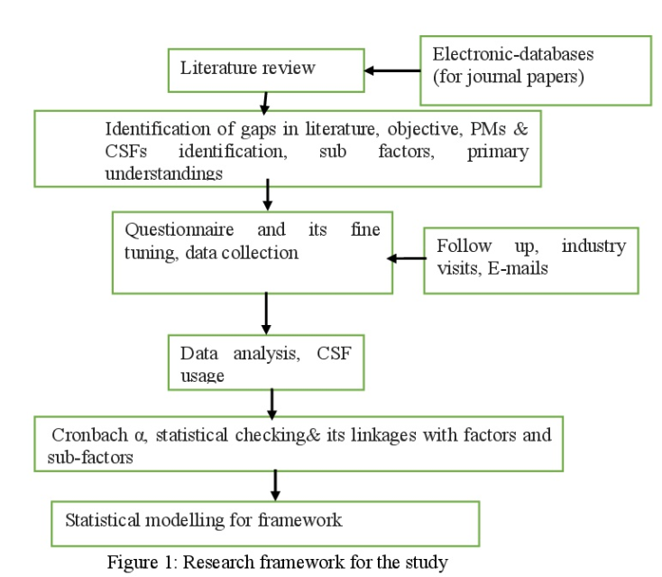
Recent Publications (minimum 5)
- Achanga, P., Shehab, E., Roy, R., and Nelder, G. (2006). Critical success factors for lean implementation within SMEs. Journal of Manufacturing Technology Management,17(4), 460-471.
- Awheda, A., Ab Rahman, M. N., Ramli, R., and Arshad, H. (2016). Factors related to supply chain network members in SMEs. Journal of Manufacturing Technology Management, 27(2), 312-335
- Badurdeen, F., Shuaib, M., Wijekoon, K., Brown, A., Faulkner, W., Amundson, J., & Boden, B. (2014). Quantitative modeling and analysis of supply chain risks using Bayesian theory. Journal of Manufacturing Technology Management, 25(5),631-654
- Brun, A. (2011). Critical success factors of Six Sigma implementations in Italian companies. International Journal of Production Economics, 131(1),158-164.
- Barve, A., and Muduli, K. (2013). Modelling the challenges of green supply chain management practices in Indian mining industries. Journal of Manufacturing Technology Management, 24(8),1102-1122.

Biography (150 word limit)
Balwinder Singh has his expertise in industrial engineering in improving the manufacturing processes. He has experience of more than 10 years in research,evaluation,teaching and administration in education institutions. He has completed his PhD in Industrial Engineering and has published many research papers in international and national journals.
Email: bal.ctiemt@gmail.com

