Environmentally Sound Spatial Management Using Conservation And Land Evaluation Approach For Sloping Lands In Humid Tropics

Susilawati* * and Andy Bhermana

*Assessment Institute for Agricultural Technology of Central Kalimantan, Indonesia
Jalan. G. Obos KM. 5 Palangkaraya-Kalimantan Tengah, Indonesia.

Corresponding author. Email: andybhermana@yahoo.com; susi_basith@yahoo.com

Abstract

The main problem faced by sloping lands in the humid tropic include land degradation that contributes natural ecosystem damage broadly. Land conversion and improper land use have been widely recognized as the main cause of environmental damage since the demands for agricultural lands become greater than land resource availability. The objective of this study was to determine the concept of appropriate land use planning through environmentally sound spatial management in order to prevent land and environmental degradation. The location of study in Antang Kalang sub-district of East Kotawaringin regency. Conservation approach by the use of USLE erosion risk prediction model and land evaluation through land suitability classification was used in this study. The geographic information system (GIS) and remote sensing (RS) technology were applied to generate spatial basic information and to assist spatial analysis. Two crops, upland rice and rubber, representing food crop and estate p have been selected based on local resource that have been existed since a long time ago. The result of spatial analysis shown that the arable land for agricultural practices covers 9,039 hectares (23.19%) while for non arable land, it is allocated for forest preservation with total areas 29,934 hectares (76.81%). The conservation aspect should be taken into account during farming practice in this sloping lands since the value of soil loss potential appears as indicator of erosion risk. Permanent cultivation system and intercropping farming system is the option of recommended agricultural practice at sloping lands in the humid tropic that have susceptibility of erosion.
Key words: sloping land, conservation, land evaluation, environment, spatial

Introduction

In Indonesia, mostly, the demands for agricultural lands become greater than land resource available. This reasonable fact appears since many landuse allocations ignore appropriate land use for forestry and wildlife as well. With population density 16 people/km² (BPS-Statistics of Kalimantan Tengah Province, 2015), in general, land resource that is still available should then be managed with environmentally sound spatial management. In order to ensure land resources can be used for future generation, on the basis of natural environment condition and capability of land resources, agricultural land use must not be on increased agricultural productivity solely, but rather on sustainable development that is appropriate to the environment.
Appropriate land use planning is then required in order to achieve long-term sustained yields involving the successful management of resources for agricultural lands to satisfy changing human needs while maintaining and enhancing the quality of the environment and conserving natural resources (Sajjapongse, 1996; Altieri, 1992). Spatial planning is underpinned by the assumption that adequate information exists for those exercising public authority to make decisions regarding the best use of land in the future (Flaherty and Smit, 1982) and it is concerned with the rational allocation of scarce resources and with the resolution of conflicts between competing land uses (Selman, 1982) and it must be based on an understanding both of the natural environment and of the kinds of land use envisaged (FAO, 1976). The function of land use planning for agricultural purposes is therefore to guide decisions on land use in such way that the resources of environment are put to the most beneficial use, while at the same time conserving those resources for the future.
The main problem related to land resources and natural environment as well that is still found in Central Kalimantan involve improper land use doing simultaneously with deforestation. Initially, land use changesare the impact of existency of sifthing cultivation as traditional agriculture system (Mulyoutamiet al., 2010). The present main issues include land use expansion for estate. Massively, opening new lands for oil palm plantation has been practiced since 2005 when local goverment established that estate development is one of leading sectors of regional development.
The land conversion due to opening new lands for agricultural purposes tend to have negative impact for natural environment. In central to northern part Central Kalimantan, mainly dominated by acid tropical soils at sloping lands, unfavourable soils development process occurs since the lands were cultivated inapproriately(Amien, 1990; Leiwakabessy, 1989). Because of its susceptibility of erosion, many agricultural practices lead to land degradation and soil erosion especially at sloping areas (Thomas et al.,2000; van Uexkull and Bosshart, 1989; Notohadiprawiro, 1989).
The sub-district of Antang Kalang located in Central Kalimantan was selected as study area because it represents relevant issues conserning land resource availability including its natural environment and local resourcethat should be preserved. Further land degradation and environmental damage including soil erosion, deforestationand loss of genetic resource should then be preventedin order to conserve the quality of environment.
The objective of this study is to provide basic concepts of environmentally sound spatial management through appropriate land use planning on the basis of local resource and long-term use and yields. The aspect of conservation and land evaluation approach were used in order to determine spatial concept as basic plans. The geographic information system (GIS) and remote sensing (RS) technology were applied to generate spatial basic information and to assist spatial analysis.

Methodology

The metodology used in this study was the implementation of soil erosion prediction model and land resource evaluation. Soil erosion prediction model is applied to determine areas susceptible to erosion spatially. The universal soil loss equation (USLE)with matematical formula by multiplying several factors involving rainfall erosivity, soil erodibility, slope, land cover and conservation practice to determine the value of average soil loss due to land surface erosion(ton ha-1 per year) (Wischmeier and Smith, 1978). While for land evaluation, the procedure refers to The “FAO Framework for Land Evaluation” through matching process between land parameters with crop requirements leads to assessment of the suitability of land use for the crop (FAO, 1976; ISRI, 2005 and Sys et al., 1993). The resulting evaluation was, therefore, then integrated into GIS environment for further spatial analysis using qualitative descriptive analysis procedure.
The GIS technology was applied to generate spatial data as part of geospatial information based on the result of USLE calculation and land evaluation. In addition to spatial analysis purposes, GIS was also apllied to facilitate, improvement, storing, displaying, future utilization, and updating data (Son and Rajendra, 2008; Andy et al., 2002;Eswaran, et al., 1992; Goodchild et al., 1992 and Tomlinson, 1968). Furthermore, the RS technology was also used in this study mainly to identify land cover, present land use, and digital elevation model (DEM) that represent basic factors for conservation aspects including soil erosion prediction model.
Basic data and information as datasets consist primarily of spatial data and tabular data obtained from field survey and literature study involving soil maps, climatic maps, land characteristics and land use requirements. These data were used for both land conservation analysis and land resource evaluation purpose. Two crops, upland rice and rubber, representing food crop and estate p have been selected based on local resource that have been existed since a long time ago.
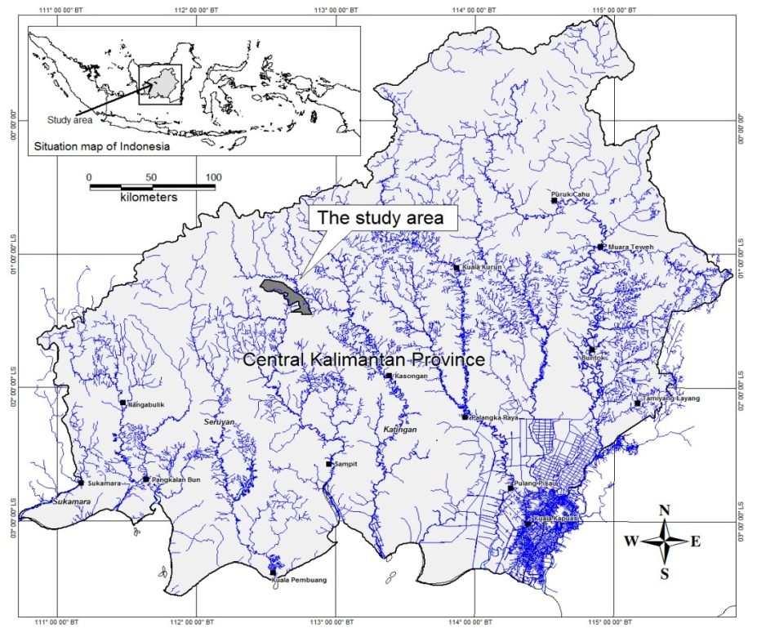
The other primary data include a) landsat imagery accessed from Landsat 8 with resolution of 30 meters on March 2015 considering the minimum cloud-covered for study area(Sitanggang, 2010) and b) DEM data taken from SRTM 30 meters (Smith and Sandwell, 2003). These data were mainly used to understand land cover spatial pattern and landform characteristics that have closely relation to soil erosion risk level and land evaluation as well.Further support data was also completed through field survey. PC-based GIS and RS softwares for data interpretation and spatial analysis used in this study were ErMapper, Global Mapper, and Arc View. An overview of general methodological steps is provided at Figure 2.

Figure 1. The map of situation showing location of study

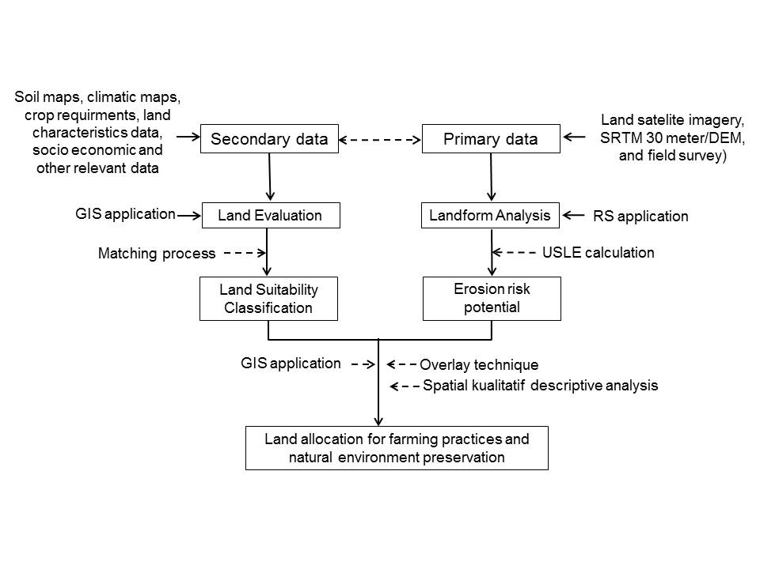
Figure 2. An overview of general methodological steps

Results And Discussion
General Overview of Study Area
The study area is focussed on Antang Kalang sub-district, Central Kalimantan province, Indonesia with total areas 38,973 hectares (Figure 1). It is situated between latitudes 01º 11’ 41” S and 01º 27’ 14” S and longitudes 112º 27’ 07” E and 112º 49’ 45” E. This site location is classified into humid tropical region because of its geographical position located below the equatorial line with humid climate system and rainfall distribution throughout the years ( Wohlet al., 2012).
Administratively, this area is belonging to Antang Kalang sub-district, Kotawatingin Timur regency. Inside the location, there are only 5 group of settlement, known as village, namely Tumbang Ngahan, Tumbang Ramei, Tumbang Hejan, Tumbang Nusa and Tumbang Gagu. They are located at river stream areas with total population of 1,569 persons and mostly dominated by Dayak tribe for these five villages. With the density of 4 persons/km², it reflects that in general, the lands is still widely available related to land use for human living.
The majority of Dayak community in this site location work as farmers and traditional farming used to agricultural practice is shifting cultivation. Some of them spend the time with latex rubber tapping, hunting, and traditional mining. These daily activities have been carried out since along time ago, derived from ancestor in the past.
Climate and Land Resource
Climatic condition of study areas generally determined by its geographical position on the equator and it is categorized into humid tropical region, charaterized by a rather constant temperature throughout the year, high humidity and high precipitation (Loo et al., 2015). Based on available nearest climate station records located in Katingan around 103 kilometers from the center of study area, it has annual rainfall around 2947mm. The rainy season starts from October to May while the dry season runs from June to September. Relative humidity is about 77% with mean temperature 30ºC. Additional information for climate can be obtained from Oldeman Agroclimtic Zone (1980) and it show that study area falls within climatic zone A according to the Oldeman system. It implies that the number of consecutive wet months is > 9 months and consecutive dry months less than 2 months.
The typology of land in study area is included into upland with specific acid tropical soils that have low fertility status and suscptible to erosion (Suharta, 2010; Amien, 1990). There are three soil great groups found in the site study location, namely, Paleudults, Hapludults, and Dystrudepts. These tropical soils are the products of rapid weathering and strong leaching, so that, most of these soils would probably be best leftunder forest (Suharta, 2010; van Uexkull and Bosshart, 1989).
The disscusion about landform and natural feature of the earth's surface in this study is mainly based on DEM data interpretation taken from SRTM 30 meters. The result of interpretation using remote sensing (RS) technology application and field ground check showed that study area is categorized into sloping land with altitude ranging from 52,03 meters to 445,79 meters above sea level. As hilly areas, there are three major landform of undulating plains, moderately steep hills, and hillocky plains that cover this site location.
The display of slope shader based on DEM ( Figure 3) was then interpreted to provide spatial data ofcontour including elevation and slope gradient (Figure 4). The result of further interpretation and spatial analysis, therefore, showed that this area is geographically divide into 3 slope classes i.e 4-8%; 16-25 and 26-40 (Figure 5) including each total areas (Table 1).
Table 1 show that study area is mainly dominated by slope class of 16-25% with total area 28,988 hectares (74.37%). Although the land could be suitable for agricultural practice, landform description sould be taken into account especially for conservation aspects because the slopes greater than 8% are being prone to erosion (Angima et al., 2003). However, the remaining lands with slope 4-8% that constitute about 23.19% of total study area have the potential to be developed. In addition to soil, slope, as part of landform, is one of several factors that determine type of agriculture (Altiery, 1987) so that it should be considered in agricultural land use planning (de Lima, 1988). In this study, slope information was used not only as one of several factors in USLE prediction modelbut it also was used to determine land suitability classification in land evaluation.
Table 1. The classification of slope and landform description for study area
No | Slope class  (%) | Landform | Areas
No | Slope class  (%) | Landform | (Hectares) | (%)
1 | 4-8 | Undulating plain | 9,039 | 23.19
2 | 16-25 | Moderately steep hills, hills with moderately steep dip and steep scar | 28,988 | 74.37
3 | 26-40 | Steep narrow ridges | 946 | 2.43
 |  | Total | 38,973 | 100.000

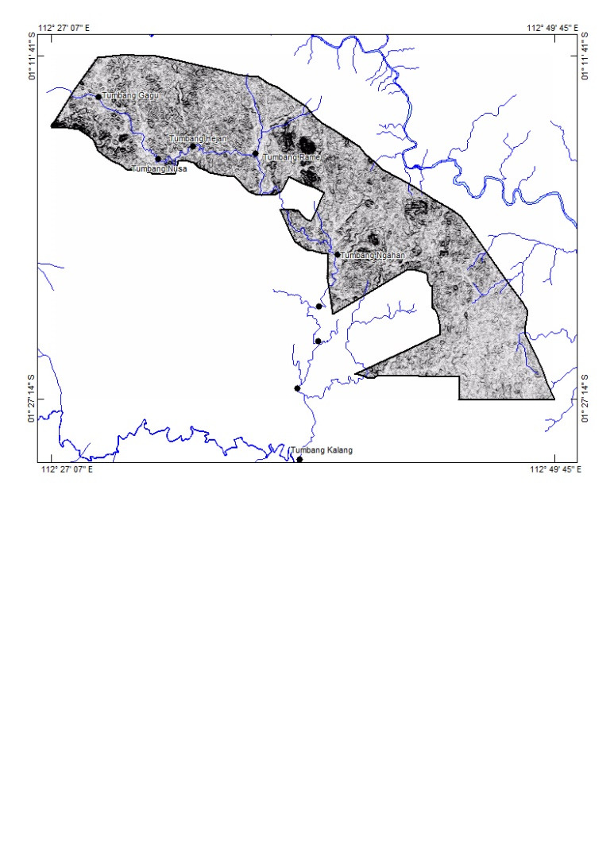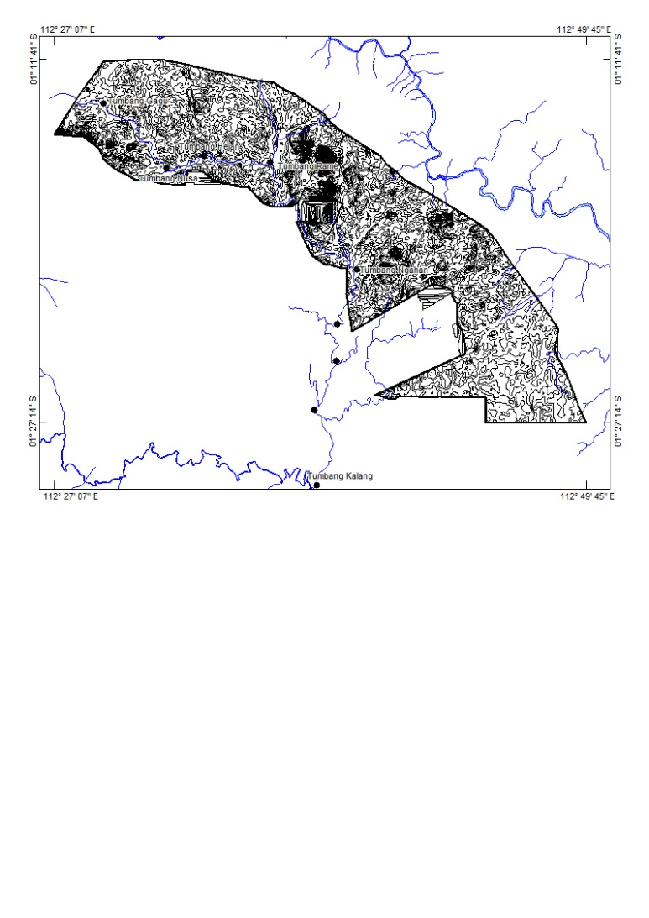
Figure 3. The view of slope shader based on DEM
Figure 4. The map of contour with interval of 20 m

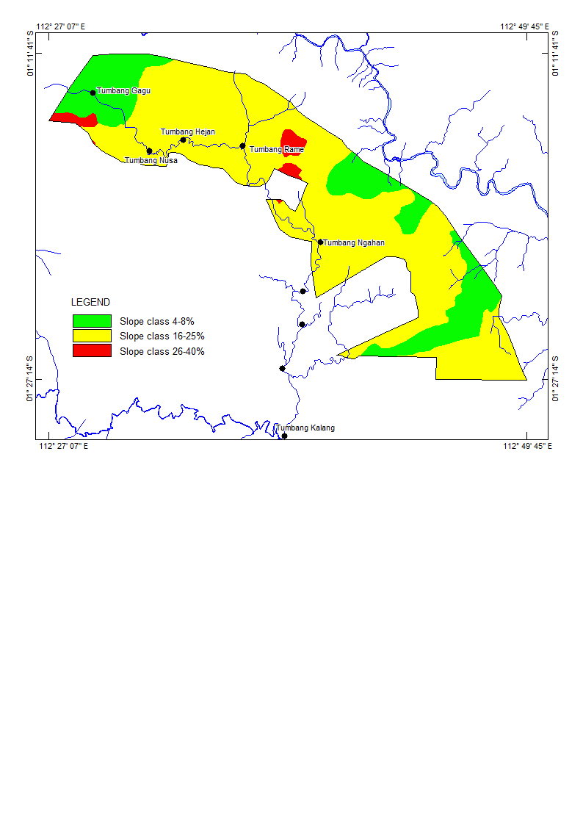

Figure 5. The map of slope class distribution in study area

Figure 6. The map of land cover showing present land use in study area

Land Cover and Vegetation
Spatial identification of land cover including specific location of vegetation used mainly RS technology based on land satelit imagery of Landsat 8 on March and April 2015 considering the minimum cloud cover percentage in order to obtain best GeoTiff format images. The result of landsat imagery interpretation was then integrated into GIS environment as shown in Figure 6 that represent land cover and present land use of study area. At present, the land is still mainly covered by forest including high density bush with total areas 29,056 hectares or 74.55% of whole areas of site study. It indicates that the lands is still available for general land use.
However, in the south, it has been identified that there are several part of areas that have been cultivated for estate. Based on ground survey, several cultivated lands are land expansion of oil palm plantation that has been existed in the southern part for several years ago. Land conversion impact to existing natural environment is therefore should be taken into account for future land use because this sloping land areas is still covered by natural vegetation.
Figure 6 also show that upland faming has been practiced through opening new land for shifting cultivation. It covers only 8,760 hectares (22.47%). Although, the land has been opened for agricultural practice, the local farmer still use traditional technique through their indigeneous knowledge. For instance, based on ground survey, they opened the land at undulating plaing with slope class less than 8%. In this case, the aspect of conservation has been fulfilled during farming practice.
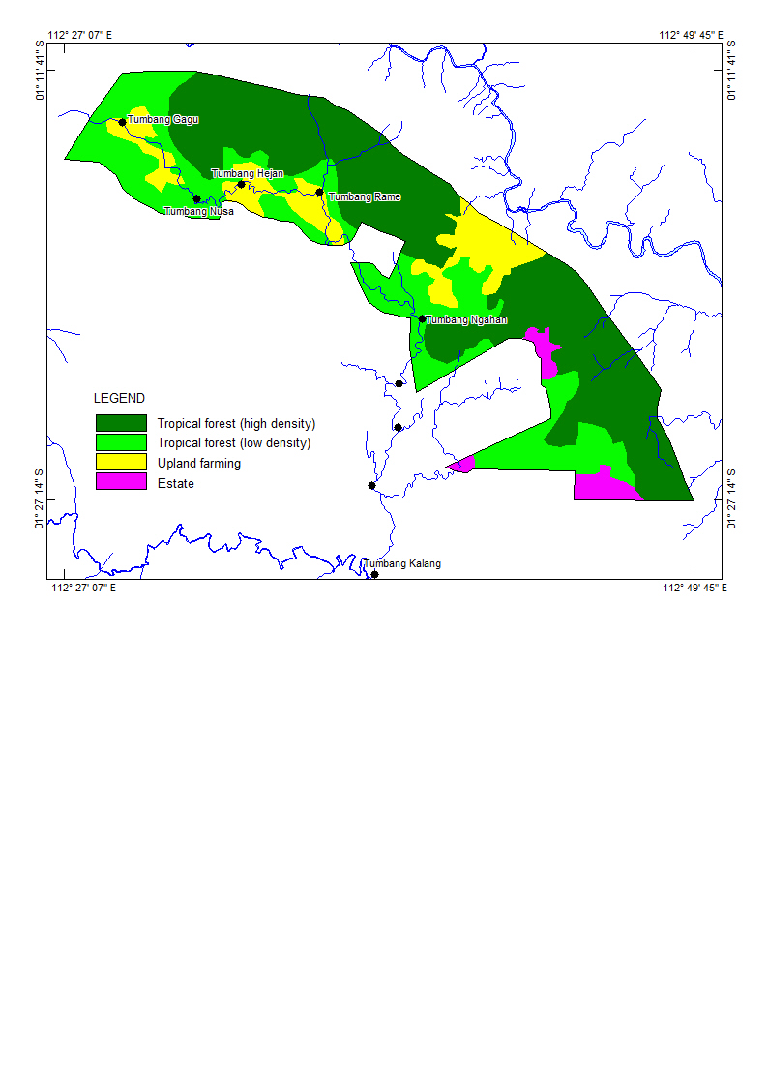

Figure 7. The map of erosion risk potensial classification in study area

Originally, located in humid tropical regions, the whole areas of Antang Kalang in which the study area take place is endowed by large area of tropical forest (Rahu et at., 2013). In Kalimantan, on larger scale of typical lowland rainforest, there are almost 180 tree species/hectare (Kartawinata, 1981). During field survey, in addtiton to giant species of Shorea spp, the others plants that have been found is local rubber (Hevea brasiliensis ). Along the river stream, some local orchid species were also found beside other species of ornamental plants. The existing of land cover involving crop growth data as well as cropping patternsand land usecontributes to USLE erosion prediction model through value of vegetation practice (Angima et al., 2003; Wischmeier and Smith, 1978).

Land and Environment Degradation
Land is important aspect in natural environment. Especially at sloping lands, the impact of land clearing include elimination of protective leaf canopy cover(Dowdle and von Uexkull, 1988).Ground cover that consist of leaf canopy cover is the factor that has the greatest impact on the rate of erosion by protecting the soil surface from the erosive impact of raindrops (Simpson, 2009). The potency of soil erosion is then should be early known through erosion risk level classification. The result of calculating data input according to USLE erosion prediction model shown that there are 3 class of erosion risk level in study area. Each class reflects level of erosion risk through soil loss potential (ton/hectare/year), total areas (Table 2) and spatial distribution (Figure 7).
Table 2. Classification of the erosion risk potential in study area
No | Class | Potential soil loss (t/ha/yr) | Actualsoil loss  (t/ha/yr)* | Total area
 |  |  |  | (ha) | (%)
1 | II | 15-60 | 32.79 | 20,123 | 51.63
2 | III | 60-180 | 72.91 | 938 | 2.41
3 | IV | 180-480 | 459.28 | 17,913 | 45.96
Note: * Data calculated using USLE model

Table 2 and Figure 7 explain that the lowest potential of erosion risk in site study is class II with average soil loss potential 32.79 ton/hectare/year. This class occupies 51.63% (20,123 hectares) of total study area located geographicallyin the southern spreading to central part.On the other side, it is also found in the northern part. This region can then be allocated for agricultural practice. However, because the value of soil loss potential appear, both soil and environment conservation intervention measures should be implemented.

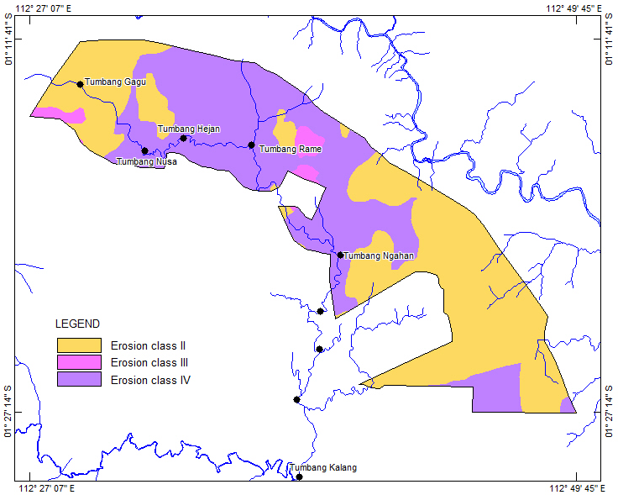

Figure 7. The map of erosion risk potensial classification in study area

Land Suitability for Farming Practice and Genetic Resourse Preservation
The availability of arable land is potency of land resource that can be used for human living. However not all the lands can be used optimally because of their limiting factors. Land evaluation approach was then used in this study to determine land suitability classifcation for several existing crops in certain areas. The importance of land resources evaluation for better agricultural land use and sustainable agriculture become more clear since it has taken environmental control into account and an efficient land use that does not degrade the land resources can be achieved (Sharuet al., 2013; Bennema, 1978).
Two selected crops based on local existing commodities consists of upland rice and rubber have used for evaluation. In fact, upland rice farming have been practicing by local farmers to meet the basic need of food in this areas. While, for rubber, it has been cultivated since their leave the land to open the other areas. The benefit of extra income taken from rubber tapping has also been widely understood by local community in this study area.
The result of land resource evaluation provide information that both upland rice and rubber were classified into marginally suitable-S3 due to limiting factors of nutrient retention such as pH and base saturation. However, this condition can be solved through proper improvement. Further evaluation to determine potential land suitability after improvement describe that both rubber and upland rich can reach the higher suitability class become highly suitable-S1. Land allocation for each crop was then justified according the priority of the needs. Therefore, mainly on the basis of land suitability, landform and existing cultivated land, the most suitable lands for rubber and upland rice is located on undulating plains with slope class 4-8% meanwhile at slope 16-25%, the lands are not recommended to be cultivated because of marginally suitable-S3 for both of crops. The map of land suitability as a result of land evaluation is shown at Figure 8.
In order to ensure optimum yield on sustained basis and conserve natural environment, the result of land evaluation was then further integrated into erosion risk potential data. The GIS application through overlay technique was used provide new layer information (O’Sullivan and Unwin, 2003). In this study, land suitability map was then overlayed to erosion risk potensial map to produce spatial information about appropriate land allocation for farming practices and natural environment preservation.The result of spatial analysis shown that most suitability of the land for selected crops occupy the region with the lowest of erosion risk potential. As a result, spatial information of land use allocation was then developed as shown at Figure 9. It describes that recommended agicultural land use planning can be implemented in the southern, central and northern part of study area with total area 9,039 hectares (23.19%). However, because the potential of erosion risk has already been occured, indicated with risk potential class of II (soil loss potential15-60 ton/hectare/year), the aspect of conservation should be integrated during agriculral practices. Among the villages located in study area, Tumbang and Tumbang Ngahan can be a priority for initial agricultural development program because they are geographically located in agricultural land region. For Tumbang Ngahan, although it lies near arable land for agriculture, it strategically considered as main gate access to enter site location.
In the case of Antang Kalang, related to conservation aspects, initial step toward to sustained land use and environment preservation is change the concept of shifting cultivation to permanent cultivation. Basically, the negative environmental impact of shifting cultivation includes any changes in soil physical and chemical properties and changes in soil nutrient status leading to land degradation and environmental damage (Stadtmueller, 1990; Christanty, 1986). Furthermore, deforestation, as part of opening the lands in this traditional system or even modern agriculture and other activities such as illegal lloging leads to a direct loss of biodiversity (Jeus et al., 2012).
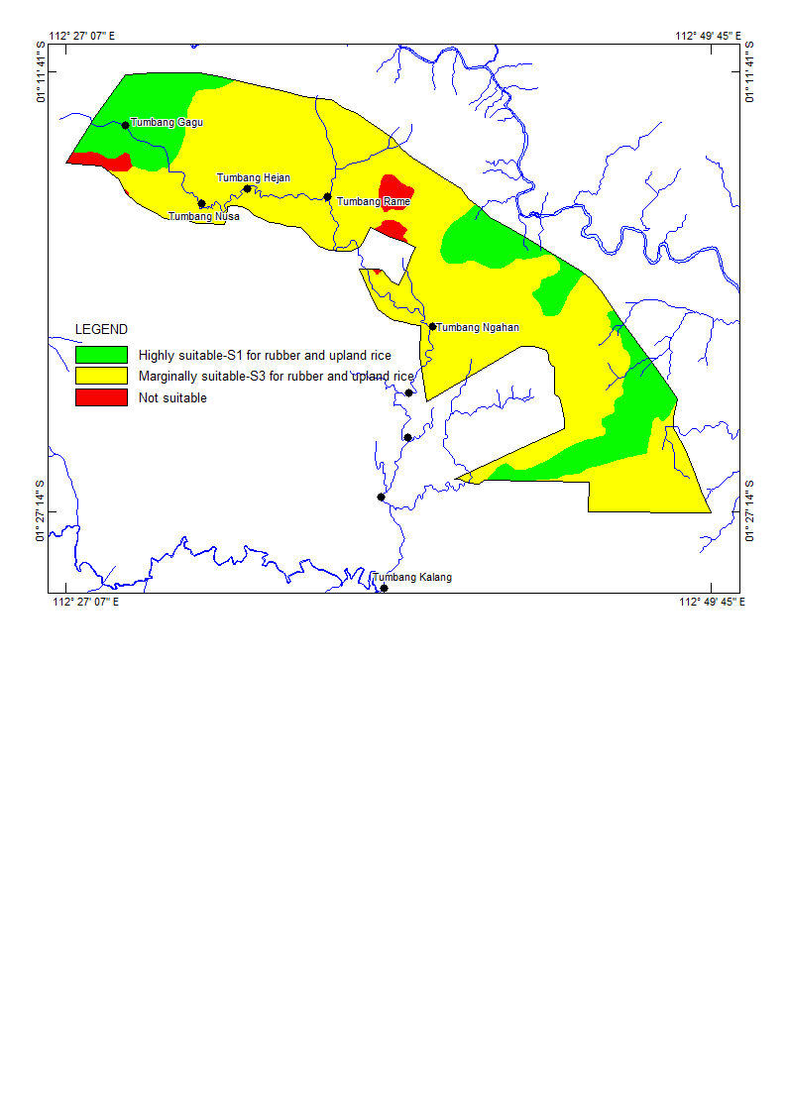
Figure 9. The map of land allocation for farming practices and forest in study area

Figure 8. The map of land suitability for rubber and upland rice in study area

\\\\\

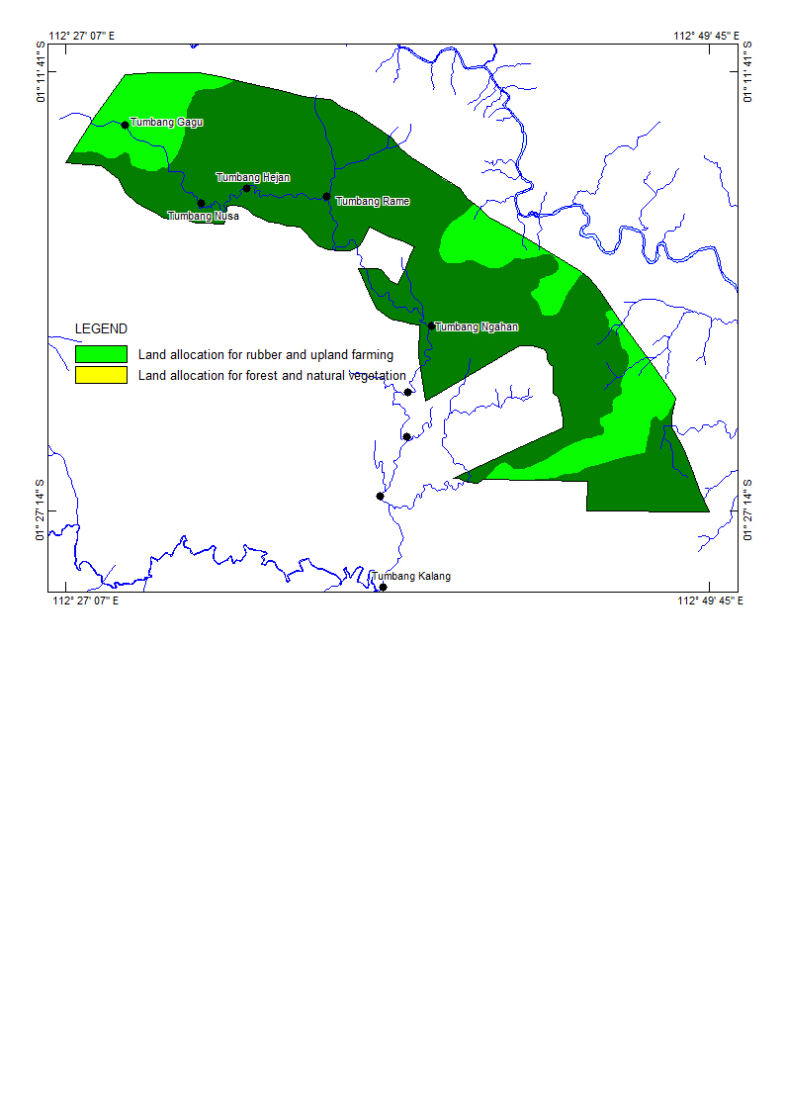

Figure 9. The map of land allocation for farming practices and forest in study area

On the other side, the non arable lands covering almost 29,934 hectares (76.81%) can be recommended for forest preservation. The existency of tropical biodiversity that play an important part in environmental balance is then should be a priority especially at sloping lands that have high susceptibility of land degradation. In the study area and its surrounding, local plants, wildlife, plants and animals were still found. Natural resource that could be direct or indirect used involve goods and service such as species for food, medicine and buildings material as well .
As a final result, spatial information about land allocation based on land resource and its natural resouce can then be used as basic consideration for land use planning at sloping lands that have permanent limiting factors for agricultural practice and other relevant activities related to land conversion in the future. The aspect of conservation should be integrated in sloping lands management. Intercropping of rubber and upland rice could be an option that can be implemented for farming practice (Simpson, 2009).

Conclusion
- The represents relevant issues conserning land resource availability including its natural environment and local that should be preserved. Further degradation of the land and environment including soil erosion, deforestation and loss of genetic resource can then be prevented in order to conserve the quality of environment.
- The concept of land suitability derived from land evaluation and USLE erosion prediction model can be used for environmental spatial management to detemine land use allocation of agricultural land region and natural environment areas precisely. The use of geographic information system (GIS) and remote sensing (RS) tehnology is urgently required in providing data, interpretation and spatial analysis.
- In the case of Antang Kalang district, it has been identified based on USLE erosion prediction model that there are three erosion classes with each value of soil loss potential i.e. class II (15-60 ton/hectare/year); class III (60-180 ton/hectare/year); and class III (180-480 ton/hectare/year). While, land suitability for both selected crops (rubber and upland rice) based on land evaluation, have suitability class of marginally suitable-S3 (aktual suitability). Considering land improvements to overcome limiting factors, the suitability class can be increased higher become highly suitable-S1 (potential suitability).
- The overlay technique within GIS environment was then applied to synchronize spatial distribution of erosion potential classes and suitability class in order to obtain proper land allocation for arable land and non arable land. The arable land for agricultural practices covers 9,039 hectares (23.19%) while for non arable land, it is allocated for forest preservation with total areas 29,934 hectares (76.81%).
- The conservation aspect should be taken into account during farming practice in this sloping lands since the value of soil loss potential appears as indicator of erosion risk. Permanent cultivation system and intercropping farming system is the option of recommended agricultural practice at sloping lands in the humid tropic that have susceptibility of erosion.
Acknowledgements

The authors wish to thank to Prof. Dr. Zulkifli Zaini as team leader who contribute both tought and funds. In addition, also thank to PT. Poyry Indonesia for any relevant data required in this study. Any remaining errors or omissions will be responsibility accepted by the authors. Last but not least, also, the authors wish to thank to Dr. Markus Anda who gave any writing guidance for this manuscripts.

References

Angima, S. D., D.E. Stott., M.K. O’Neill., C.K. Ong., and G.A. Weesies. 2003. Soil erosion prediction using RUSLE for centralKenyan highland conditions. Agriculture, Ecosystems and Environment 97 (2003): 295–308.

Altieri, M.A. 1992. Agroecological foundations of alternative agriculture in California.Agriculture, Ecosystems and Environment.Vol 39 NOS. 1-2: 23-53.

Altieri, M.A. 1987. Agroecology, The Scientific Basis of Alternative Agriculture. Westview Press. London.

Amien, L.I. 1990. Utilization of Acid Tropical Soils for Sustainable Agriculture.Indonesian Agricultural Research & Development Journal, Vol.12. No.2: 17-22.

Andy B., Hamdan J., Anyar A. R. and Peli M. 2002.Determination of Agricultural Land Regions UsingAgroecological Zone (AEZ) Approach and Geographic Information System. A case study of Kotawaringin BaratRegency, Kalimantan, Indonesia. Proceeding of The Malaysian Society of Soil Science Conference 2002. Application of Modern Tools in Agriculture: 36-39.

Bennema, J. 1978. Land Evaluation for Agricultural Land Use Planning. In: Swindale, L. D. (Editor). Soil Resources Data for Agricultural Development. Hawaii Agricultural Experiment Station College of Tropical Agriculture, University of Hawaii: 130 – 140.

BPS-Statistics of Kalimantan Tengah Province. 2015. Kalimantan Tengah in Figures.

Christanty, L. 1986. Sifthing Cultivation and Tropical Soils: Patterns, Problems, and Possible Improvement. In: Marten, G. G. Traditional Agriculture In Southeast Asia: A Human Ecology Perspective. Westview Press: 226-240.
de Lima, J.L.M.P. 1988. Morphological Factors Affecting Overland Flow On Slopes. Proceeding of a Symposium Organized by The International Society of Soil Science (ISSS), Wageningen, Netherlands, 22-26 August 1988: 321-324.

Dowdle, F and von Uexkull, H.R. 1988.Management practices for favorable nutrientcycling in tropical upland cropping systems. In:Proceedings of an International Conference onManagement and Fertility of Upland Soils inTropics and. Subtropics, Sept. 7-11. 1986, Nanjing,PRC: 91-97.

Eswaran H., Kimble J., Cook T. and Beinroth F. H. 1992.Soil Diversity in the Tropic: Implications for AgriculturalDevelopment. Myths and Science of Soils of the Tropics,SSSA Special Publication. No. 29: 1-16.

FAO. 1976. A Frame Work for Land Evaluation. SoilsBulletin No. 32. Rome, Italy. p. 72.

Flaherty, M and Smit, B. 1982. An Assessment of Land Classification Techniques in Planning for Agricultural Land Use. Journal of Environmental Management. No. 15: 323 – 332.

Goodchild, M., Robert. H., and Stepen. W. 1992. Integrating GIS and Spatial Data Analysis: Problem and Possibilities. Int. J. Geographical Information Systems, 1992, Vol. 6, No. 5: 407-423.

Indonesian Soil Research Institute. 2005. Land Evaluationfor Agricultural Commodities. A Guideline. IndonesiaAgency for Agricultural Research andDevelopment.Ministry of Agriculture. p. 154.

Jeus, M., Henriques, P., Laranjeira, P., Narciso, V., and da Silva Carvalho, M. L. 2012. The impact of shifting cultivation in the forestry ecosystems of Timor-Leste. CEFAGE-UE Working Paper 2012/16.

Kartawinata, K., 1981. Composition and structure of a lowlanddipterocarp forest at Wanariset. east Kalimantan. MalayForester. 44, 397±406.

Leiwakabessy, F.M. 1989. Management of Acid Humid Tropical Soils inIndonesia. In: Craswell, E.T and E. Pushparajah. Management of Acid Soilsin the Humid Tropics of Asia: 54-61.

Loo, Y. Y., L. Billa., and A. Singh. 2015. Effect of Climate Change On Seasonal Monsoon In Asia and Its Impact On The Variability of Monsoon Rainfall in Southeast Asia. Research Paper. Geoscience Frontier 6 (2015): 817-823.

Mulyoutami, E., van Noordwijk, M., Sakuntaladewi, N. dan Agus, F. 2010. Perubahan Pola
Perladangan: Pergeseran persepsi mengenai para peladang di Indonesia. Bogor, Indonesia.World Agroforestry Centre - ICRAF, SEA Regional Office.

Notohadiprawiro, T. 1989. Farming Acid Mineral Soils for Food Crops: an Indonesian Experience. In: Craswell, E.T and E. Pushparajah. Management of Acid Soils in the Humid Tropics of Asia: 62-68.

O’Sullivan, D and D. J. Unwin. 2003. Geographic Information Analysis. John Wiley and Sons. Hoboken. New Jersey.

Rahu, A. A., Hidayat, K., Ariyadi, M., and Hakim, L. 2013. Ethnoecology of Kaleka: Dayak’s Agroforestry in Kapuas, CentralKalimantan Indonesia. Research Journal of Agriculture and Forestry Sciences Vol. 1(8), 5-12, September (2013): 5-12.

Sajjapongse, A. 1996. Implementation and Adaptation of Conservation Practices. Extension Bulletin No. 472 (FFTC).
Selman, P. H. 1982.The Use of Ecological Evaluations by Local Planning Authorities. . Journal of Environmental Management.Vol. 15.pp: 1-19.

Sharu, M. B., M. Yakubu., S. S. Noma. And A.I Tsafe. 2013. Land Evaluation of an Agriculture Landscape in Dingyadi District, Sokoto State, Nigeria. Nigerian Journal of Basic and Applied Science (June, 2013), 21(2): 148-156.
Simpson, L. A. 2009. A Manual of Soil Conservation and Slope Cultivation. Caribbean Agricultural Research and Development Institute (CARDI) December, 2009.

Sitanggang, G. 2010. Kajian Pemanfaatan Sateli Masa Depan: Sistem Penginderaan Jauh Satelit LDCM (Landsat8). Berita Dirgantara Vol. 11 No. 2 Juni 2010:47-58.

Smith, B and D. Sandwell. 2003. Accuracy and Resolution of Shuttle Radar Topography mission data. Geophysical Research Letters, Vol. 30, No. 9, 1467, doi:10.1029/2002GL016643, 2003.

Son N. T and Rajendra P. S. 2008. GIS-AssistedLandEvaluation For Agricultural Development in MekongDelta, Southern Vietnam. Journal of SustainableDevelopment in Afrika. 10(2): 875-884.

Stadtmueller, T. 1990. Soil Erosion in East Kalimantan, Indonesia. Proceedings of The Fiji Symposium, June 1990. Research Needs and Applications to Reduce Erosion and Sedimentation in Tropical Steeplands. IAHS-AISH Publ. No. 192, 1990: 221-230.

Suharta, N. 2010.KarakteristikdanPermasalahan Tanah Marginal dariBatuanSedimenMasam di Kalimantan.JurnalLitbangPertanian, 29(4): 139-146.

Sys C., Van Ranst E., Debaveye J. and Beernaert F. 1993.Land Evaluation. Part III. Crop requirements. AgriculturalPublication No. 7. Brussels - Belgium.

Thomas, R. J., M. Ayarza., and A. S. Lopes. 2000. Management and Conservation of Acids Soils In the Savannah of Latin America: Lesson From The Agricultural Development of The Brazilian Cerrados. In: Management and Conservation of Tropical Acid Soils for Sustainable Crop Production. Proceeding of a consultants meeting organized by the Joint FAO/IAEA Division of Nuclear Techniques in Food and Agriculture and held in Vienna, 1-3 March 1999: : 5-28.

Tomlinson R.F. 1968. A Geographical Information Systemfor Regional Planning. Papers of a CSIRO SymposiumOrganized in Cooperation with UNESCO, 26 - 31 August.Macmillan of Australia. pp. 200-210.

van Uexkull, H. R and R.P. Bosshart. 1989. Management of Acid Upland Soils in Asia. In: Craswell, E.T and E. Pushparajah. Management of Acid Soilsin the Humid Tropics of Asia: 2-19.
Wischmeier, W.H and Smith, D.D., 1978. Predicting Rainfall Erosion Losses. A Guide to conservation planning. United StatesDepartment of Agriculture, Agricultural Research Service(USDA-ARS) Handbook No. 537. United States GovernmentPrinting Office, Washington, DC.

Wohl, E., A. Barros., N. Brunsell., N. A. Chappell., M. Coe., T. Giambelluca., S. Goldsmith., R. Harmon., J. M. H. Hendrickx., J. Juvik., J. McDonnell., and F. Ogden. 2012. The hydrology of the humid tropics. Nature Climate Change. Vol 2. September 2012: 655-662.

