Toward Quality Control of Biogas Product in Indonesia : A Brief Overview
Dr. Oman Zuas, BSN, INDONESIA

Abstract
The quality control of the final product of biogas is essential for providing a maximum level of consumer’s satisfaction. The most important criteria for any biogas products are its regulatory compliance and safety. Based on a desk study of document and laboratory experiment, this paper overviews the development of quality infrastructure for controlling the quality of a final product of biogas, aiming at summarising the experience, problems and demonstrating development status of quality infrastructure in Indonesia in the hope of providing references for the present condition. The discussion is made to cover issues related to biogas that are emphasised on three pillars of quality infrastructure in Indonesia, i.e., standardization, metrology, and conformity assessment. From the overview, the critical conclusions where understanding and continuing the development quality infrastructure of assuring the safety and quality of biogas remain essential.

Image

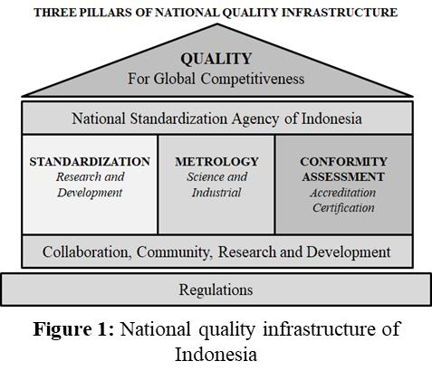
Recent Publications (minimum 5)
- Hindayani, A., Zuas, O., Sujarwo, Krismastuti, F. S. H., Hamim, N. (2019) Preparation of a Secondary pH of Phthalate Buffer Solution using Differential Potentiometric Cell: A Method Validation and Its Application” Journal of Chemistry & Chemical Technology (In Press).
- Aryana, N., Hindayani, A., Zuas, O., Krismastuti, F.S.H. (2018) Borax buffer solution for pH measurement: Homogeneity and stability studies and its application in the proficiency testing program” Journal of Electrochemistry Science and Engineering, 8: 261-270 8 .
- Zuas, O., Budiman, H., Mansur, D., Mulyana, M.R. (2018) Measurement of HDO Products Using GC-TCD: Towards Obtaining Reliable Analytical Data” Catalysis for Sustainable Energy, 5:1-11.
- Zuas, O., Budiman, H., Hamim, N. (2017) Measurement of SF6 using gc-ecd: a comparative study on the utilization of CO₂-N₂ mixture and CH₄-ar mixture as a make-up gas” Chemistry & Chemical Technology, 11: 420–429.
- Zuas, O., (2017) Effect of Carrier Gas Flow Rate And Column Temperature on The Suitability Parameters of GC-ECD For SF₆ Measurement, Tche QuImica, 14: 120-129.

 Biography
Oman Zuas is a senior researcher at the Centre for Research and Human Resources Development, National Standardization Agency of Indonesia (BSN). He graduated from Lampung University Indonesia, with bachelor degree (BSc) in analytical chemistry in 1997. His master degree (MSc) in food safety was obtained from Wageningen University and Research Centre, The Netherlands in 2006. His doctoral degree (Dr.) was obtained from University of Indonesia in 2014 with full doctoral research was conducted at Gas Analysis Laboratory in Korea Research Institute for Standards and Science (KRISS) Republic of Korea (South). He has published more than 50 research articles in various indexed journal. At present he appointed as head of sub-directorate for Standard Development of chemistry National Standardization Agency of Indonesia..
Email: oman@bsn.go.id

Notes/Comments:

