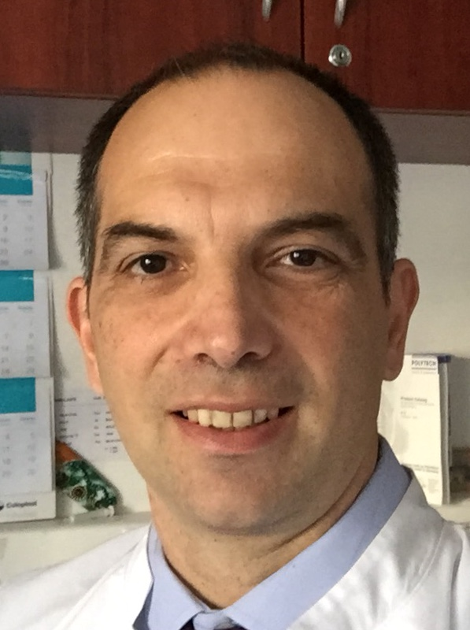

Title: Bilateral leg replantation in a 3 month old baby – a 4 year follow-up
Name: Kresimir Bulic
University Hospital Zagreb

We present a 4-year follow up of a child with bilateral leg replantation performed at the age of 3 months following a traumatic knee level amputation. Legs were replanted after a period of 4 hours of warm and additional 2,5 and 3,5 hours of cold ischaemia. Both legs achieved excellent motor and sensory reinnervation and exhibit excellent bony growth in spite of loss of all the knee growth plates. The remaining growth plates in the ankle and hip exhibit an increased growth rate thus compensating for the loss of knee growth plates (figure 1.). The leg growth rate for the first 2 year follow up was 33 and 34%, compared to the expected 41%, indicating his legs are expected to be somewhat but not significantly shorter then normal. The child is progressing well with rehabilitation and is now able to stand up, walk, climb up and down the stairs independently. Several knee reconstruction options are being considered at this time.
Figure 1. Legs X-ray at 4 year followup.
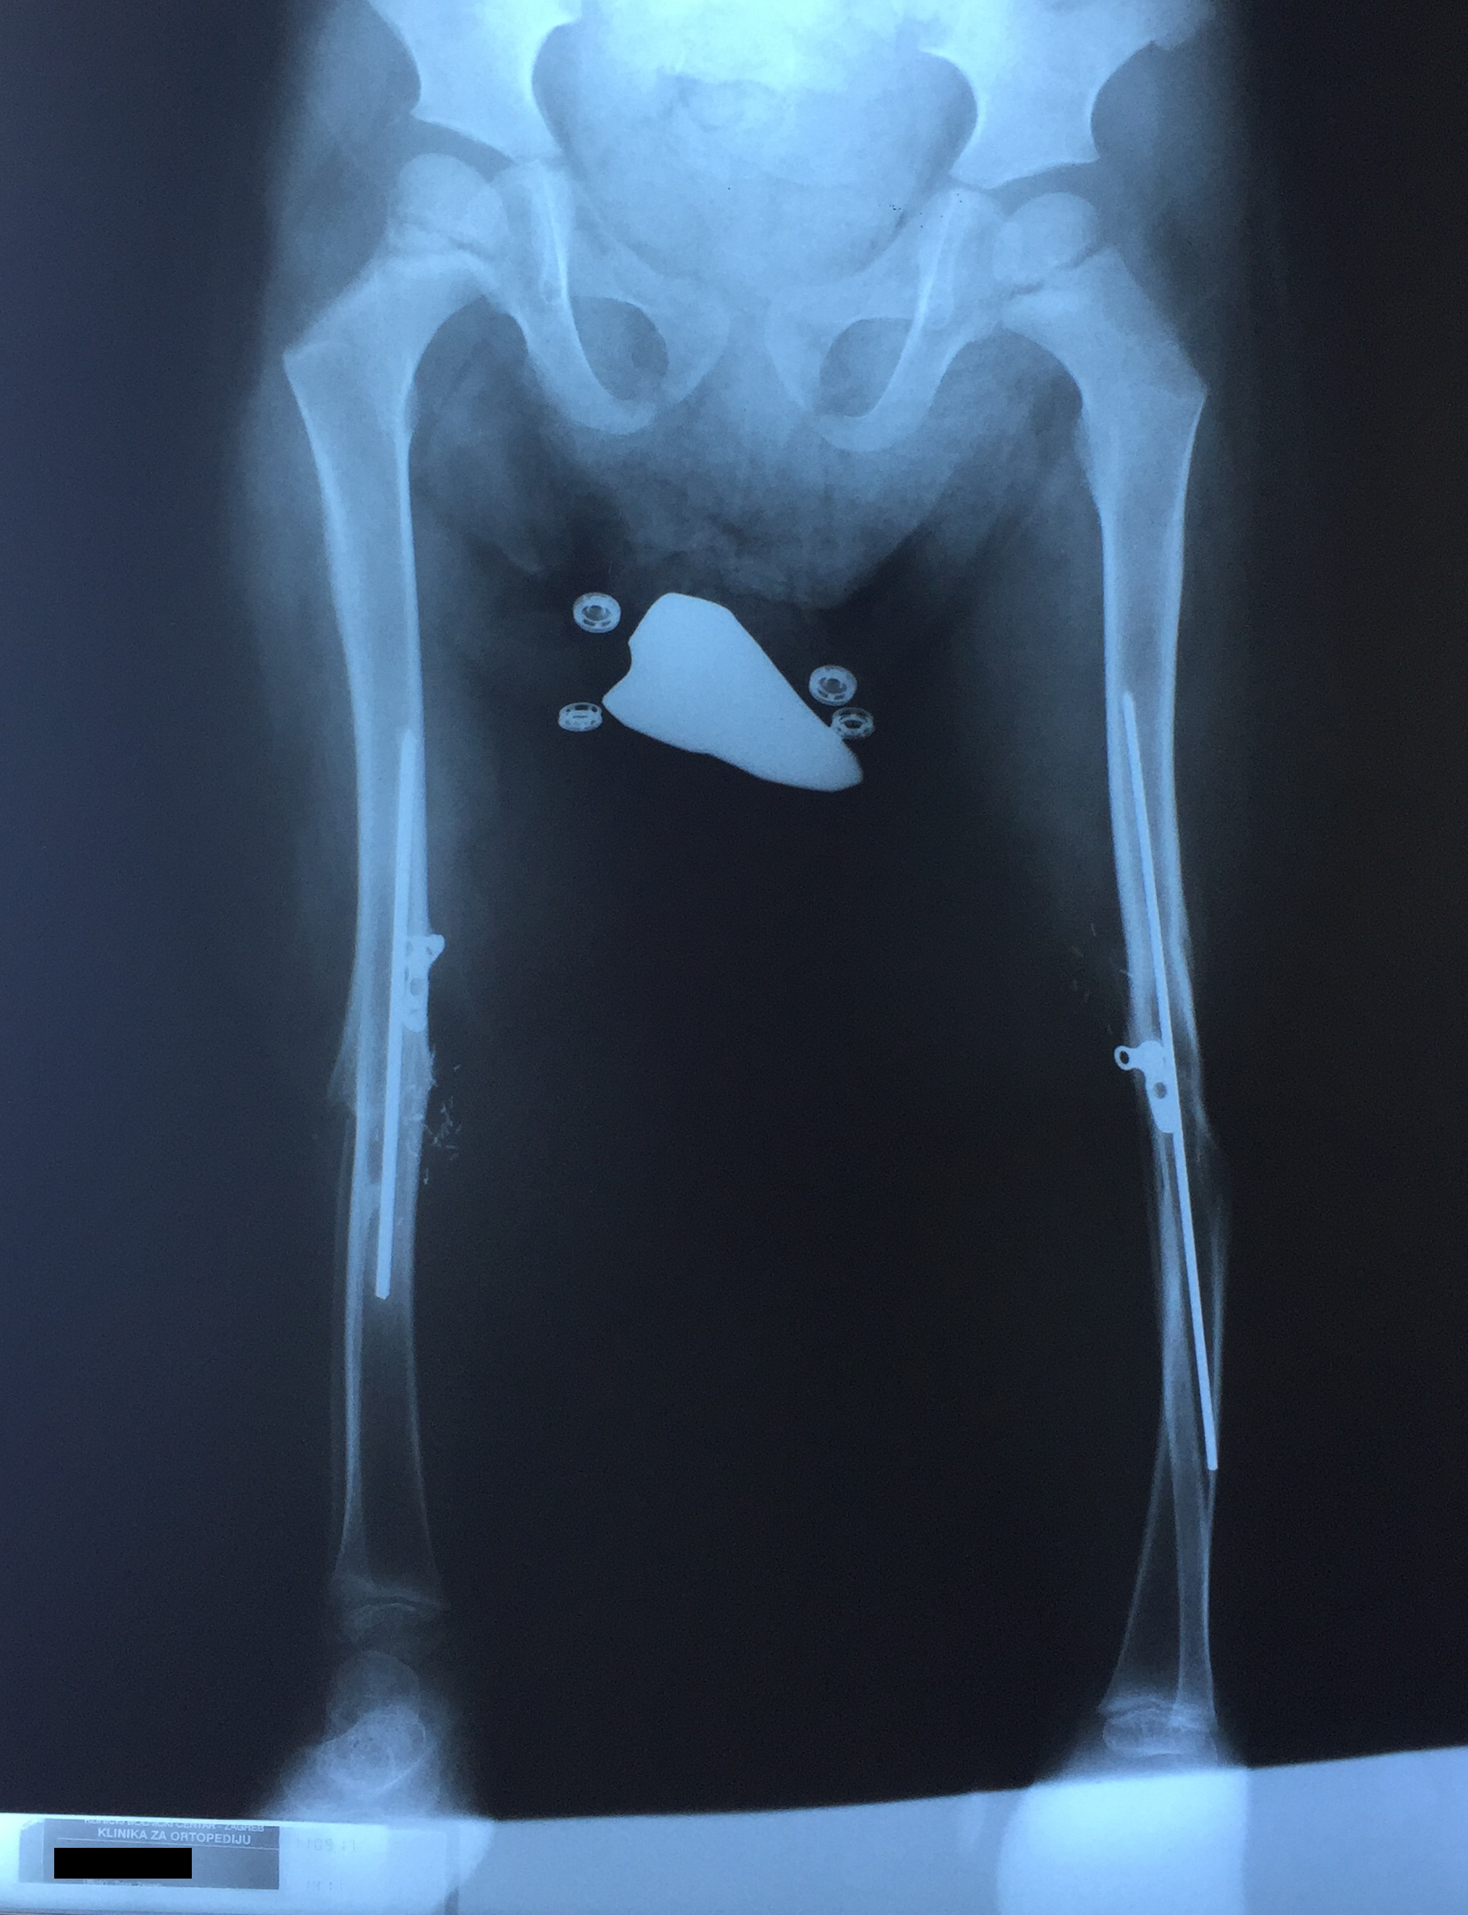

Biography

Kresimir Bulic is an Assistant Professor of Surgery at University of Zagreb School of Medicine and University Hospital Zagreb where he works as a plastic and reconstructive surgeon. He received his Ph.D. from the University of Zagreb and has published more then 40 papers in reputed journals and has been serving as an editorial board member of several journals. His surgical fields of interest include congenital hand malformations, head and neck reconstruction, breast reconstruction, hand surgery.
Presenting author details
Full name: Kresimir Bulic
Contact number: 00385959053214
Twitter account:
Linked In account:
Session name/ number:
Category: Oral presentation

