Outcomes of paediatric dental rehabilitation following head and neck reconstruction: a systematic review
Georgina Wellstead MBBS BSc, Norfolk and Norwich University Hospital, UK
Robert Coe, MBBS MA (OXON), Norfolk and Norwich University Hospital, UK

Abstract
Introduction
Dental rehabilitation is an important part of a patient’s treatment following head and neck reconstruction and can provide significant improvements in both functional and psychosocial outcomes. The current literature is particularly scarce with regards to dental rehabilitation in children. The aim of this work is therefore to examine the best techniques available for paediatric dental rehabilitation, including the ideal sequence of events to support the best outcomes.
Methods
A literature search was performed of all children undergoing dental rehabilitation following head and neck reconstruction between 1975 and June 2019 using the MEDLINE and Cochrane databases. Each article was assessed for inclusion before data was extracted. Data items extracted for each article included: age; primary pathology; surgery; dental rehabilitation details; radiotherapy; functional outcomes; and psychological outcomes.
Results
Six articles were finally in the final analysis, all of which were case reports or case series. The patient’s primary pathologies were a mixture of congenital deformities, benign tumours, malignancies and infections. All of the reconstructive options, including free scapular, parascapular, iliac crest and fibula flaps were reported to be successful. Positive outcomes were demonstrated following both immediate and delayed dental rehabilitation with removable and osseointegrated prostheses.
Radiotherapy was not performed in any of the cases.
Conclusions
From the cases examined, it has been demonstrated that a variety of osseous free flap reconstructive options can facilitate successful dental rehabilitation in children. However, the outcomes reported for each of the studies varied greatly, with no two studies reporting their outcomes in the same way. Additionally, although this small selection of studies shows some positive results for dental rehabilitation following paediatric head and neck reconstruction, no firm conclusions can be made, particularly regarding long-term outcomes. Many more cases must therefore be reported and examined in order to make any wider-reaching conclusions for paediatric patients.
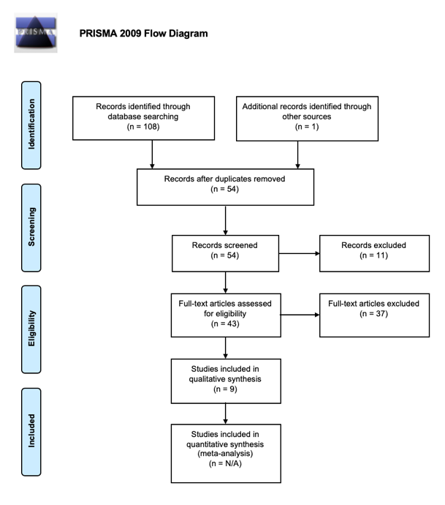

Figure 1. PRISMA flow diagram showing the study selection process
Recent Publications
- Behnia H, Jafarian M, Dehghani N, Dehghani S, Seyedan K. Comprehensive Treatment and Rehabilitation of a Patient With Maxillary Arteriovenous Malformation. J Craniofac Surg. 2014 Sep;25(5):e463-7. doi: 10.1097/SCS.0000000000001054.
- Aksu AE, Dursun E, Calis M, Ersu B, Safak T, Tözüm TF. Intraoral Use of Extraoral Implants for Oral Rehabilitation of a Pediatric Patient After Resection of Ewing Sarcoma of the Mandible and Reconstruction With Iliac Osteocutaneous Free Flap. J Craniofac Surg. 2014 May;25(3):930-3. doi: 10.1097/SCS.0000000000000709.
- Li JS, Chen WL, Huang ZQ, Zhang DM. Pediatric Mandibular Reconstruction After Benign Tumor Ablation Using a Vascularized Fibular Flap. J Craniofac Surg. 2009 Mar;20(2):431-4. doi: 10.1097/SCS.0b013e31819b96db.
- Vinzenz K, Holle J, Würinger E. Reconstruction of the Maxilla with Prefabricated Scapular Flaps in Noma Patients. Plast Reconstr Surg. 2008 Jun;121(6):1964-73. doi: 10.1097/PRS.0b013e3181706dd6.
- Warren SM¹, Borud LJ, Brecht LE, Longaker MT, Siebert JW. Microvascular Reconstruction of the Pediatric Mandible. Plast Reconstr Surg. 2007 Feb;119(2):649-61.
- Pace-Balzan A, Rogers SN. Dental rehabilitation after surgery for oral cancer. Curr Opin Otolaryngol Head Neck Surg. 2012 Apr;20(2):109-13. doi: 10.1097/MOO.0b013e32834f5fef.

Biography
Georgina Wellstead is a core surgical trainee in the UK with an interest in head and neck reconstruction and microsurgery. She is currently completing an MSc in Reconstructive Microsurgery at Barts and The London School of Medicine and Dentistry.

Email: georgina_wellstead@msn.com

Notes/Comments:

