Repair of Skull Base Encephaloceles: Nuances and Pearls
Dr Andrew J Kobets, MD, MHS, Albert Einstein College of Medicine, New York, NY, USA

Abstract (300 word limit)
Introduction: Basal encephaloceles are rare anterior skull base defects incident in 1/35,000 live births and may be life-threatening in infants, presenting as airway obstruction, respiratory compromise, CSF rhinorrhea, or meningitis. In the context of a repair of a giant basal encephalocele containing eloquent neural tissue, we describe the technical nuances of this repair compared to others reported in the literature.
Methods: A 16-month-old girl presented with progressive airway obstruction from a giant sphenoethmoidal encephalocele. She had multiple congenital anomalies including agenesis of the corpus callosum and cleft lip and palate. CT showed complete absence of the bony anterior cranial base and MRI demonstrated the presence of the pituitary gland and hypothalamus in the hernia sac. We describe the operative repair as well as those of similar cases reported in the literature.
Results: We repaired the encephalocele using a combined microsurgical and endoscopic multidisciplinary approach working through transcranial, transnasal and transpalatal corridors. The procedure was completed in a single stage, including cleft lip repair and calvarial bone harvesting from the same incision. The child made an excellent neurological and aesthetic recovery with preservation of pituitary and hypothalamic function. Others have reported purely endoscopic endonasal approaches for small defects, staged repairs of facial anomalies, the use of rib grafts or foreign material for skull base repair, the obliteration of all intralesional tissue for intracranial reduction, as well as the removal of the orbital bandeau in lieu of spinal drainage for improved access.
Conclusion: A novel technique for treating a giant sphenoethmoidal encephalocele containing eloquent brain is presented in the context of other repair methods presented in the literature. Utilizing a combined approach, autologous bone for repair, a single-stage facial repair, and the integration of a vascularized pericranial graft together improved upon previously reported repairs.

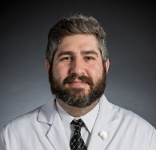

Image
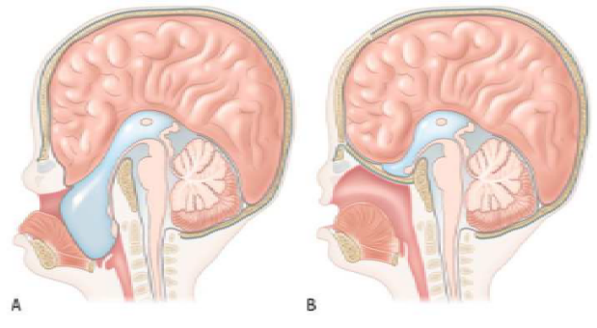
Figure 1. Artist’s depiction of the repair of the herniated encephalocele. Note the red pericranial graft tucked underneath the harvested parietal bone slinging up the encephalocele sac. The repaired mucosa is noted in the oral cavity, and midline tissue has been reinstated to close the cleft defect.
Recent Publications (minimum 5)
- Goodrich JT. Pediatric Neurosurgery. New Yorkm, NY: Thieme, 2008, pp 69–75.
- Hoving EW. Nasal encephaloceles. Childs Nerv Syst. 2000;16(10-11):702–706.
- Tirumandas M, Sharma A, Gbenimacho I, et al. Nasal encephaloceles: a review of etiology, pathophysiology, clinical presentations, diagnosis, treatment, and complications. Childs Nerv Syst. 2013;29(5):739–744.
- Suwanwela C, Suwanwela N. A morphological classification of sincipital encephalomeningoceles. J Neurosurg. 1972;36:201-211.
- Rathore YS, Gupta D, Mahapatra AK. Transsellar transsphenoidal encephalocele: a case report. Pediatr Neurosurg. 2010;46(6):472–474.
- Hoff SR, Edwards MS, Bailey CM, Koltai PJ. The transpalatal approach to repair of congenital Basal skull base cephaloceles. J Neurol Surg B Skull Base. 2014;75(2):96–103.
- Ogiwara H, Morota N. Surgical treatment of transsphenoidal encephaloceles: transpalatal versus combined transpalatal and transcranial approach. J Neurosurg Pediatr. 2013;11(5):505–510.

Photograph

Biography
Dr. Kobets is an Assistant Professor of Neurological Surgery at the Albert Einstein College of Medicine. Dr. Kobets specializes in pediatric neurological surgery with a focus on minimally invasive tumor resection, neuro-endoscopy for hydrocephalus, and craniofacial reconstruction. In 2005, Dr. Kobets received his Bachelor of Arts degree in systems neuroscience from Johns Hopkins University and in 2012, he received his Master of Health Sciences and Doctor of Medicine degrees from the Yale University School of Medicine. He completed his postgraduate neurosurgical training in 2019 at the Albert Einstein College of Medicine and was awarded a fellowship in pediatric neurosurgery at the Johns Hopkins Hospital the same year, before returning to Albert Einstein as a Pediatric Neurosurgeon in 2020.
Email: Akobets@montefiore.org,
Phone: 7189202597
Presentation Format: Oral

