Expanded bi-pedicled “sleeve” flap for
reconstruction of the upper extremity after
large circumferential nevus excision in
children
Yair Shachar, Department of Plastic, Reconstructive, and Hand Surgery, Hadassah University Medical Center,
Jerusalem, Israel

Abstract
Background: Large congenital melanocytic nevi entail significant medical and cosmetic ramifications for patients and families. Reconstruction is a challenging endeavor, especially when the lesion is present on the limbs. The literature describes various methods by which a plastic surgeon can address reconstruction; yet, to date, there has been no series describing a method that provides consistent results with low complication rates.
In this study, we describe our surgical technique for reconstruction of the upper extremity after excision of large circumferential CNM with a pre-expanded bi-pedicled flap, namely the “sleeve” flap.
Methods: A systematic review of our database of pediatric patients treated for large and giant nevi was performed. Patients with large and giant circumferential upper extremity nevi were
retrieved, and their charts reviewed for demographics, number of procedures performed, duration of follow-up, and complications.
Results: Over a course of 12 years, eight patients with large or giant circumferential nevi of the upper extremity were treated at our institution with “sleeve” flap reconstruction. Mean follow-up time was 36 months. A single complication was seen. All reconstructions achieved satisfactory results, both functionally and cosmetically.
Discussion: We describe our surgical approach for treating upper extremity large and giant circumferential nevi with pre-expanded bi-pedicled “sleeve” flaps. When properly planned and executed, this technique enables successful treatment of large and giant nevi of the arm and the forearm. Although arduous and complex, the process yields excellent aesthetic results with low complication rates. This technique is promising as the reconstructive option of
choice for these difficult lesions.

Image
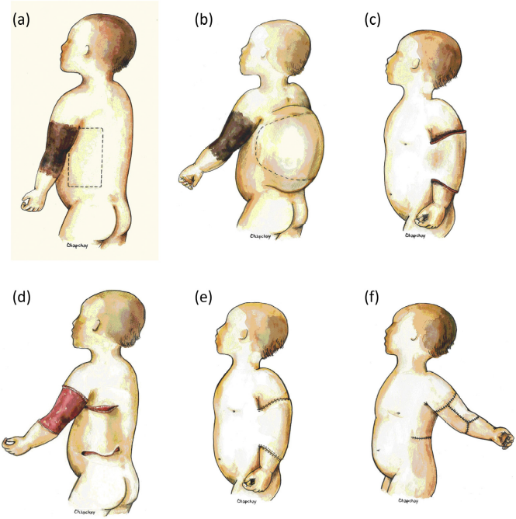
Recent Publications (minimum 5)
1. Alper JC, Holmes LB. Thee incidence and significance of
birthmarks on a cohort of 4,641 newborns. Pediatr Dermatol
1983;1(1):58e68.
2. Marghoob AA. Congenital melanocytic nevi. Evaluation and
management. Dermatol Clin 2002 Oct;20(4):607e16 [viii].
3. Castilla EE, Dutra MG, Oriolo-Parreiras IM. Epidemiology of
congenital pigmented naevi: I. Incidence rates and relative
frequencies. Br J Dermatol 1981;104:307e15.
4. Vourc’h-Jourdain M, Martin L, Barbarot S. Large congenital
melanocytic nevi: therapeutic management and melanoma
risk: a systematic review. J Am Acad Dermatol 2013 Mar;68(3):
493e8.Experimental neurology 213:10-17.
5. Gosain AK, Santoro TD, Larson DL, et al. Giant congenital nevi:
a 20-year experience and an algorithm for their management.
Plast Reconstr Surg 2001;108:622e31.
6. Bauer BS, Margulis A. The expanded transposition flap: shifting
paradigms based on experience gained from two decades of
pediatric tissue expansion. Plast Reconstr Surg 2004 Jul;
114(1):98e106.
7. Kroon S, Clemmensen OJ, Hastrup N. Incidence of congenital
melanocytic nevi in newborn babies in Denmark. J Am Acad
Dermatol 1987;16:788e92.
8. Yun SJ, Kwon OS, Han JH, et al. Clinical characteristics and risk
of melanoma development from giant congenital melanocytic
naevi in Korea: a nationwide retrospective study. Br J Dermatol
2012 Jan;166(1):115e23.
9. Goss BD, Forman D, Ansell PE, et al. The prevalence and
characteristics of congenital pigmented lesions in newborn
babies in Oxford. Paediatr Perinat Epidemiol 1990;4:448e57.
10. Ingordo V, Gentile C, Iannazzone S, Cusano F, Naldi L.
Congenital melanocytic nevus: an epidemiologic study in Italy.
Dermatology 2007;214:227e30.
11. Corcoran J, Bauer BS. Management of large melanocytic nevi in
the extremities. J Craniofacial Surg 2005;16:877e85.
12. Margulis A, Bauer BS, Fine NA. Large and giant congenital
pigmented nevi of the upper extremity: an algorithm to surgical
management. Ann Plast Surg 2004;52:158e67.
13. Rompel R, Mo¨ser M, Petres J. Dermabrasion of congenital
nevocellular nevi: experience in 215 patients. Dermatology
1997;194:261.
14. Michel JL. Laser therapy of giant congenital melanocytic nevi.
Eur J Dermatol 2003 Jan-Feb;13(1):57e64.
15. Reynolds N, Kenealy J, Mercer N. Carbon dioxide laser dermabrasion
for giant congenital melanocytic nevi. Plast Reconstr
Surg 2003 Jun;111(7):2209e14.
16. Bauer BS, Vicari FA, Richard ME. Expanded full-thickness skin
grafts in children: case selection, planning and management.
Plast Reconstr Surg 1993;92:59e69.
17. Quaba AA, Wallace AF. The incidence of malignant melanoma
(0e15 years of age) arising in ‘large’ congenital nevocellular
nevi. Plast Reconstr Surg 1986;78:174e81.
18. Bittencourt FV, Marghoob AA, Kopf AW, et al. Large congenital
melanocytic nevi and the risk for development of malignant
melanoma and neurocutaneous melanocytosis. Pediatrics
2000;106:736e41.
19. Arad E, Zuker RM. The shifting paradigm in the management
of giant congenital melanocytic nevi: review and
clinical applications. Plast Reconstr Surg 2014 Feb;133(2):
367e76.
20. Friedman RM, Ingram AE, Rohrich RJ, et al. Risk factors for
complications in pediatric tissue expansion. Plast Reconstr
Surg 1996;98(7):1242e6.
21. Adler N, Dorafshar AH, Bauer BS, et al. Tissue expander infections
in pediatric patients: management and outcomes.
Plast Reconstr Surg 2009;124(2):484e9.
22. Huang X, Qu X, Li Q. Risk factors for complications of tissue
expansion: a 20-year systematic review and meta-analysis.
Plast Reconstr Surg 2011;128(3):787e97.
23. Tang L, MacKenzie Ross AD, Nduka C. The Cake Flap: a new
technique for serial excision of benign cutaneous lesions. J
Plast Reconstr Aesthet Surg 2011 Sep;64(9):1194e6.
24. Hassanein AH, Rogers GF, Greene AK. Management of challenging
congenital melanocytic nevi: outcomes study of serial
excision. J Pediatr Surg 2015 Apr;50(4):613e6.
25. Liu Y, Huang J, Wen K, Liu N, Wang J. Treatment of giant
congenital melanocytic nevus of the left upper extremity with
staged expanded flap. J Plast Reconstr Aesthet Surg 2012 Feb;
65(2):258e63.

Biography (150 word limit)
Dr. Shachar is the chief resident at Hadassah Medical center plastic and reconstructive surgery. Working under the supervision of Prof. Alexander Margulis, the department has become a reference center in Israel for pediatric plastic surgery. Our chief expertise is pediatric tissue expansion for congenital and acquired deformities. As such, we perform more than a hundred cases of reconstructions for congenital melanocytic nevi annually.
Email: yairshach@hadassah.org.il
Full name : Yair Shachar
Date of Birth Oct 7th 1982
Contact No.: 972-2-6778076
Twitter:
LinkedIn:
Session name/ number:
Category: (Oral / Poster) oral

Notes/Comments:

