Restoration of the Facial deformities (Depressed nose &Nasal Fistulae) in Leprosy
Dr. Sajid Husain Emeritus Professor Dept. Of Plastic Surgery JALMA Institute Agra ,India
Nasal deformities is synonymous to leprosy and gives the cosmetic deformity and breathing problems . The surgeons have tried various bone grafts fat grafts full thickness skin grafts . silicon grafts with variable results.
We have tried 2nd Meta tarsal bone as a graft in moderately depressed nose and local facial flaps to cover the nasal fistula . 107 cases of depressed nose and 81 fistula were operated during last 30 years.
The long term results of these cases evaluated and the nose shape is found very close to normal . The other cosmetic and functional problems were also satisfactory to the patients.
This paper will discuss the long term results in comparison to other procedures.

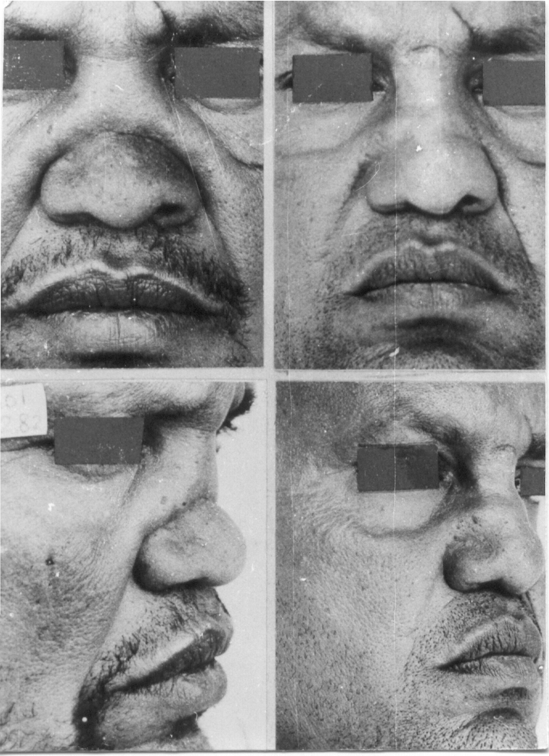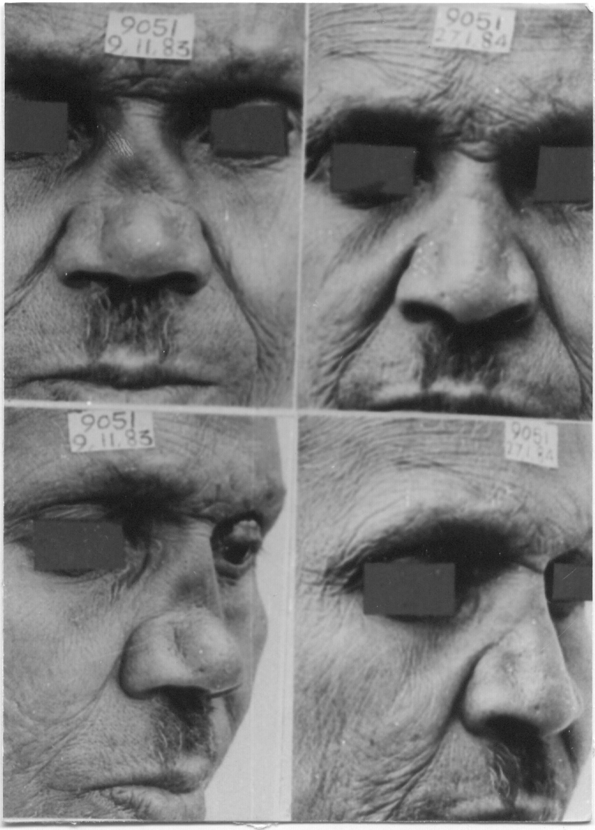
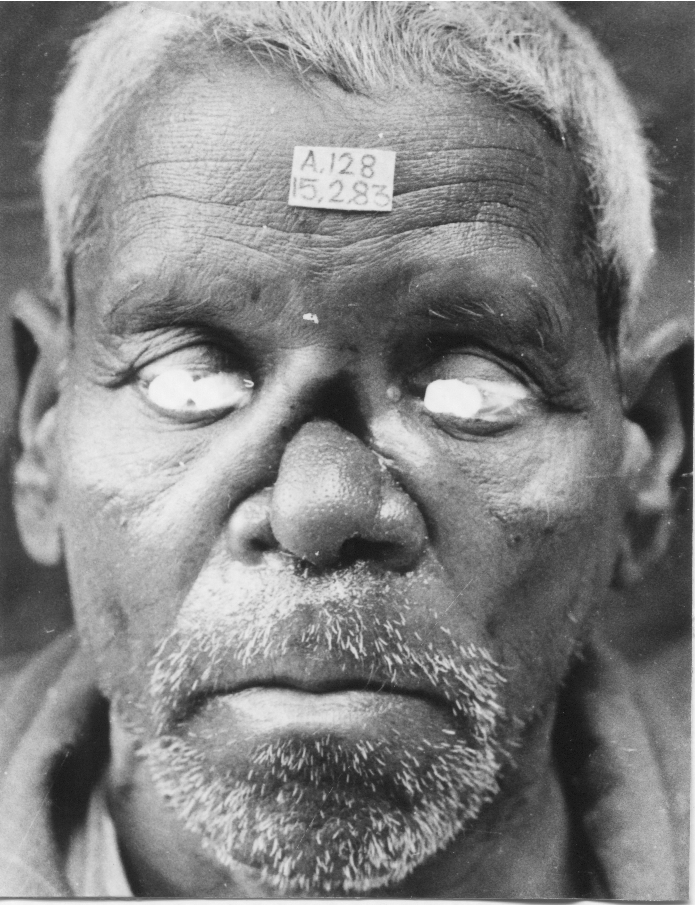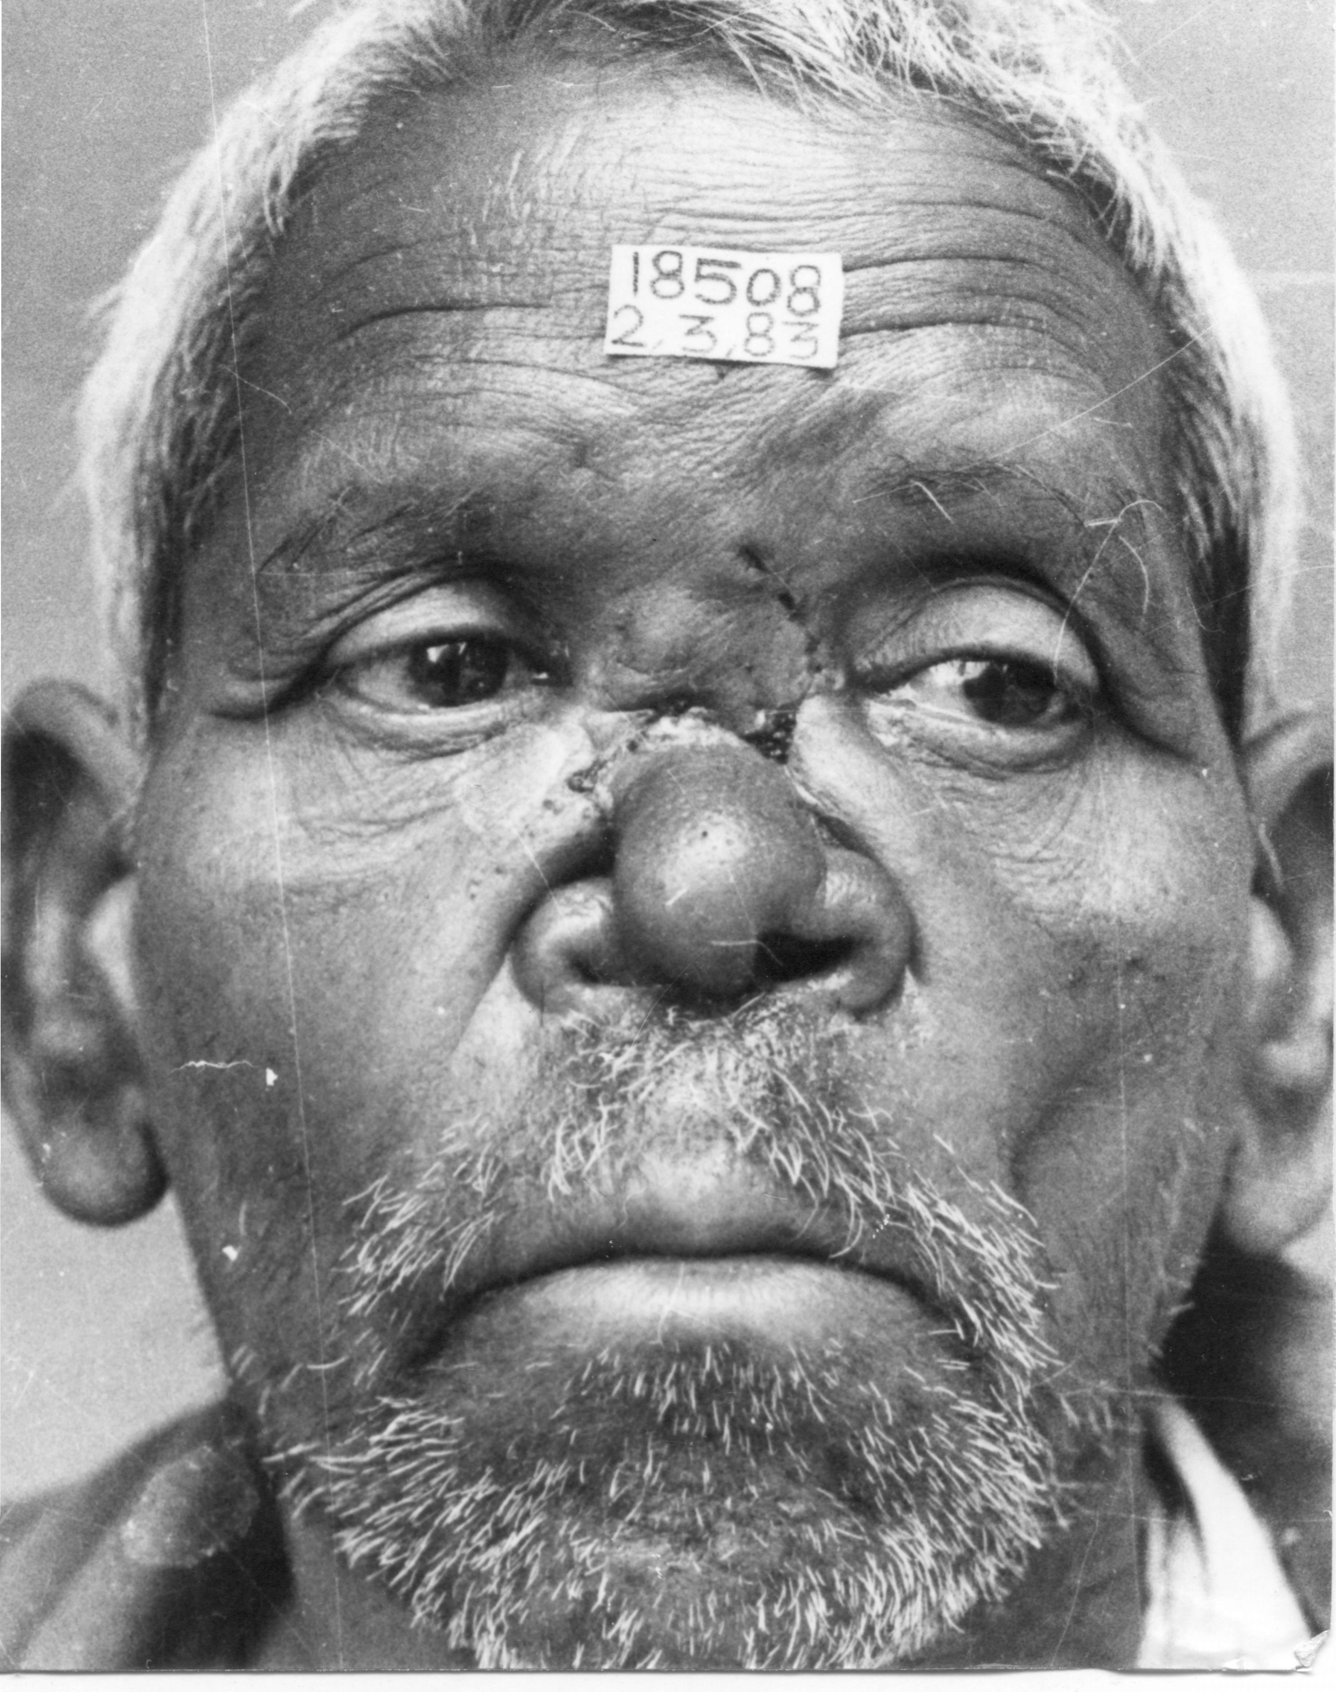

The Author is post graduate training in Plastic Surgery in 1981 and joined the Plastic Surgery Dept at National JALMA Institute for Leprosy Agra as Junior specialist and retired from Head department on 31-3.2016
39 Papers in national and 21 papers published in International Journal ,contributed 8 chapters in various Plastic Surgery Text books.

