Modified Wedge Labiaplasty with an Aesthetic Eye: The True Technique

Abstract
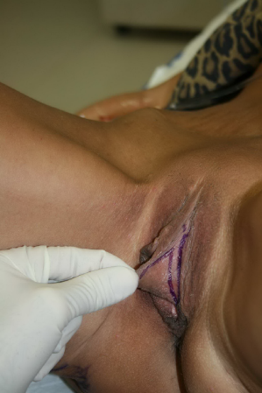
Statement of the problem: Many labiaplasty procedures result in unacceptable aesthetic results. Summary: Labiaplasty procedures have become very popular but results vary depending on the technique and experience of the surgeon. There are many techniques of performing the procedure and many times women are unhappy about the results due to an unsatisfactory aesthetic result. There are numerous reasons why women desire labiaplasty. These include embarrassment, poor self-esteem, , functional and emotional enhancement. To achieve the best aesthetic result one must consider the specific characteristics of a more aesthetic genital area. I would like to describe a different technique for performing labiaplasty which emphasizes this goal, versus other techniques that may not result a more natural aesthetic appearance. I developed a technique is called a modified posterior wedge technique that results in a more aesthetic and natural appearance of the labia. A similar technique has been described in the past, but I developed this technique separately and based on what constitutes a more aesthetic look.
Description of technique: I discuss my technique of performing labiaplasty from initial evaluation, markings, surgical details, results, potential complications and how to avoid them.
Conclusion: The rationale, goals and technique for performing a modified posterior wedge labiaplasty is described.

Biography: Robert True, MD is board certified in cosmetic surgery, specializing in breast and body, and is also board certified in gynecology. The combination of these gives him the advantage of developing a more aesthetic technique for the genital areas. His practice primarily services the Dallas Fort-Worth areas. He is also trained in Anti-Aging Medicine. Combined, these disciplines help him achieve his goal of improving the appearance of his patients, both internally with improved health, and externally with cosmetic enhancements. He has given presentation for the AACS, ASOCP, and A4M.
Publications: None

Veale D, et al. Psychological characteristics and motivation of women seeking labiaplasty. Psychol Med. 2014 Feb;44(3):555-65.
Miklos JR, Moore RD, Labiaplasty of the labia minora: patients’ indications for pursuing surgery. J Sex Med, 2008 Jun; 5(6): 1492-5.
Sorice SA, et al, Why Women Request Labiaplasty. Plast Reconstr Surgj. 2017;139(4):856-863.
Zwier S “What Motivates Her”: Motivations for Considering Labial Reduction Surgery as Recounted on Women’s Online Communities and Surgeons’ Websites. Sex Med. 2014 Apr;2(1):16-23.
Kelishadi SS, et al. Posterior wedge resection: a more aesthetic labiaplasty. Aesthet Surg J. 2013 Aug 1;32(6):847-53.

