Evaluation of Facial Scar Improvement by Autologous Fat Graft Injection
Professor Ari Raheem Qader, Kazim A Kakaways
Abstract:

Background: Autologous fat injection widely used in plastic surgery not just for filling the defect, but also for improvement of Scars, this effect of autologous fat may originate from variable contents of adult stem cells and varieties of growth factors in the Lipo - aspirate. Objective: is to show the effect of autologous fat graft injection on improvement of facial Scar. Method: twenty patients with thirty-two facial Scars, submitted to be treated by autologous fat injection, between April of 2015 - March of 2016 in plastic department and burn Center Hospital in Sulaimaniyah, Preoperative and postoperative follow up include use of patients and observers Scar assessment scale (POSAS) and Photo documentation in first, third and sixth months. Results: during sixth months of follow up, Refinement of Scar achieved in all cases, with satisfaction of both patients and observers and all scores of POSAS was significantly improved, for instance; pliability and stiffness, itching and so on. Conclusion: Autologous fat graft is not foreign material, easily achieved, its procedure is minimally invasive. It is very good way to improve scars of face, mainly burn scar, bigger sample and more follow up time are necessary to delineate the exact effective of autologous fat graft injection on Scarز
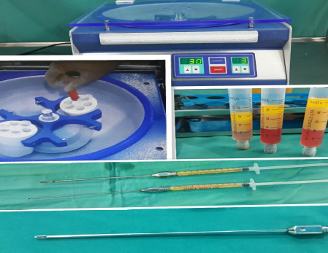
Recent Publications
1. Pallua N, Baroncini A, Alharbi Z, Stromps JP. Improvement of facial Scar appearance and microcirculation by autologous lipofillin. Journal of Plastic, Reconstructive & Aesthetic Surgery. 2014; 67:1033-7.
2. MAZZOLA RF, CANTARELLA G, TORRETTA S, SBARBATI1 A, LAZZARI2 L, PIGNATARO L. Autologous fat injection to face and neck: from soft tissue augmentation to regenerative medicine. ACTA OTORHINOLARYNGOLOGICA ITALICA. 2011; 31:59-69.
3. Vico PG, AxelDelange, Vooght AD. Autologous Fat Transfer: An Aesthetic and Functional Refinement for Parotidectomy. Surgery Research and Practice.2014; 2014:1-6.
4. Modarressi A. Platlet Rich Plasma (PRP) Improves Fat Grafting. PRP in fat grafts. 2013; 2(1):6-13.
5. Arcuri F, Brucoli M, Baragiotta N, Stellin L, Giarda M, Benech A. The Role of Fat Grafting in the Treatment of Posttraumatic Maxillofacial Deformities. Craniomaxillofacial Trauma and Reconstruction.2013; 6(2):121-126.
Biography :Ari Raheem Qader
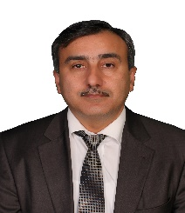

Professional Experience
- Professor in plastic and reconstructive surgery
- Vice present of Kurdistan association of Plastic and Reconstructive Surgeon
- Heading the Scientific Committee at Medical School.
- Supervisor of the Iraqi board for plastic and reconstructive surgery.
- Supervisor of the Arabian Board for plastic and reconstructive surgery.
- Supervisor of the Kurdistan Board for plastic and reconstructive surgery.
- Supervisor and director of high diploma in plastic and reconstructive surgery/ University of Sulaimani.
- Supervise and director of high diploma in plastic and reconstructive surgery/ Ministry of health.
- Supervise and director of high diploma in hand surgery/ University of Sulaimani.
- Supervise and director of high diploma in burn surgery/ Ministry of health.
- Heading of plastic and reconstructive surgery department in Sulaimani plastic surgery hospital.

