Primary Tendon Grafting of Flexor Tendons Injuries in Zone II
Anani RA, Azab AA and Gouda ME
Department of Plastic and Reconstructive Surgery, Faculty of medicine, Zagazig University
Zagazig, Egypt

Author Note
Raafat Abdallatif Anani: MD, Professor of plastic and Microscopic surgery, Faculty of medicine, Zagazig University.
Email:
Ahmed Abo-hashem Azab: MD, Assistant Professor of plastic and Microscopic surgery, Faculty of medicine, Zagazig University.
Email:
Mahmoud Elsayed Gouda: MB.B.Ch., Resident of Plastic and Microscopic surgery.
Email: goudamahmoud@rocketmail.com

Corresponding Author Contact Information Page:
The complete name and address of the corresponding author, or the author who is responsible for handling reprints, must appear. This information must include an e-mail address.

Financial Disclosure and Products Page
all sources of funds supporting the work and a statement of financial interest, if any, must be included for each author, along with a list of all products, devices, drugs, etc., used in the manuscript. All manuscripts must have all of this information.

Abstract (250 words)
Background: Obtaining good functional outcomes after flexor tendon repair in zone II has always become a challenge due to being crowded by the FDP and the two slips of the FDS within a tight fibrossoeus tunnel, thus increasing the possibility of postoperative adhesions. Methods of primary flexor tendon repair are continuously being modified still today. For achieving better results, primary flexor tendon grafting was suggested as new approach for flexor tendon repair in zone II.
Methods: This study was conducted on 24 patients (30 digits) with primary tendon grafting was done using palmaris tendon. Tendon graft interposition was done for FDP and FPL tendons distally, in zone I and proximally, in zone III and zone V for (respectively) bypassing zone II. FDS cut ends was done in situ in zone II. Modified Kleinert technique was chosen for rehabilitation and Adjusted Strickland system for evaluation of TAM. Follow up of the ROM was extended up to six months postoperatively.
Results: Results described recovery of motion in 93.3% of cases. Excellent to good results account for 66.6% at 12 weeks postoperatively and 70% at 6 months postoperatively. Complications incidence was 19.2 % in the form of tendon rupture (6.7%) and superficial wound infection (12.5 %).
Conclusions: Results of this study revealed that primary flexor tendon grafting could be a competitive approach for flexor tendon injuries in zone II.
Clinical question / Level of evidence: Therapeutic, II.
Key words: Flexor tendons; Primary repair; zone II; tendon grafting.

Manuscript (3000 words)

Flexor tendon injuries are a challenging problem for surgeons due to three main reasons. Firstly, flexor tendon injuries of the hands are a clinical problem because they cannot heal without surgical treatment. Secondly postoperative management needs to be carefully planned as mobilization has shown to be essential to prevent adhesions and improve gliding but this carries the risk of rupture. Lastly due to the unique anatomy of the tendons running through flexor tendon sheaths to function, surgeons need to plan preventing increasing the bulkiness of the tendon through its sheath, which is not always possible from scarring as this affects the functional outcome of the tendon 1.
Previously, delayed tendon grafting was the policy in flexor tendon repair in zone II. The last 50 years is notable for the reversal of this policy and recognition that results after primary, or delayed primary that is within a few days of tendon division, flexor tendon repair are likely to be better than delayed tendon grafting. This change was largely pioneered in the 1950s and 60s by Verdan, Young and Harman and Kleinert. The availability of antibiotics in the treatment of hand injuries may have had a significant influence in the success of this advance ².
The goals of surgical treatment of a lacerated intrasynovial flexor tendon have remained constant: accurate coaptation of the tendon ends in such a manner as to allow application of a postoperative rehabilitation protocol that encourages tendon gliding, inhibits the formation of peritendinous adhesions, stimulates restoration of the gliding surface, allows for primary healing of the repair site, and ultimately restores normal range of motion to the finger ^{3,4}.
The management in view of zone II flexor tendon injuries is a highly debatable topic. This zone has a fibro osseous digital canal where the tendons of flexor digitorum superficialis and flexor digitorum profundus interweave in a complex manner. The multiple pulleys increase its complexity because minimal swelling of the epitenon can impair free motion of the tendon. The margin of error, therefore, in this zone is very small. Zone II injuries have a delayed recovery compared with injuries to other zones, with slightly inferior overall results ⁵.
With advances in the understanding of flexor tendon anatomy, biomechanics, nutrition, and healing zone II flexor tendon repairs have improved ⁶.
Tendon grafts are used to achieve a functional result, usually in the face of a biologically unfavorable zone II injury with crush or scarring. The concept of tendon graft is to traverse through the zone of injury with a relatively normal tendon surface, minimizing adhesion formation and transferring the site of repairs from biologically unfavorable for gliding to more favorable ones ⁷.
Our idea to enhance better healing and less adhesions through bypassing the critical anatomy of zone II using primary tendon grafting.
Patients and Methods
Ethics
Ethics approval was obtained from the Institutional Review Board (IRB)
Patient selection
This prospective study was conducted in the Plastic and Reconstructive Surgery Zagazig University Hospitals from February 2015 till February 2016; 24 patients (30 digits) with acute flexor tendon injuries in zone II were enrolled in this study and underwent flexor tendon repair using primary flexor tendon grafting and referred to our outpatient clinic where they participated in the rehabilitation program and follow-up visits for 6 months postoperatively. Informed consents were obtained from all patients after thorough explanation of the whole procedure and possible complications. Inclusion criteria were (1) age group between 15-70 years old: (2) acute injury of F.D.P and F.D.S tendons in Zone II and interference was done within the 1st 48 hours of injury. Exclusion criteria were (1) age <15 years old or >70 years old; (2) fingers with fractures; (3) fingers with neurovascular injuries;(4) patients with joint disorders e.g. rheumatoid arthritis. All patients were initially seen at the emergency room; detailed history, thorough general and local examination for the injured hand and assessment for the availability of donor tendons were carried out. Basic investigations and a dose of one gram of cefotaxime sodium was given I.V to all patients one hour preoperatively.
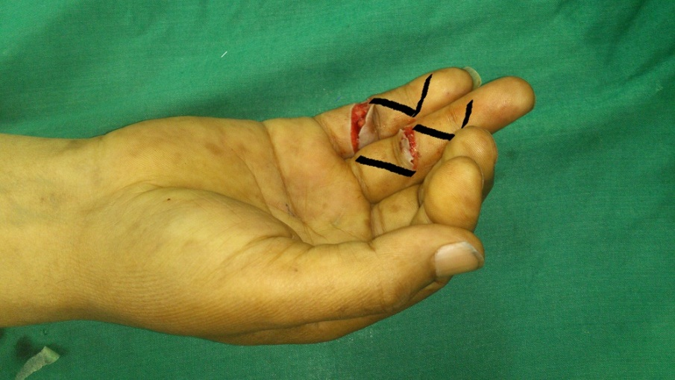
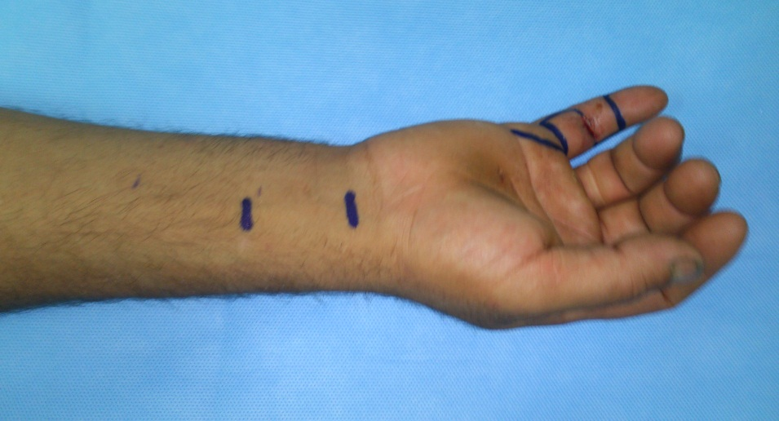
Surgical technique
Figure (1): Photo demonstrating the zigzag incision (A) and the medlateral incision (B).

B
A
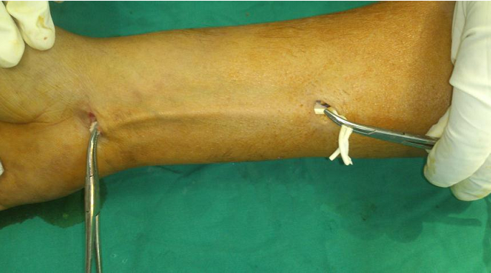
All operations were done in the emergency operating rooms and under magnification using 3.5 magnifying loupe. After application of a pneumatic tourniquet & prepping and draping, surgical incision was made through either the midlateral (Bunnell ) incision or zigzag (Bruner) incision (Fig. 1). Debridement & irrigation and exploration of the wound. Once the neurovascular bundles were identified and protected, full thickness flaps including subcutaneous fat were raised to expose the fibro-osseous flexor sheath.Delivery of the distal stmps was done by passive DIP hyperflexion. While delivery of the proximal stumps was attempted by milking the sheath from proximal to distal and then grasping the deep fibers of the tendon with fine non-crushing Debaiky forceps. If this was unsuccessful, a midpalmar incision (on the distal palmar crease) was made to identify the tendon. Once delivered into the wound it is secured by passing a 25-gauge needle transversely through the proximal flexor sheath, transfixing the tendon for repair. Suturing the cut ends of the FDS tendon in situ (zone II) using 4-stranded modified Kessler repair or transverse mattress sutures if the injury near the insertion as the tendon become flat. Approximately 1 cm of the FDP (or FPL) stump is preserved distally. The reminder of the injured FDP tendon is sharply excised just distal to the lumbrical origin in the palm. In case of FPL tendon , the tendon is excised till zone V .At this point, the wound was covered with a moist dressing till harvesting of the graft would be done. The palmaris longus tendon was obtained in all patients. This was done through a transverse incision just above the distal wrist crease. Another small transverse incision was made proximally, according to the required length (Fig. 2)
B
B
B
Figure (2): Intraoperative photo demonstrating dissection of plamaris. ….tendon.

The repair was started by suturing one end of the graft to the proximal cut end of FDP tendon using 4-stranded modified Kessler repair at zone III (just distal to lumbrical origin). In cases of FPL tendon injury, proximal repair was done in zone V. Then we anchored the tendon graft to a chilled pediatric Nelaton catheter, of size 10 F, to aid in gaining passage of the graft through the flexor sheath. The chilled catheter was pushed from proximal to distal through the sheath and the camper’s chiasma (Fig. 3).
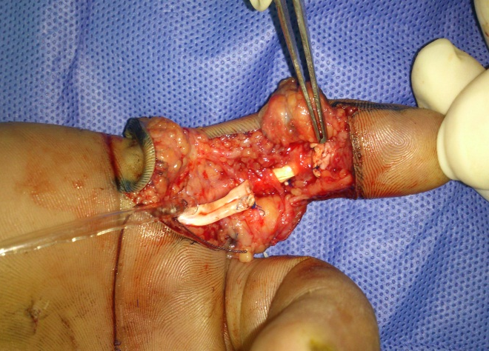
Distal juncture was done in zone I between the distal end of the graft and the FDP (or FPL) tendon cut end using 4-stranded modified Kessler technique (Fig.4).

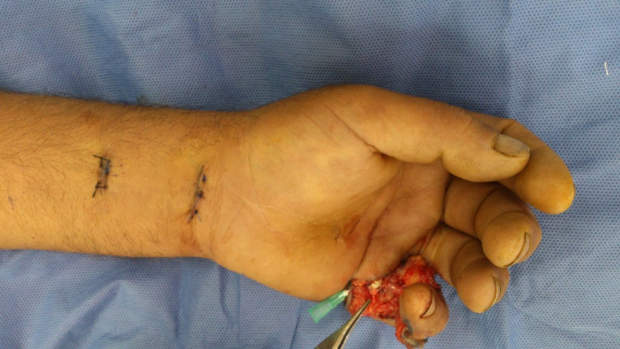
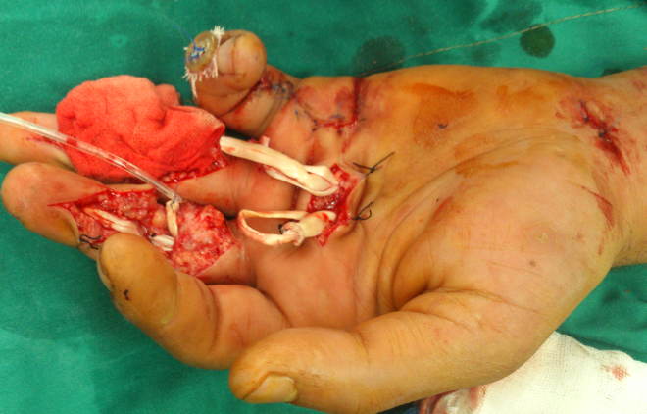
Figure (5): Intraoperative photos demonstrating graft tensioning. With wrist in neutral position, each finger falls into slightly less flexion than its ulnar neighbor.

Figure (3): Intraoperative photo demonstrating usage of catheter to aid the passage of the tendon graft through the flexor sheath.

The appropriate length and tension of the graft was achieved when the fingers became in the normal hand cascade as demonstrated in (Fig.5). Gliding of the FDS and the tendon graft within the flexor sheath and pulleys was carefully evaluated throughout the arc of motion. Both, FDP and FDS were repaired in above mentioned zones by modified Kessler using 4-0 Prolene sutures (4-strand repair). A simple running peripheral epitendenious suture was added using 6-0 Prolene sutures. FDS cut ends were repaired with transverse mattress sutures if the injury near the insertion as tendon become flat. Closure of the skin was done using simple interrupted 4-0 Prolene sutures.
Figure (4): Intraoperative photos demonstrate distal repair of tendon graft in zone I.

Postoperative splinting:
An immediate dorsal blocking splint that extends beyond the fingertips was applied while the patient was still under anaethesia. This was designed to maintain wrist flexion in 40 degrees and MP joint flexion in 50 degrees with IP joints in neutral. Rubber band traction was implemented; this was done using a nylon fishing thread that was attached to a hook placed on the fingernail and passed under a palmar pulley to be attached to a rubber band fixed to the splint on the proximal forearm as shown in (Fig.6). The elastic band is detached at night and the fingers are strapped into extension within the splint to minimize the risk of flexion contractures of the fingers. In case of severance of the flexor pollicis longus, a dorsal thumb-slab was applied with the wrist also in 40 degrees flexion.
Postoperative Rehabilitation Program:
Modification of Kleinert rehabilitation protocol was used as follow ⁸:
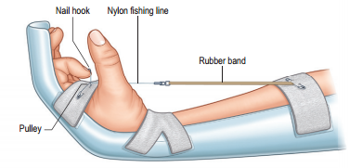
1. During the first 3 weeks postoperatively, the wrist was fixed in a thermoplastic splint in a neutral position with rubber bands flexing the fingers. The main goal was the complete active extension of the fingers as soon as possible, with an additional flexion of the MCP joint of the injured finger or thumb. Patients performed ten active IP joint extension exercises each hour; this involved placing a pad on the dorsum of the proximal phalanx to act as a fulcrum for full extension and unloading the tension of the rubber bands by drawing them distally with collateral hand.
Figure (49): The splint used for postoperative rehabilitation ⁹

2. In the following 3 weeks a neoprene cast for the forearm with rubber bands for passive finger flexion was customized by the occupational therapists. During the night, the hand was still splinted as in phase one device. Encourage hourly exercises ten repetitions of passive digital flexion. No active flexion is permitted. Slowly increase range of flexion over the first 3weeks
3. During the next 6 weeks, rehabilitation continues with night splinting only. Active mobilization was carried out to start tendon activity. During this period, the patient was warned from any energetic movement.
Return to professional activity was usually allowed after 3 months postoperatively to allow for maximum recovery.
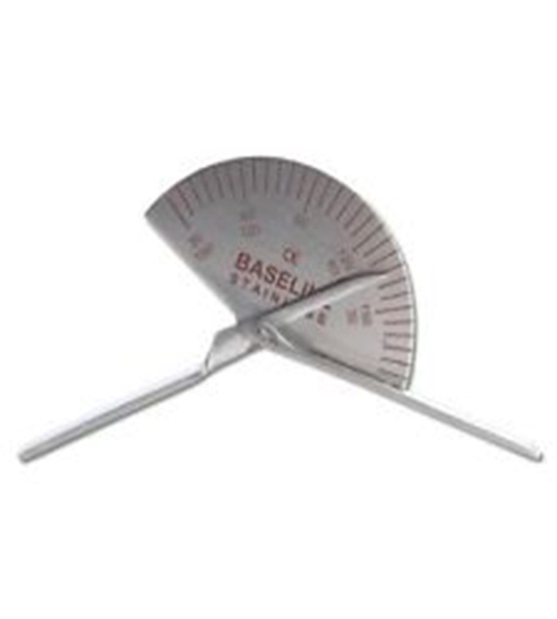
Follow-up of patients and postoperative clinical examination:
Figure (6): The Goniometer.
Patients were seen with the following frequency: weekly in the first month, every 2 weeks during the second and third months, and once every month until the end of the follow-up period.
In each visit patients were evaluated for: range of motion of both active and passive, using the standard Goniometer. Assessment and early detection of complications as tendon rupture, finger contracture, wound infection or complex regional pain syndrome.
Final assessment
- Timing:
At the 12th week and 6 month postoperatively, Active digit motion was measured at PIP & DIP joints for each finger and recorded.
- Methods used for the final assessment:
Clinical results were evaluated using Total Active Motion (TAM) of the injured finger or fingers and examined, according to the Strickland Formula ⁹. TAM is the sum of maximal active range of motion of the PIP and DIP for the fingers and IP for the thumb, minus the total extension deficit at these joints. The values in degrees were compared with those of the uninjured contralateral fingers, expressing the deficit in percentages. Range of movement in that digit was classified according to Adjusted Strickland System ¹⁰ (see Table: 1).One physiotherapist evaluated all the patients independent of the surgeon.
Table (1): Adjusted Strickland’s classification system ¹⁰
Adjusted Strickland % | (active flexion PIP + DIP) – (extension deficit PIP + DIP)  175 ◦  100 %
Excellent | 75-100
Good | 50-74
Fair | 24-49
Poor | 0-24
Statistical analysis
The collected data were computerized and statistically analyzed using SPSS program (Statistical Package for Social Science) version 18.0.Qualitative data were represented as frequencies and relative percentages. Chi square test was used to calculate difference between qualitative variables. Mc Nemar test was used to calculate difference between qualitative variables between 6 weeks and 12 weeks post therapy. Paired Wilicoxon test was used to calculate difference between quantitative variables in at 12 weeks and 6 months post therapy. The significance Level for all above mentioned statistical tests done. The threshold of significance is fixed at 5% level (P-value) *P value of >0.05 indicates non-significant results. *P value of <0.05 indicates significant results.**P value of <0.01 indicates highly significant results.

Results:
This study included 24 patients with 30 digits injured. Four patients had more than one digit injured. Three patients had only the FPL injured and the remaining digits has both FDP & FDS tendon injured (total of 57 tendon injured).
Patient demographics:
Figures given in Table (2) revealed the socio-demographic characters of the patients in our study that indicated the predominance of injury in adolescent males who lived in urban area and whose right hand was the dominant hand. The age range was between (16-46 years old) while mean age was 27 years old with male: female ratio of 11:1 and the right hand was the dominant hand in 87.5 %. When looking at the occupation we found that most of patients were manual &industrial worker which indicates that the occupation has a great role as risk factor in hand injuries. Also, the majority of our patients were not highly educated (87.5 %) and smokers (66.7 %). This is clearly demonstrated in Table (3). From findings indicated in Table (4) it is noticed that the most common cause was the sharp injuries and the most causative agent was the knife and the majority of studied case has single finger injury in the non-dominant hand. Results given in Table (5) revealed that in our study 58.3 % of cases undergone surgical pair within 6- 12 hours from the injury time. The time of operation was between (1-2) hours in 70% of cases. Also we notice that the ring finger followed by the little finger are the most involved digits (30% and 26.7%, respectively).
TAM results
The overall final results were evaluated according to Strickland evaluation system. Tables (6) & (7) show the absolute overall results of the series. Overall recovery of range of motion in our cases was 93.3%. Excellent to good results account for 66.6% (excellent in 23.3%, good 43.3%) at 12 weeks postoperatively and 70% (excellent in 33.3%, good 36.7%) at 6 month postoperatively. Therefore there was significant improvement in results after 6 month postoperatively. This was represented in Tables (6) & (7) and Fig.(56) .
Because of multiple fingers injuries in the same patient that occurred in 4 patients of our cases, we adopted -in the following tables- the results of each finger as an independent unit for comparing between the results and the affecting factors.
It’s obvious from Table (8) that there’s significant association between better results and middle age, non- manual work, high educated, non- smoker and right handed persons. Table (9) revealed that the sharp injuries has statistically significantly better outcome than blunt injuries and also the single finger injury had better outcome than multiple fingers injury. It’s also noticed that there was significance influence of time of surgical intervention and our results and there was no significant association between the name of finger and the better results.
Complications
The incidence of complications was 19.2 % in the form of tendon rupture (6.7%) and superficial wound infection (12.5 %). There were no other complications as deep wound infection, flexion contracture, tourniquet related complications or complex regional pain syndrome.
Discussion
Flexor tendon injuries still remain a challenging condition to manage to ensure optimal outcome for the patient ¹. It is undisputed nowadays that primary or delayed primary treatment of acute tendon transection is the best method of treatment ¹¹. In zone II ,where both FDS & FDP tendons passes through the flexor tendon sheath , 1ry repair of both was almost complicated by adhesions and flexion contracture hence the term “no man’s land” was common and widely used among hand surgeons till the last 50 years ¹².
The study of flexor tendon surgery can be frustrating due to the enormous variation in the methods of evaluation and classification encountered in literature. Despite the efforts of many authors, no universally accepted system has evolved. This lamentable absence makes it virtually impossible for surgeons to compare reported results with each other in a meaningful manner ¹³. In addition, Comparison of the range of motion results in this study with those in other reports may be of limited value because of differences in patient compliance with the rehabilitation protocol and in the rehabilitation regimens themselves. In addition, the method used to score the range of motion is a confounding factor between studies, which share only the categorization of results into excellent, good, fair, or poor categories. Other investigators have commented that many uncontrolled variables make it extremely difficult to meaningfully compare results between different centers ^{9,14}.
Nevertheless, it is reported at the end of follow-up period good to excellent results in 70% of cases (excellent in 33.3%, good 36.7%) and fair to poor results in 30 % of cases (fair 16.7% and poor in 13.3%). On the other hand, Galanakis et al., 2003 ¹⁵ reported better results; 91% excellent to good results and 9% fair to poor results. This figure seems to be better than that of Bal et al., 2011 ¹⁶ who reported excellent to good results in 52% of cases (excellent in 4%, good 48%) and fair to poor results in 48 % of cases (fair 48% and poor in 0%) as well as the results of Peck et al., 2014 ¹⁷ who reported excellent to good results in 49% of cases (excellent in 22%, good 27%) and fair to poor results in 51% of cases (fair 32% and poor in 19%). Oppositely, better results published by Su et al., 2006 ¹³ who reported good to excellent results in 71% of cases (excellent in 30%, good 41%) and fair to poor results in 29 % of cases (fair 19% and poor in 11%) as well as Farzad et al., 2014 ¹⁸ who reported excellent to good results in 77% of cases (excellent in 45%, good 32%) and fair to poor results in 23% of cases (fair 23% and poor in 0 %).
Conclusions
This preliminary study assessing the outcomes of primary tendon grafting in flexor tendon injuries in zone II demonstrates encouraging results that makes this new approach is a competitive to the conventional repair.
Acknowledgements
References
1. Griffin, M., Hindocha, S., Jordan, D., Saleh, M. & Khan, W. An Overview of the Management of Flexor Tendon Injuries. Open Orthop. J. 6, 28–35 (2012).
2. Elliot, D. & Giesen, T. Avoidance of unfavourable results following primary flexor tendon surgery. Indian J. Plast. Surg. 46, 312 (2013).
3. Strickland, J. W. Flexor Tendon Injuries: I. Foundations of Treatment. J. Am. Acad. Orthop. Surg. 3, 44–54 (1995).
4. Strickland, J. W. Flexor Tendon Injuries: II. Operative Technique. J. Am. Acad. Orthop. Surg. 3, 55–62 (1995).
5. Hung LK et al. Active mobilisation after flexor tendon repair: comparison of results following injuries in zone 2 and other zones. J Orthop Surg Hong Kong (2005).
6. Ansari, M. T. & Kotwal, P. P. Zone 2 flexor tendon injuries: Venturing into the no man’s land. Indian J Orthop (2012).
7. Thorne, C. H. et al. in Grabb and Smith’s Plastic Surgery (LIPPINCOTTWILLIAMS & WILKINS, 2007).
8. Moriya, K. et al. Clinical outcomes of early active mobilization following flexor tendon repair using the six-strand technique: short- and long-term evaluations. J. Hand Surg. Eur. Vol. 1753193414551682 (2014). doi:10.1177/1753193414551682
9. Strickland, J. W. & Glogovac, S. V. Digital function following flexor tendon repair in Zone II: A comparison of immobilization and controlled passive motion techniques. J. Hand Surg. 5, 537–543 (1980).
10. Libberecht, K., Lafaire, C. & Van Hee, R. Evaluation and functional assessment of flexor tendon repair in the hand. Acta Chir. Belg. 106, 560–565 (2006).
11. Elliot, D. Staged tendon grafts and soft tissue coverage. Indian J. Plast. Surg. Off. Publ. Assoc. Plast. Surg. India 44, 327–336 (2011).
12. Newmeyer, W. L. & Manske, P. R. No man’s land revisited: the primary flexor tendon repair controversy 1. J. Hand Surg. 29, 1–5 (2004).
13. Su, B. W. et al. A device for zone-II flexor tendon repair. Surgical technique. J. Bone Joint Surg. Am. 88 Suppl 1 Pt 1, 37–49 (2006).
14. Strickland, J. W. Development of flexor tendon surgery: twenty-five years of progress. J. Hand Surg. 25, 214–235 (2000).
15. Galanakis, I. et al. Functional Evaluation of Digits After Flexor Tendon Primary Zone Ii Repair. J. Bone Joint Surg. Br. 85-B, 218–219 (2003).
16. Bal, S. et al. Anatomic and functional improvements achieved by rehabilitation in zone II and zone V flexor tendon injuries. Am J Phys Med Rehabil 90, 24 (2011).
17. Peck, F.H et al. The Manchester short splint: A change to splinting practice in the rehabilitation of zone II flexor tendon repairs. Hand Therapy. 19, 47–53 (2014).
18. Farzad, M. et al. A prospective randomized controlled trial of controlled passive mobilization vs. Place and active hold exercises after zone 2 flexor tendon repair. Hand Surg. Int. J. Devoted Hand Up. Limb Surg. Relat. Res. J. Asia-Pac. Fed. Soc. Surg. Hand 19, 53–59 (2014).

