Upper Eyelid Lifting - Correcting Ptosis of the Infra-Brow Skin
Patrícia Périssé, MD, Rio de Janeiro, Brazil
Luiz Alberto Soares Pimentel, MD, Rio de Janeiro, Brazil

The author presents hers and Dr. Pimentel’s experience with their personal technique named “Ascending Upper Blepharoplasty” – used , in the initial cases, to correct ptosis of the orbital rim skin (sub-eyebrow skin) over the upper eyelid, a frequent occurrence after an upper blepharoplasty performed without a concomitant facial lifting. The technique can be used to correct “fatty eye”, a consequence of a lateral retro-orbicularis oculi fat (Roof) excess in the upper eyelids, and four more conditions can be treated with good results. The author makes a brief historical report about the blepharoplasty, describes the technique and presents some results. The access way for this procedure is a sub-eyebrow zigzag incision that can be used for frontal procedures, for corrugator supercilii muscles resection and for primary blepharoplasties. The described surgery start a zigzag or W sub-eyebrow incision followed by a subcutaneous undermining and orbicularis muscle incisions to treat the fat pads and Roof excesses, to ascend the eyelid’s lateral corner and to resect skin excess making a true upper eyelid lifting.

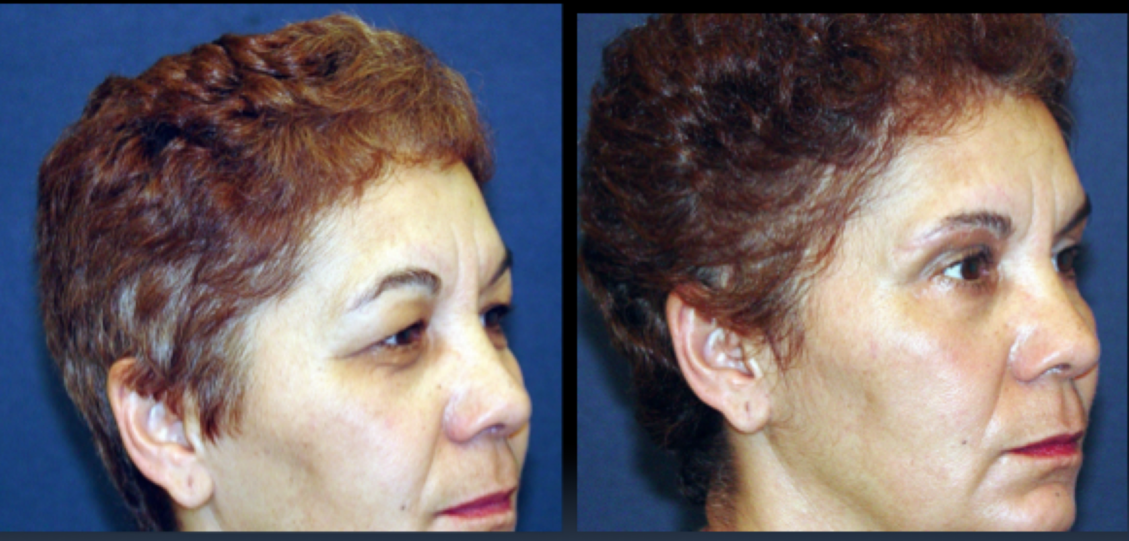
The technique has been published in the Brazilian Plastic Surgery Society’s magazine in 2006 and has been presented in the following congresses/meetings:
Vegas Cosmetic Surgery , Las Vegas, USA, 2016
ISAPS – International Society of Plastic Surgery, California, USA, 2010
American-Brazilian Meeting, Park City, Utah, USA, 2009
Plastic surgery congress, QMP, Chicago, Illinios, USA, 2007

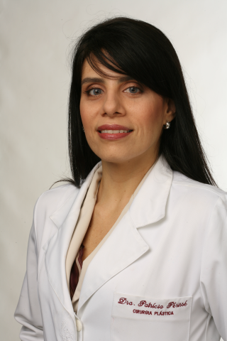 | Highly qualified and widely recognised as a leading plastic surgeon, Dr Périssé possesses over 10 years’ experience performing a wide range of procedures in the field of reconstructive and cosmetic surgery including teaching and coordinating projects. A Board Certified plastic surgeon who is experienced in mammoplasty, liposuction, breast implants, tummy tucks, otoplasty, face and neck lifts, Botox, weight loss, laser therapy, burn care, and eyelid, nose, and thigh lift and brachioplasty surgery. As a professional in the field of cosmetic and reconstructive surgery, Dr Périssé practices in clinics and hospitals within Rio de Janeiro, Brazil.

